Introduction to MS Dynamics ERP NAV 5.0 SP1 in concise clauses = part five
Created by : Jaromír Skorkovský
Date : 10.11.2010
Reason : Concise instrument helping in tuition and study
Accompanying mat. : no

- Go to Customer 10000 and Ctrl-F5 – see entries. Put cursor to Document type column and by F7 and then F6 enter filter for Invoice. Then go to the column Open and by F6 and F6 make a choice for Yes =Open and you will get only open (not paid) entries which were generated by posting orders or invoices by F11.
- Our client decided to pay us ,so we have got from bank a statement of customer payment and we have to enter manually this payment an apply this payment to appropriate invoice specified by variable symbol (number of the posted invoice)
- Go to the menu :



and open general Journal and by use of show column function add field Applies-to Doc.No. (right click on the upper part of the window and check the appropriate filed and OK.)

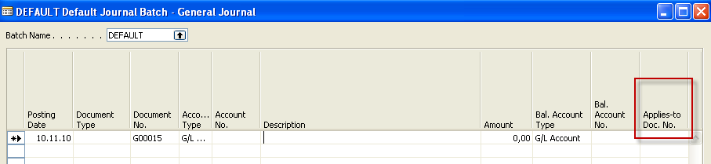

4. We will start to enter payment parameters :

- Document type=Payment
- Account Type = Customer - tutor will show you how you can find on customer card appropriate G/L Account related to the customer number
- Make a choice for our model customer 10000
- Go to the other (right part of the General Journal)

- Enter Account Type=bank and make a choice for bank

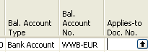

6. By use of the key F6 from the field Applies-to Doc.No. you will enter window with the list of all open invoices :

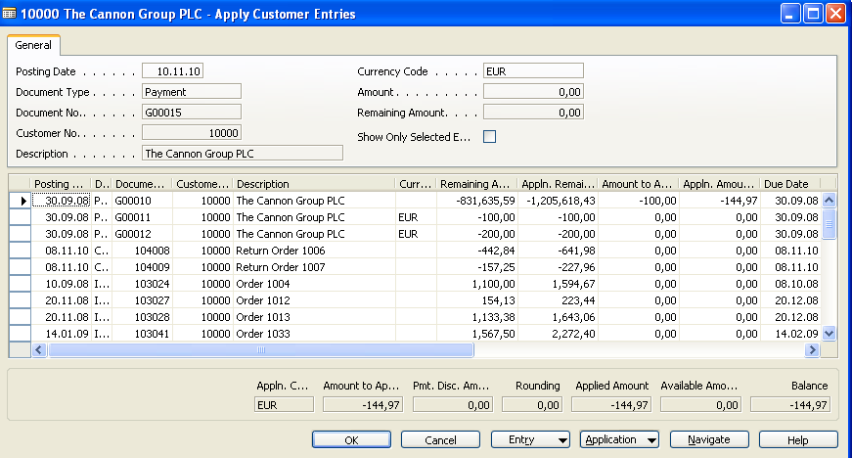

- Make a choice of one of them and confirm by OK :

You will get the following window:

Post it by F11 and go to the Customer 10000 and see the entries by Ctrl-F5 and you will see closed invoice by entered payment.

7. Go to the menu Financial Management –Registers:



and go by cursor to the last line of this window and by button Register show General ledger entries

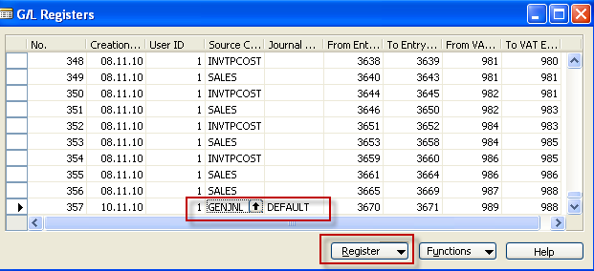

General ledger Entries looks like :

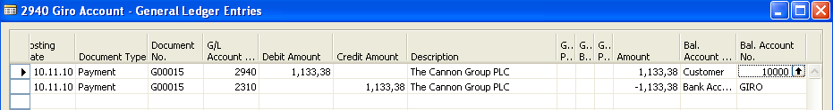

Go from the account by use of F6 to the chart of account to see the names of the accounts.

Do the same operation for chosen Vendor !!!
Try to find button on the entries window to find applied entries of close ones.

