BPH_EPS1 (Enterprise Resource Planning Systems) – questions spring 2013
Created by : Ing. J.Skorkovský,CSc. KPH ESF MU BRNO, Czech Republic ; 1730@mail.muni.cz;skorka@cmail.cz; jaromir.skorkovsky@navertica.co, tel : +420 731113517
Date : 11.04.2013
Version : I.

All questions could be studied with the help of related study materials handed over to students during lessons held in Brno ( Spring 2013)

Will be shortly reviewed (explained) during last lessons (11.04.2013) taking into consideration, that 17.5.2013 is a first assigned date for exams. Important parts of below specified questions may be found in your Seminar works (if this was assigned- for Spring 2013 it was not the case)

Resources:

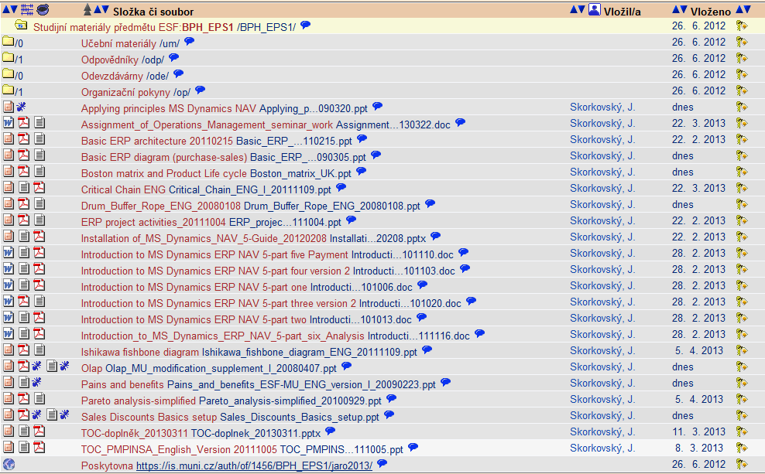

Below listed material (are including in the copy of the student material above as well ) have to be used for MS Dynamics NAV 5.0 studies. Mind you, that access to ERP system MS Dynamics NAV 5.0 ENG version is possible in both public computer rooms !

Introduction to MS Dynamics ERP NAV 5-part one
Introduction to MS Dynamics ERP NAV 5-part two
Introduction to MS Dynamics ERP NAV 5-part three selling : simple business case
Introduction to MS Dynamics ERP NAV 5-part four
Introduction to MS Dynamics ERP NAV 5-part five
Introduction to MS Dynamics ERP NAV 5-part six (analysis)

Applying principles MS Dynamics NAV (has been uploaded to the study material 11.4.2013)

Sales discount basics (was already concisely presented and it uploaded in the above listing of the study material).

Basic ERP diagram (purchase-sales) – PWP ( was be uploaded to the study material 11.4.2013)

Pain and benefits ( was be uploaded to the study material 1.4.2013)

Listing of Theory Resources – will be used below to show you mapping knowledge -resources

A. ERP project activities _ 20090102
B. Pains_and_benefits_ESF-MU_ENG_version_I_20090223
C. Critical_Chain_ENG
D. TOC_PMPINSA_English
E. Short explanation of applying principles
F2. Boston Matrix and Product Life Cycle (PLC) + Magic Quadrant Matrix from Gartner
F3. Applying principles MS Dynamics NAV
G1. Ishikawa fishbone diagram ENG
G2. Pareto Analysis Simplified
- Basic Budget and Analysis
- Drum – Buffer-Rope PWP presentation (uploaded 11.4.2013) – will be discussed
- OLAP PWP presentation (uploaded 24.4.2012) - – will be discussed
- Magic quadrant from Gartner (PWP loaded 19.4.2013)

ERP Resources (practice)

- Demo version of MS Dynamics NAV 5.0 W1
- 1st Part of Helping material
- 2nd Part of Helping material
- 3th Part of Helping material –selling (simple business case)
- Sales discount basic for foreign students (PWP)
- Material related to Sales Discount Setup (Intro to MS Dynamics ERP NAV in concise clauses-part four)
- ERP Basic and very simplified Principles (chosen slides only- not the ones with feedbacks)
- Basic ERP Architecture
- 4th part of Helping material
- 5th part of helping material (Exercise for payment of the open entries)
- 6th Introduction_to_MS_Dynamics_ERP_NAV_5-part_six_Analysis (dimensions, analysis by dimensions)

Theory Questions (resources A-H):

Structure of the theory question:

Number Description : Resource (slides if required )

1. What is required by competitive ERP markets: A, B, F2 (innovation, road map, PLC,..)
2. Name some reason for change the old ERP system: A and B
3. Name key activities of the implementation project (project entries): A
4. What is a Gantt chart: A and C
5. Evaluation of the project result. How we can know, that the Project was successful? : A, C
6. Which knowledge is necessary for project management? : A ,C
7. Simplified chart (diagram) of ERP functions (feedback diagram) : A
8. Specify the basic concept of the Theory of Constraints : D
9. TOC metrics : D
10. Cost World and Throughput World : D
12. TOC five steps: D and Drum-Buffer- Rope (see resource I. for DBR concept)
13. Basic trees (Thinking process tools) – Current Reality Tree, Evaporating Cloud Tree and Future Reality Tree: D
14. Project and its budget: C
15. What is bad multitasking? : C
16. Critical path and Critical Chain: C
17. Use of project buffer (buffer management concept) : C
18. Pains and benefits: B
19. Creation of the vision: B (nine steps slide in the PWP presentation B
20. Ishikawa fishbone diagram: G1
21. Boston matrix and Product Life Cycle(PLC) + Gartner Magic matrix : F2 and K
22. Pareto analysis: G2
23. OLAP (see resource J)
24. Basics of budgeting (H) – may be shown by use of MS Dynamics NAV (not for summer 2013 !!)

Practice Questions (resources I-S) :

1. Modularity of the ERP systems.
2. Main windows (forms) used in ERP and syntax for Debits and Credits (posted General Ledger Entries
3. Users modification of the ERP windows (Hide and Show column, moving column)
4. Main tables (Item, Customer, Vendor and Account).
5. Purchase of an item and impacts of F11 (posting) -> item and vendor entries, G/L entries.
6. Sale of an item and impacts of F11 (posting) -> item and customer entries, G/L entries.
7. What is an applying principles. (F3- list of the theory resources)
8. Payment of the open entry (customer or vendor) by use of the Financial Journal.
9. Discounts and the use of this.
10. Contact Card and its profile and use of it.
11. Analysis examples and Accounting schedule (See our example of simplified VAT report – see resource U). Only basic principles (name of the analysis, line template and column template)
12. Production (basics such as Bill of material routing, production order and related item ledger entries such as Output and Consumption). Machine and Work centres, setup times and production times in routing, reason for production (customer requirement,…lack-shortage of items in inventory, Prognosis) - (not for summer 2013 !!)

