**Class 5 (March 21st)**

1. **Defining business cycles**

**Business** cycle represents the short-run (year-to-year) fluctuations in real GDP and employment. If real GDP is growing in the short-run, we call this period economic *expansion*. If real GDP is declining (negative growth rate compared to previous quarter), the economy shrinks or contacts, entering a period of *recession*. The phases of economic expansion and economic contraction change each other, and we call such changes or fluctuations of GDP as business cycles. The starting date of a cycle is called a *peak* and the ending date is called *trough*.

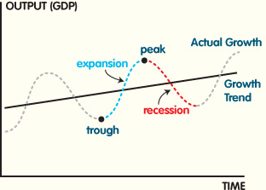

The Business Cycle Dating Committee of the NBER maintains a chronology of the U.S. business cycles. The chronology comprises alternating dates of peaks and troughs in economic activity. A **recession** is a period between a peak and a trough, and an **expansion** is a period between a trough and a peak. During a recession, a significant decline in economic activity spreads across the economy and can last from a few months to more than a year. Similarly, during expansion, economic activity rises substantially, spreads across the economy, and usually lasts for several years. The rule of thumb for determining recession is two consecutive quarters of negative growth of real GDP.

Eleven business cycles were observed in the US economy during 1945-2012. The last business cycle in the US is: December 2007 – June 2009. The longest period of the US economic history without recession was 1990 – 2001.

Dating of the business cycles in Europe is done by the Euro Area Business Cycle Dating Committee of the Center of Economic Policy Research. The starting date of the last business cycle (peak) is 3rd quarter of 2013, and the EU economy still remains in recession. Previous business cycle was from 1st quarter of 2008 till 2nd quarter of 2009.

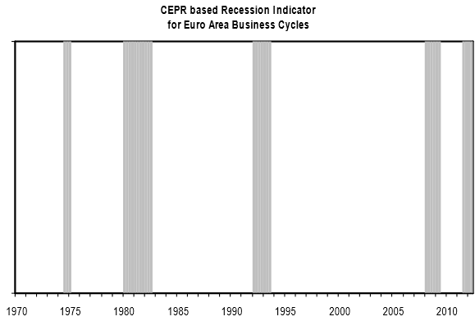

The EU recession periods (quarterly data)

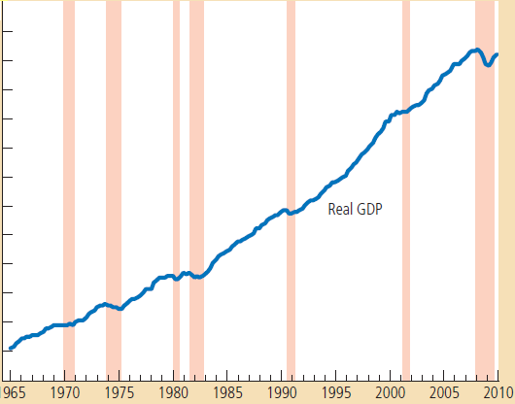

The US real GDP and recession periods (quarterly data).

* *Are business cycles in different countries correlated? In other words, will American recession have impact on the European economy? Explain using two pictures above.*

1. **Consequences of economic slowdown**

Business cycle represents the short-run (quarter-to-quarter) fluctuations of real GDP over its long-run growth trend. When the economy experiences a period of falling output and increasing unemployment, the economy is said to be in recession. Periods of severe recession (substantial fall in output) are called *depression.* The term “business cycle” is misleading, as fluctuations of real GDP are not predictable and they do not happen on regular basis. Figure below shows the dynamics of the real GDP growth rate for the US. Shaded areas in the graph show the periods of recession.

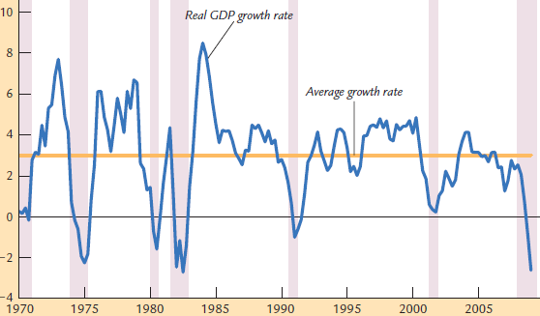

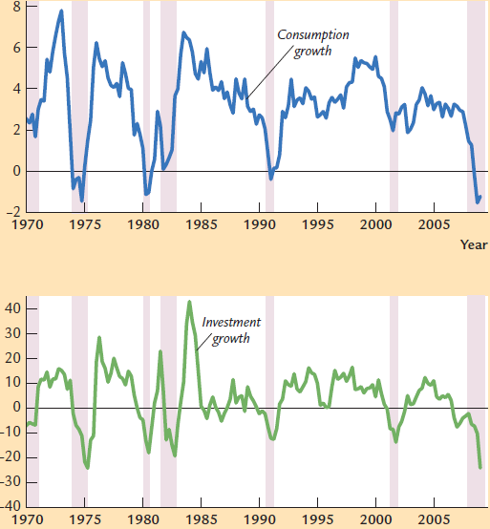As most macroeconomic variables fluctuate together, the fall in real GDP is accompanied by changes in other macroeconomic indicators. In the picture below we observe the dynamics of consumption and investment growth rates for the US.

**%**

* *Analyze the graphs and explain how consumption and investment behave during recessions? What is the reason for that?(Hint: recall the definition of the GDP). Which variable is more volatile (shows larger swings over the average value) and why?*

When the Business Cycle Dating Committee decided about the starting and ending dates of recession, they take into account the growth rate of GDP and unemployment rate dynamics. The unemployment rate is defined as a percentage of the working age population who are not working, but actively looking for jobs. Relationship between GDP growth rate and unemployment rate is known as Okun’s law.

**%**

* *Look at the graph of unemployment rate dynamics for the US. What is the relationship between two indicators and why it is like this?*

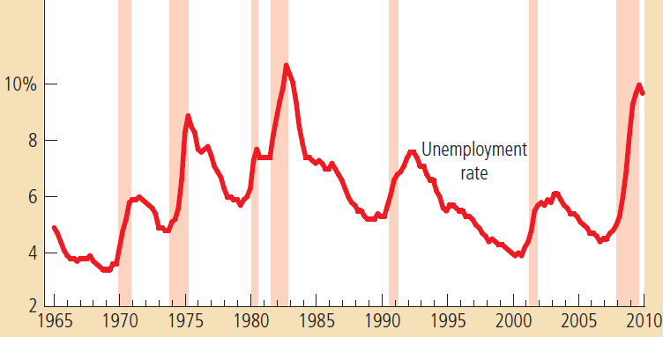

1. **Sticky prices**

In the book *The General Theory of Employment, Money and Interest (1936),* John MaynardKeynes proposed that an economy’s total income was, in the short run, determined largely by the spending plans of households, businesses, and government. The more people want to spend, the more goods and services firms can sell. The more firms can sell, the more output they will choose to produce and the more workers they will choose to hire. Keynes believed that the problem during recessions and depressions was in *inadequate spending*.

Many economists believe that the difference in the behavior of the economy in the short run and long run is due to the difference in behavior of *prices*. In the short run, prices are *sticky* at some predetermined level. For example, firms cannot immediately cut wages, stores cannot immediately change price tags on their goods, and restaurants cannot change their menus. Failure of prices to adjust quickly implies that output and employment must do some of the adjustment instead. Sticky prices are very common. The typical firm in the economy adjusts its prices once or twice a year.

How does the introduction of sticky prices change our view of how the economy works? We can answer this question by considering forces of supply and demand. In **classical** macroeconomic theory, the amount of output depends on the economy’s ability to supply goods and services, which in turn depends on the supplies of capital and labor and on the available production technology. This is the essence of the basic classical model, as well as of the Solow growth model. Flexible prices are a crucial assumption of classical theory. The theory posits that prices adjust to ensure that the quantity of output demanded equals the quantity supplied. The economy works quite differently when prices are sticky. In this case, output also depends on the economy’s demand for goods and services. Demand, in turn, depends on a variety of factors: consumers’ confidence about their economic prospects and firms’ perceptions about the profitability of new investments.

The classical school and Keynes differ in terms of remedies for the economy’s recovery from recession. The classical theory starting from Adam Smith taught us about the **market forces**. If we have a free market and the government does not intervenient into the economy, whenever there is a shift from equilibrium, market forces would bring the economy back. Government does not need to intervene; the invisible hand of the market will help to sort things out. The adjustment would go through the price mechanism. Prices adjust in the way that the economy reaches the equilibrium, and output gets to the level of the full employment and economy is working at its full capacity.

Keynes argues for the active intervention of the government by means of monetary and fiscal policies to help the economy to recover from recession. As the short run prices of goods and services are fixed or sticky, the only way the firms can respond to the increase or decrease in demand for goods and services in the economy is by changing production, which results in the changes in the aggregate (whole economy) output, which is GDP and total income.

* *Recall the definition of GDP from expenditure approach. Which side of the equation stands for the supply and for the demand? This definition reflects equilibrium in the market. Explain how the equilibrium is restored from the classical theory prospective and from the prospective of Keynes.*

1. **Circular flow diagram and the government**

Recall the circular flow diagram.

* *What is the main message of the diagram? What effect will business cycle fluctuations have on the income and expenditures of the economy? What are the assumptions of the model?*

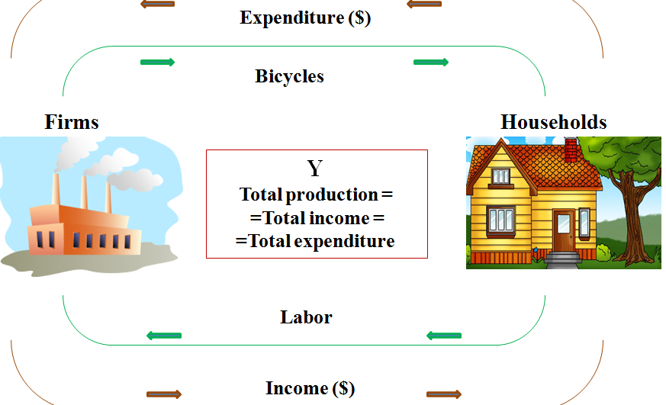

Now, think about the role of the government. The government as other economic agents receives income and consumes. The primary source of government income are taxes (denoted by T), and the expenditure of the government is denoted by G. These two indicators – government spending and taxes – comprise the tools of the **fiscal policy**.

* *Will the flow be preserved after introduction of the government into the picture? What effect would have both fiscal policy tools on the economy’s output?*

1. **The role of households’ spending**

We start building the Keynes’ model of economy in the short run. It is a model where GDP growth is driven by demand. If people do not buy stuff, the goods are accumulated in the store shelves. As an outcome, firms cut their production and lay-off workers.

Recall the definition of GDP from **expenditure** approach. One of the substantial components of expenditure is the households’ consumption (denoted C), which represents a purchase of goods and services by people. The household consumption is determined to the large extent by the household income. The relationship between these two variables is positive: as income rises, consumption also rises. However, when the income of a household increases by 1$, do people spend the whole dollar on consumption? On average, no! Some part of the extra income is saved. We can define the **marginal propensity to consume** (MPC) as the amount consumed out of additional dollar of income. MPC is always greater than 0 and it is a value in the interval [0, 1].

* *What does MPC=0.5 mean?*

The consumer expenditures can be represented as a function of income: ***C = a+bYD*** ,where *b* is MPC, Y is disposable income which is left after taxes (*YD=Y-T*), and **a** stands for the *autonomous consumption* – a proportion of consumption that is not related to income. People always need to eat and buy some necessities regardless of their income. If income is 0, a person deeps into the savings to cover his/her consumption.

* *Think about yourself. What are your values of* ***a*** *and* ***b****?*

Relationship between consumption and income can be represented graphically in the following way:

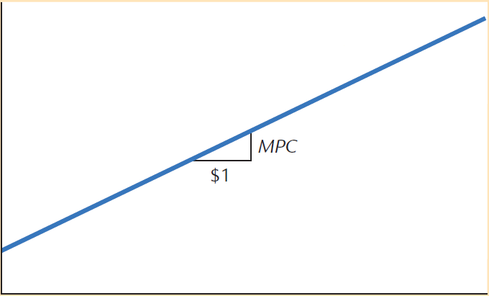

Soon after Keynes proposed a consumption function, economists began collecting and examining the data to test his hypothesis. These studies show that households with higher income consume more, which confirms that MPC is >0. Also, households with larger income save more, which confirms that MPC<1. Studies also show that the correlation between income and consumption is very strong.

1. **Aggregate expenditure**

We start building the Keynes’ model of economy in the short run. It is a model where GDP growth is driven by demand. If people do not buy stuff, the goods are accumulated in the store shelves. As an outcome, firms cut their production and lay-off workers.

Recall the definition of GDP from *expenditure* approach. It is also known as the fundamental macroeconomic identity: Y=C+I+G+NX, where C represents purchases of goods and services by households, I is purchases of goods and services by firms for the purpose of increase of future production, G is government purchases of goods and services, and NX is net export. For now, we consider closed economy only (NX=0). In this case, the right-hand-side of the equation represents aggregate expenditure (AE) – spending plans of all agents in the economy.

Graphically, the AE function is built in the following way. For simplicity, we assume fixed investments of firms (I) and fixed size of the government spending (G), thus both of them do not depend on Y. Only consumption is a function of autonomous spending and income. As I and G are constants, the AE line is consumption function which is shifted upwards by size I and G.

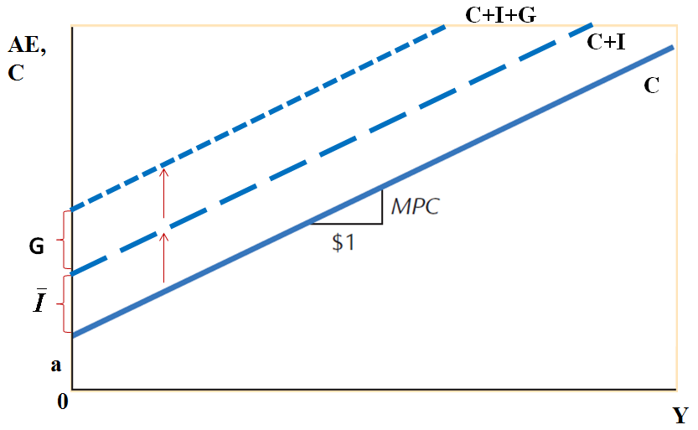

The slope of the consumption function is marginal propensity to consume (MPC) – what share of the additional 1$ of income will be spent on consumption. It is a number between 0 and 1.

* *Imagine that households anticipate a slowdown of the economy, and they decide to save more income for the rainy day. How would this decision affect MPC? How would the AE function change graphically?*
* *If we relax the assumption about fixed investment and allow I to vary. What would firm investment depend on?*

1. **The equilibrium in the goods market (Part I)**

In the macroeconomic sense, equilibrium is a situation when spending of all economic agents is equal to the amount of goods and services actually produced. In other words, the equilibrium in the goods’ market is a situation when aggregate demand (Aggregate expenditure AE) is equal to aggregate supply (Y or GDP): Y=AE. Aggregate expenditure (AE) is the amount consumers, firms, and the government would like to spend on goods and services. AE is defined in the following way:

AE= C + I+ G, were C is consumers’ spending, I - investment of firms, and G – government consumption.

Let’s consider a graphical representation of the equilibrium. First, we plot the AE function. We consider I and G as fixed for now, thus being independent of income (Y). Only households’ consumption depends positively on income. To find the equilibrium, we need to find the intersection of AE line with a 45 degrees line. The latter represents all possible points when Y=AE, thus all possible equilibrium points which represent the balance in the economy (total income is equal to aggregate expenditures). However, for given levels of C, I , and G, there will be only one relevant point on the 45 degrees line, it will be *the point of intersection* of two lines, which would determine the equilibrium.

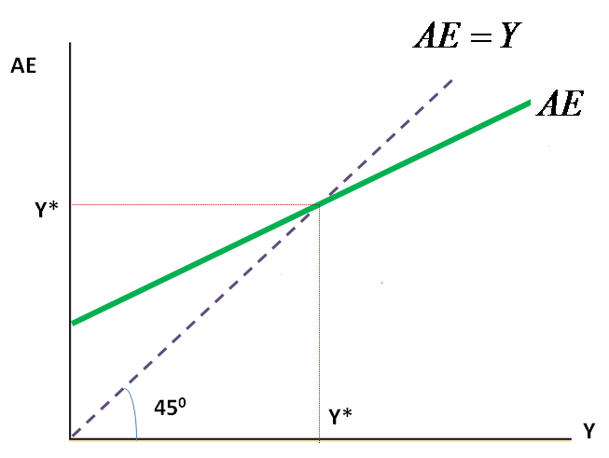

If the economy is not in the equilibrium, it will get there. Assume that the economy is not at the equilibrium level of Y*. In particular, the actual output is smaller (to the right of Y*). This is a situation when the demand (aggregate expenditure) is much larger than the output Y. Thus, firms notice that their inventories are depleted very fast, so they decide to increase production. Recall that the prices in the short-run are sticky implying that they do not change immediately to respond to the changes in demand. Thus, in order to meet higher demand for their goods, firms increase their production by hiring more people. As output increases, the economy approaches Y*.

* *Consider a situation when the economy is to the right of the equilibrium Y*. Will the economy return to equilibrium and what will be the means of such adjustment?*

1. **Equilibrium in the goods’ market (Part II)**

Equilibrium in the goods’ market is a situation when aggregate demand (Y or GDP) is equal to aggregate supply (Aggregate expenditure - AE): Y=AE. In the case of closed economy, AE represents the sum of all spending in the economy made by households, firms and the government: AE= C + I+ G.

Consider the following economy:



Solve for the following variables:

1. Equilibrium GDP (Y*)
2. Disposable income (YD=Y-T). What is the marginal propensity to consume?
3. Equilibrium consumption (C*)
4. Compute total demand (AE). Does it equal to production and why or why not?
5. **The multiplier effect (Part 1)**

Recall the equilibrium in the goods market when aggregate expenditure (demand) are equal to the economy’s output (supply): Y=AE. In turn, aggregate expenditure represent the sum of consumer expenditure, firms’ investments and government purchases: , where I and G stand for the fixed or pre-determines levels, thus they are independent of Y in our analysis. YD – the disposable income – is the difference between total income and taxes (Y-T).



Two equations combined together yield the following identity:



Autonomous spending

Multiplier

The right-hand-side of the equation is a product of **1/(1-b)** term and **autonomous spending** by all economic agents. The spendings are autonomous as they do not depend on income or Y. The first term is called the **multiplier** which depends on b - *marginal propensity to consume* (how much of additional dollar income a household would spend on consumption). Y* stands for the equilibrium value of GDP.

As marginal propensity to consume is a number between 0 and 1, the multiplier is always a number greater than 1. Thus, any components of autonomous spending in the right-hand-side would have a larger effect on GDP than the initial increase. Increase in spending serves as catalysts for a larger increase in equilibrium income.

* *Assume that b=0.6 in the Czech Republic, and the government purchases increase by 1,000,000 Korunas in the 1st quarter of 2014. By how much the GDP of the Czech Republic would increase from this increase in government purchases?*
* *The* *government purchases multiplier in the US is estimated being equal to 1.57, while the tax multiplier is only 0.99. What do these numbers mean?*

1. **The multiplier effect (Part II)**

Recall the equilibrium in the goods market when aggregate expenditure (demand) are equal to the economy’s output (supply): Y=AE. In turn, aggregate expenditure represent the sum of consumer expenditure, firms’ investments and government purchases: , where I and G stand for the fixed or pre-determines levels, thus they are independent of Y in our analysis. YD – the disposable income – is the difference between total income and taxes (Y-T).



Two equations combined together yield the following identity:



Autonomous spending

Multiplier

The right-hand side of the equation is a product of **1/(1-b)** term and **autonomous spending** by all economic agents. These spending are autonomous as they do not depend on income(Y). The first term is called multiplier which depends on b - *marginal propensity to consume* (how much of additional dollar income a household would spend on consumption). Y* stands for the equilibrium value of GDP, or the GDP in the short-run.

The principle of the multiplier can be illustrated by the following example:

Image that you went for a walk on a Sunday afternoon and you decided to treat yourself with a cake. You go to the bakery shop in the neighborhood and buy a cake for 300 CZK. Your purchase becomes income of a pastry-cook who owns this bakery. The cook, in turn, spends 150 CZK out of 300 CZK on a dinner at his favorite Italian restaurant and saves the rest. The owner of the Italian restaurant where the pastry cook eats his dinner now gets additional income of 150 CZK. He, in turn, decides to buy with this additional income a T-shirt with a logo of his favorite music band for 75 CZK and saves the rest. And the process goes on and on. Thus, your single decision to treat yourself with a cake generates a continuous process. In the short run, increase in demand for goods and services results in higher income, which, in turn, generates even higher demand, and so on.

* *Using numbers from our example, calculate the change in Y* which is due to your initial purchase of the cake (ΔC=300 CZK). Hint: What is the marginal propensity to consume in our example?*

1. **The multiplier effect (Part III)**

Recall the equilibrium in the goods market when aggregate expenditure (demand) are equal to the economy’s output (supply): Y=AE. In turn, aggregate expenditure represent the sum of consumer expenditure, firms’ investments and government purchases: , where I and G stand for the fixed or pre-determines levels, thus they are independent of Y in our analysis. YD – the disposable income – is the difference between total income and taxes (Y-T).



Two equations combined together yield the following identity:



Autonomous spending

Multiplier

The right-hand side of the equation is a product of **1/(1-b)** term and **autonomous spending** by all economic agents. These spending are autonomous as they do not depend on income or Y. The first term is called multiplier which depends on b - *marginal propensity to consume* (how much of additional dollar income a household would spend on consumption). Y* stands for the equilibrium value of GDP, or the GDP in the short-run.

Increase in any component from the right-hand-side results in even larger increase in equilibrium income Y*. Consider a graphical illustration of the multiplier effect. The graph shows the change in government purchases G and its effect on the equilibrium output Y*. Increase in G shift the AE line up and a new intersection with 45 degrees line yields a new value of Y* which is larger than previous equilibrium. When we analyze the size of initial increase in G which is ΔG depicted as a vertical distance between AE and AE`, and consequent changes in the Y*, depicted as a horizontal distance between Y* and Y`*, we conclude that ΔY* > ΔG.

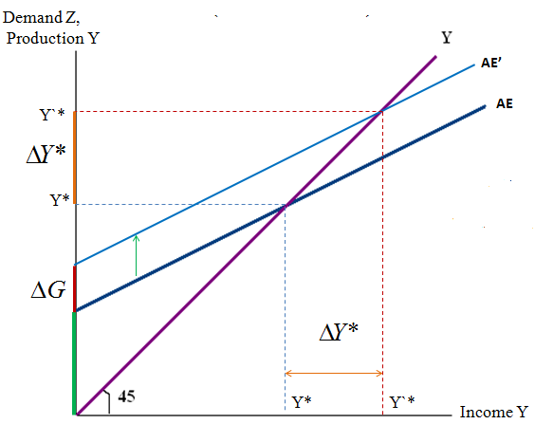

* *Calculate the value of the multiplier if MPC=0.6.*
* *Assume that households decide to save a larger share of their income. What effect that would have on the size of the multiplier? On the GDP in the short-run?*

**12. Fiscal policy**

Consider the equilibrium in the goods’ market. It is a situation when the output is equal to the aggregate expenditure: Y=AE. Aggregate expenditure (AE) is the amount consumers, firms and the government would like to spend on goods and services. AE is defined in the following way: AE= C + I+ G, were C is consumers’ spending, I - investment of firms, and G – government consumption. The equilibrium is depicted in the figure below:

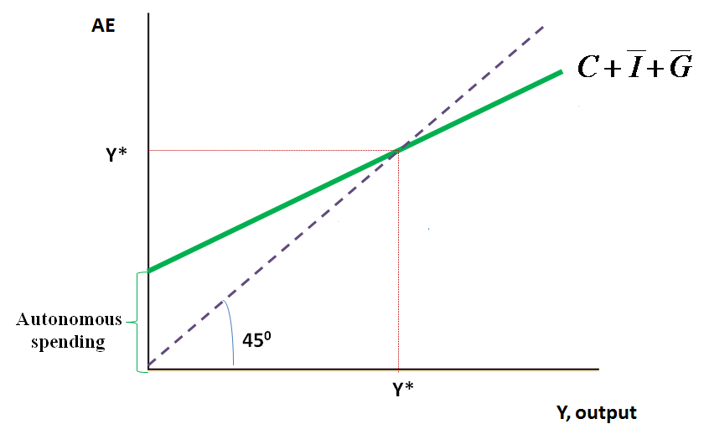

Now, let’s conduct the comparative statics exercise to see how the equilibrium output changes with changes in aggregate expenditure. For instance, when the government changes its **spending (G)** or the level of **taxes (T) –**instruments of fiscal policy**-** it affects the demand for the economy’s output of goods and services.

* *Consider increase in taxes by ΔT. What component of aggregate demand would be affected? How would such increase in taxes affect the equilibrium output Y*? Show your result graphically*.
* *Now assume that the government intends to cool down the over-heated economy and, consequently, cuts its spending. Show the consequences of such intervention for the economy and equilibrium values.*
* *What changes in other components of AE may help to cool down the economy?*

**12. The paradox of savings**

The savings of the household is that part of the disposable income that is not consumed: S=YD-C.

Recall the consumption function of households: *C = a + bYD,* where a is autonomous consumption which does not depend on income, b is a marginal propensity to consume, and *YD* is disposable income left after taxes. One part of *YD* is channeled to consumption, while the rest is saved. Consequently, we can represent *YD=C+S,* where S denotes households’ savings.

In the short run, saving has a contractionary (negative) effect on output. Consumers can increase savings either by reducing autonomous consumption (eating less), or by changing their marginal propensity to consume (b). Recall the formula for the short-run equilibrium GDP:



* *If households decide to save more by lowering their autonomous consumption, what effect would it have on Y*? Now, assume that households decide to save more by lowering their marginal propensity to consume. What effect would such change bring to Y*?*

Because a contractionary effect of saving appears to be a ‘paradox’, this is sometimes called the

Saving paradox (paradox of thrift). In the long run, the saving paradox disappears, as saving increases the growth potential of the economy, causes the interest rate to fall, and increases investment. These mechanisms are absent in the simple model with I= I.

What makes this phenomenon a “paradox” is that it seems counterintuitive. An extreme example helps build intuition for the logic behind it. Imagine that all agents in the economy, households, firms and government, at a particular moment in time decided to save everything they earned. Saving would

be, for an instant, at a maximum. But spending would be zero. If there is no spending, there can be no income. And if there is no income, there can be no saving. The paradox of thrift represents this basic economic truth. Spending and income are two sides of the same activity. One cannot logically analyze higher desired saving, and therefore a reduction in desired spending, without at the same time recognizing the consequent destruction of income.

Consider the following illustration. A couple that has been spending all their income suddenly decided to begin accumulating some funds for their children’ education. When they raise their saving by $5,000, they obviously reduce their spending by an equivalent amount. This act lowers the sales and income of merchants that had sold goods and services to the couple previously. It is not the couple’s intention to lower anyone’s income, but this is the inevitable result of their decision to save more than they had in the past.

Those agents who receive less income will save less. Suppose that the merchants who suffered the $5,000 decline of income keep their spending exactly the same after their income drop as they did before.

Then, by definition, their saving must fall by $5,000. Total saving in society will therefore no t increase at all, even though the couple saves $5,000 more. The couple’s voluntary choice to save more forced involuntary adjustments on other agents that reduced their saving by an offsetting amount. Of course, the merchants who suffered the income reduction may not absorb the entire reduction of their with lower saving. They may also reduce their spending to adjust to lower income. But this action just spreads the

problem as it will reduce the incomes of yet another group of agents. The economy will not reach equilibrium between saving and spending until one or more agents in the economy have cut saving in

an amount just equal to the in itial $5,000 increase in saving. This is the essence of the famous “paradox of thrift:” Total saving in the economy cannot be increased by individual decisions to save.

Therefore, policies that encourage savings in the short-run may lead to recession. As an example can be mentioned German recession in 2003-2003, when the savings rate increases from 9 to 15 %.