Increasing Government Purchases to Stimulate the Economy: The Obama Spending Plan
From: Mankiw, 2009 & 2012

When President Barack Obama took office in January 2009, the economy was suffering from a significant recession. (The causes of this recession are discussed in a Case Study in the next chapter.) Even before he was inaugurated, the president and his advisers proposed a sizable stimulus package to increase aggregate demand. As proposed, the package would cost the federal government about $800 billion, or about 5 percent of annual GDP. The package included some tax cuts and higher transfer payments, but much of it was made up of increases in government purchases of goods and services.
Professional economists debated the merits of the plan. Advocates of the Obama plan argued that increased spending was better than reduced taxes because, according to standard Keynesian theory, the government-purchases multiplier exceeds the tax multiplier.
The reason for this difference is simple: when the government spends a dollar, that dollar gets spent, whereas when the government gives households a tax cut of a dollar, some of that dollar might be saved. According to an analysis by Obama administration economists, the government purchases multiplier is 1.57, whereas the tax multiplier is only 0.99. Thus, they argued that increased government spending on roads, schools, and other infrastructure was the better route to increase aggregate demand and create jobs.
Policymakers focused on three kinds of spending. First, there was spending on “shovel-ready” projects. These were public works projects such as repairs to highways and bridges on which construction could begin immediately, putting the unemployed back to work. Second, there was federal aid to state and local governments. Because many of these governments are constitutionally required to run balanced budgets, falling tax revenues during recessions can make it necessary for them to lay off teachers, police, and other public workers; federal aid prevented that outcome or, at least, reduced its severity. Third, there were increased payments to the jobless through the unemployment insurance system. Because the unemployed are often financially stretched, they were thought to be likely to spend rather than save this extra income. Thus, these transfer payments were thought to contribute more to aggregate demand—and thereby production and employment—than tax cuts would.
Other economists were more skeptical about the plan. One concern was that spending on infrastructure would take time, whereas tax cuts could occur more immediately. Infrastructure spending requires taking bids and signing contracts, and, even after the projects begin, they can take years to complete. The Congressional Budget Office estimated that only about 10 percent of the outlays would occur in the first nine months of 2009 and that a large fraction of outlays would be years away. By the time much of the stimulus went into effect, the recession might be well over.
In addition, some economists thought that using infrastructure spending to promote employment might conflict with the goal of obtaining the infrastructure that was most needed. Here is how Gary Becker, the Nobel Prize–winning economist, explained the concern on his blog:
Putting new infrastructure spending in depressed areas like Detroit might have a big stimulating effect since infrastructure building projects in these areas can utilize some of the considerable unemployed resources there. However, many of these areas are also declining because they have been producing goods and services that are not in great demand, and will not be in demand in the future. Therefore, the overall value added by improving their roads and other infrastructure is likely to be a lot less than if the new infrastructure were located in growing areas that might have relatively little unemployment, but do have great demand for more roads, schools, and other types of long-term infrastructure.
While Congress debated these and other concerns, President Obama responded to critics of the bill as follows: “So then you get the argument, well, this is not a stimulus bill, this is a spending bill. What do you think a stimulus is? That’s the whole point. No, seriously. That’s the point.” The logic here is quintessentially Keynesian: as the economy sinks into recession, the government is acting as the demander of last resort.
In the end, Congress went ahead with President Obama’s proposed stimulus plans with relatively minor modifications. The president signed the $787 billion bill on February 17, 2009.
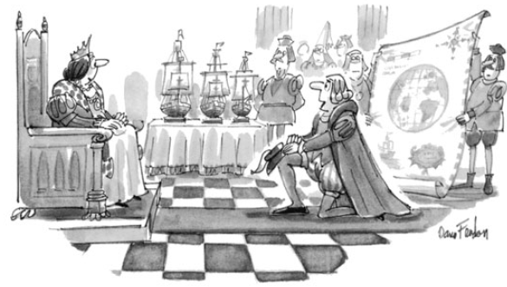
It is impossible to know for sure what effect the stimulus in fact had. Because we get only one run at history, we cannot observe the counterfactual—the same economy without the stimulus package. One thing is clear: While the economic downturn of 2008–2009 was severe, it could have been worse. As judged by the fall in GDP or rise in unemployment, it did not approach the magnitude of the
Great Depression of the 1930s.

