Customer Relationship Management in MS Dynamics NAV
Created by : Skorkovský, KPH,ESF.MU
Date : 28.3.2014

- Relationship Customer/Vendor <->Contact Card (Customer- Vendor ->entries such a invoices, payments and so on. Contact->interaction with prospect, clients,… Button Customer->Contact

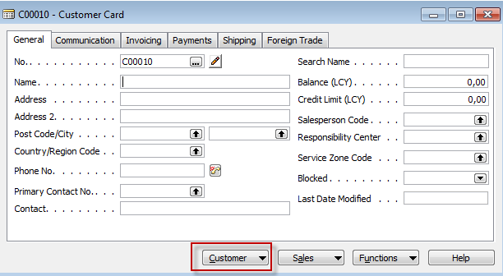

- Contact card. To see all contacts and both types of contacts, use F5 !!!
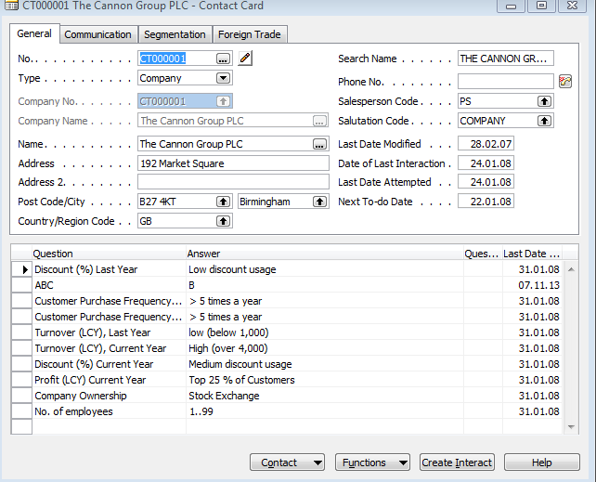

- Types of the contact (companies and employees)
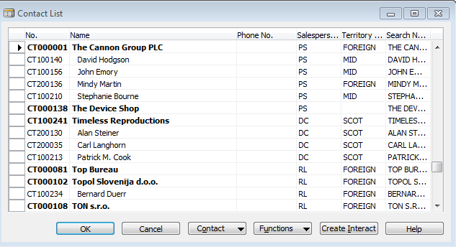

- Observe all tabs of the contact card of chosen company as well as employee contact card.

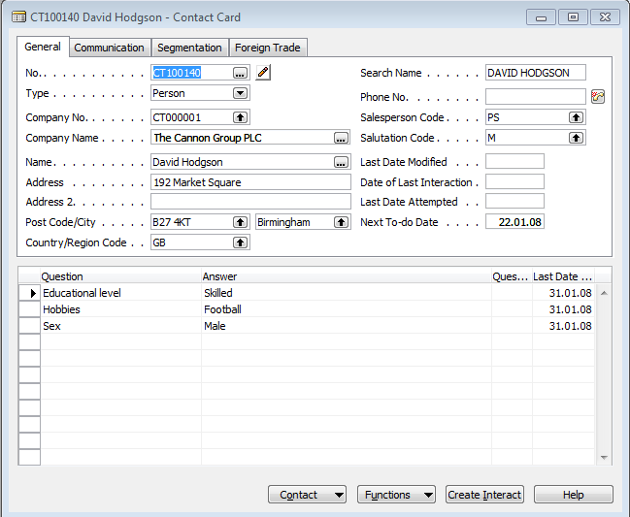

- By use of shown field with 3 dots open profile and make a modification
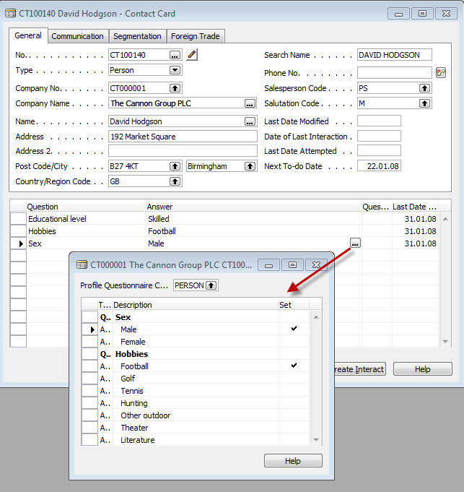

- Start to create interaction by use of wizard.
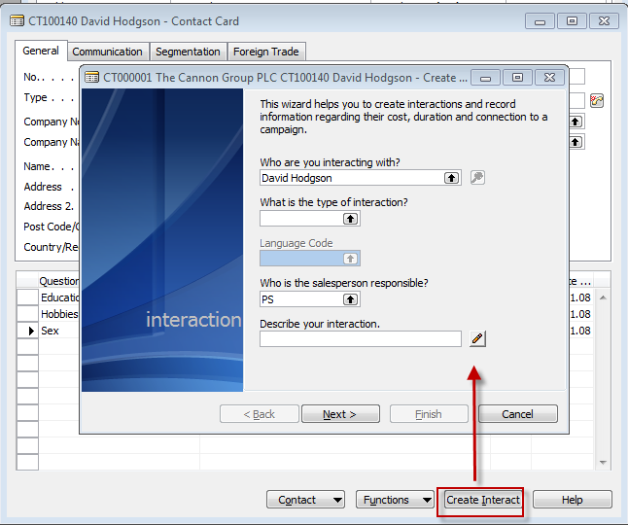

- See from contact card by use of Ctrl-F5 created contact entry (interaction entry)

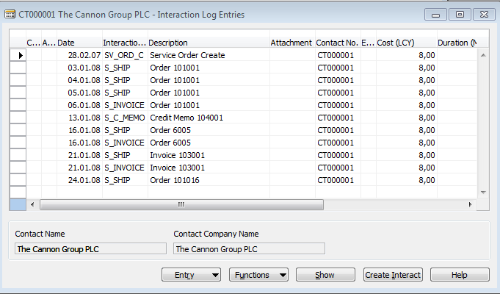

- Create a new contact card of the type company (manually- F3 and enter data) and from there create customer card by use of template (button Function and create as customer). See the sequence of forms below.

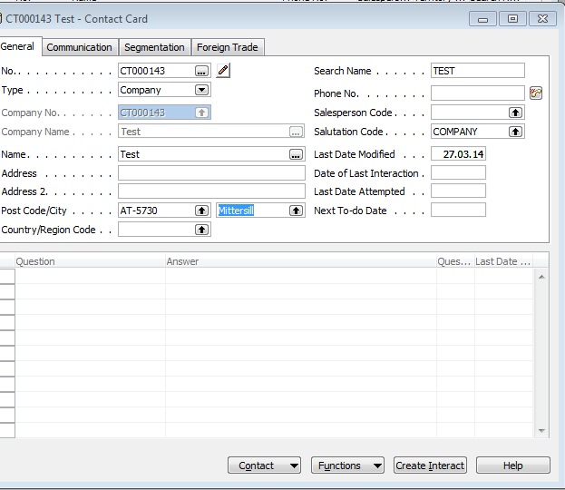

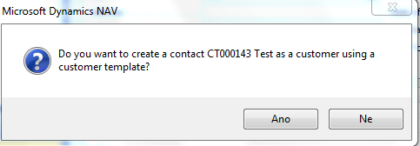

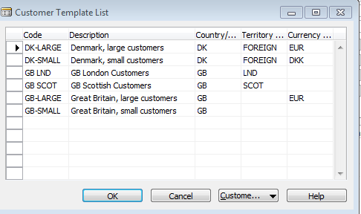

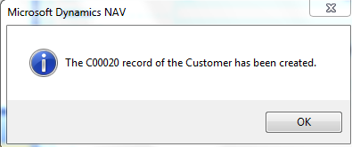

- Go to the new created customer card and from there back to the contact card.
- Create one interaction related to contact card in question
- Create a quote from the contact card from the button Contact->Sales quote
- Change the quote status to Sales order

