BPH_EPS1 (Enterprise Resource Planning Systems) – questions spring 2014
Created by : Ing. J.Skorkovský,CSc. KPH ESF MU BRNO, Czech Republic ; 1730@mail.muni.cz;skorka@cmail.cz; jaromir.skorkovsky@navertica.co, tel : +420 731113517
Date : 24.04.2014
Version : I.

All questions could be studied with the help of related study materials handed over to students during lessons held in Brno ( Spring 2014)

Will be shortly reviewed (explained) during last one of the last lessons (2.5.2014 or 9.5.2014) taking into consideration, that date 16.5.2014 is assigned date for exams. Important parts of below specified questions may be found in your Seminar works (if this was assigned- for Spring 2014 it was not the case)

Resources:
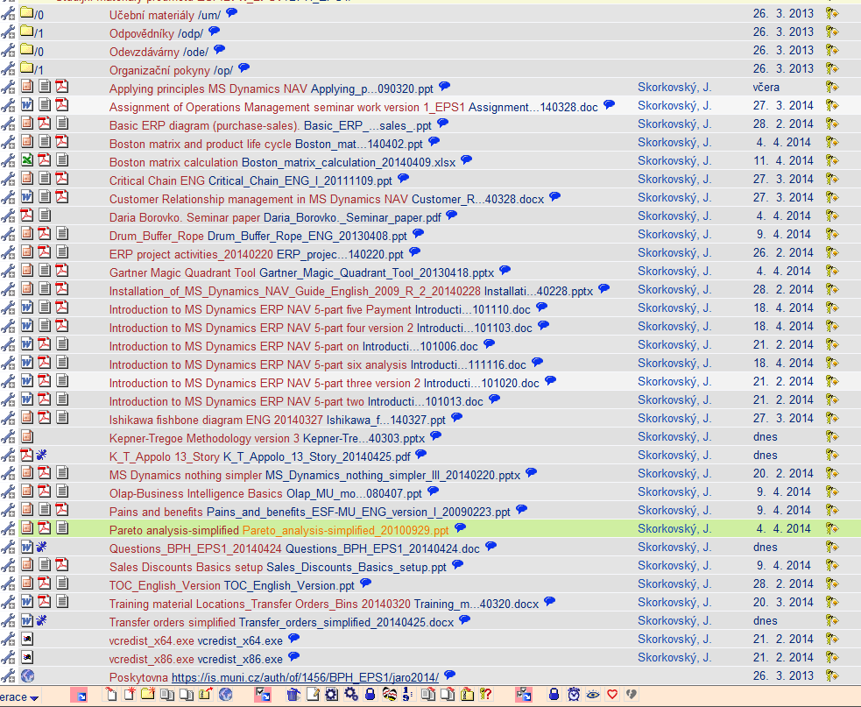

Below listed material (are including in the copy of the student material above as well ) have to be used for MS Dynamics NAV 2009 studies. Mind you, that access to ERP system MS Dynamics NAV 2009 ENG version is possible also in both public computer rooms!

Introduction to MS Dynamics ERP NAV 5-part one (N)
Introduction to MS Dynamics ERP NAV 5-part two (O)
Introduction to MS Dynamics ERP NAV 5-part three selling : simple business case (P)
Introduction to MS Dynamics ERP NAV 5-part four (U)
Introduction to MS Dynamics ERP NAV 5-part five (V)
Introduction to MS Dynamics ERP NAV 5-part six (analysis) (W)

Sales discount basics (was already concisely presented and it uploaded in the above listing of the study material).

Basic ERP diagram (purchase-sales) – PWP ( was uploaded to the study material 28.2.2014)

Pain and benefits –PWP ( was uploaded to the study material 9.4.2014)

Listing of Theory Resources – will be used below to show you mapping knowledge -resources

A. ERP project activities PWP presentation (26.2.2014)
B. Pains_and_benefits_ESF-MU_ENG_version (9.4.2014)
C. Critical_Chain_ENG (27.3.2014)
D. TOC_PMPINSA_English (28.2.2014)

F2. Boston Matrix and Product Life Cycle (PLC) + Magic Quadrant Matrix from Gartner (9.4. a 4.4. see K)
F3. Applying principles MS Dynamics NAV (24.4.2014)
G1. Ishikawa fishbone diagram ENG (27.3.2014)
G2. Pareto Analysis Simplified (4.4.2014)
- Basic Budget and Analysis (Introduction - part six (analysis)- see above)
- Drum – Buffer-Rope PWP presentation (uploaded 9.4.2014)
- OLAP PWP presentation (uploaded 9.4.2014)
- Magic quadrant from Gartner (PWP loaded 4.4.2014)
- Kepner-Tregoe methodology (was uploaded 25.4.2014)

ERP Resources (practice)

- Demo version of MS Dynamics NAV 2009 W1
- 1st Part of Helping material
- 2nd Part of Helping material
- 3th Part of Helping material –selling (simple business case)
- Sales discount basic for foreign students (PWP)
- Material related to Sales Discount Setup (Intro to MS Dynamics ERP NAV in concise clauses-part four)
- ERP Basic and very simplified Principles (chosen slides only- not the ones with feedbacks)
- Basic ERP Architecture
- 4th part of Helping material
- 5th part of helping material (Exercise for payment of the open entries)
- 6th Introduction_to_MS_Dynamics_ERP_NAV_5-part_six_Analysis (dimensions, analysis by dimensions)
- See clause F3 above (Applying principles)
- Transfer order simplified (25.4.2014)

Theory Questions (resources A-H):

Structure of the theory question:

Number Description : Resource (slides if required )

1. What is required by competitive ERP markets: A, B, F2 (innovation, road map, PLC,..)
2. Name some reason for upgrade (change) of the old (current) ERP system: A and B
3. Name key activities of the implementation project (project entries): A
4. What is a Gantt chart: A and C
5. Evaluation of the project result. How we can know, that the Project was successful? : A, C
6. Which knowledge may be necessary (useful) for project management? : A ,C
7. Simplified chart (diagram) of ERP functions (feedback diagram) : A
8. Specify the basic concept of the Theory of Constraints: D
9. TOC metrics : D
10. Cost World and Throughput World : D
12. TOC five steps: D and Drum-Buffer- Rope (see resource I. for DBR concept)
13. Basic trees (Thinking process tools) – Current Reality Tree, Evaporating Cloud Tree and Future Reality Tree: D
14. Project and its budget: C
15. What is bad multitasking? : C
16. Critical path and Critical Chain: C
17. Use of project buffer (buffer management concept) : C
18. Pains and benefits: B
19. Ishikawa fishbone diagram: G1
20. Boston matrix and Product Life Cycle(PLC) + Gartner Magic matrix : F2 and K
21. Pareto analysis: G2
22. OLAP (see resource J)
23. Kepner-Tregoe: L
24. Magic Gartner Quadrant: K

Practice Questions (resources M-X):

1. Modularity of the ERP systems. What areas can be contolled by ERP MS Dynamics NAV
2. Main windows (forms) used in ERP and syntax for Debits and Credits (posted General Ledger Entries) – card window, line window, matrix window, header and line window
3. Users modification of the ERP windows (Hide and Show column, moving column)
4. Main tables (Item, Customer and Vendor)
5. Purchase of an item and impacts of F11 (posting) -> item and vendor entries, G/L entries
6. Sale of an item and impacts of F11 (posting) -> item and customer entries, G/L entries
7. What is an applying principles. (X->F3- list of the theory resources)
8. Payment of the open entry (customer or vendor) by use of the Financial Journal and impacts which can be shown in Financial Management->General Ledger->History->Registers
9. Discounts and the use of this (incentives, type of discounts)
10. Contact Card and its profile and use of it. Connection to Customer (Vendor) card.
11. Analysis examples and Accounting schedule. Start chosen Accounting schedule (see resource W). Only basic principles (name of the analysis, line template and column template)
12. Simple Transfer Order (from blue location to red location)-M (will be reviewed) - Y
13. Production (basics such as Bill of material routing, production order and related item ledger entries such as Output and Consumption). Machine and Work centres, setup times and production times in routing, reason for production (customer requirement,…lack-shortage of items in inventory, Prognosis) - (not for summer term 2014 !!!!!!!)

