Transfer orders simplified

Created by : Skorkovský

Date : 25.4.2014

Reason : Study materiál for ERP courses

1.

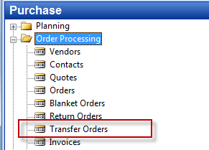

2. Create header of the transfer order to transfer chosen item from **Blue** to **Red**  stock location

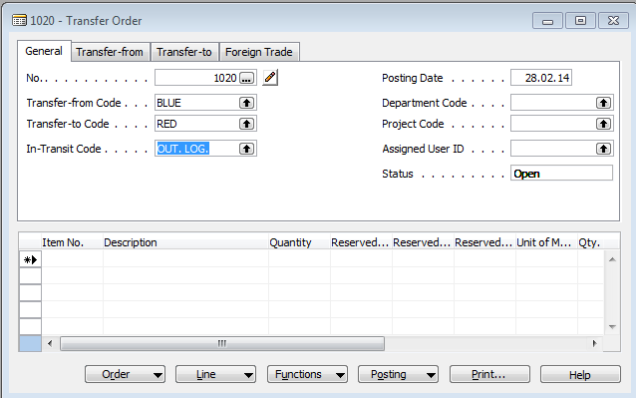

3. Create lines of the transfer order and check Item availability par location from button Line in order t know if we have enough of item in chosen location **Blue**

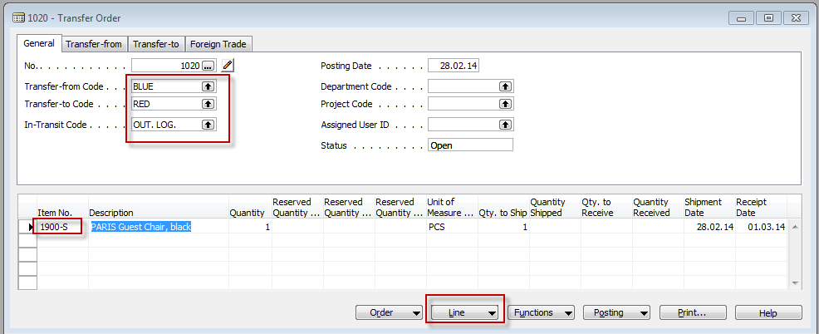

4. Availability looks like this

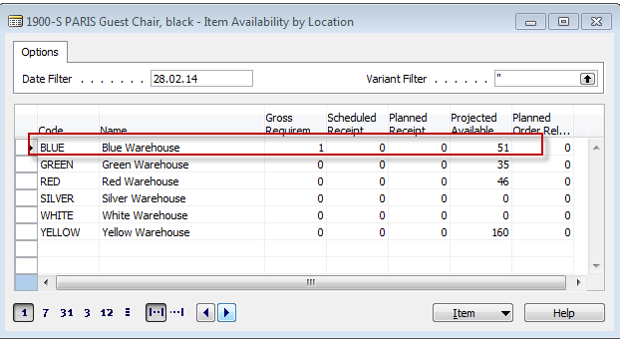

5. F11 in order to book shipment from **Blue** to external location defined for transport (out.log) – Enter OK

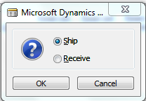

You will get this line :

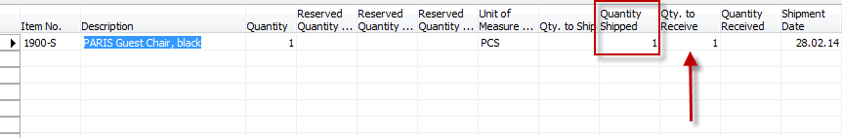

And after going from the field item number by F6 to list of items and then by using Ctrl-F5 you will get these entries :



Go back to the transfer order (by ESC keys) and do what is described in clause 6.

6. F11 again in order to transfer item from out.log location to **RED** location (push OK)

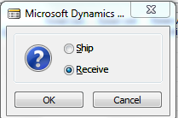

And You will get this message :

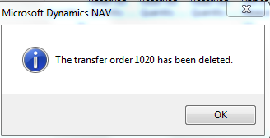

7. Go to Warehouse-History- Posted documents- Posted Transfer Shipment and you will get :

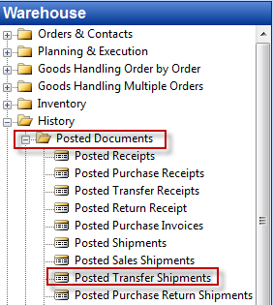

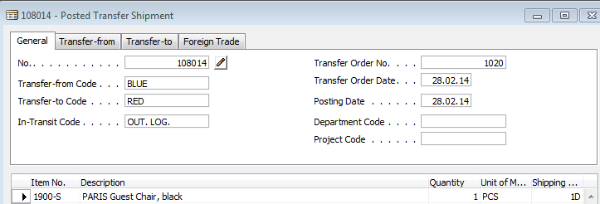

And from there you go (field Item No) by F6 and Ctrl- F5 to entries related to posted transfer order

