Simple example of using accounting schedules
Written by : J.Skorkovský
Date : 28.4:2014
Subjects : all NAV courses
- Application start

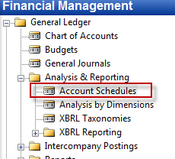

- Templates of existing schedules

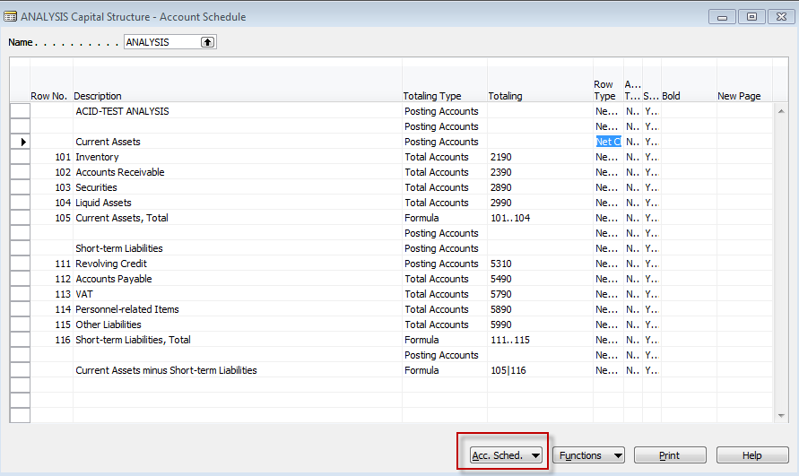

For Czech accounts you can see this (Czech account numbers) :
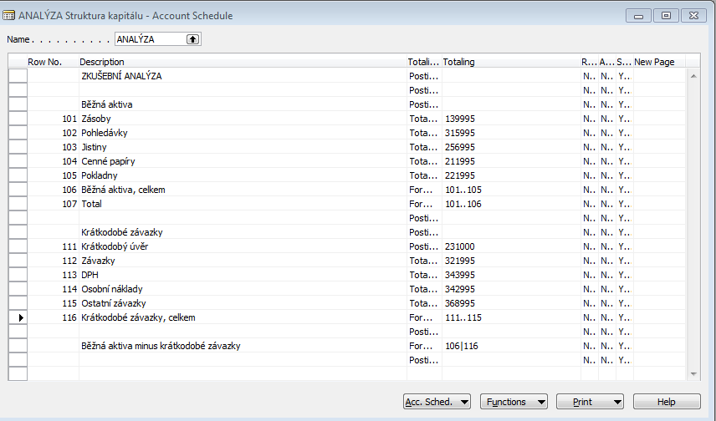

- Start to see date from G/L accounts (from button Account Schedule) – change timing window as shown

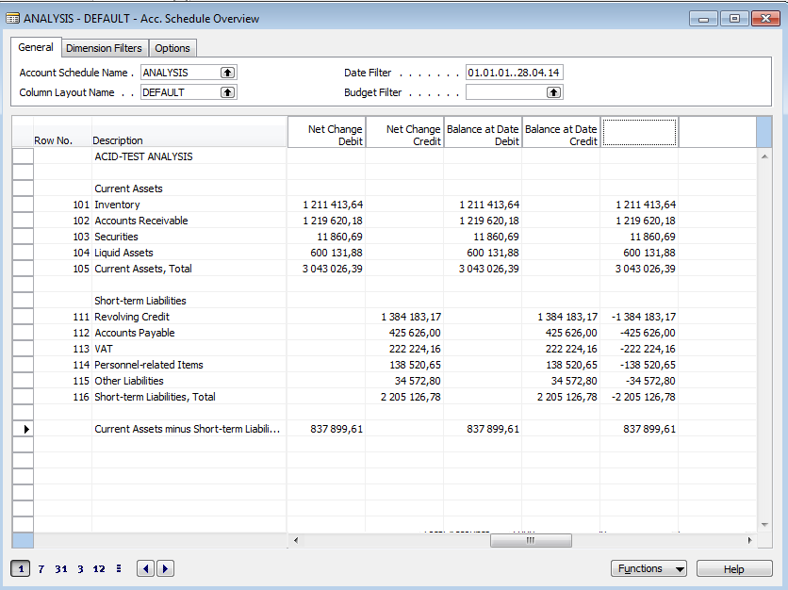

For Czech accounts you can see this (Czech account numbers) :
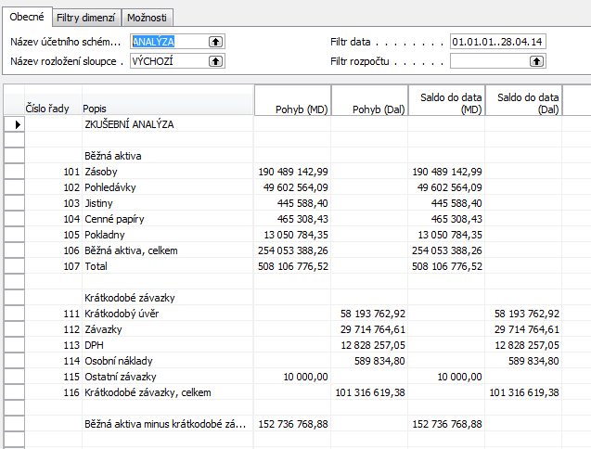

By use of button template you can export data to Excel or print it as well
- Creation of new Accounting schedule
Go to Name field (window) and F6 (look up). By F3 create new lien and enter VAT (DPH) and type of column as shown below :
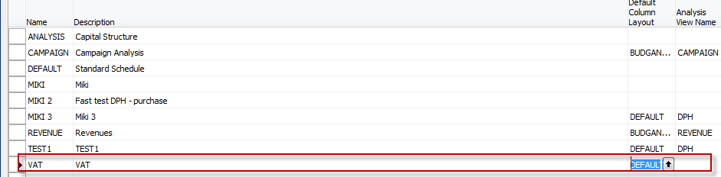

- Enter and add accounts by use of button function. Rewrite rows (in order to simplify calculations. These are variables :
English version

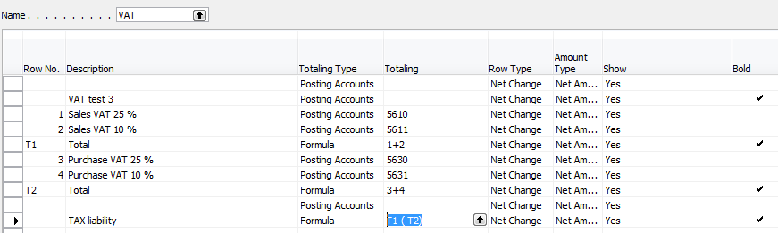

Czech version
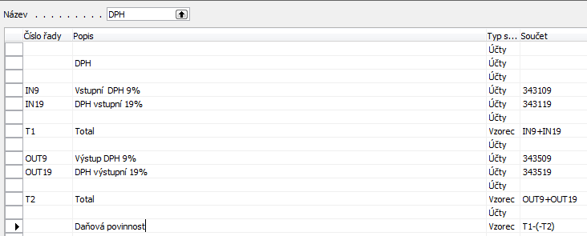

- Results

English version
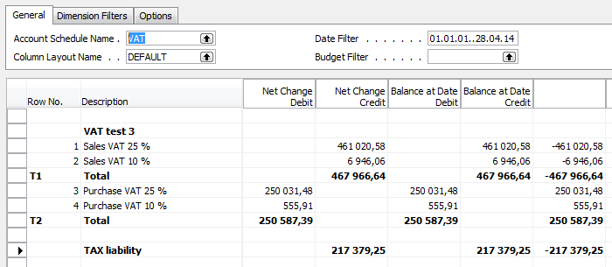

Czech version

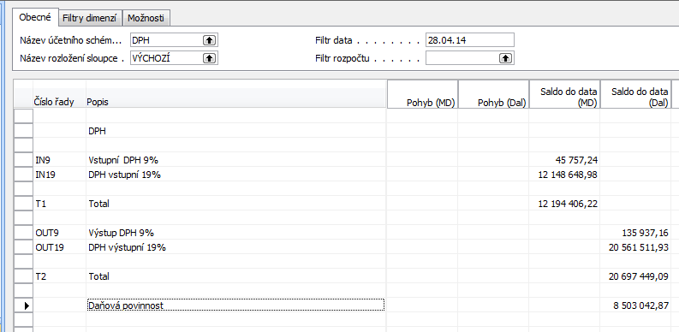

Example of a real-life Accounting Schedule (Balance sheet- P&L )- only part of it :

