Training material : Transfer orders, Stock locations and Bins
Created by : J.Skorkovský
Date : 20.3.2014
For : ERP students

- Warehouse menu->Setup
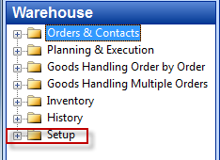

- Check if this setup is valid. If not, please do so !
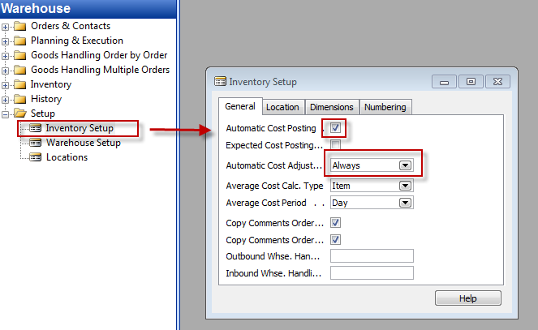

- Setup of Locations. Go from Locations to F5 and find White Location and go to the card of this stock location by Shift-F5
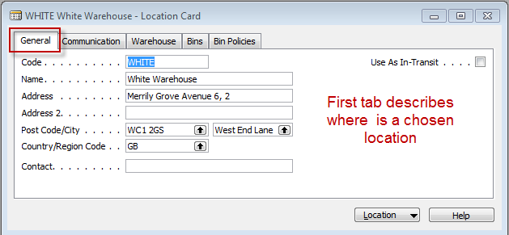
- Second tab describes communication links with stock location
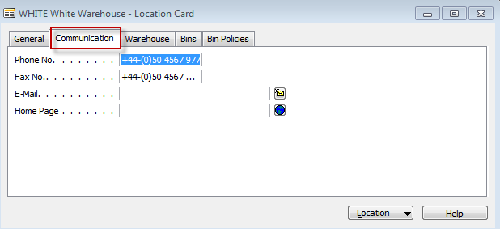

- Tab warehouse describes (specifies) rules (ways) how to control flow of goods (components, material, stock items,..)
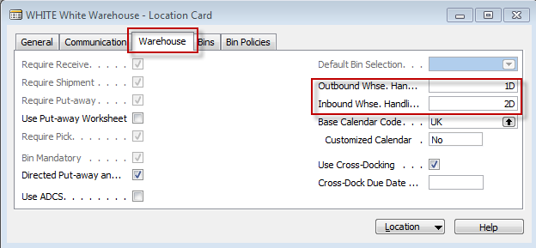

- One possibility how to flow (movements) of item can be setup :

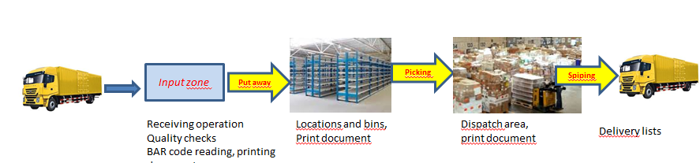

- Go to tab Bins
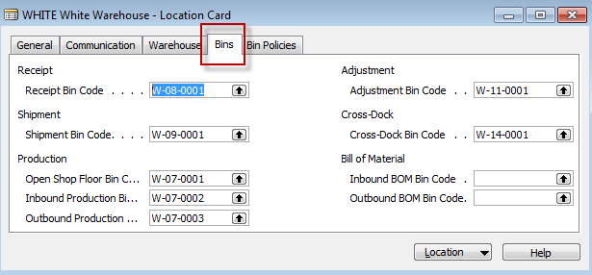

- Go to button Locations ->Bins and you have to chose one bins which is empty (see not checked field Empty)

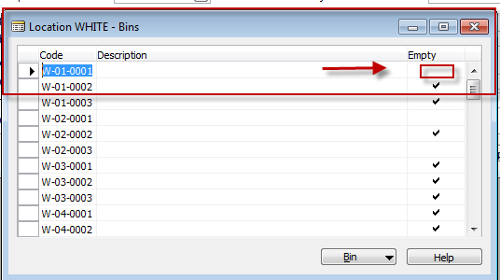

- You will see there what is stored in the chosen bin (by use of button Bins->Contents

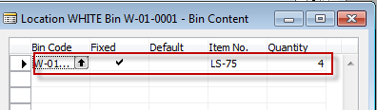

- You can see all items in all bins by use of Shift-Ctrl-F7
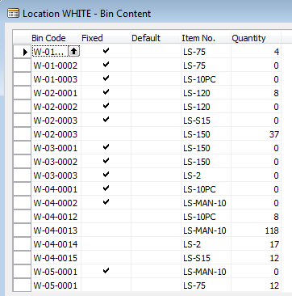

- To see only chosen item (e.g. LS-75 put the cursor there and use F7 :
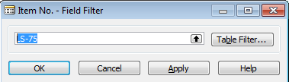

- You will get
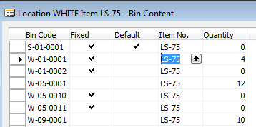

- Create a purchase order of item 1952-W (F3, chosen vendor 10000, to location Blue (10 pcs) and after entering document number (invoice number of your chosen vendor) post it by F11

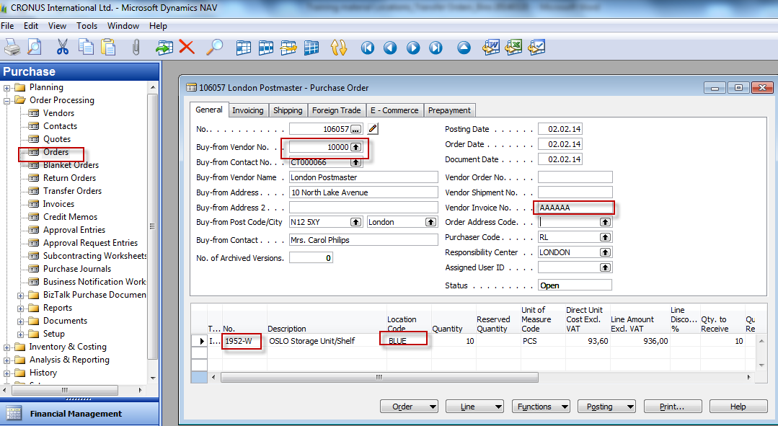

- Go to History (purchase submenu) and go by Ctrl-END (Cursor in the header of actually posted purchase invoice)
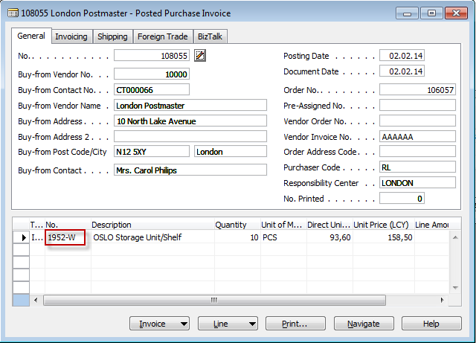

- Go to Item 1952-W and by use of Ctrl-F5 you can see item ledger entry and last posted purchase to location blue

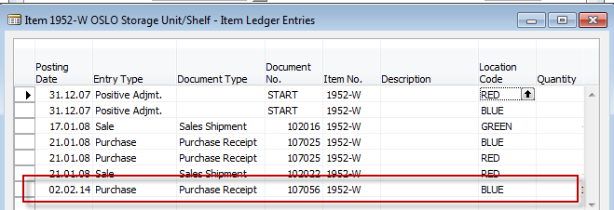

- Go to menu :
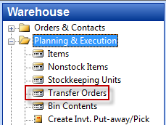

- Open by F3 new transfer order (we will transfer 5 pcs of 1952-W from Location blue to location Red by use of Foreign transport location :

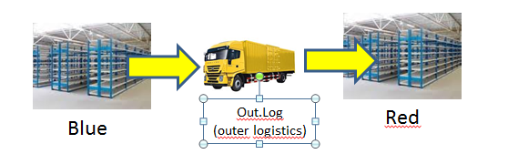

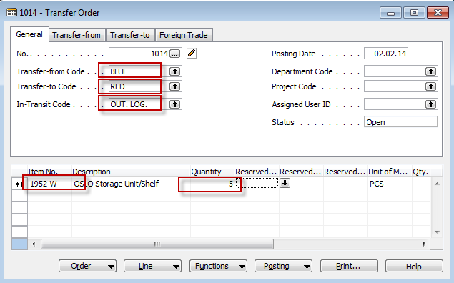

- F11 and you will transfer 5 x 1952-W from, Blue to Lorry Outer Logistics
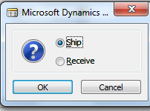

- Do it again (F11) in order to transfer 5 x 1952-W from Lorry Outer Logistics to Red
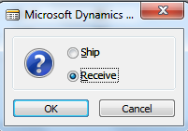
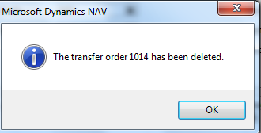
19.Go to Item card 1952-W (you can go to history – see below) and you can find item there
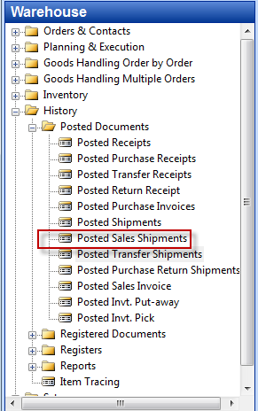

Use Ctrl-End !!!

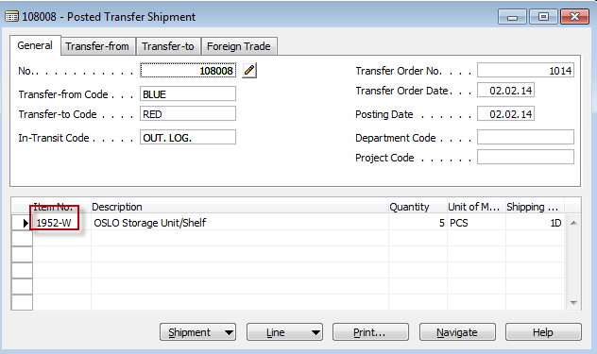

- From Item 1952-W you can see item ledger entries type Transfer representing actually posted transfer

- Sometimes you can get Transfer -5 from Blue to Logistics and e.g. +1 and +4 to Logistics and then -1 and -4 from Logistics and +5 transfers to red location. This is due to applying input item ledger entries created in different times because it takes into consideration FIFO applying principles and system has to maintain exact value of the stock on the same level meaning that transfers never changed value of the stock if transfer cost is zero.

