Name: Matej Godáň 440663

Operations Management: seminar work
(Utilization (application) of the Theory of Constraints (TOC) and Critical Chain (CC) as a Project Management Methodology based on TOC principles.)

Questions which have to be answered in the seminar work:

- How would you apply CC and TOC tools (CRT=Current Reality Tree) for the planning of Your own dissertation (writing the dissertation is in fact a project)? Can you name the project risks? Do you know how to diminish (reduce) these risk factors (to avoid obstacles)?

- How would you persuade Your new (in the future, after you start to work) colleagues, that CC project management methodology might be suitable for the project management? Can you define basic CC benefits?

- What kind of effects do you expect by possible using buffers (time buffers) during the working out of your thesis (dissertation)? Can you explain what is the buffer?

- Can you specify by use of Thinking Process Tools Your personal bottleneck as far as studying processes or writing a work or working on assigned school tasks (by other tutors) is concerned? Try to use CRT (see full meaning above) and create a list of Undesirable Effects (named by You).

- State clearly Your suggestions to improve Your dissertation writing (project management question) and related benefits.

At the outset , I would like you to acquaintance with my topic, which I have choosen for this work. I have choosen topic concerning my diploma thesis, which I wrote from mid November 2014 until march of 2015. Title of my diploma thesis is Tax evasion in small service- Cosmetics, Hairdresser s, Manicure and Massage services. In the thesis 3 surveys were conducted. The main aim of the thesis was to estimate how big the tax evasion in small services is.

Theory of constrains has 5 stages/steps:
Hovewer,before the steps we have to identify the main goal of the System or Organization and subsequently is necessary to determined a way how to measure progress.
- Identify the constraint.
- Exploit the constraint.
- Subordinate everything else to the above decision.
- Elavate the constraint.
- If a constraint is broken, is necessary to go to Step 1. Hovewer it s not permissible inertia to become a constraint.

The key point in the theory of constraint is to determine a bottleneck. Bottlenecks determine the throughput of a supply chain. Recognizing this fact and making improvements will increase cash flow. A bottleneck in a supply chain means the resource that requires the longest time in operation of the supply chain for certain demand. An important thing about bottlenecks is that bottlenecks determine the throughput of a supply chain. In case a bottlenecks are not recognized enough, you will miss a chance to increase throughput.

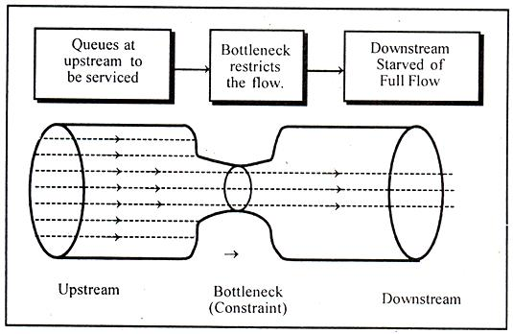

Project management:
Projects come in all shapes and sized, but have certain features in common: defined objectives, a time limit, specified resources ( staff, budget, equipment,...) The role of the project leader is to plan and manage the tasks, costs and resources of the project so that the objectives are reached in the most efficient way
- How would you apply CC and TOC tools (CRT=Current Reality Tree) for the planning of Your own dissertation (writing the dissertation is in fact a project)? Can you name the project risks? Do you know how to diminish (reduce) these risk factors (to avoid obstacles)?

Planning and sheduling diploma thesis is a project, which is divide into various parts. At the outset is absolutely essential to correctly identified to main purpose of the work. Therefore,It s neccesary to discuss the issues from every conceivable angles with my supervisor. Kick-off meating is important given the unifying objective. This work is my second large-scale project.
Planning goals:
- Ensure the project fits in with supervisor expectation
- Meet the constraints
- Secure the necessary resources
- Create a work-breakdown structure –WBS
- Draw up a realistic shedule
- Make contingency plans for unforseen events
- Build time buffers into the planning
Kick-off meeting with my supervisor
- Explain the purpose/ objective of the project
- Make sure and clarify the constraints

Way to achieve the objective and measure the developments.
- Quality of deliverables VS time
- Meet a deadline
5 steps of theory of constraints which i have abovementioned are essential.
1.Identify the constraints.
- First thoughts concerning about thesis
- Timing of work
- Vis-a-vis with supervisor
- Seeking suitable source of information
- Shedule of work
- Writting chapter 1 of the thesis
- Acquiring information- unavailable on the internet
- Consultation with supervisor via skype
- Thoughts concerning second chapter
- Encountered small problem-vis-a-vis with supervisor
- Writting of the second chapter
- 3 questionnaires surveys
- Acquisition of the necessary information
- Consultation with supervisor
- Redraft/ re-do certain parts
- Writting of the third chapter
- Text editing
- Oral presentation
Constrainsts:
Seeking suitable information could be potential constrainst. If i have no reliable sources i cannot start and continue to write. Suitable sources of information are basic prerequisite to write high quality work. The resulting effect of the whole thesis depends from quality information. Especially chapter 2 where are conducted 3 surveys could be a little bit tricky, because it s demanding to estimate how much time do you spend on this part, because the questioners are not paid for it and therefore you cannot expect immediate return of requested questionners. Simultaneously you can not continue and go futher, because information from questioners are indispenseble.Acquiring necessary information- unavailable on the internet could be also bottleneck.
Immediately afterwards hand over second part is a crusial point follow-up debriefing session with my supervisor, where supervisor determines which part must be rewrite. This step is very important for overall time spend on project.

2 and 3 Exploit the constraint and manage all processes
I have to ensure that the Schedule is set appropriately and its easy to reach. And also it necessary to count with some stuck( buffers) and immidiately after a hit a snag, dont be fazed, but to know respond appropriately.

4.Elevate the constraint
In my diploma thesis i m supposed to work alone, because it s one of the basic requirement of either bacherol or diploma thesis in general. Therefore i can be checked, evaluate and foresee each step just one by myself. The overall result depends on my previous experience, knowledge and from ability to obtain correct information.

Tasks | Resources | Time resources | Prerequisites
1,First thoughts concerning about thesis | Browsing internet | 4 hours | -
2, Timing of work | - | 4 hours | 1
3, Randevous/ vis-a-vis with supervisor | My own documents | 6 hours | 1,2
4, Seeking suitable source of information | Internet, library | 3 days | 1,,3
5, Shedule of work | - | 2 hours | 3,4
6, Writting chapter 1 of the thesis | Books and relevant internet pages | 7 days | 3,4
7,Acquiring information- unavailable on the internet | Admistrative staff | 3 days | 6
8, Consultation with supervisor via skype | - | 1 hours | 6, 7
9,Thoughts concerning second chapter | Similar thesis, own ideas | 2 days | 6,7,8
10,Encountered small problem- vis a vis with supervisor | Internet, books | 6 hours | 6,7,9
11, Writting of the second chapter | Knowledge, books, similar thesis, questionneirs, action plan | 10 days | 6,10
12,3questionnaires surveys | Acquired data | 7 days | 11
13, Acquisition of the necessary information | Statistics Office SR | 10 days | 11, 12
14,Consultation with supervisor | Diploma thesis | 2 hours | 11,12,13
15,Redraft/ re-do certain parts | Books, knowledge, acquiring information | 3 days | 7,11,12,14
16,Writting of the third chapter | Knowledge | 7 days | 7,11,12,14,15
17,Text editing | Diploma thesis | 1 day | 6,11,12,13, 15,16
18,Oral presentation | Diploma thesis- all information | 1 day | 1....17

As you can see in GANTT CHART i use multitasking aproach, and most of the tasks are overlaping. The overall time will most depend on ability to cope with certain tasks.

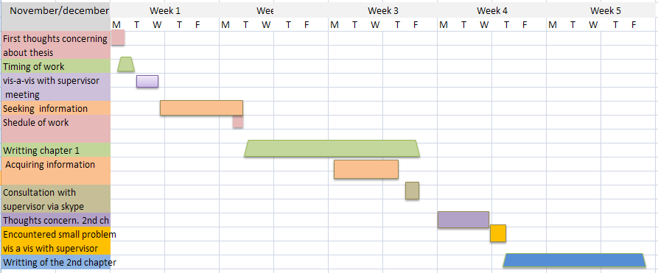

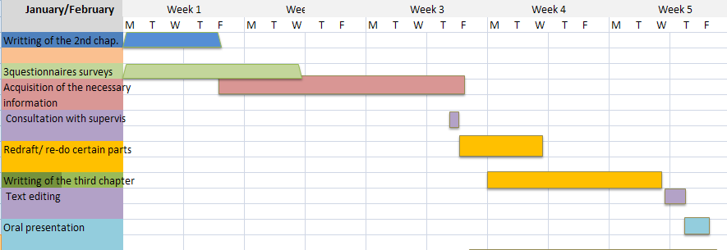

Risk
- Some tasks are very difficult to estimate the duration, which could result to prolongation the overal estimated time.
- Inability to cope with some dificult parts
- Unwillingless to provide necessary information,
- Supervisor dissatisfaction with content

Risk reduction is possible to reduce:
- Time buffer
- Regullar communication with supervisor
- Sufficient knowledge in particular in the field

2,How would you persuade Your new (in the future, after you start to work) colleagues, that CC project management methodology might be suitable for the project management? Can you define basic CC benefits?

I can persuade my supervisor through my previous knowledge in this area and also effort involved through i can achieve the desired result.

- To have enough knowledge and skills
- Measure advancement
- Foresee unexpected obstacles- bottleneck
- Communicate with supervisor
- Early warning

3,What kind of effects do you expect by possible using buffers (time buffers) during the working out of your thesis (dissertation)? Can you explain what is the buffer?

In project management, time buffer is an extra time added into a time estimate to keep a project on a track. The purpose of this leeway in planning is risk management. It allow project managers to be able to account for unforseen situations without having to change the coordination of the project in a major way. This time may be official designed as a buffer, or it may be built into tasks.

Generally we can see 2 types of buffer time:
- Project buffer time
- Task buffer time
Project buffer time is the time, which is usually added to the end of the project, that is managed by the project manager.
Task buffer time is speciffic to individual tasks along the way.

According to my previous experience with my bacherol thesis i decided to use 7 days buffers after possible bottlnecks ( tasks 4, 12,13,15). In the tasks number 4 i decided to use one day time buffer and in the others 2 days.

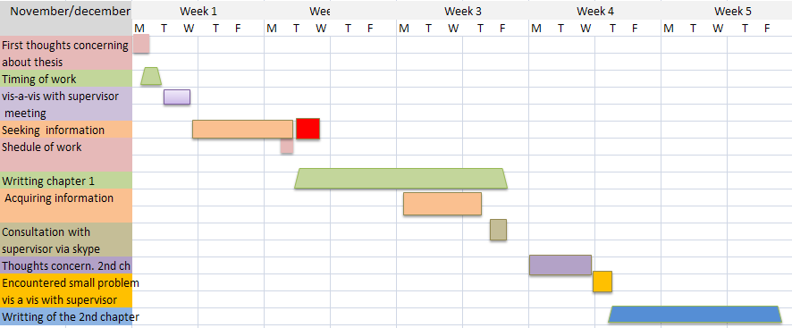

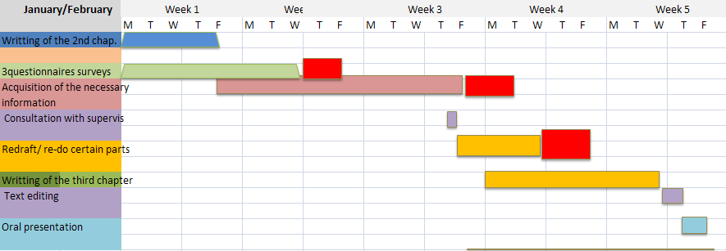
4,Can you specify by use of Thinking Process Tools Your personal bottleneck as far as studying processes or writing a work or working on assigned school tasks (by other tutors) is concerned? Try to use CRT (see full meaning above) and create a list of Undesirable Effects (named by You).

Current reality tree: try to find an answer for question- What is a core problem? What should be change. Why to change something and what is something /core proble= constraint, bottleneck/. Core problem is UDE- undesirable effects. We should try to solve this problem throught logic- casual or sufficient logic.

I identified 3 main undesirable effects, which subsequently generates to a series of negative consequences for the rest of the project. This undesirables effects i have to try to diminish onto acceptable level.

- I have a girlfriend I play football
- I play a football
- I m studying at the University
- I m chatting on facebook to much
- I have various tasks to do in the same time
- I m not able to do everything on time
- I have not enough knowledge
- I have to read more articles and books, which help me to deal with problems
- I have not enough time
- I m under stress
- mistakes as a result of stress
- rewrite and edit some parts

12. rewrite and edit some parts
11. mistakes as a result of stress
9.I have not enough time- I m under stress
7. I have not enough knowledge

8.I have to read more articles and books, which help me to deal with problems
1.I have a girlfriend

5.I have various tasks to do in the same time

6.I m not able to do everything on time

2.I play football

3.I m studying at the University

4.I m chatting on facebook to much

10.I m under stress

5,State clearly Your suggestions to improve Your dissertation writing (project management question) and related benefits.

The main problems which could happend a trouble are lack of knowledge and not enough time as well as unability to handle with stress. If i want to be able to work as efficient as possible i have to take a procaution- using injections. Therefore i need to recreate a current reality tree by adding some tools.

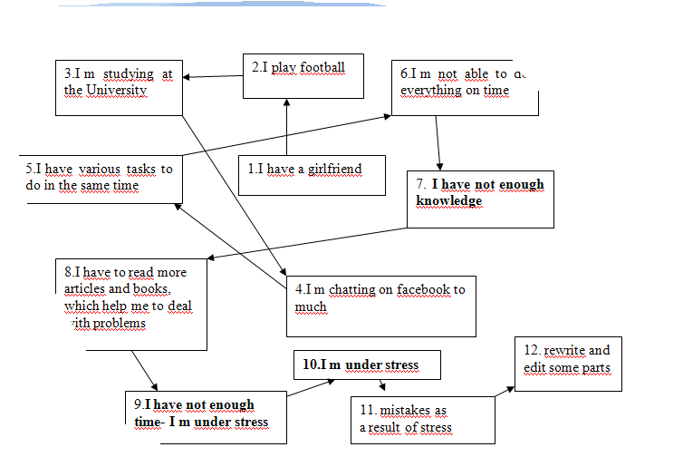
Injection 2: attend some presentation concerning time efficiency and procrastination, instead of facebook attend lessons of yoga
Injection 1: private lessons with the expert in the field

Injection 1: private lessons with the expert in the field
The main purpose is to broadening my horizont and to better understand the cause and effect,which in final result decrease number of rewriting parts and increase quality of overall thesis.

Injection 2: attend some presentation concerning time efficiency and procrastination, instead of facebook attend lessons of yoga Better concentration at work will result to less mistakes.

