BPH_EPS1 (Enterprise Resource Planning Systems) – questions spring term 2016
Created by : Ing. J.Skorkovský,CSc. KPH ESF MU BRNO, Czech Republic ; 1730@mail.muni.cz; miki@econ.muni.cz; jaromir.skorkovsky@navertica.co, tel : +420 731 113 517
Date : 05.05.2016
Version : I.

All questions could be studied with the help of related study materials handed over to students during lessons held in Brno during spring term 2016)

Will be shortly reviewed (explained) during last one of the last lessons (6.6.2016 and possibly 13.5.2016) taking into consideration, that the first date (20.5.2016) is partly assigned date for exams. Important parts of below specified questions may be found in your Seminar works

Resources (see original in is.muni.cz):

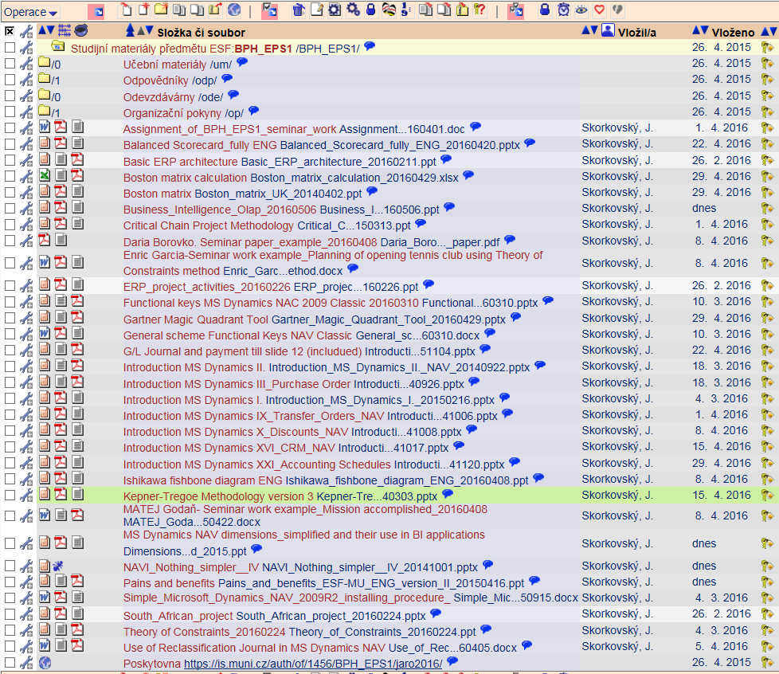

Below listed material (are including in the copy of the student material above as well ) have to be used for MS Dynamics NAV 2009 studies. Mind you, that access to ERP system MS Dynamics NAV 2009 ENG version is possible also in all public computer rooms! It is expected, that the system was installed on Your computer if technical conditions were suitable, meaning all PC with any kind of Microsoft operating system. So far I have learnt, that nobody reported any problems regarding installation of the MS Dynamics NAV product.

OLAP and Business Intelligence presentation - PWP presentation (was uploaded to the study material 4.5.2016) and will be concisely presented 6.5.2016

Pain and benefits - PWP presentation (was uploaded to the study material 4.5.2016) and will be concisely presented 13.5.2016

MS Dynamics NAV dimension and their use in BI applications - PWP presentation ( was uploaded to the study material 4.5.2016) and will be concisely presented 6.5.2016

NAVI Nothing Simpler - PWP presentation ( was uploaded to the study material 4.5.2016. This material was not directly used during practical lessons but includes all basic principles needed to understand concisely basics of ERP MS Dynamics NAV

Listing of Theory Resources – will be used below to show you mapping knowledge -resources

A. ERP project activities PWP presentation
B. Pains and Benefits (will be presented 13.5.)
C. Critical Chain ENG
D. TOC PMPINSA English
E. Boston Matrix Calculation (and Product Life Cycle)
F. Magic Quadrant Matrix from Gartner company
G. Ishikawa use and Pareto calculation and use (Lorenz curve)
H. Pareto Analysis Simplified
I. Business Intelligence-OLAP (will be presented 6.5:2016)
- Kepner-Tregoe methodology
- Balanced Score Card

List of ERP Resources (practice)

- Installation MS Dynamics NAV
- Introduction MS Dynamics NAV-IX-Transfers
- Introduction MS Dynamics NAV-I-Introduction and Introduction II
- Introduction MS Dynamics NAV-II-Sales
- Introduction MS Dynamics NAV-III-Purchase
- Introduction MS Dynamics NAV-XVI-CRM- Customer Relationship Management
- Introduction MS Dynamics NAV-X-Discounts
- Dimensions simplified
- MS Dynamics NAV Nothing Simpler
- General Ledger Journal and payment

Theory Questions (resources A-L):

Structure of the theory question:

Number Description : Resource (slides if required )

1. What qualification (knowledge) should be required of ERP consultant of project managers? A , B,C D, E, K
2. Name key activities of the implementation project (project steps): A
4. What is a Gantt chart: A and C
5. Simplified chart (diagram) of ERP functions (feedback diagram) : A
8. Specify the basic concept of the Theory of Constraints: D
9. TOC metrics : D
10. Cost World and Throughput World : D
12. TOC five steps: D
13. Basic trees (Thinking process tools) – Current Reality Tree, Evaporating Cloud Tree and Future Reality Tree : D
14. What is bad multitasking? : C
16. Critical path and Critical Chain: C
17. Use of project buffer (buffer management concept) : C
18. Pains and benefits : B
19. Ishikawa fishbone diagram: G
20. Boston matrix and Product Life Cycle(PLC) : E
21. Gartner Magic Quadrant (matrix) : F
21. Pareto analysis: G and H (first three slides)
22. Business Intelligence- OLAP : I
23. Kepner-Tregoe basics : J
24. Balanced Score Cards : K

Practice Questions (resources L-U):

1. Modularity of the ERP systems. What areas can be controlled by ERP MS Dynamics NAV : N,T
2. Main windows (forms) used in ERP and syntax for Debits and Credits (posted General Ledger Entries) – card window, line window, matrix window, header and line window : N,O,P,T
3. Main tables (Item, Customer and Vendor) : N,O,P
4. Purchase of an item and impacts of F11 (posting) -> item and vendor entries, G/L entries : P
5. Sale of an item and impacts of F11 (posting) -> item and customer entries, G/L entries : O
6. Discounts and the use of this (incentives, type of discounts): R, T, S
7. Transfer of an Item form one stock Location to another stock location : M
8. Contact Card and its profile and use of it. Opportunity. Interactions. Connection to Customer (Vendor) cards : Q
9. Dimension and its use : S
10. Basic used of General Ledger Journal (payment from customer- apply open invoice to payment) : U

