Case #12. Rattlesnake Wrangles Fight to Preserve a Cultural
Tradition in Texas

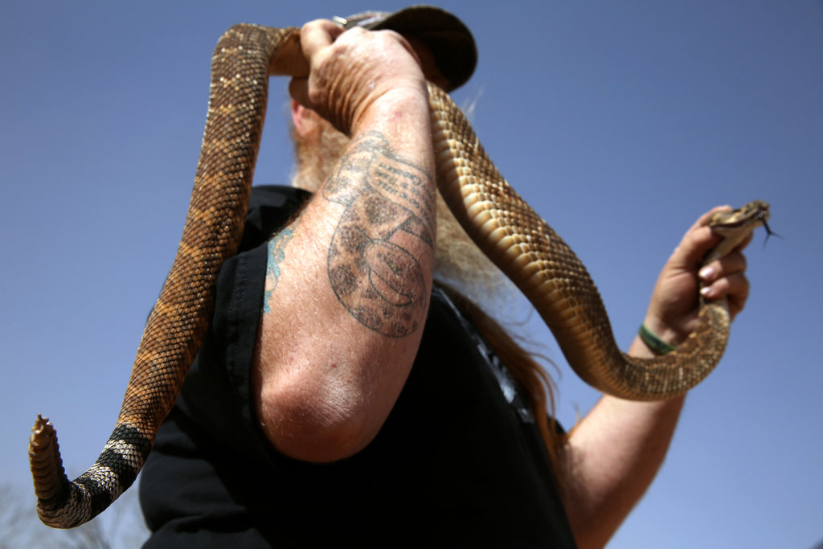

Wrangling Rattlesnakes
Credit Dylan Hollingsworth for The New York Times
SWEETWATER, Tex. — At the foot of a rocky cliff here, Riley Sawyers looked into a small, dark hole, searching for rattlesnakes. One had already bitten his Kevlar-reinforced boot. The venom was still drying when Mr. Sawyers went to fetch the gasoline.
It was not for his S.U.V. It was for the snakes.
To encourage the rattlesnakes to come out, Mr. Sawyers slipped a thin copper tube into the hole and hand-pumped gas fumes into it. In West Texas, snake hunters like Mr. Sawyers have been using gas fumes to flush rattlesnakes out of their holes for decades.
The practice, known as “gassing,” has outraged animal rights activists and reptile researchers who say that spraying a toxic substance like gasoline in wildlife habitats hurts the environment, the snakes, and other animals and insects that live underground or use the same burrows.
In recent months, the opponents of gassing have gained a powerful, unlikely ally: the State of Texas Wildlife Agency. The Agency is considering banning the use of gas fumes to capture rattlesnakes — a move that would add Texas to the list of more than two dozen states that have partly or completely outlawed the practice, including Arkansas, Louisiana, New Mexico and Oklahoma, all of which share borders with Texas.
Texas is a state that advertises its limited government interference in business and has fought efforts to protect the dunes sagebrush lizard and other animals as endangered species. As a result, the Agency’s involvement in snake wranglers’ affairs and its attempt to safeguard a creature that bites and frightens ranchers and others strikes some as “anti-Texan.” If the ban goes through, snake hunters noted, it will be illegal to use gas to chase out a rattlesnake, but legal to use it to catch a gopher.
The debate over the proposed ban has mushroomed into a larger, stranger battle that has attracted the attention of Gov. Rick Perry and other Republican leaders and underscored the cultural divisions between urban and rural Texas. (NOTE: The State of Texas Wildlife Agency reports to the governor, who appoints its director. Its budget is controlled by the Texas State legislature, which is controlled by the Republican Party.)
“A lot of people bringing this to issue have never encountered a snake,” said Mr. Sawyers, 46, a state-licensed snake hunter and Marlboro chain-smoker who has a cheerful quotation from Davy Crockett, a famous Texan from the 19th century, next to the snake tattoos on his arm: “You may all go to hell, and I will go to Texas.” “If you’re into the Bible, snakes have intimidated people from the beginning, and I don’t think that’s changed to this day. If they were on your land, would you want restrictions on how we can get them off, or would you want them removed?”
In Houston and other cities, people have barely noticed the proposal to prohibit gassing. When the agency considering the ban, the State of Texas Wildlife Agency, held hearings in Fort Worth and San Antonio, just 21 people attended. No one showed up at the one in Houston.
But the hearing in the town of Sweetwater in January drew an estimated 250 people. This town of roughly 11,000, about 40 miles west of Abilene, has unusually high stakes in the matter.
Every March, Sweetwater puts on the country’s largest rattlesnake “roundup” (a term usually referring to gathering cattle). (A billboard on the highway into town claims it is the biggest in the world.) The snakes for the event are supplied by wranglers like Mr. Sawyers, the majority of whom use gassing to capture rattlesnakes in the rugged, dry terrain nearby. Hunters are paid by the pound; at this year’s roundup, they brought in hundreds of live western diamondbacks, totaling about 3,900 pounds. A ban would make it harder for hunters to collect a large number of snakes, and some believe the hunters would not bother to take part because there would be no financial incentive.
Sweetwater town leaders and organizers of the roundup said a ban on gassing would end the roundup and its 56-year tradition, or shrink an event that pumps millions of dollars into the local economy every March as thousands of people travel to Sweetwater to shop, eat and visit. The Sweetwater Jaycees, the nonprofit group that organizes the roundup, use the proceeds to finance community projects, including feeding needy families on Thanksgiving, buying equipment for the fire department, and helping local students, Little League teams and disabled adults.
“It would be a devastating blow to us,” said David Sager, 63, a snake handler at the roundup and a member of the Jaycees. “The rattlesnake roundup is our organizations’ sole source of revenue.”
The good deeds that come from the roundup are preceded by rather gruesome ones at the event itself, where attendees and organizers celebrate, photograph, skin and eat the most widespread venomous snake in the state. The live diamondback rattlesnakes are squeezed for their venom — a valuable commodity sold by the Jaycees — and then slaughtered, all in front of the men, women and children at the event. In their most recent report, from 2004, organizers estimated that from 1958 to 2003, the roundup handled 254,000 pounds (~100 metric tons) of diamondbacks.
Though State of Texas Wildlife Agency officials have been examining the issue of gassing for years, the primary catalyst for the proposed ban was a petition sent to the agency last year signed by 57 zoologists and others, many from out of state. Some of those who signed the petition oppose not only gassing, but the roundup as well.
“The behavior that occurs at the traditional roundups is animal abuse,” said Kristen Leigh Wiley, curator of the Kentucky Reptile Zoo and one of those who signed the petition. “Just because it’s a rattlesnake and not any other animal does not mean that it cannot experience pain or suffering.”
Officials at the State of Texas Wildlife Agency said their goal was not to end roundups, but to protect the various species besides rattlesnakes that are exposed to the fumes. They pointed to a 1989 study that showed that a 30-minute vapor exposure impaired or killed seven species of snakes, lizards and toads.
“I liken this to fishing with dynamite,” said John Davis, director of the department’s wildlife diversity program. “It’s about a means of take, a means of collection.”
Some lawmakers, led by state Representative Susan L. King, whose district includes Sweetwater, oppose the proposal and want more extensive field research. Snake hunters and residents said the amount of fumes used in holes and crevices was too insignificant to warrant a ban, and expressed fear that without the gassing and the roundup, the town would be overrun with diamondbacks — a claim that supporters of a ban deny.
At the roundup, young women compete for Miss Snake Charmer. This year’s winner of the fried rattlesnake-eating contest — Tonya Osteen, 39, a mother of three — has found diamondbacks on her porch, and one bit the neck of one of her dogs. “It just helps thin out the population,” said Ms. Osteen, whose teenage daughter skinned a snake at the roundup. “Somebody sitting there saying, ‘Oh, poor little snakes’ — I don’t want my kids getting bit by rattlesnakes. My three-legged dog, imagine him getting bit by a snake.”
Out at the rocky cliff a few miles outside town, Mr. Sawyers and his nephew Alex Newman hunted mostly without the gas sprayer — a red can similar to the kind used to spray weed killer on lawns. “You don’t go around shooting fumes in every hole,” said Mr. Sawyers, who has become rattlesnake royalty in Sweetwater as one of the stars of the Animal Planet reality show “Rattlesnake Republic.”
At the hole, they pumped fumes for less than a minute from a can that held about 50 cents’ worth of gas. No snakes emerged. Their only catch of the day was a three-foot diamondback that Mr. Newman, 32, grabbed with a pair of metal tongs.
Since the roundup had passed, Mr. Sawyers did not want to go to the trouble of selling one snake. Instead, he said, he planned to marinate it and then smoke it on a barbecue grill.
A version of this article appears in print on March 31, 2014, on page A10 of the New York edition with the headline: Rattlesnake Wranglers, Armed With Gasoline.
The actors in the case are in bold and underlined. You may combine them as follows:
- the Republican governor and Texas state legislature as a single actor, “Texas Republicans”
- Mr. Sawyers and other snake hunters as “Snake hunters” (They are the business in this case.)
- the town of Sweetwater and the Sweetwater Jaycees as “Sweewater”
- Susan King
Keep “animal rights activists” (assume they are like an NGO) and reptile researcher ” as separate
Keep State of Texas Wildlife Agency as a separate actor, but remember it reports to the Texas Republican Governor and legislature.
Questions:

- (2) Define property rights conflict in this case as:
……(actor’s)…… right to ……( )……
……(actor’s)…… right to ……( )……versus
……(actor’s)…… right to ……( )……
……(actor’s)…… right to ……( )……

- (2) How do the Snake Hunters resolve this conflict, i.e., how do they define their “social contract?”

- (10) What political strategy would you recommend to the Snake Hunters to achieve their goal of protecting their continued ability to hunt rattlesnakes with gasoline?
- in answering this question you must begin with a model from Module 10 of how you think the State of Texas Wildlife Agency and the pro-business, limited government-oriented “Texas Republicans” each will make decision on this issue. (Their models could be different.)

- you must also draw a power diagram, with the predisposition of actors and potential and actual power of all relationships clearly identified.

- Given the “cowboy culture” of Texas (or if you don’t understand this term or this stereotype, if this were your home country), what do you think would be the most-likely scenario for how this issue will evolve over the next 10 years. Based on these scenarios, would you recommend the Snake Hunters find another hobby and Sweetwater and its Jaycees find another community activity to promote the town and raise money for local charities?

