Use of Reclassification Journal in MS Dynamics NAV
Written by : Skorkovský
Date : 5.4.2016
Reason : hands on MS Dynamics NAV (subject BPH_EPS1,MPH_RIOP and BPH_PIS1|2 ¨

1.
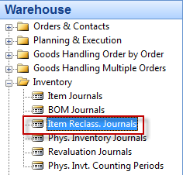

2. Open Journal and add by right click and show columns New Location (if not shown in demo version)

3. Add chosen item and related source and destination locations. Before try to see if the chosen item is already located in source location by use of button Item (from Item Card) and Item by Location (se below). Below card (type matrix) is filtered by F7 and 196* to see only part of items.

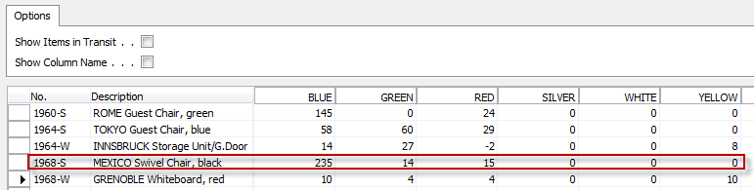

For our simple example use e.g. Item=1968-S (marked by red line)

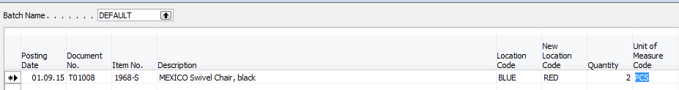

4. Use F11 to register (post) prepared journal line. Confirm by ANO=Yes

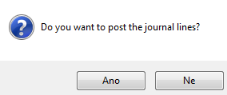
5. You will get
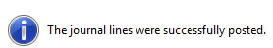

6. See Item Ledger Entries from card 1968-S by use of Ctrl F5 ! You will see two transaction type Item Ledger entries
