**How to create graph representing combination of problem, weights of these problém and cumulative % representing Lorenz curve**

Created by :Skorkovský

Date : 25.4.2018

For : stduents of MPH:AOMA, MPH:AOPR and BPH_EPS1

1. See resource data and how it is created (Excel file)
2. Mark area B5:C10

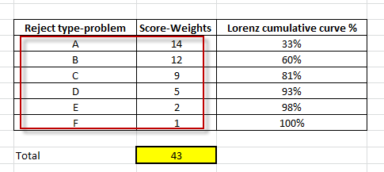

1. Insert->Graphs->two-dimensional (planar) type bar chart and you will get :

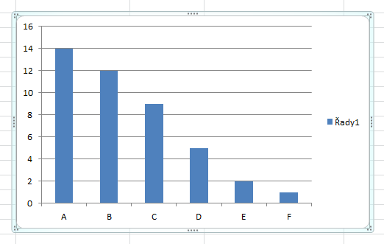

1. Now we have to add to already created chart column with calculated percentages (Lorenz cumulative curve)

How to do it ? Pout the cursor to already created chart and by right mouse click and choose data you will get :

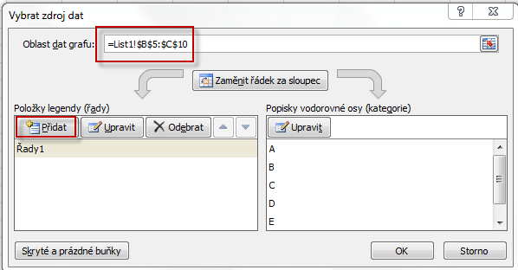

Then you have to change this form by adding new column (with %). To add is in Czech language means Přidat see red marked area and then add data (D5:D10) in chart area (see second red marked icon)

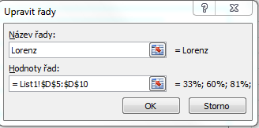

And you will get :

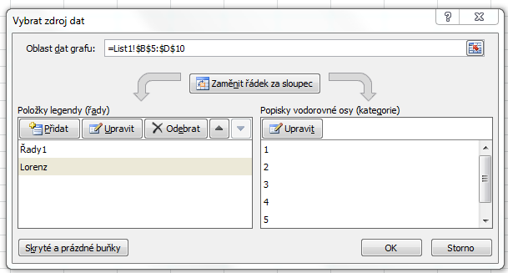

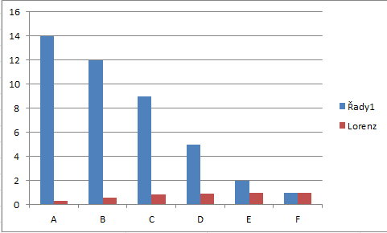

1. Now we have to make some modifications :

You will need possibly to change horizontal description by use of blue marked button

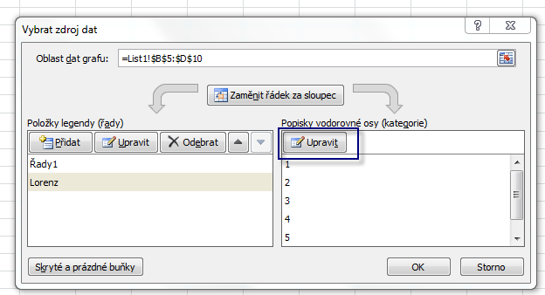

Click on red Lorenz part of chart :

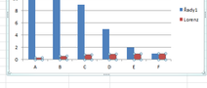

And go to the upper menu :

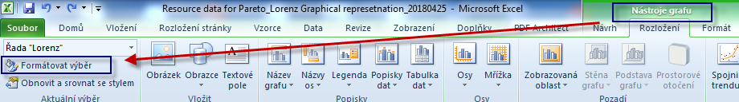

Nástroje grafu = Chart tools or similar in English

After click on Format chart you will get :

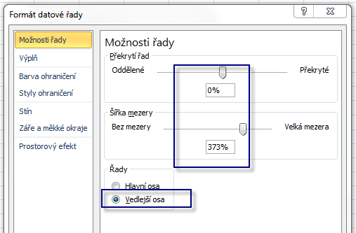

Vedlejší osa= secondery axis

And you will get

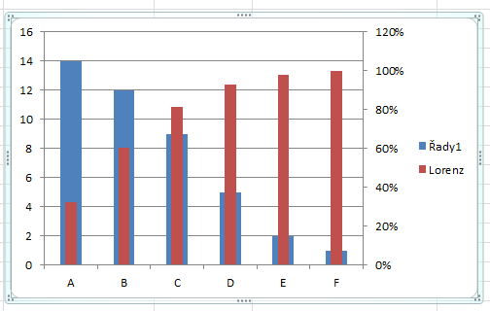

Than it would be nice if you change the type of the second data set (Lorenz curve cumulative to Lice chart)

Click on red part of chart you choose lice type of chart

