PARETO ANALYSIS MS Dynamcis NAV – easy way of setup
Created by : Skorkovský
Date : 27.4.2018
For : BPH_EPS1 and MPH_AOMA and MPH_AOPR cousres

- Searching window -> 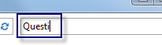
- Make Questionnaires setup
- You will get :

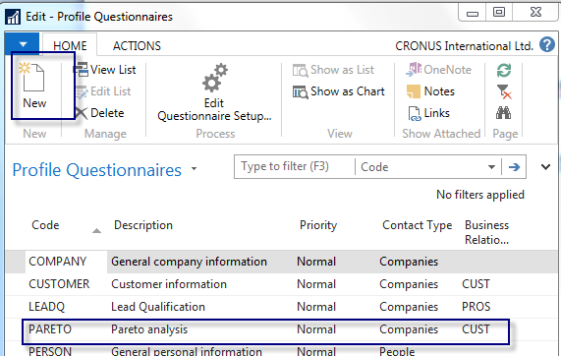

- You have to enter New (see icon) and add new line as shown above (make choises Companies and CUST)
- Use icon Questionnaires setup
- Firstly make Question – Pareto (your text)
- Navigate ->Question details (will be commented by tutor)

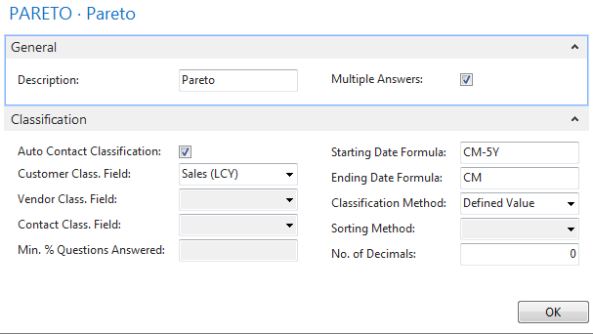

8- Enter three lines with thresholds (see next page)
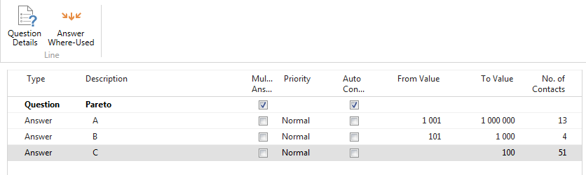

Make update by use of icon

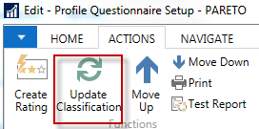

You will get results – go from number of contacts to the contact profiles… and it is done !!!!

