How to install „home“ MS Dynamics NAV version
„school one“ CZ + EN database

Minimal recommended PC configuration PC : processor i5 or higher
8 GB RAM and higher
OS Windows 10

- Uninstall all older versions of MS NAV program (if any)

- Create the address folder C:\Temp (if you do not have it already)

- Copy from flash disk data from folder NAV2016 to new created folder C:\Temp
(as an effect of above actions you will get directory C:\Temp\NAV2016
See server address Programs(\\nas01) (Q:)\MS Dynamics NAV\NAV2016 where you can find folder which
has to be firstly copied to your flash disk (see clause 2)

- Find and start file C:\Temp\NAV2016\_install.cmd

!!! You have to start it as an Administrator – by use of right mouse click – option Run as Administrator
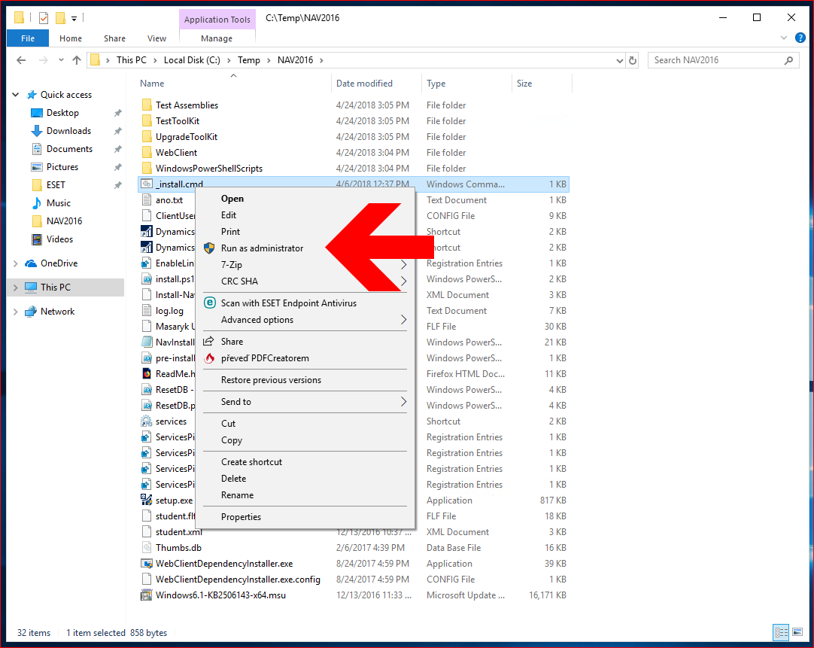

- Click step by step through installation wizard of MS Dynamics NAV program. During installation process do not change anything.
You have only to confirm preset option “Install predefined product components“.

6. After this installation copy two files from directory C:\Temp\NAV2016\_ICONS – to your desktop area.
These icons are shortcuts for starting CZ or English database versions of MS Dynamics NAV 2016

Postup při „home“ instalaci MS Dynamics Nav
pouze demo CZ databáze

Minimální doporučená konfigurace PC : procesor i5 a vyšší
8 GB RAM a více
Windows 7 a vyšší

- Odinstalovat starší verze programu MS NAV

- Vytvořit nový adresář C:\Temp (pokud neexistuje)

- Z flash disku nakopírovat adresář NAV2016 do C:\Temp
( vznikne tedy adresář C:\Temp\NAV2016 )

- Najít a spustit soubor C:\Temp\NAV2016\setup.exe

- Proklikat instalačního průvodce programu MS Dynamics NAV. Během průvodce potvrdit přednastavenou volbu “Instalovat ukázku”.

