Resource : http://www.allaboutlean.com/drum-buffer-rope/

How Drum-Buffer-Rope Works
Taking these boy scouts as an analogy for a factory created the Drum-Buffer-Rope method. The drum is the bottleneck, defining the overall speed of the system. The system cannot go faster than the drum. Pretty much all sources on Drum-Buffer-Rope agree on that.
As for the buffer and the rope … well … that is where it gets a bit fuzzy.

Drum-Buffer-Rope for People
Many sources take the example of the boy scout literally. The drum is the slowest person. The rope extends to the first person in the line, which cannot walk faster than the drum. The buffer is the free space between the drum/bottleneck and the next person in front of him, allowing him to walk even if the next person is temporarily slowing down (for example to tie his shoe laces)
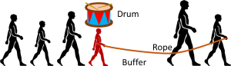This may work for people, but it needs a fair bit of imagination to extend this version of Drum-Buffer-Rope to manufacturing systems. You have to remember that the people in this example are the processes, not the parts. The parts are actually the ground covered. In the image above the people walk from left to right, but the ground covered (the parts processes) would move from right to left. Hence, it looks more like the image below.
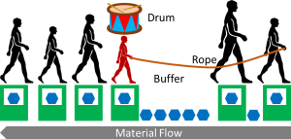Therefore, let’s take this example and put it in a proper manufacturing setting.

Drum Buffer Rope for Manufacturing Systems
In manufacturing, the drum is still the bottleneck. The buffer is the material upstream of the bottleneck and has to make sure that the drum is never starved. The rope is a signal or information from the buffer to the beginning of the line. If the drum processes parts, the buffer moves forward. The rope is a signal when material is taken out, and gives an information to replenish another part at the beginning of the line as shown in the Illustration below.
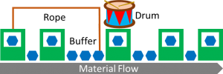
Signal when material is taken out … information to replenish … I have heard something very similar before … Kanban! Yes, Drum-Buffer-Rope is similar to Kanban with the supermarket before the bottleneck. Whenever a part is taken out of the buffer/supermarket, a signal is sent via the rope/kanban to the beginning of the line/kanban loop to replenish material. A Drum-Buffer-Rope system as shown above is very similar to a kanban loop as shown below.
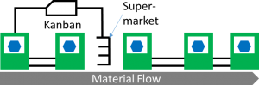However, there are some differences which I would like to go into some detail below. But before that first for completeness sake another variant of Drum-Buffer-Rope, the Simplified Drum-Buffer-Rope:

Simplified Drum Buffer Rope (S-DBR)
Simplified Drum-Buffer-Rope is very similar to Drum-Buffer-Rope. The key to simplifying the approach is the assumption that the market or the customer is the largest bottleneck. I.e. in average your system always has enough capacity to satisfy demand. The rope then spans the entire length of the system.
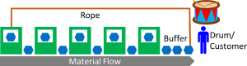

Good Things about Drum Buffer Rope
Drum-Buffer-Rope has some underlying good ideas.

Prevents Overloading of the System
Most importantly, it does try to constrain the work-in-progress and aims to prevent an overloading of the system. As such it can be considered sort of a pull system like Kanban or CONWIP, and hence Drum-Buffer-Rope is superior to the traditional push systems.
Furthermore, the WIP in Drum-Buffer-Rope fluctuates less than with Kanban. A Kanban system defines the number of Kanban, which consists of the WIP, the supermarket stock, and the kanban without parts. Drum-Buffer-Rope (like CONWIP) is more precise as it limits only the physical parts (WIP and Stock), but dose not include the variation through fluctuation of kanban without parts.

Measuring Workload in the System as Time
Another good thing about Drum-Buffer-Rope is that it measures the work in the system not in pieces, but in time. Depending on how many hours worth of work are in the system the rope may release another part in the system.
In comparison, a Kanban system usually only counts pieces. In my view, counting pieces is fine if the pieces are similar, as in mass production. Measuring the workload in time may be beneficial if the items to produce have vastly different work content, as for example in a job shop. However, measuring time is also more difficult, as you need to determine the time for each product rather than merely counting them. In any case, a Kanban system can be adapted to measure time if needed, resulting in the same complexity as a Drum-Buffer-Rope system.

Flaws and shortcomings of Drum Buffer Rope
In my view, however, Drum-Buffer-Rope does have quite some shortcomings. For my daily work I therefore much prefer a Kanban system.

No Consideration for Shifting Bottlenecks
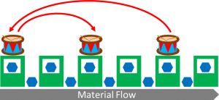Moving around…
One of the major underlying assumptions of Drum-Buffer-Rope is the assumption of a fixed bottleneck. I.e. the bottleneck does not move. If the bottleneck shifts, then the drum is in a different place over time, which makes Drum-Buffer-Rope more difficult.
Goldratt claimed that in his experience this was not a problem in practice. However, Goldratt claimed many things if it benefited him. For example he claimed that his software MARS was able to find the optimal solution, until a judge ordered him to stop (He then rolled out his next software package with the most unfortunate name DISASTER).
In my experience, shifting bottlenecks are not the exception but the norm in most manufacturing systems, and simply assuming a fixed bottleneck will lead to problems. This problem may be confounded that his Theory of Constraints does not offer any good approach to find the bottleneck (see also my methods Bottleneck Walk and Active Period). Of course, increasing buffer sizes will lead to less shifting, but increasing buffers has a lot of disadvantages by itself.

Drum-Buffer-Rope considers only Starving of the Bottleneck, not Blocking
Drum-Buffer-Rope explicitly places a buffer in front of the drum to prevent starving. I.e. the buffer prevents the drum from running out of material. However, it completely omits the possibility of the drum being blocked by a downstream process, which may equally lead to bottleneck downtime. While the buffer after the bottleneck is usually near empty, it is necessary to provide the space in case a downstream process acts up and blocks the bottleneck.
To be fair, some sources of Drum-Buffer-Rope have recognized this problem and introduced a space buffer after the drum, although many other sources still omit this.

Only the Upstream Inventory matters in Drum-Buffer-Rope
Drum-Buffer-Rope controls not only the buffer in front of the drum, but the entire inventory upstream of the bottleneck. However, little or no consideration is given for the downstream inventory, not only the buffer immediately afterwards, but the entire value chain to the customer. Hence, the inventory is not limited and under the right circumstances can still lead to overproduction. Combined with shifting bottlenecks it is almost certain that the downstream inventory will at least temporarily spiral out of control.

Which Part to Produce next?
A Kanban pull system not only constrains the total inventory, but also helps deciding which part to produce next. In the simples case it is merely the next Kanban waiting in line that is produced. Hence at least for high-runners it is clear what to produce next. Drum-Buffer-Rope does not really offer much guidance. If there are multiple product variants in the system, Drum-Buffer-Rope leaves more decisions to humans with all its flaws. For example the bullwhip effect may lead to overproduction of some parts while others are short in supply.

