MASARYK UNIVERSITY
FACULTY OF ECONOMICS AND ADMINISTRATION

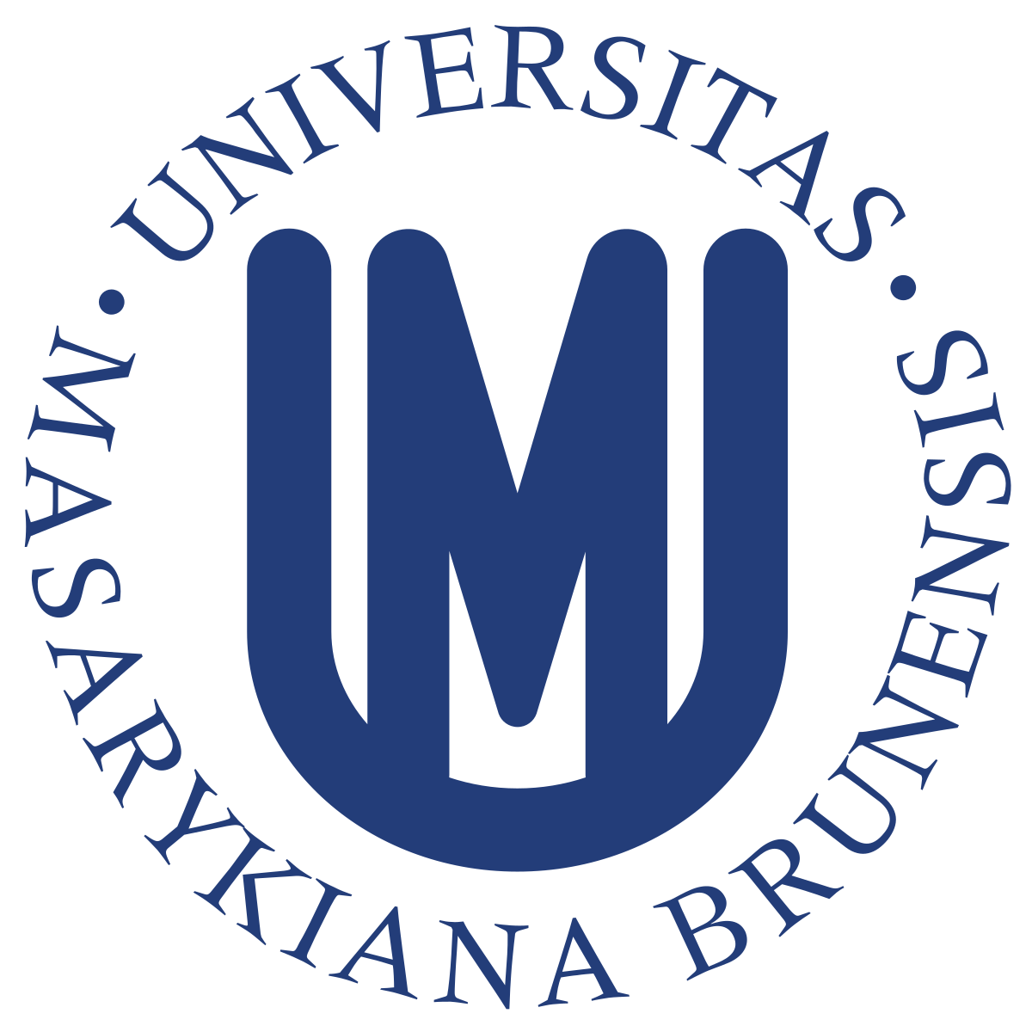

Hunting and Retaining Top Talents
Summary
MPH_AHMR Human Resources Management

Authors:
Arbnora Kllokoqi 495722
Besa Gjonbalaj 495723
Maralmaa Anand 495741
Petra Hladky 495682
Zolbayar Khatanbaatar 495737

Brno, 2020
- Why is talent management important?
In today’s economy, 50% of domestic product (GDP) in developed economies is knowledge based, which is grounded on intellectual assets and intangible people skills (Oladapo, 2014). This has led organizations to establish a highly integrated method to talent management as a requirement to ensure productivity, profitability, and sustainable growth over time. Talent management and retention have become widely recognized as among the most important factors for organizational success (Story, et.al, 2016). It is often described as the systematic attraction, identification, development, engagement/retention and deployment of talents (Thunnissen, 2016). Attracting, selecting, engaging, developing and retaining employees are the five key focuses of talent management (Oladapo, 2014). The “millennials,” who constitute a major share of the global workforce, are known as job-hoppers (Narayanan et.al, 2018). They may change jobs if they do not find compelling reasons to stay on and become active job hunters throughout their career. As talented employees are a major source of competitive advantage attracting and retaining them has become a strategic priority for organizations. The ability to establish and implement integrated talent management is viewed as the roadmap for organizational success in the 2020 workplace, with benefits like increased revenue per employee, less need for downsizing, lower turnover among high performers, lower overall voluntary turnover, and greater ability to hire best talent and develop great leaders (Narayanan et.al, 2018).

- HR strategies on how to recruit and hire top talents
Leaders of the organizations work very hard to attract, hire, develop, and retain talents. They believe people are the only asset that innovates in any organization, and innovation is the only path to sustain performance (Baqutayan, 2014). Based on research for recruiting and attracting talent, major recruitment strategies include employee referrals, the organization website, and social networks methods (Shrm, 2020).
Employee Referrals: One of the most commonly used for recruiting and hiring talents. Referrals from current employees are an especially effective way to bring job openings to the attention of people who are not actively looking for a job but do possess desirable skills, work experience, and a work ethic. Compared with those recruited by other methods, applicants generated by employee referrals tend to have better job qualifications and make better employees, better performances, and remaining longer (Shrm, 2020 p.11).
Organizational Websites: Employers are increasingly using web sites as a method for recruiting. There are some aspects of website recruitment. A site should: grab the viewer's attention with effective use of colors and design, easy to navigate with a few clicks, include information to job candidates, provide an easy way to post a resume, and explain the next steps in the hiring process (Shrm, 2020 p.12).
Social Networks: Social networking involves one of two strategies. In the first strategy, an employer places an advertisement on a site. The second strategy includes social networking sites that allow an employer to search for individuals who have listed qualifications, work experience, or a geographic location the employer is seeking. Alternatively, an employer could use its members with sites on a social network such as LinkedIn to bring a job opportunity to the attention of all their contacts (SHRM, 2020 p.13).

- Ways managers can retain top talents
Retention of the talented workforce is one of the most crucial issues businesses are facing today. Because keeping talent has become the driving force for business success. Job satisfaction does not come from the salary and compensation alone, but the companies must engage in other additional activities to give their employees more reasons to stay. Most employees leave due to a lack of professional challenges, having received little or no recognition, and the absence of career growth and development (Mngomezulu et al., 2015).
In order to retain key talent, the company should consider the following:
Training and Development: Offering training and development opportunities decreases the desire to leave; this may be particularly critical in certain jobs that require constant skills updating (Hom & Griffeth, 1995). Mentor programs can also be a powerful tool in acclimating employees to corporate culture and values.
Compensation and Rewards: Research suggests that market-leading variable or incentive pay, benefits, or intrinsic rewards can powerfully motivate people to stay (Allen, 2008).
Supervision: The company needs to prepare and train supervisors and managers providing training and coaching that covers how to be a good boss but also how to retain key employees.
Employee Engagement: Engaged employees are more satisfied with their jobs, enjoy their work and the organization. They also believe that their job is important, take pride in the company, and believe that their employer values their contributions (Allen, 2008).
Open communication: Effective communication and healthy relationships with their immediate boss will make the workforce choose not to leave the employer (Mngomezulu et al., 2015).

- Company culture plays a role in hiring and retaining top talent
Top talent refers to the person most suited for the position in the firm due to their values and characteristics that could be valuable to the business (Grice, 2020). Company culture is the shared values, goals, attitudes and practices that characterize an organization (Jackson, 2020). The company culture is very important to the business and usually the culture corresponds to the region that the business resides in. Therefore, the company culture plays a big part in the employees lives while in work and that includes the top talents the firm intends to hire. In fact, part of being a top talent personnel is having similar values to the business culture. That means that human resource hiring personnel will be looking for top talent workers that have values and talent needed at their business. In fact, 66% of job seekers consider a company’s culture and values the most important factor when considering career opportunities (Burgess, 2020). Therefore, one of the most important factors to people looking for a job is the corporate culture. Retaining the top talent employees that the business hired also has a lot to do with the firm’s culture. Businesses with strong cultures have 72% higher employee engagement rates which means that culture stimuluses employee engagement having a direct impact on worker’s performance (Denison, 2020). The facts, also, show that firms that actively manage their culture can gain 40% higher employee retention (Bersin, 2020). All in all, corporate culture must be considered when searching for top talent individuals to hire within the firm. With a business that has a good, active culture which it uses to interact with their employees, retaining and hiring top talent employees should be easier than without the knowledge of these factors.

- Strategic Talent Management
Strategic talent management is an operation and process involving the structured recognition of key positions that contribute differently to the sustainable competitive advantage of the company, the creation of a high-potential talent pool and high-performance candidates to fill these roles, and the establishment of a differentiated human resource infrastructure to promote filling these positions with proficient candidates and to ensure their continued commitment to the organization (Collings and Mellahi, 2009).
Identifying key talent positions: The first stage of any strategic talent management program should be the recognition of key talent positions. Successful identification and retention of key positions have the potential to impact on the sustainable competitive advantage of the company differently. The contribution of strategic human capital/key talent positions is maximized when they are embraced by the employees of the organization, and the systems and processes which create and manage this strategic human capital exist. Human capital is of little economic value unless it is used to carry out the strategic intent of the organization. (Collings and Mellahi, 2009)
Developing a talent pool: Talent pool refers to the pool of high-potential and high-performance candidates. The secret to strategic talent management is the creation of a talent pool to fill crucial roles, having defined key talent positions within an organization. Simply put, this implies a change from vacancy led recruitment toward ‘recruiting ahead of the curve. It includes systematically identifying future business needs in terms of knowledge, skills, and capabilities that will be required in the future but are not currently available in the house and recruit on this basis. Stahl et al.’s (2007) study of global talent management confirmed that the high performing organizations they studied followed a talent pool strategy- recruiting the best people and then finding positions for them. (Collings and Mellahi, 2009)
Strategic HR teams: Another critical practice of effective talent management is a Human Resources team with a thorough understanding of the strategy and business preferences of the organizations. Companies are 1.4 times more likely to report out-performing rivals and 2.5 times more likely to report successful talent management when respondents state that their organizations have a strategy-oriented HR department. The results also point to the value of openness about strategy and company goals for all employees. Respondents who say employees of their organizations understand the overall strategy are twice as likely to say that their Human Resources team understands the strategy in depth. (Andrianova, Maor and Schaninger, 2018.

References

Andrianova, S., Maor, D. and Schaninger, B., 2018. Winning With Your Talent-Management Strategy. [online] McKinsey & Company. Available at: <https://www.mckinsey.com/business-functions/organization/our-insights/winning-with-your-talent-management-strategy> [Accessed 7 May 2020].
Allen, D., 2008. Retaining Talent. [online] Shrm.org. Available at: <https://www.shrm.org/hr-today/trends-and-forecasting/special-reports-and-expert-views/Documents/Retaining-Talent.pdf>
Algotsson, F., Johansson, C. and Lindskog, A., 2016. Talent Retention. [online] Diva-portal.org. Available at: <http://www.diva-portal.org/smash/get/diva2:932189/FULLTEXT01.pdf>
Baqutayan, S., 2014. Is Talent Management Important? An Overview of Talent Management and the Way to Optimize Employee Performance. Mediterranean Journal of Social Sciences,.

Collings, David & Mellahi, Kamel. (2009). Strategic Talent Management: A review and research agenda. Human Resource Management Review. 19. 304-313. 10.1016/j.hrmr.2009.04.001.

Stahl, G. K., Bjorkman, I., Farndale, E., Morris, S. S., Stiles, P., Trevor, J. & Wright, P. M. (2007) Global Talent Management: How Leading Multinationals Build and Sustain Their Talent Pipeline, Faculty & Research Working Paper. Fontainebleau, France, INSEAD.

Shrm.org. 2020. [online] Available at: <https://www.shrm.org/hr-today/trends-and-forecasting/special-reports-and-expert-views/Documents/Recruiting-Attracting-Talent.pdf> [Accessed 7 May 2020].
Oladapo, V., 2014. The Impact of Talent Management on Retention. Journal of Business Studies Quarterly, 5(3).
Story, J., Castanheira, F. and Hartig, S., 2016. Corporate social responsibility and organizational attractiveness: implications for talent management. Social Responsibility Journal, 12(3), pp.484-505.
Narayanan, A., Rajithakumar, S. and Menon, M., 2018. Talent Management and Employee Retention: An Integrative Research Framework. Human Resource Development Review, 18(2), pp.228-247.
Thunnissen, M., 2016. Talent management. Employee Relations, 38(1), pp.57-72.

Monster Employer Resources | Monster.com. 2020. Strategies For Retaining High Performing Employees | Monster.Com. [online] Available at: <https://hiring.monster.com/employer-resources/workforce-management/employee-retention-strategies/talent-management-strategies/>
Burgess, W., 2020. These Are Job Seekers’ Top 3 Priorities Right Now, According to Linkedin. [online] Fast Company. Available at: <https://www.fastcompany.com/3061250/these-are-job-seekers-top-3-priorities-right-now-according-to-linkedin> [Accessed 8 May 2020].

Bersin, J., 2020. Becoming Irresistible: A New Model for Employee Engagement. [online] Deloitte Insights. Available at: <https://www2.deloitte.com/us/en/insights/deloitte-review/issue-16/employee-engagement-strategies.html> [Accessed 8 May 2020].

Denison, 2020. Organizational Culture & Employee Engagement: What Is The Relationship? [ebook] Denison Consulting LLC. Available at: <https://www.denisonconsulting.com/sites/default/files/documents/resources/rn_engagement_0.pdf> [Accessed 8 May 2020].

Grice, S., 2020. Nurturing the Top Talent In Your Organization | Halogen Software | Resources. [online] Saba.com. Available at: <https://www.saba.com/uk/resources/how-tos/nurturing-the-top-talent-in-your-organization> [Accessed 8 May 2020].

Jackson, B., 2020. Company Culture: Definition, Benefits and Strategies | Built In. [online] Builtin.com. Available at: <https://builtin.com/company-culture> [Accessed 5 May 2020].

