**Case #11. Who “Owns” the Finnish Forests?**  
The management of Finland’s forests, and the uses to which its wood is put, is a central issue in the EU’s green strategy and its pursuit of carbon emissions goals for 2030 and beyond.

The prevailing conflict centers on whether the Finnish forests are primarily to be viewed as carbon sinks as environmentalists claim, or, as Finland’s big forestry companies and the Finnish government claim, seen primarily as a source of possible replacements for fossil fuels? Currently, Finnish forests provided carbon sinks to cover half of Finland’s carbon emissions.

Forests are considered the nation’s ‘green gold’ in Finland. Finland is a ‘forest giant’, with roughly sixteen times more forest per capita on average than other European countries. 73 per cent of the Finnish landmass is covered by forests and more than 10 per cent of the population owns some forest property.

The forest products industry jumpstarted the industrialization of Finland in the 19th century, in particular the production of pulp and paper. Despite many modern technology companies like Nokia, the forestry sector still is central to the Finnish economy and accounts for a fifth of Finland’s $70bn($60bn euros) of annual exports.

In recent years, a number of Finnish forest products companies are moving away from producing paper to focus on wood as a biomaterial capable of being turned into products like biofuels and biochemicals, i.e., as an alternative to fossil fuels.

**EU Forest Policy**

The June 2021 draft of the EU’s new forestry sector strategy initially focused on forests as carbon sinks to the detriment of forest products. (The forestry sector is defined as ‘Land Use, Land Use Change and Forestry’ (LULUCF) in climate jargon and EU policy.)

**Finland’s Ministry for Agriculture and Forestry** and the **Finnish Forest Industries Federation Association (FIFA)** mobilized in opposition when theysaw the proposed policy as a threat to the transformation of Finland’s industry by failing to endorse the role wood could play in bioenergy and “short-lived products”. In the Finnish view, which was joined by Sweden, EU policy should encourage the replacement of fossil products with renewable materials.

The Finnish-led resistance worked. The EU’s final forestry strategy, published in mid-July, was more favorable towards Finland, making allowances for the possibility of wood products being used to replace fossil ones.

Furthermore, the controversial clear-cutting technique that is widely used in Finland — where all trees in an area are harvested,— was not outlawed, as the leaked draft had hinted they should be.

**NGO Response**

**Greenpeace** argued that Finland and Sweden succeeded in frustrating the EU’s strategy to protect corporate and economic interests, insisting that wood could not replace all fossil fuels, and that forests should not have a narrow focus on forest products.

The Finnish response was to insist that forests can be both carbon sinks and, with active management, the source of wood-based products that are renewable substitutes for fossil fuels.

The **Finnish Natural Resources Institute (LUKE in Finnish)** has predicted that this will mean Finland’s forest carbon sink will halve, from -26.6 million tonnes down to -13.3, something Finland’s own forest strategy also foresees, and the Finnish national Energy and Climate Strategy 2016 further confirms. (LUKE is a quasi-governmental organization with more than a thousand “researchers and specialists working to provide new solutions towards the sustainable development of the Finnish bioeconomy and the promotion of new biobased businesses.”) For details of the LUKE argument for a strong Finnish “bioeconomy,” see the pdf on its website, [www.luke.fi/en/](http://www.luke.fi/en/))

**Fern**, a Europe-based NGO whose declared mission is to achieve greater environmental and social justice, focusing on forests and forest peoples’ rights in the policies and practices of the European Union, is highly critical of the Finish forest industry position. In a 2019 article entitled, “Finland’s forestry myth undermines its radical climate ambition,” Fern argues Finland’s forestry industry is “bad for carbon emissions, biodiversity and its indigenous Sámi people.” (Sami people are indigenous Finno-Ugric-speaking people inhabiting Sápmi, which today encompasses large northern parts of Norway, Sweden, Finland and the Kola Peninsula within the Murmansk Oblast of Russia.)

In **Fern**’s view, “Finnish policymakers’ embrace of the bioeconomy, however, wasn’t about solving the climate crisis, but solving the crisis in Finland’s economy. It wasn’t about saving forests, but saving the Finnish welfare state. What’s more, it fitted a time-honoured Finnish narrative that what’s good for forest corporations, is good for the state and for the country as a whole.” <https://www.fern.org/publications-insight/finlands-forestry-myth-undermines-its-radical-climate-ambition-1990/>

**World Wildlife Fund**

*Posted on 16 July 2021*

The new EU Forest Strategy was intended to chart a more sustainable path for the management of EU forests, but pressure from some Member States and industry puts economic gains ahead of many climate, biodiversity and social considerations.

The European Commission has adopted its new forest strategy, which aims to improve the health and resilience of EU forests by encouraging management practices that are better for nature, climate and people.  
  
Compared to a draft from June, which [showed the Commission taking important steps](https://www.wwf.eu/what_we_do/biodiversity/?uNewsID=3915891) towards addressing EU citizens’ concerns about the state of Europe’s forests, the final version retains the emphasis on the need for a unified effort to restore their health and resilience but it weakens certain important elements. While it still contains a plan to come up with a legislative proposal for an EU-wide forest observation and reporting framework [1], for example, this proposal has been weakened. The previous draft contained a mandatory set of criteria for assessing whether a forest is 'sustainably managed' [2]. These have been dropped from the legal proposal and will only be used on a voluntary basis.  
  
The last-minute changes came after some Member States and the forest industry claimed that the EU has no competence on forest-related issues and accused the Commission of “reducing forests to environmental considerations” and “not taking into account socio-economic aspects”.  
  
“This kind of false rhetoric completely misses the bigger picture,” said **Sabien Leemans, Senior Biodiversity Policy Officer at WWF European Policy Office** in reaction to the Member States’ position. “Unless we urgently act on climate change and biodiversity loss, we will have no healthy and resilient forests left to speak of. By putting short-term economic gains ahead of other considerations, the industry and farming ministers have shown that they do not understand the scale of the crisis. Arguing for increased harvesting and exploitation is misguided on so many fronts when forests across the EU are losing their ability to capture and store greenhouse gases and their health is deteriorating.”  
  
**The good:** As it stands, the forest strategy recognises the need to strengthen the protection and restoration of forests and the need for more biodiversity-friendly sustainable forest management to ensure their resilience and productive capacity for decades to come.   
  
The strategy also emphasises the need to set up schemes to reward forest owners for ecosystem services other than timber production - like water retention, climate regulation, and recreational services - and for adopting climate- and biodiversity-friendly forest management practices.  
  
**The bad:** However, while the strategy states that the bio-economy should be “boosted within sustainable boundaries”, it lacks concrete safeguards to prevent intensified forest management and harvesting that go against the EU’s climate and biodiversity objectives.  
  
This is a double blow given the Commission’s [shameful decision this week](https://www.wwf.eu/?uNewsID=4039866) to side with the biomass industry lobby and reject any meaningful revision to the rules on bioenergy in the renewable energy directive (RED). This means the RED will continue to incentivise burning trees for energy, increasing emissions compared to fossil fuels and putting forests under ever greater pressure. “The forest strategy is not a legal instrument, and so will not be able to drive the necessary change for our forests if its principles are not mirrored in the relevant legislation like RED and LULUCF,” added **Sabien Leemans**.

**Actors in the Case**

**Finland’s Ministry for Agriculture and Forestry**

**Finnish Forest Industries Federation Association (FIFA)**

**Finnish Natural Resources Institute (LUKE in Finnish)**

**EU** [**Standing Forestry Committee**](https://ec.europa.eu/agriculture/minco/othco/forest/index.htm)

**European Commission**

**Environmental NGOs (Fern**, **Greenpeace, and World Wildlife Fund)**

**Case Questions**

The prevailing conflict centers on whether the Finnish forests are primarily to be viewed as carbon sinks as environmentalists claim, or, as Finland’s big forestry companies and the Finnish government claim, seen primarily as a source of possible replacements for fossil fuels?

* 1. **(2) If you were the FIFA, what would be the main issues and actors you would monitor as you seek to influence the ongoing work of the EU** [**Standing Forestry Committee**](https://ec.europa.eu/agriculture/minco/othco/forest/index.htm)

***Format: I’d monitor______ because__________.***

**(maximum words: 80)**

* 1. **(3) Summarize the power situation in the case (maximum 100 words)**
  2. **(3) As FIFA, what is your most likely scenario on how EU forest policy will unfold (without active intervention on your part) as the European Commission Green Deal is implemented?**
  3. **(1) What public policy model do you think will best describe how the EU** [**Standing Forestry Committee**](https://ec.europa.eu/agriculture/minco/othco/forest/index.htm) **will formulate and implement EU forest policy? Explain your choice (maximum words: 40)**
  4. **(6)** **Given your power summary, scenario and public policy model, as FIFA, what will be your strategy going forward to maximize the possibility that the Finnish government and FIFA will together be able to formulate and implement Finnish forest policy without EU interference? (maximum words: 150)**

.

**Appendix A. EU Forest policies**

[**https://ec.europa.eu/environment/forests/fpolicies.htm**](https://ec.europa.eu/environment/forests/fpolicies.htm)

**In the European Union the formulation of forest policies is the responsibility of the Member States..**. Although the Treaties for the European Union make no provision for a common forest policy, there is a long history of EU measures supporting certain forest-related activities, coordinated with EU Member States mainly through the [**Standing Forestry Committee**](https://ec.europa.eu/agriculture/minco/othco/forest/index.htm)**.**

**However forests are affected by a broad array of Community policies** and initiatives arising from diverse EU sectoral policies, mainly in relation to the protection of biodiversity and, more recently, in the context of climate change impacts and policies.

[The *EU Forestry Strategy*](https://ec.europa.eu/agriculture/fore/index_en.htm) was initially adopted in 1998 and amended numerous times since.

On 23 July 2019, the **European Commission** adopted an [*EU Communication on Stepping up EU Action to Protect and Restore the World’s Forests*](https://eur-lex.europa.eu/legal-content/EN/TXT/?qid=1565272554103&uri=CELEX:52019DC0352) *.*

The Communication has the objective of protecting and improving the health of existing forests, especially primary forests, and significantly increasing sustainable, biodiverse forest coverage worldwide. It sets out five priorities:

* Reduce the footprint of EU consumption on land and encourage the consumption of products from deforestation-free supply chains in the EU;
* Work in partnership with producer countries to reduce pressures on forests and to “deforest-proof” EU development cooperation;
* Strengthen international cooperation to halt deforestation and forest degradation, and encourage forest restoration;
* Redirect finance to support more sustainable land-use practices;
* Support the availability and quality of information on forests and commodity supply chains, the access to that information, and support research and innovation.

**Appendix B. Finnish Forest Association Response to Critique of Nordic forestry**

<https://forest.fi/article/8-claims-on-nordic-forestry-as-to-biodiversity-and-climate-change-mitigation-forest-use-passes-the-test/#abdb8d83>

forest.fi is published by the [Finnish Forest Association](https://smy.fi/en/).

1.4.2021 /

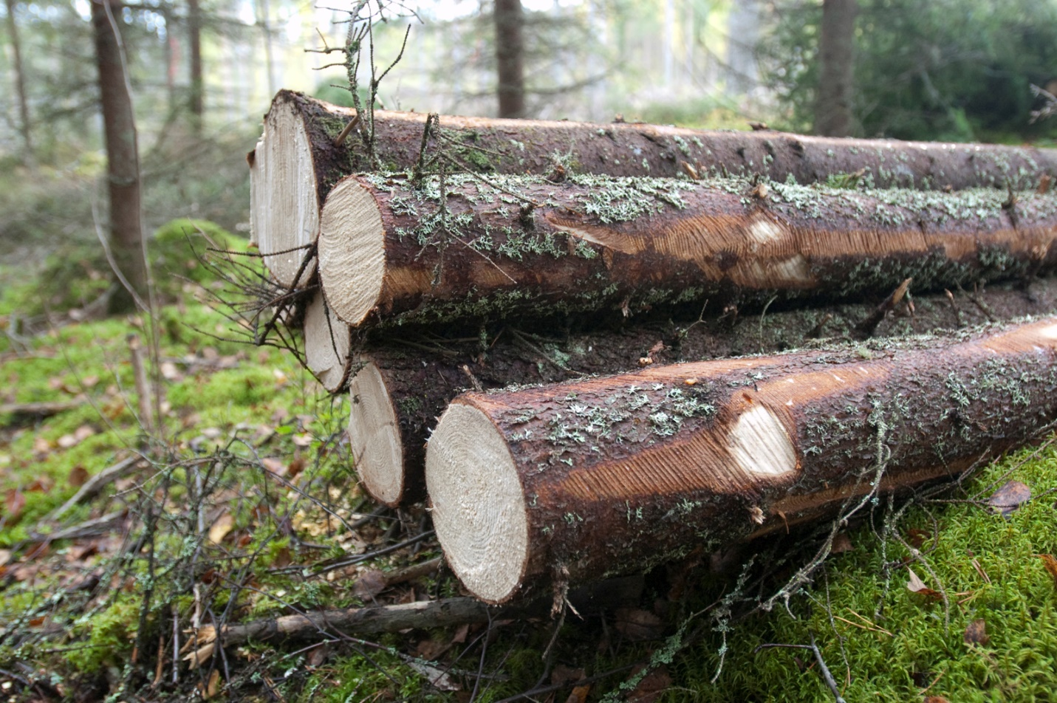

**CLAIM 1: The rate of protection in the Nordic countries is slow, compared to the rapid rate of logging. Virtually all unprotected natural forests will soon be lost.**

The area of protected forest land has increased many times over in the Nordic countries since the 1970’s.

In Finland, for instance, the area has more than tripled.

Sweden has strictly protected 97.7 percent of its natural forests, and Finland 98.9 percent. These figures included not only forests that have never been harvested, but also forests that have not been touched in 60–80 years.

The logging rate in cubic metres has increased 1,5 times since the beginning of 1970s, but, mainly due to sustainable forestry methods, the increase in forest growth has doubled.

On the other hand, if instead of cubic metres we look at the area of regeneration fellings, which may be more relevant for nature values, the figure has remained more or less the same since the beginning of 1970s. In Finland, for instance, the area of regeneration fellings on the average has been 0.6% of the area of commercial forests.

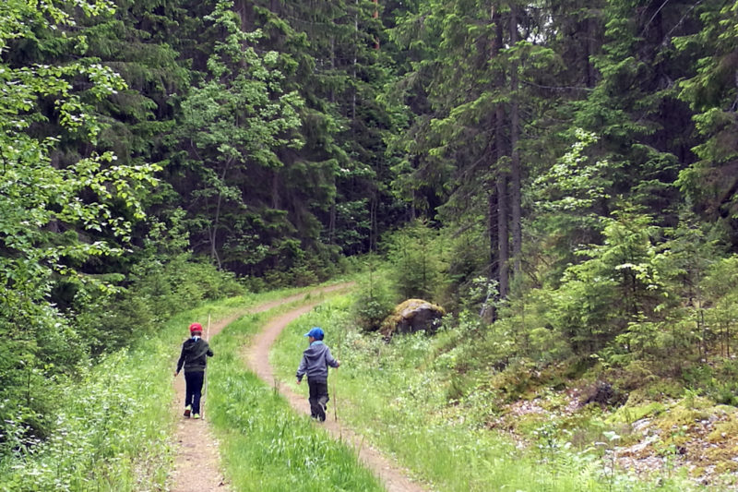Private individuals and families own clearly over half of the forests in the Nordic countries. Their rights to their forest property are very strong and they manage their forests very independently. Photo: Anna Kauppi

**CLAIM 2: The European Union aims at climate neutrality in 2050. This cannot be achieved without prioritizing the protection of ecosystems.**

Nordic forestry has shown that forest can be a significant carbon sink, if they are managed sustainably. In Finland, for example, timber stock has increased from 1.500 million cubic metres by close to 70 percent and is still increasing. During the same time, due to productive forestry and industry, a total of 3.700 million cubic metres have been harvevested. In Sweden the figures are alike.

**CLAIM 3: Clearcutting does not represent sustainable forestry. The climate crisis has to be solved faster than the clearcutted trees grow back.**

Although it takes 60–100 years for a tree to grow “adult”, carbon dioxide molecule has not to wait to be sequestrated into a tree growing on the very same place as the logged one. It also is not very reasonable to evaluate the carbon balance of forest on the level of one tree or not even one logging area.

As to the climate, it is more relevant that the carbon storage in Nordic forests has, mainly due to sustainable, clearcut-based forestry, increased by more than half since the beginning of 1970s and continues to increase.

**CLAIM 4: Biofuels, paper and cardboard lead to carbon dioxide emissions.**

Biofuels, paper and cardboard are made of renewable raw materials. They are thus part of nature’s carbon flow. Unlike fossil carbon, which enhances the climate change in the atmosphere, they do not increase the amount of carbon in this flow.

In the Nordic countries, forest-based biofuels are only produced from sidestreams of the forest branch, with minor exceptions, such as wood used as household fuel. These sidestreams would create equal carbon emission into the atmosphere whether or not they were used as fuel. If we did not use them as fuel, their energy should be procured otherwise, from fossil raw materials, for instance.

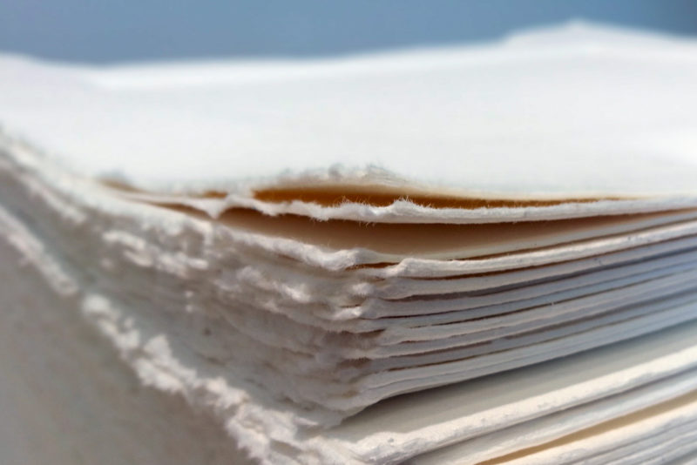In the 19th century, before the advent of paper and cardboard industry, the outer parts of logs were collected in high piles in the vicinity of sawmills and were ultimately burned. Using this raw material to produce paper, for example, was a huge innovation enabling an almost unlimited use of paper in all human activity. Photo: Anna Kauppi

**CLAIM 5: Reduced biodiversity leads to reduced resilience to climate change.**

This is true. But if this is told to concern Nordic forestry, it includes a statement that forest biodiversity in the Nordic countries is declining.

Research does not prove this unambiguously. Instead, we are gaining more old-growth forest, large trees, broadleaved trees and deadwood. Not all forest is harvested simultaneously. There are always forests of all ages and stages of development. As a result, the populations of Nordic megafauna, such as elk, deer, forest reindeer, lynx, beaver, bear and wolf, have grown significantly since the 1970’s.

**CLAIM 6: Nordic commercial forests are tree agriculture – the ground is harrowed and the most common regeneration method is to plant pre-grown seedlings. Each forest stand includes only one tree species of one age.**

Saying that Nordic forestry resembles agriculture is like comparing apples and oranges.

When establishing an agricultural field, you first remove all vegetation, while in forestry only a share of the trees is removed. You also remove the humus and substitute it with another humus, which is never done in forestry. You grow just one single species and systematically remove or poison all others, while in forestry all other species are left to grow.

**CLAIM 7: The overall age of Nordic forests is decreasing.**

In the long run, that is, centuries, the age distribution of Nordic forests has been close to a steady state. The average age has increased due to protection of exceptionally old forest stands.

According to statistics, the average age of Nordic forests is rather increasing and will increase over the next few decades if conservation and set-aside areas are included.

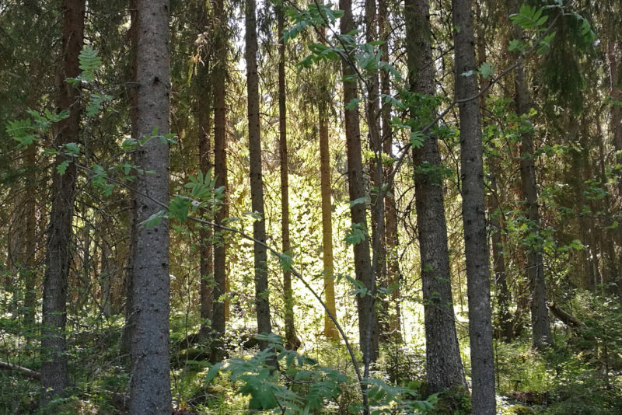During the growing season, the carbon stock in the Nordic forests increases every second. Photo: Anna Kauppi

**CLAIM 8: Old-growth forests continue to sequestrate carbon and store high amounts of carbon.**

Old-growth forests may contain large carbon storages, but the amount depends on a range of factors, such as location and history. There is scientific evidence that they sequester carbon to a certain extent, but as stands age, their carbon uptake declines and eventually falls close to zero, when the trees grow very slowly and the carbon storage in the soil increases slightly.

‘Forest biomass growth is bound to follow an S-curve, where carbon is sequestered first at an accelerating rate and, after a peak, at a decelerating rate,’ says Kauppi.