Case #8. The Ocean Shipping Industry Faces New Emissions Regulations
This case is based on excerpts from the following three articles.

The first excerpt is from an article from the Wall Street Journal about the International Maritime Organization that regulates shipping, entitled “For the Shipping Industry, Moves to Cut Carbon Emissions Remain a Struggle.”
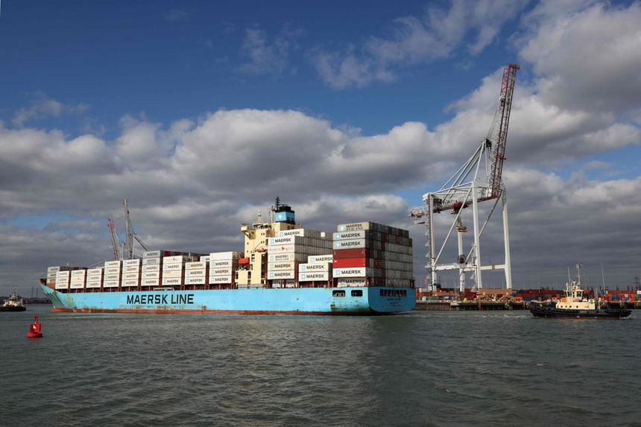

Shipping companies face a 2050 deadline set by the International Maritime Organization (I.M.O) that seeks sharp cuts in vessels’ carbon-dioxide emissions. Photo: adrian dennis/Agence France-Presse/Getty Images
By Costas Parris Oct. 27, 2021 Wall Street Journal
Shipping operators are under pressure from governments and big customers such as Amazon.com Inc. to clean up vessels’ carbon emissions. But viable alternatives to fossil fuels are just taking shape.
Supplies of methanol and ammonia—two cleaner-burning alternatives to crude-distilled bunker oil—are too limited to power the world’s 60,000 oceangoing ships, and those fuels are several times more expensive, companies say.
Industry competitors are also split on how soon to start the transition. Smaller Shipping Companies worry that Large Shipping Companies are able to make investments and borrow money, and a lack of consensus exists in the industry over what cleaner-burning fuel should power future ships.
The International Maritime Organization, a United Nations body regulating maritime affairs, set a 2050 deadline for shipping companies to sharply cut the amount of carbon dioxide that vessels pump into the atmosphere.
Large Customers (e.g., Amazon, IKEA and Unilever) said last week that they want to move their products on what are known as zero-carbon ships by 2040, a more stringent target than the one agreed upon by the industry. The commitment came days before the November 2021 U.N. Climate Change Conference, also called COP26, in Glasgow, Scotland. It adds to demands by other industry competitors to cut greenhouse-gas emissions.
“It’s premature to order ships that will comply with regulations in 2040 or 2050, because there is no clarity on future fuels and how much will be available,’” said Polys Haji-Ioannou, the chief executive of Cyprus-based Safe Bulkers Inc., a smaller shipper which operates 47 ships that run on bunker oil.
Maritime shipping is among segments of the broader global transportation industry that are bracing to make big investments to meet long-range goals on reducing greenhouse-gas emissions.


IKEA wants its products transported on so-called zero-carbon ships by 2040. Photo: Michael M. Santiago/Getty Images
Clarkson Research Services Ltd., a shipping-services provider, has estimated that it might cost the shipping industry $3 trillion to switch to new modes of power. Ships collectively contribute about 2.5% of the world’s greenhouse-gas emissions, according to the International Maritime Organization, an amount that is comparable to the emissions of some of the largest European Union countries.
A.P. Moller-Maersk A/S (Maersk), the world’s biggest boxship operator, recently ordered eight methanol-powered ships—slated for delivery in 2024—that can also run on traditional bunker oil. Morten Bo Christiansen, head of decarbonization at Denmark-based Maersk, said the ships’ annual methanol needs are about 10 times greater than the volumes currently available in the market. “It’s a huge challenge to get ample fueling supply,” he said.
Ship orders in 2021were at multiyear highs: More than 480 were ordered through mid-October 2021, compared with 115 for all of 2020 and 107 in 2019, according to maritime data provider VesselsValue.
But apart from the Maersk order, the rest were for ships that burn conventional heavy oil or have a dual fuel capacity.
“What to order is a big dilemma,” said Nils Haupt, a spokesman for large German boxship company Hapag-Lloyd AG , who added that the company is opting to use liquefied natural gas. “It’s not the perfect solution, but that’s what we got,” he said.
Banks (including Citigroup Inc., Société Générale SA of France and DNB AS A of Norway) are part of a group that aims to reduce the industry’s carbon emissions by extending new shipping loans to owners that will verifiably operate cleaner vessels. The banks have a combined shipping portfolio of about $185 billion, or about half of the global ship-finance market.
Michael Parker, Citi’s chairman for shipping and logistics, said the group asked the COP26 delegates to push the International Maritime Organization toward adopting a net-zero carbon-emissions policy by 2050.
International Maritime Organization’s current mandate calls for vessels to be 40% more fuel-efficient over the next decade and cut overall carbon-dioxide emissions in half by 2050, compared with 2008 levels. The group has said that it could adopt earlier deadlines and more stringent emissions cuts when it reviews its strategy in 2023. #
The first excerpt is from an article from the New York Times about the International Maritime Organization that regulates shipping, entitled, “Tasked to Fight Climate Change, a Secretive U.N. Agency Does the Opposite.” by Matt Apuzzo and Sarah Hurtes, New York Times, June 3, 2021
https://www.nytimes.com/2021/06/03/world/europe/climate-change-un-international-maritime-organization.html
Global ocean shipping produces as much carbon dioxide as all of America’s coal plants combined. (Yet t)he organization that sets standards for global shipping, the International Maritime Organization (I.M.O),” has repeatedly delayed and watered down climate regulations, even as emissions from commercial shipping continue to rise, a trend that threatens to undermine the goals of the 2016 Paris climate accord.
Ocean shipping, unlike other industries, is not easily regulated nation-by-nation. A Japanese-built tanker, for instance, might be owned by a Greek company and sailed by an Indian crew from China to Australia — all under the flag of Panama…So if the I.M.O. does not curb shipping emissions, it is unclear who will.

A Storm on the Horizon

…(T)he political winds are shifting. The European Union is moving to include shipping in its emissions-trading system (See Appendix A). The United States, after years of being minor players at the agency, is re-engaging under President Biden and recently suggested it may tackle shipping emissions itself, but to date has not acted in this arena.
(When) delegates met in secret to debate what should constitute a passing grade under (its) new rating system for ships, (u)nder pressure from China, Brazil and others, the delegates set the bar so low that emissions can continue to rise — at roughly the same pace as if there had been no regulation at all. Delegates agreed to revisit the issue in five years.

What follows is an excerpt from the website, Globalmaritimeforum, entitled, “Getting to Zero Coalition.”
https://www.globalmaritimeforum.org/getting-to-zero-coalition/

The Getting to Zero Coalition is a powerful alliance of more than 140 companies within the maritime, energy, infrastructure and finance sectors, supported by key governments and IGOs. The Coalition is committed to getting commercially viable deep sea zero emission vessels powered by zero emission fuels into operation by 2030 – maritime shipping’s moon-shot ambition.
The Getting to Zero Coalition builds on the Call to Action in Support of Decarbonization launched in October 2018 and signed by more than 70 leaders from across the maritime industry, financial institutions and other stakeholders, as well as on the Poseidon Principles – a global framework for climate-aligned ship financing – launched on 18 June 2019.

The challenge
International shipping emits 2-3 percent of global GHG emissions, transporting close to 80 percent of global trade by volume. To curb the emissions from shipping, the International Maritime Organization (IMO) has agreed on an ambition to reduce GHG emissions from shipping by at least 50 percent by 2050. To reach this goal and to make the transition to full decarbonization possible, commercially viable zero emission vessels must start entering the global fleet by 2030, with their numbers to be radically scaled up through the 2030s and 2040s. This will require both developing the vessels as well as the future fuel supply chain, which can only be done through close collaboration and deliberate collective action between the maritime industry, the energy sector, the financial sector, and governments and IGO (Intergovernmental Organizations).
Maersk Moves Green
On 24 August 2021, Denmark-based Maersk, one of the world’s largest ocean shipping companies, announced it had ordered eight vessels which are able to run on carbon-neutral methanol to accelerate the decarbonisation of its fleet and meet increased customer demand for greener transportation.
Maersk has vowed to only order new vessels which can use carbon-neutral fuel as it seeks to deliver net-zero emissions by 2050. As vessels typically have a lifetime of 20-35 years, this means it must have a carbon-neutral fleet by 2030.
The ships, which can each carry 16,000 containers, will be built by South Korea's Hyundai Heavy Industries (267250.KS) and are expected to be delivered by early 2024.The vessels will be 10-15% more expensive than normal ones and will each cost $175 million.
The new ships will be fitted with engines which can run on both green methanol, which is produced by using renewable sources such as biomass and solar energy, as well as normal bunker fuel as there is still not enough carbon-neutral fuel available in the market.
ACTORS IN THE CASE:

Large Shipping Companies (like Maersk and Hagen-Lloyd)
Small Shipping Companies
International Maritime Organization (IMO)
Big Customers (e.g., Amazon, IKEA and Unilever)
Banks (including Citigroup Inc., Société Générale SA of France and DNB AS A of Norway)
Getting to Zero Coalition
Transport & Environment
United States
European Union/Commission (EU/C)

CASE QUESTIONS
- (7) Draw a power diagram for the case, following the model shown in Exhibit 8.2, with the actors identified above
2. (4) Summarize what your power diagram tells you about the power situation the ocean shippers, big or small, face in the case (Summary means summary! Do not simply repeat what is in your diagram. Summarize key elements, leading to a concluding statement about position, positive or negative, of (a) big shippers) and (b) small shippers, i.e., a “summary” of your summary in power terms.) (maximum 150 words)
3. (4) Referencing where appropriate your foregoing power analysis, is there a viable strategy for (a) the big shippers, and (b) the small shippers to survive if there is major legislation in the EU requiring them to abandon bunker fuels and shift to green energy sources? If yes, explain. If not, explain why not. (maximum 150 words)

Appendix A. EU strategy to reduce CO₂ emissions from shipping
https://eur-lex.europa.eu/legal-content/EN/TXT/HTML/?uri=LEGISSUM:20010301_1&from=EN

The European Union (EU) has an ambitious agenda to tackle climate change. Up until now, every form of transport, except the international maritime sector, has been contributing to the objectives the EU has set itself. Moves are now under way for shipping to start playing its part.
ACT
Communication from the Commission to the European Parliament, the Council, the European Economic and Social Committee and the Committee of the Regions - Integrating maritime transport emissions in the EU’s greenhouse gas reduction policies (COM(2013) 479 final of 28.6.2013).
SUMMARY
WHAT DOES THE COMMUNICATION DO?
The EU makes it clear that it fully supports international efforts to reduce maritime greenhouse gas (GHG) emissions. In parallel, the EU is taking its own initiatives. The communication sets out a gradual approach for including shipping in its overall target to reduce GHG emissions.
KEY POINTS
This gradual approach contains the following three steps.
- 1.
Applying an effective monitoring, reporting and verification (MRV) system. This would establish reliable data on shipping’s GHG emissions. Ship-owners would be able to use whichever reliable methodology they wished. A proposed regulation sets out the scope and operational features of such a system.
- 2.
Setting intermediary reduction targets. Legislation already exists for all other industrial sectors and forms of transport to contribute to the EU’s target of cutting GHG emissions by at least 40 % below 1990 levels by 2030. This could be extended to shipping. The 2011 White Paper on transport established a reduction target of 40 % (if feasible, 50 %) by 2050, compared to 2005, as an aspirational goal for maritime shipping.
- 3.
Using market-based measures (MBMs). These could require a vessel to pay into a compensation fund or to exchange allowances within the EU’s emissions trading system, depending on the level of emissions it produces.
BACKGROUND
EU shipping accounts for 4 % of all EU GHG emissions. However, these are set to increase significantly in the future - possibly by 50 % by 2050, compared to 2010 levels. Reducing these emissions will not only help tackle climate change, but it will also reduce fuel consumption and a vessel’s operating costs.
For more information, see the European Commission’s website on reducing emissions from the shipping sector.
RELATED ACT
Proposal for a Regulation of the European Parliament and of the Council on the monitoring, reporting and verification of carbon dioxide emissions from maritime transport and amending Regulation (EU) No 525/2013 (COM(2013) 480 final of 28.6.2013).

Appendix B. EU’s supposedly ‘green’ shipping law will lock in fossil fuels
https://www.transportenvironment.org/press/leaked-eu%E2%80%99s-supposedly-%E2%80%98green%E2%80%99-shipping-law-will-lock-fossil-fuels
Transport & Environment is an NGO focused on all forms of transportation.
According to Transport & Environment (T&E) an EU law intended to drive the uptake of clean fuels by ships will actually lock in the use of fossil fuels for decades, according to a leaked proposal, making the European Green Deal goal of decarbonisation by 2050 impossible. Transport & Environment (T&E), which obtained the documents, said the European Commission could still fix the law by excluding liquified natural gas (LNG) and crop-based biofuels and providing incentives for green e-fuels like renewable hydrogen and ammonia.
More than half (55%) of the energy used by ships calling at EU ports could be LNG and biofuels by 2035, according to T&E’s analysis of the proposal’s ‘climate’ targets. This is despite LNG offering minimal emissions reductions and releasing methane - a global warming gas up to 36 times more potent than CO2. Most biofuels are worse for the climate than the fuels they replace, and those that do offer emissions savings are not available at scale.
Faig Abbasov, shipping programme director at T&E, said: “This supposedly green fuels law would push the cheapest alternatives, which are also the most destructive. Counting fossil gas and biofuels as green will lock shipping into decades of further pollution while we should be promoting renewable hydrogen and ammonia. There’s still time to kick out fossil fuels and stop the European Green Deal turning shipping’s transition into an ecological disaster.”
Biofuels would provide one-fifth of the fuel of ships calling at EU ports in 2035, according to the analysis of the draft law. If all of it comes from used cooking oil (UCO), this would drive up demand by EU transport for UCO by an additional 5.1 Mt in 2030, further increasing the gap with what can be supplied sustainably to Europe. The EU’s own auditors have raised concerns about imports of UCO because of inadequate systems to stop virgin oils like palm, which drive deforestation, being passed off as used.

Faig Abbasov said: “It’s not too late to save the world’s first green shipping fuel mandate. The EU Commission should exclude LNG, crop biofuels and, at a minimum, apply the same sustainability criteria for waste biofuels as under the Renewable Energy Directive. There also needs to be incentives for the uptake of e-fuels, green hydrogen and ammonia, such as dedicated sub-targets or multipliers to boost their competitiveness.”

Smaller Shipowners want ‘polluter pays’ principle at core of carbon pricing proposal
The European Commission is revising the European Union Emissions Trading Scheme (EU ETS) directive in line with the European Green Deal and it plans for the first time to include international maritime emissions.
Small Greek, Italian and Swedish shipowners, along with T&E, have put their weight behind calls for the European Commission to put the ‘polluter pays principle’ at the core of its maritime carbon pricing proposal. In a letter to the Commission, the coalition demands that the soon to be introduced maritime Emissions Trading System (ETS) is both ambitious and tailor-made for the industry.
The current European Union Emissions Trading Scheme (EU ETS) - puts a cap on the carbon dioxide (CO2) emitted by business and creates a market and price for carbon allowances. It covers 45% of EU emissions, including energy intensive sectors and approximately 12,000 installations.
The coalition launched by T&E has grown steadily, encompassing a wide range of shipping interests from progressive to more traditional. What they all have in common, says T&E, is the desire for carbon pricing rules that are clear, fair and crafted in such a way that is both good for the planet and does not undermine the smooth running of international shipping.
Faig Abbasov, shipping director at T&E, said: “This is a chance to put shipping on a path to decarbonisation. Our unique industry-NGO coalition underlines how important it is that the EU doesn’t waste it. The ETS should not be limited to voyages within the EU but also cover voyages between the EU and third countries. An intra-EU only ETS would reduce the environmental effectiveness of the measure and place the burden unfairly on short-sea shipping companies.”
Beyond scope, the coalition has also asked the Commission to rule out free emission allowances to avoid punishing smaller companies that have less capacity to take advantage of the system. This, they say, would ensure both environmental effectiveness and a level-playing field. They also back the European Parliament's proposal of establishing an "Ocean Fund" which will channel ETS revenue into research and development and the deployment of green fuels, among other things.
This comes as a new report shows that deploying enough e-fuels to account for 7% of shipping fuel by 2030 would put EU shipping on track to decarbonise by mid-century. Modelling by T&E points to a clear path which involves modest deployments of e-fuels combined with efficiency measures such as wind-assist and speed optimisation.
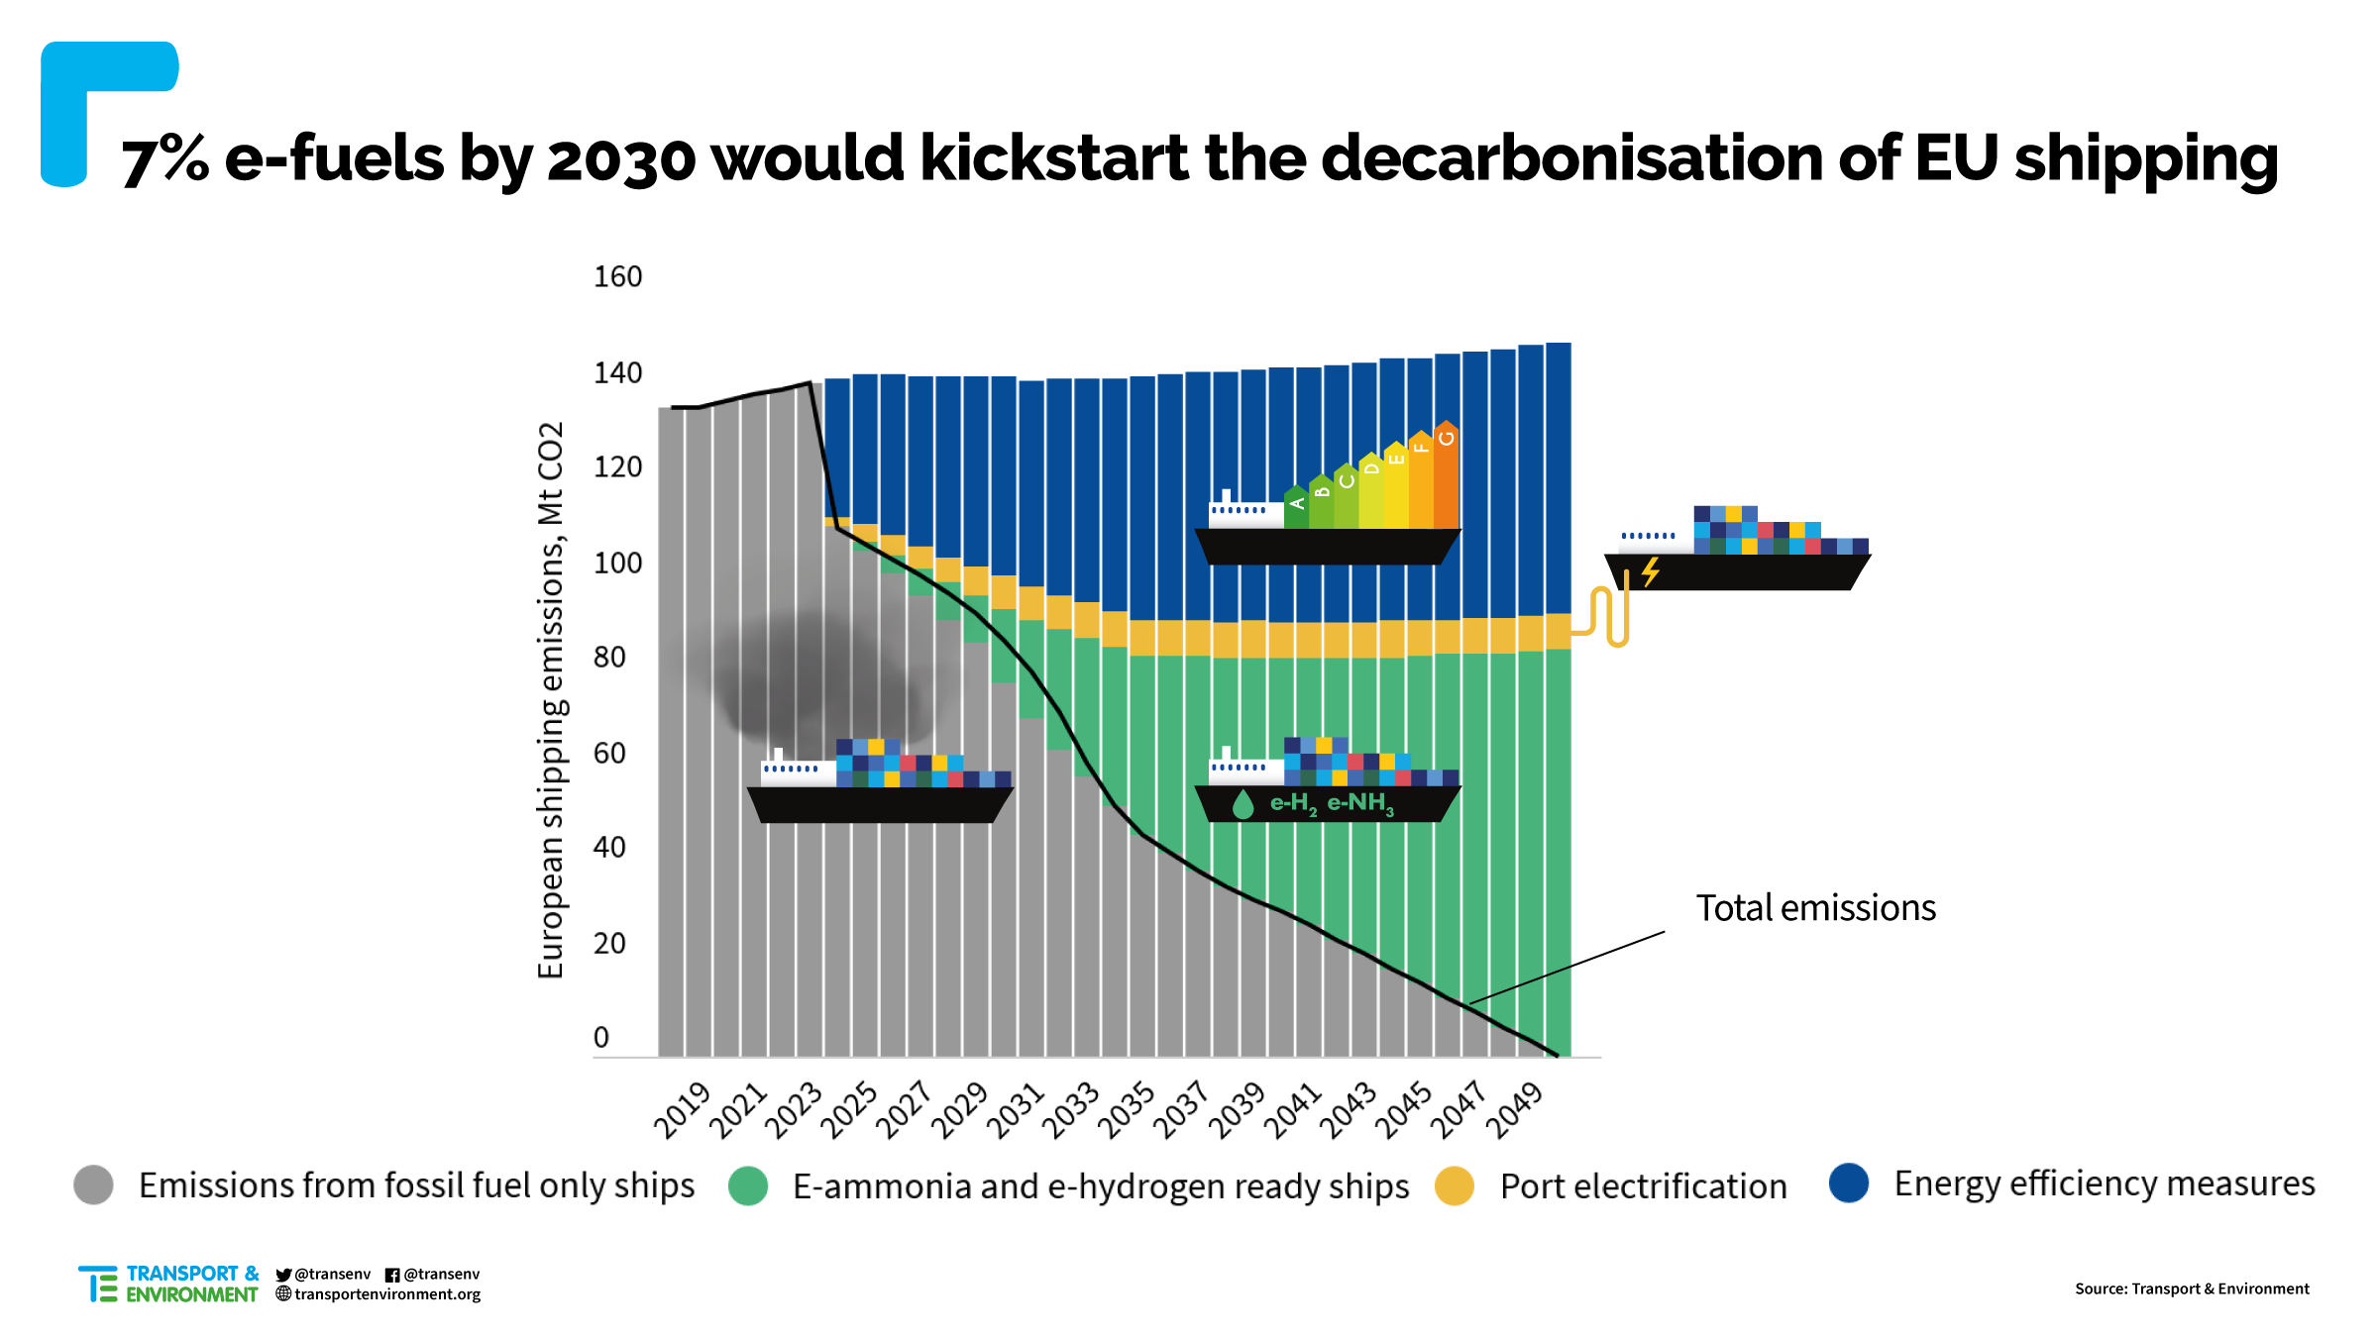
Faig Abbasov added: “We have shown that decarbonising shipping is doable. But the uptake of green fuels like e-ammonia won’t happen unless shipping companies are required to deploy them. As well as an ambitious ETS, the EU should mandate 7% e-fuels by 2030 as part of the forthcoming FuelEU maritime legislation.”

