**Case #6. Amazon Packaging and Sustainability**

**Paper mills produce 500,000,000 tons of paper and paperboard each year. Some of that is in Amazon packaging at your front door.**

**The following is from the Amazon website**

Amazon is committed to building a sustainable business for our customers and the planet. In 2019, Amazon co-founded [The Climate Pledge](https://sustainability.aboutamazon.com/about/the-climate-pledge)—a commitment to be net zero carbon across our business by 2040, 10 years ahead of the Paris Agreement. As part of this pledge, Amazon has made ambitious commitments toward reaching this goal.

* Net Zero Carbon

Deploying our technology and people to reach net zero carbon across Amazon by 2040, one decade ahead of the Paris Agreement.

* 100% Renewable Energy

On a path to powering our operations with 100% renewable energy by 2025.

* Shipment Zero

Making all Amazon shipments net zero carbon through Shipment Zero, with 50% of all shipments net zero carbon by 2030.

* Electric Delivery Vehicles

Purchasing 100,000 electric delivery vehicles, the largest order ever of electric delivery vehicles.

* Climate Pledge Fund

Investing $2 billion to support the development of technologies and services that reduce carbon emissions and help preserve the natural world.

* Right Now Climate Fund

Investing $100 million in reforestation projects and climate mitigation solutions.

**Packaging and Products**

We are redesigning packaging to reduce waste and making our private-label products in responsible ways.

[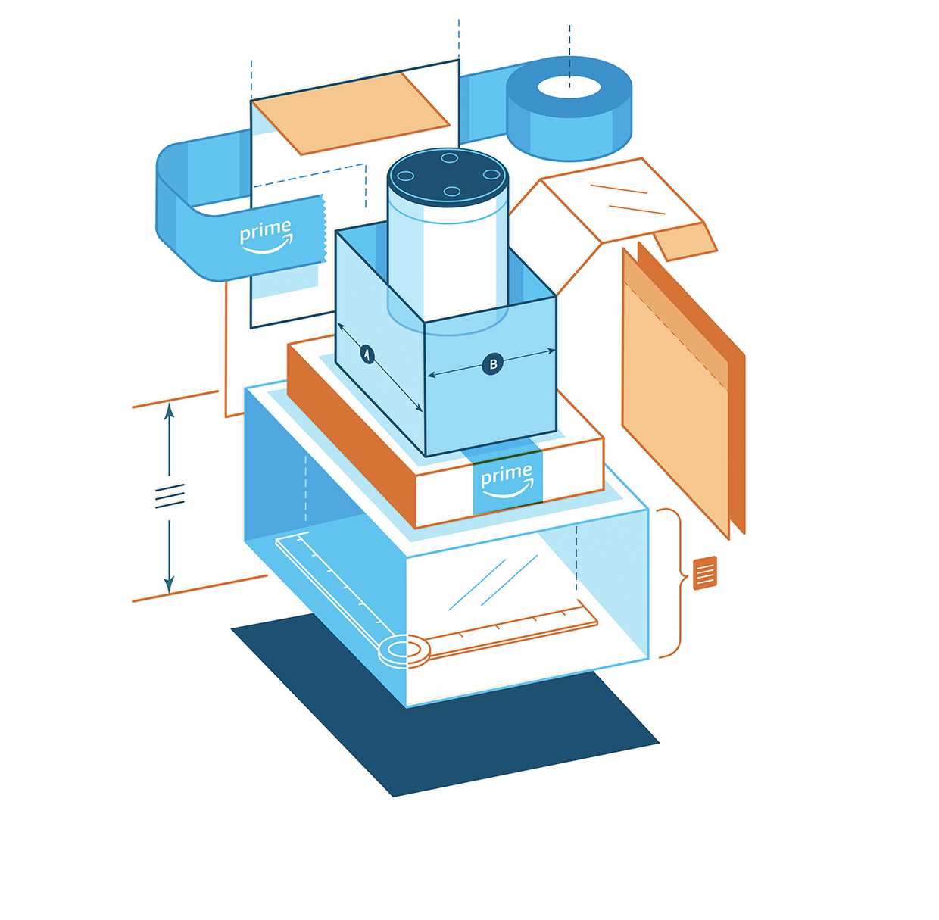](https://sustainability.aboutamazon.com/environment/packaging-and-products/packaging)

[Improving Our Packaging](https://sustainability.aboutamazon.com/environment/packaging-and-products/packaging)

Our customers want right-sized, recyclable packaging that minimizes waste and ensures damage-free delivery. We work to reinvent and simplify our sustainable packaging options using a science-based approach that combines lab testing, machine learning, materials science, and manufacturing partnerships to scale sustainable change across the packaging supply chain.

[Sustainable Packaging Initiatives](https://www.aboutamazon.com/sustainability/packaging)

Amazon's mission is to optimize the overall customer experience by collaborating with manufacturers worldwide to invent sustainable packaging that delights customers, eliminates waste, and ensures products arrive intact and undamaged.

Since 2015, Amazon has reduced packaging weight per shipment by over 36% and eliminated more than 1 million tons of packaging. Amazon invites Vendors to participate in Frustration-Free Packaging (FFP) programs, which set industry standards and guidance for brands. Optimized packaging delights customers, is more sustainable, and improves operations. We are excited to announce the [2021 Frustration-Free Packaging programs incentive expansion](https://www.aboutamazon.com/packaging/overview/2021-incentive) to further this progress.

**Amazon Certified Frustration-Free Packaging Programs**

**Same Product, Better Packaging**

The product you selected is certified under our Frustration-Free Packaging Program. It’s designed and tested to ship to customers in its own packaging without the need for additional Amazon packaging. Products in Frustration-Free Packaging offer more sustainable packaging that is right sized, reduces damages, is made of recyclable packaging materials and is easier to open.

**Designed to Reduce Waste**  
Right sized and ships without Amazon packaging

**Lab Tested Protective Design**  
Certified to minimize damage

**Recyclable Packaging Materials**  
100% curbside recyclable

**Easy to Open**  
No plastic clamshells, no wire ties

Ship in Amazon Packaging Option In the event that you want Amazon to ship your item certified under the Frustration-Free Packaging program in Amazon packaging, simply choose “Ship in Amazon packaging” at checkout. These items are listed on the Amazon product page with the following language: “**Item arrives in packaging that reveals what's inside**. To hide it, choose **Ship in Amazon packaging** at checkout.” Amazon provides this option at no cost to customers.

Reducing packaging waste, one package at a time at Amazon, we obsess over providing a great packaging experience to our customers.

We introduced Frustration-Free Packaging in 2008, an innovation designed to reduce waste and delight customers with easy-to-open, 100% recyclable packaging. Since then the program has grown to include a wide range of initiatives designed to optimize packaging we use in our fulfillment centers and by working with manufacturers worldwide to help them to develop sustainable packaging for online fulfillment.

Since 2015, we have reduced the weight of outbound packaging by 33% and eliminated more than 900,000 tons of packaging material, the equivalent of 1.6 billion shipping boxes. To learn more about our sustainability initiatives, please visit our [Sustainability Website](https://www.amazon.com/gp/redirect.html/ref=s9_acss_bw_cg_FFPSTORE_md1_w?_encoding=UTF8&location=https%3A%2F%2Fsustainability.aboutamazon.com%2F%3Futm_campaign%3Dffp%26utm_source%3Dnode&source=standards&token=ACBA68C896CD3C21E0994B718DD3B69266336647&pf_rd_m=ATVPDKIKX0DER&pf_rd_s=merchandised-search-1&pf_rd_r=WDX8ESZNS0ZMEZPJ3T7E&pf_rd_t=101&pf_rd_p=ab8d7431-62d1-4b4d-858f-078023b6a24e&pf_rd_i=5521637011). <https://sustainability.aboutamazon.com/>

EU vendors using amazon have eliminated 120,000 US tons tonnes (around 109,000 tonnes) of packaging waste, the equivalent of 176 million boxes.

<https://packagingeurope.com/amazon-addressing-the-challenges-of-e-commerce/>

**EU Packaging and Packaging Waste Legislation**

[**https://ec.europa.eu/environment/topics/waste-and-recycling/packaging-waste_en**](https://ec.europa.eu/environment/topics/waste-and-recycling/packaging-waste_en)

**The main law covering packaging and packaging waste in the EU is the “**[Packaging and Packaging Waste Directive](http://eur-lex.europa.eu/legal-content/EN/TXT/?uri=CELEX:01994L0062-20150526)” which **entered into force on**31 December 1994. It has been amended a number of times since. It declared,

*“Whereas the differing national measures concerning the management of packaging and packaging waste should be harmonized (among EU countries) in order, on the one hand, to prevent any impact thereof on the environment or to reduce such impact, thus providing a high level of environmental protection, and, on the other hand, to ensure the functioning of the internal market and to avoid obstacles to trade and distortion and restriction of competition within the Community;*

*Whereas the best means of preventing the creation of packaging waste is to reduce the overall volume of packaging;*

*Whereas it is important, in relation of the objectives of this Directive, to respect the general principle that measures taken in one Member State to protect the environment should not adversely affect the ability of other Member States to achieve the objectives of the Directive;*

*Whereas the reduction of waste is essential for the sustainable growth specifically called for by the Treaty on European Union.”*

**Overview**

EU rules on packaging and packaging waste currently cover both packaging design and packaging waste management. They aim to deal with the increasing quantities of packaging waste, which cause environmental problems. They also aim to remove barriers in the internal market caused by EU countries adopting different rules on packaging design.

Although the implementation of these rules has been considered a success, the amount of packaging waste in the EU is still increasing, and too many of our finite resources are being wasted without being recirculated into the economy.

EU rules on packaging cover all types of packaging and packaging waste placed on the European market. This means all materials, and packaging including industrial, commercial, household and other sectors. These rules regulate what kind of packaging can be placed on the EU market, as well as packaging waste management and packaging waste prevention measures. All packaging placed on the EU.

Implementation of the [Packaging and Packaging Waste Directive](http://eur-lex.europa.eu/legal-content/EN/TXT/?uri=CELEX:01994L0062-20150526) and [new circular economy action plan (CEAP)-](https://eur-lex.europa.eu/legal-content/EN/TXT/?qid=1583933814386&uri=COM:2020:98:FIN) is the responsibility of the Directorate General of the Environment, reporting to European Commissioner for the Environment, Oceans and Fisheries

# EU Green Deal Circular economy action plan

The EU’s new circular action plan paves the way for a cleaner and more competitive Europe.

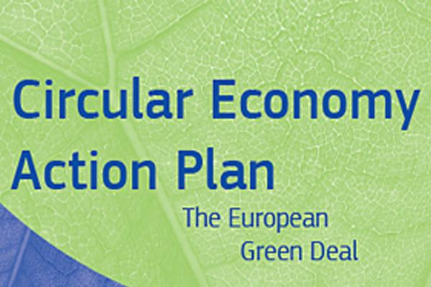

The **European Commission** adopted the [new circular economy action plan (CEAP)](https://eur-lex.europa.eu/legal-content/EN/TXT/?qid=1583933814386&uri=COM:2020:98:FIN) in March 2020. It is one of the main building blocks of the [European Green Deal](https://ec.europa.eu/info/node/123797), Europe’s new agenda for sustainable growth. The EU’s transition to a circular economy will reduce pressure on natural resources and will create sustainable growth and jobs. It is also a prerequisite to achieve the EU’s 2050 climate neutrality target and to halt biodiversity loss.

The new action plan announces initiatives along the entire life cycle of products. It targets how products are designed, promotes circular economy processes, encourages sustainable consumption, and aims to ensure that waste is prevented and the resources used are kept in the EU economy for as long as possible.

It introduces legislative and non-legislative measures targeting areas where action at the EU level brings real added value.

The EU’s new circular action plan paves the way for a cleaner and more competitive Europe.

**Paper and Plastic Recycling in Europe: Current Results**

In 2019, fibre-based packaging (paper and paper board) represented 38% of all packaging brought to market in Europe. In 2019, **72%** of all paper and board consumed in Europe was recycled. The collection of paper for recycling decreased by 2.5% compared to 2018 and reached 57.5 million tonnes. Paper and board consumption has decreased more strongly compared to 2018 and dropped to 79.8 million tonnes.

All plastic packaging on the EU market must be recyclable by 2030, and the use of microplastics circumscribed. The measures are the toughest in the world and have already pushed plastic packaging recycling rates in the EU to an all-time high of **41.5 percent** — three times that of the United States.

According to a report by the NGO **Oceana,** Amazon generated almost 500 million pounds of plastic packaging in 2019, more than 22 million pounds of which ended up in rivers and oceans, potentially threatening efforts by Amazon CEO Jeff Bezos to establish his firm’s sustainability credentials. According to Oceana, plastic air pillows and bubble wrap accounted for most of the waste from Amazon’s 7 billion deliveries last year alone. And this was before Covid and the surge in on-line buying.

**4evergreen is a cross-industry alliance with the goal of optimizing fibre-based packaging circularity and climate performance**

[**https://4evergreenforum.eu/about/**](https://4evergreenforum.eu/about/)

**4vergreen** is a paper packaging industry association spanning the paper packaging value chain, dedicated to “contribute to a climate-neutral society by perfecting the circularity of our products.”

According to its website,

*“We pay particular attention to packaging with a lower circularity performance today, namely the types used for household, out-of-home and on-the-go consumption. Innovation stands at the heart of our alliance. We are accelerating the development of novel technologies to address targeted sorting or recycling challenges, specifically for barrier paper and board.*

*Our aim is to raise the overall recycling rate of fibre-based packaging to 90% by 2030. To reach this goal,* ***4evergreen*** *has identified four intermediary targets to be met by 2025:*

*Industry adopts 4evergreen’s recyclability evaluation protocol and its circularity by design guidelines for fibre-based packaging*

*Separate collection streams are available for all fibre-based packaging types,including for those used in household, out-of-home and on-the-go consumption*

*All Paper for Recycling (PfR) is sorted according to the different paper and board categories specified in the EN643 standard*

*All collected fibre-based packaging, specifically from household, out-of-home and on-the-go consumption, is recycled.”*

4evergreen has focused on four technical ***workstreams (WS)*** dealing with different aspects of fibre-based packaging:

WS-1: recyclability evaluation protocol. WS-1 will develop a standardised, publicly available, Recyclability Evaluation Protocol for fibre-based packaging.

WS-2: "circularity by design" guidelines. WS-2 will compile “circularity by design” guidelines to ensure that more fibre-based packaging is recycled from the start.

WS-3: guidelines for collection and sorting. WS-3 will identify the best practices that can support the goals of 4evergreen.

WS-4: innovation WS-4 will accelerate the development of technologies and new processes that can raise the circularity of fibre-based packaging.

**Covid, Online Buying and Packaging Volume**

 For years, online retail has grown steadily to new levels, roughly at a rate of 15% annually. . The COVID-19 pandemic increased online shopping to incredible new levels as consumers turned to online ordering to get all manner of consumer goods when stores were forced to temporarily shut their doors and when health risks multiplied. ACI Worldwide reports that online purchases increased by 74% in March 2020, year on year at the start of the pandemic. All of those online orders led to an influx of boxes and shipping materials being recycled and often trashed by households when much of it, especially all paper packaging materials, could be conveniently recycled.

**For Amazon alone, the company reported a year-on-year increase on on-line sales of 44% in April 2021, and a 66% increase in the use of its website by other retailers.** Amazon had a record-breaking year in Europe in 2020, with revenue of **44 billion euros** while people were shopping from home during the pandemic. Total revenue for Amazon from all sources was $384 billion (~$325 billion euros).

**Amazon Packaging in the Crosshairs of NGOs**

The dramatic increase in shipping and associated packaging materials with on-line shopping, coupled with the decrease in paper recycling among EU households, has attracted the attention of EU regulators seeking to reduce resource consumption associated with packaging production. It has also attracted more attention from NGOs focused on forest preservation and Climate Change of which **Appendix B. Canopy Planet’s Pack4Good Campaign**, is a typical example.

Amazon’s plastics use has also come under fire. According to the NGO **Oceana**, Amazon’s plastic packaging waste soared by almost a third, to 270,000 tonnes, during the pandemic last year.

Oceana estimates up to 10,700 tonnes of this plastic, including air pillows, bubble wrap and plastic-lined paper envelopes, equivalent to a delivery van’s worth every 67 minutes, is likely to end up in the sea.

Amazon rejected Oceana’s figures and said it had overestimated the plastic waste by 300%. It also questioned the model used to estimate the percentage likely to enter the sea. It did not provide alternative figures.

Matt Littlejohn, Oceana’s senior vice-president, said: “We are using the best data available to us. If [**Amazon**](https://www.theguardian.com/technology/amazon) was transparent, we would gladly use their data. Yes, they are using more non-plastic packaging, but they are also selling a ton more product. We understand people need Amazon. And so we’re hoping Amazon can fix this problem and become a leader in reducing plastic, which is really important for the oceans.”

**ACTORS IN THE CASE**

**Amazon**

**Amazon Customers**

**Amazon Vendors**

**4vergreen**

**Directorate General of the Environment, reporting to European Commissioner for the Environment, Oceans and Fisheries**

**European Commission**

**Canopy Planet**

**Oceana**

**CASE QUESTIONS**

1. **(2) How do the following see the social contract of Amazon?**
2. **Amazon**
3. **Canopy Planet**

**Answer should be in the form:**

**_________believes the social contract of Amazon to be _______.**

**(maximum words: 30 words each.)**

**Reminder: Amazon is a for-profit company!**

1. **(2) What would be your response to Oceana’s challenge to Amazon that Amazon share its data. (40 words maximum)**
2. **(2) Would you agree to invite Canopy Planet into your operations and agree to "partner" with them "...to reduce (your) paper packaging footprint through the use of smart design, recycled fibre, and by implementing readily available Next Generation Solutions throughout (your) packaging supply chains." (40 words maximum)**
3. **(2)** **Given the** [**Packaging and Packaging Waste Directive**](http://eur-lex.europa.eu/legal-content/EN/TXT/?uri=CELEX:01994L0062-20150526) **and** [**new circular economy action plan (CEAP)**](https://eur-lex.europa.eu/legal-content/EN/TXT/?qid=1583933814386&uri=COM:2020:98:FIN)**, what would be your response to the assertion that Amazon need not deal with the NGOs since the future of packaging will be dictated by the EU, not NGO direct or indirect pressure on Amazon? (maximum words: 80)**

**Appendix A.** **Model of a Circular Economy**

A **circular economy** (also referred to as "circularity") is an [economic system](https://en.wikipedia.org/wiki/Economic_system) that tackles global challenges like climate change, biodiversity loss, waste, and pollution. It is presented as a contrast or alternative to a **linear economy,** where businesses take a [natural resource](https://en.wikipedia.org/wiki/Natural_resource) and turn it into a product which is ultimately destined to become waste because of the way it has been designed and made. This process is often summarised by "take, make, waste". By contrast, a circular economy employs [reuse](https://en.wikipedia.org/wiki/Reuse), [sharing](https://en.wikipedia.org/wiki/Sharing_economy), repair, refurbishment, [remanufacturing](https://en.wikipedia.org/wiki/Remanufacturing) and [recycling](https://en.wikipedia.org/wiki/Recycling) to create a closed-loop system, minimising the use of [resource inputs](https://en.wikipedia.org/wiki/Resource_depletion) and the creation of [waste](https://en.wikipedia.org/wiki/Waste_minimisation), pollution and carbon emissions. The circular economy aims to keep products, materials, equipment and infrastructure in use for longer, thus improving the productivity of these resources.

**Appendix B.** **Canopy Planet’s Pack4Good Campaign**

[**https://canopyplanet.org/campaigns/paper-futures/**](https://canopyplanet.org/campaigns/paper-futures/)

Canopy Planet is an NGO focused on saving Ancient and Endangered Forests! It’s **Paper Futures campaign** aims to transform the paper supply chain. One program is to help consumers’ change their paper selection based on where the wood that goes into making their paper is sourced from or on use of paper without wood fibre in it. It advocates for use of a wide range of 100% recycled and FSC® certified papers that are already available. We are supporting the emergence of straw based pulps and papers which can displace significant amounts of pulp fibre from Ancient and Endangered Forests. Good fibre sourcing decisions are critical to leveraging permanent, legislated protection/conservation in landscapes of hope globally.

*FSC® certified paper is paper that has been harvested in a responsible manner. … FSC is an acronym for the* ***Forest Stewardship Council®****, which is an independent, non-governmental, not-for-profit organization that was established to promote the responsible management of the world’s forests.*

**Canopy Planet also has a campaign entitled, “pack4good.”**

**(from the Canopy Planet website)**

[***https://canopyplanet.org/campaigns/pack4good/***](https://canopyplanet.org/campaigns/pack4good/)

***Did you know that three billion trees are cut down every year for paper packaging? That means thousand-year-old forests are being destroyed to make boxes.***

***Let’s work together to change that.***

Packaging is a hot topic these days and for good reason.

As the world deals with the growing impacts of the global climate crisis, we need to consider how our packaging choices impact the natural world. Never has this been so apparent as now. The surge in e-commerce over recent years, amplified further by increased on-line shopping arising from the COVID-19 pandemic, means paper-based packaging is having a significant impact on the world’s forests, wildlife, and climate.

To address these issues and transform the packaging supply chain, Canopy is partnering with companies around the world **to ensure the world’s Ancient and Endangered Forests do not end up as shipping or pizza boxes, and other single-use packaging**. Instead, Pack4Good supports companies on their commitment to reduce their paper packaging footprint through the use of smart design, recycled fibre, and by implementing readily available Next Generation Solutions throughout their packaging supply chains.

**Why Pack4Good?**

Each year the equivalent of roughly three billion trees is cut down to produce paper-based packaging, many of which come from high-carbon forests, endangered species’ habitats, and other controversial sources. This number is projected to grow by more than 20% by 2025, which is directly at odds with imperatives for climate stability and biodiversity health.

Forest conservation has been identified by the United Nations as 30% of the climate solution. Forests are also vital for protecting species and preventing future pandemics. It is critical that we keep Ancient and Endangered Forests standing to protect human health, wildlife, and to keep our planet’s natural systems stable.

The good news is that there are solutions!

***“We face a breakdown of our natural systems, and warnings that more viruses will emerge from disrupted forest landscapes.  It’s never been more important for forward-thinking companies to shift from high-impact paper packaging to smarter, planet-friendly alternatives.”* — Nicole Rycroft, Founder and Executive Director of Canopy**

**How to Pack4Good**

Ensuring paper packaging is free of Ancient and Endangered Forests is essential. Here are solutions to help companies achieve this:

**DESIGN:** The best place to start to Pack4Good is to rethink how much packaging you need, how it is designed and how it gets used. Significant material reductions can be made by designing packaging that’s lighter, stronger, smaller, and best of all, reusable. That’s good for the environment and your bottom line.

**USE RECYCLED:** Utilize 100% recycled, preferably post-consumer recycled materials. Various life cycle analyses (LCA) have shown that recycled and post-consumer recycled fibre reduce impacts on forests, and use both less water and energy to produce. It is also widely available, making it a great choice.

**NEXT GEN:** Innovative, **next generation** fibre options are increasing, and proving to be great alternatives to forest-fibre. These technologies use residues or waste, such as wheat straw (leftover after wheat is harvested for food), which would usually be burned or landfilled. In addition to the environmental benefits of using agricultural waste, it also brings new revenue to farmers and rural communities.

A win-win-win!

For more information on Next Generation Solutions click [here](https://canopyplanet.org/solutions/next-generation-solutions/).

For more information on recycled, post-consumer recycled, and next generation fibre paper and packaging options, visit Canopy’s **[EcoPaper Database](http://epd.canopyplanet.org/)**. The EPD lists more than 800 environmentally superior paper and paper packaging products.