This case involves the International Fur Federation fighting a proposed ban on fur sales in New York City

My comments on the student’s diagram and summary are in red. Note the following:
- all actors’ predisposition are indicated as + (supporting the ban), - (opposed to the ban), or o (neutral). I would prefer you to indicate a + for the business position and a – for the opponents, but you can do it either way.
- All arrows are weighted by potential and actual power. Actual power is your assessment of how much of Actor a’s power over Actor B will be used in the case situation.
- Th student has followed my advice by putting the focal company on the left followed by its allies, the government entities in the middle, and the opponents on the right. This structure makes the diagram easier for you to create and for me to evaluate.

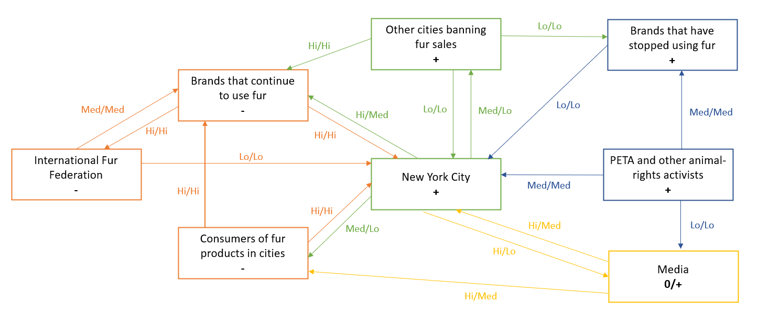

- Note Exhibit 8.1. Power diagram for a Case involving fur retailers (on the left) vs. NGOs (on the right) tryin

2. (4) Summarize what your power diagram tells you about the International Fur Federation (IFF)’s situation in the case in less than 150 words (Summary means summary! Do not simply repeat what is in your diagram. Summarize key elements, leading to a concluding statement about position, positive or negative, of the IFF, i.e., a “summary” of your summary in power terms.)
NOTE: The student’s first two paragraphs highlight key elements of her power diagram:
IFF has no or just low influence on NY as it’s a representative organization and has no influence on customers. Instead, brands have power over NY, because of their tax payments. But NY also has power over brands as a ban influences their sales and business model. The most influential opponent of the ban are customers. They’re potential voters and represent bargaining power for NY.
Among supporters PETA and Media are influential to NY as they have public awareness. Public opinion is an important source of power since PETA and Media base their influence/power on it. Moreover, society could also influence consumers.
Here is the student’s “summary of her summary”: Overall IFF has a weak position. Their power depends on the brands selling fur. Moreover, supporters basing their power on societies interests are highly influential and therefore weaken the IFFs position especially since they have also potential power over consumers, which are a powerful party opposite NY.

