PICTURE 1: Public administration in the Czech Republic - general scheme

The Czech public administration distinguishes There have been the following levels of public administration in the
the following components of public administration: Czech republic:
PUBLIC ADMINISTRATION
TERRITORIAL
State administration
Municipal
Self-government
District

Regional
CENTRAL

Picture 2: Czechoslovak public administration: perion 1948 - 1990

In the period 1948 - 1990 the structure of the Czechoslovak public administration was (with a level of simplification) following:
PUBLIC ADMINISTRATION
State administration
TERRITORIAL
Municipal
District
Regional
CENTRAL

The territorial public administration had been exersised by the system of „national committees“

Self-government
- in practice the importance of the self-government was minimal because of the political influence

PICTURE 3: Period 1990 - 2001 - real situation (THE LEGAL SITUATION WAS DIFFERENT)

In the period of 1990 - 2001 (11. 11. 2000) the practice was following:

PUBLIC ADMINISTRATION
TERRITORIAL
Municipal
District
Regional
CENTRAL

State administration
municipalities

district authorities

Self-government

the central level created the so-called „deconcentrates“ especially on the territory of former (abolished) regional and district national committees

PICTURE 4 (Period 12. 11. 2001 - 31. 12. 2002)

PUBLIC ADMINISTRATION

State administration

Self-government

TERRITORIAL
Municipal
District
Regional
CENTRAL
municipalities
district authorities

the central level created the so-called „deconcentrates“ especially on the territory of former (abolished) regional and district national committees
regions

PICTURE 5: PUBLIC ADMINISTRATION 1. 1. 2003 TILL NOW

It must be stressed, that the district as an territorial unit is still existing and is important for territorial competencies of some institutions. We still have e. g. district courts and also district labour authorities, cadastral authorities etc. - the group that is called by the ministry of interior as "special territorial agencies of state administration" (= "ASSYMETRIC MODEL")
PUBLIC ADMINISTRATION

State administration

Self-government

TERRITORIAL
Municipal
District
Regional
CENTRAL
municipalities ("microregions")
district authorities

according to the goals of the reform the most the „deconcentrates“ should be replaced by the new regions and their tasks, however the practice is different

- new MINISTRY OF INFORMATICS
regions
THE HIGHEST ADMINISTRATIVE COURT

Tabel 1: MUNICIPALITIES AND HIGHER SELF-GOVERNMENTAL UNITS IN THE EU-15 and CR
 | Number of municipalities | Average number of inhabitants in a municipality | First higher level of self-government | Second higher level of self-government
France | 36 565 | 1 600 | 96 | 22
BDR | 13 854 | 5 900 | 323 | -
ITALY | 8 100 | 7 100 | 103 | 20
SPAIN | 8 106 | 4 900 | 50 | 17
GREECE | 1 033 | 10 200 | 50 | -
AUSTRIA | 2 539 | 3 400 | - | -
BELGIUM | 589 | 17 400 | 10 | -
NETHERLANDS | 504 | 31 500 | 12 | -
FINLAND | 448 | 11 500 | - | -
PORTUGAL | 278 | 36 000 | - | -
SWEDEN | 289 | 30 700 | 21 | -
DANMARK | 275 | 19 400 | 14 | -
LUXEMBOURG | 188 | 3 700 | - | -
IRELAND | 85 | 47 200 | 29 | 8
GREAT BRITAIN | 433 | * | 7 | -
CZECH REP. | 6 258 | 1 645 | 14 | -
Table 2: STRUCTURE OF MUNICIPALITIES IN THE CZECH REPUBLIC (1. 1. 2001)

NUMBER OF INHABITANTS | NUMBER OF MUNICIPALITIES | NUMBER OF MUNICIPALITIES ( %) | TOTAL NUMBER OF INHABITANTS
to 199 | 1 648 | 26,30 | 203 640
200 - 499 | 2 043 | 32 | 663 848
500 - 999 | 1 283 | 60 | 895 275
1 000 - 1 999 | 657 | 20,50 | 910 062
2 000 - 4 999 | 367 | 5,90 | 1 134 947
5 000 - 9 999 | 128 | 2,00 | 888 274
10 000 - 19 999 | 68 | 1,10 | 960 339
20 000 - 49 000 | 42 | 0,07 | 1 246 442
50 000 - 99 999 | 17 | 0,03 | 1 243 485
over 100 000 | 5 | 0,008 | 2 146 621
Σ | 6258 | 100,00 | 10 292 933

Table 3: "Regions of cohesion" - NUTS II in the Czech Republic

Region of Cohesion | Km² | Number of inhabitants  (1. 1. 2000)
Prague | 496 | 1 186 855
Mid Bohemia | 11 014 | 1 111 354
Southwest | 17 615 | 1 177 982
Northwest | 8 650 | 1 131 974
Norteast | 12 440 | 1 489 407
Southeast | 13 991 | 1 658 761
MidMoravia | 9 100 | 1 240 355
Moravia-Slezia | 5 554 | 1 281 410
Czech Republic | 78 860 | 10 278 098

Regions of the Czech Republic

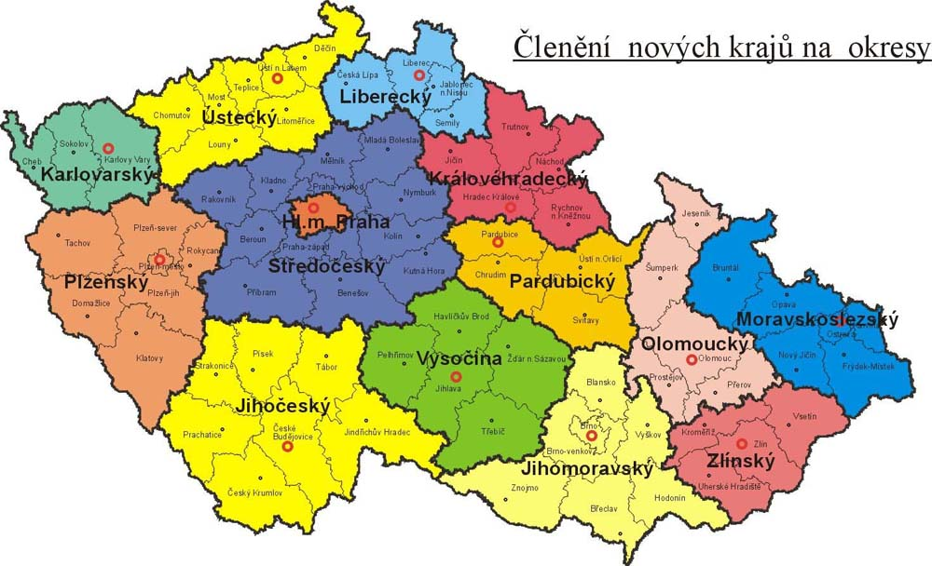

NUTS 2 areas ("regions of coherence") and regions (in our lang. region = "kraj") (NUT 3) of the Czech Republic

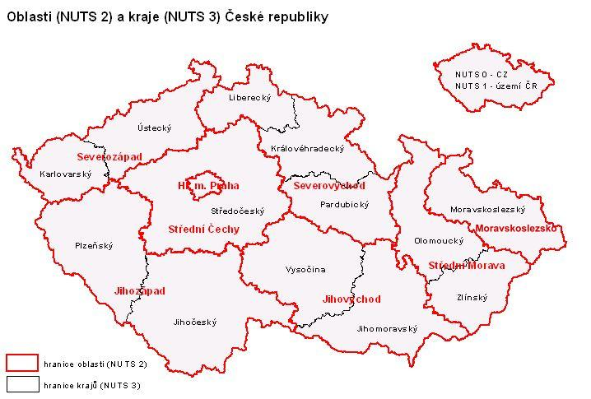

Regions (NUTS3) and former districts (NUTS4)

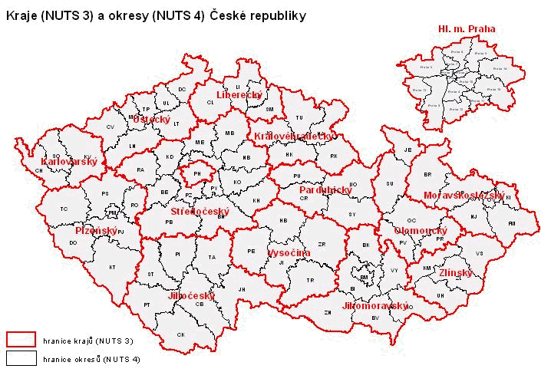

Organizational structure of municipalities
MUNICIPAL (or TOWN) ASSEMBLY
- directly elected deliberative and decision-making body (from 5 to 55 members)
BOARDS: always the Financial board and Control board
= initiative and control bodies

MUNICIPAL (OR TOWN) COUNCIL
- executive organ elected by municipal assembly, not elected in municipalities where the municipal assmebly has less than 15 members (in that case, municipal assembly fulfill its tasks); 5 - 11 members
COMMISSIONS
= initiative and deliberative bodies

MAYOR and DEPUTY MAYORS
- deputize the municipality, elected by municipal assembly from its own members;
MUNICIPAL SECRETARY
- appointed by the mayor in municipalities with municipalities with "commissioned" municipal office and in municipalities with enlarged sphere of activity; the agreement of the director of regional committee is required
MUNICIPAL OFFICE
- comprising the mayor, the mayor's deputies, the municipal secretary and employees of the municipality thate are included into municipal office

Organizational structure of regions
REGIONAL ASSEMBLY
- directly elected deliberative and decision-making body (from 45 to 65 members)
"HEJTMAN OF THE REGION" AND HIS DEPUTY (- IES)
- deputize the region, elected by regional assembly from its own members;
REGIONAL COUNCIL
- executive organ elected by regional assembly,
BOARDS: always the Financial board and Control board and Board for upbringing, education and employment; = initiative and control bodies

REGIONAL OFFICE
- comprising director and employees of the region

COMMISSIONS
= initiative and deliberative bodies

Source: http:\\www.mvcr.cz (the www site of the Ministry of interior of the Czech republic)
Source: http:\\www.mvcr.cz (the www site of theMinistry of interior of the Czech republic)
? Source: http:\\www.czso.cz (the www site of the Czech Statistical Authority)

