Cvičení –přiřazení poplatků – nákladů k řádkům dokumentů
Exercise – Item charge assignment
Vytvořil (created) : Skorkovský
Datum (date) : 9.11.2010
Charakter (type) : draft
Určeno pro (for) : studenty PIS2

- Create new Purchase Order with some item (your choice) :
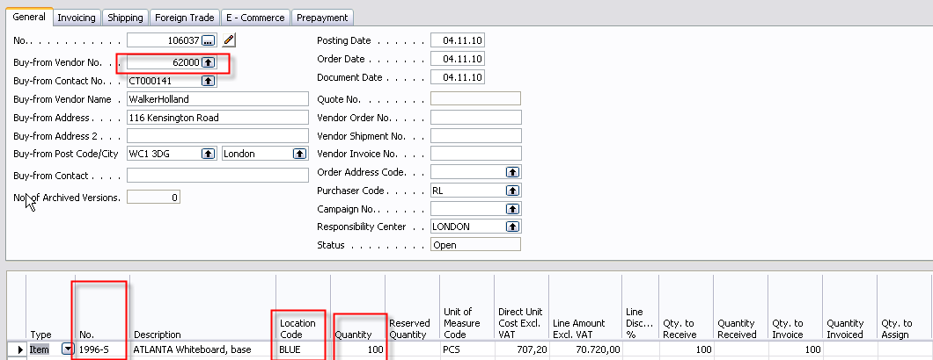

- Enter Vendor Invoice number and post it (F11). Go to the item card 1996-S and by Ctrl- F5 see Item entries and repeatedly by Ctrl-F5 you will get to Value Entries (položky ocenění)
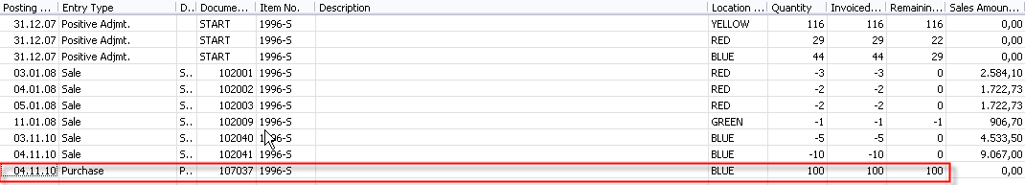
and
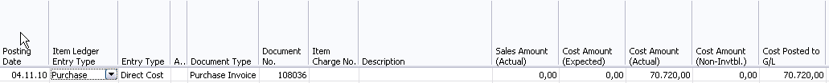

- You create new Purchase order – you have to pay transport of 100 items purchased recently. The order (invoice) is issued by hauliers. Instead of use Item typu in the purchase lines you will choose by F6 Item charges. Next filed – number by use of F6 you will choose type of the Item charge. Enter 100 miles and price for 1 mile.
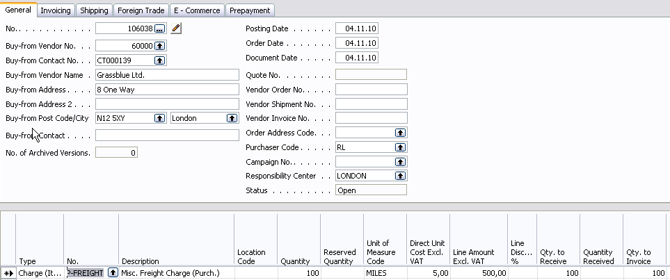

- You have to assign this charge to already created and posted purchase line with 100 items. So go to the button Line and choose Item charge assignment . You will get
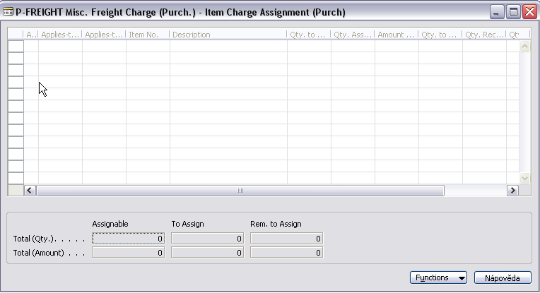

- Go to th button Functions and find already posted document (by use of Get receive lines) an OK:
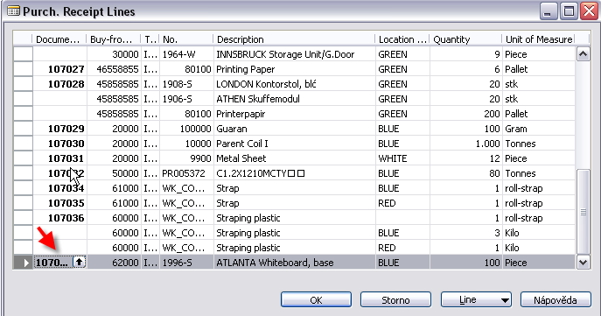
- Again use Function button and Suggest Item Charge Assignment :
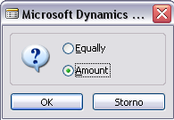
Make a choice – will be explain during tutorials – and you will get :
Assignment cab be done also manually
- Post Purchase order an go to the Item card 1996-S and by Ctrl- F5 see Item entries and repeatedly by Ctrl-F5 you will get to Value Entries (položky ocenění) :
