Cvičení –Analýzy prodeje (Exercise Sales Analysis)
Vytvořil (created) : Skorkovský
Datum (date) : 2.11.2010
Charakter (type) : draft

- Menu from where you can start

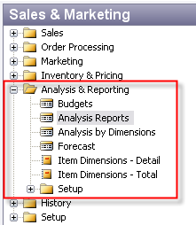

- Open Analysis report and make a choice of Analysis report name, which determines used lines and column templates . Then enter also start and end date (time interval from which the related entries will be used)
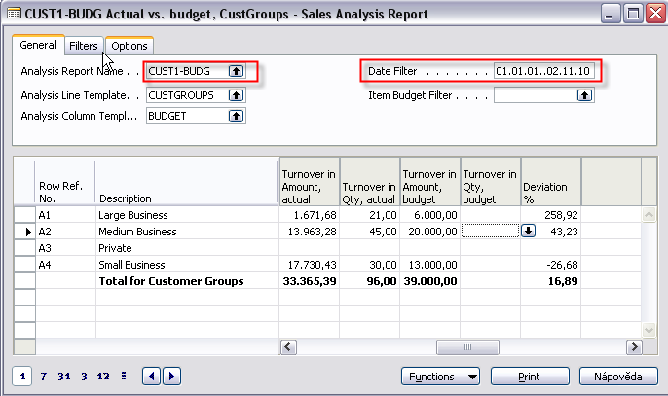
- Let´s go to setup of the analysis line templates and make a choice of My Customers :
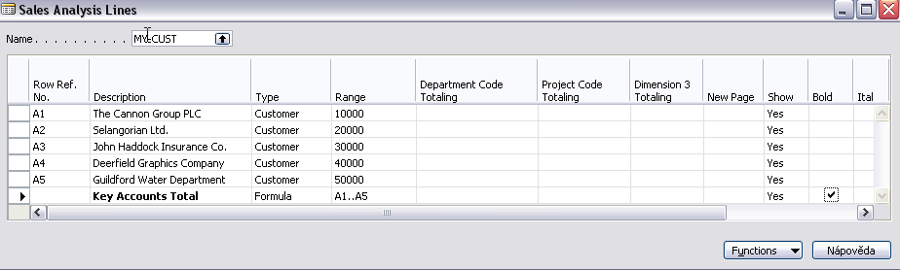
By use of button Function you can add items, group of items, customers of group of customers. Row Reference ID is a variable, which have to be inserted by the user.

- Let´s go to setup of the analysis column templates and make a choice of Profit :
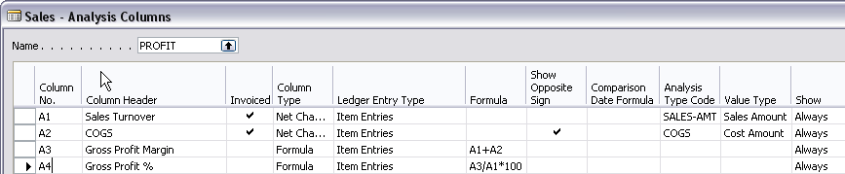
First column have a similar meaning as lines one. Invoiced columns means, that you can see (these entries will be used for calculations) only invoiced type of entries. Columns type is same as it was explained in chart of account. Ledger entries might be Item entries or Item budget Entries (used to compare business plan to reality). Type Formula is use to calculate what you want to see. Analysis Type Code and Value Type you can get by F6 key specify chosen value type and area from where these values are taken (cost amount, sales amount and so on).

- From menu Analysis Line Template you will get :
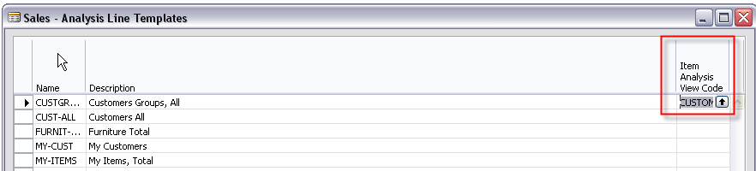
- By F6 from Item Analysis View Code you will get :
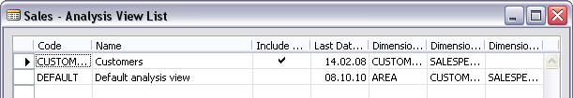
which is used to setup dimensions form the bottom of this window you will (button Analysis->Card) you will get :

- Sales Analysis view card :
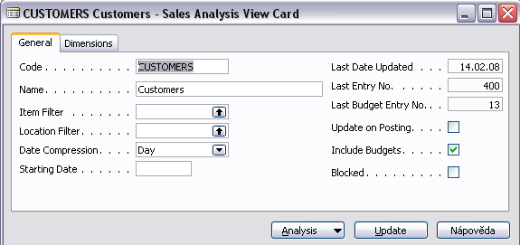
Use Update button to update a set of entries which will be analysed :
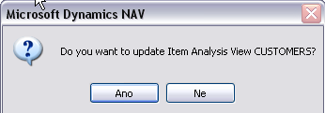
and you can see the update effect marked by red frame (400->598 entries integrated for analysis)
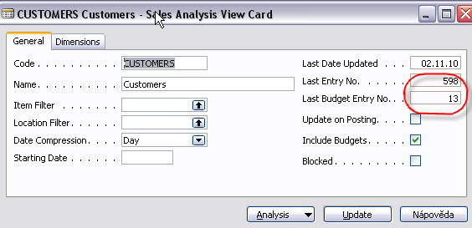

- If you change Analysis repro name to item sales you will get :
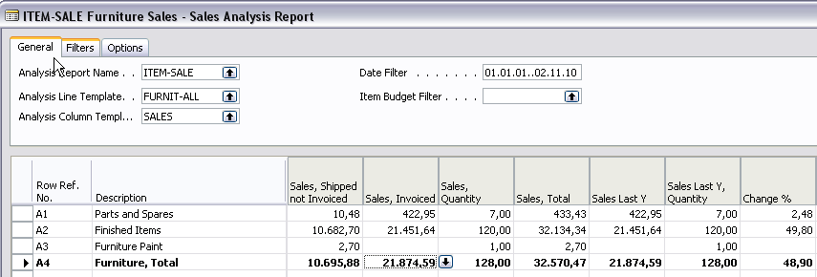
You should be aware of column setup (Sales) in order to see sales this year and last year:
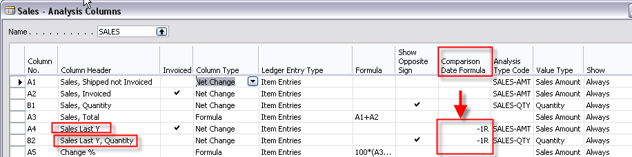

Small exercise:
- Sales budget setup :
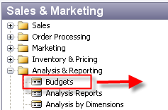

- You will get this window :
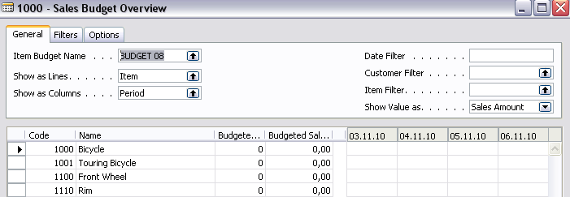
- From Item Budget Name by use of F6 (look up) you will open this window :
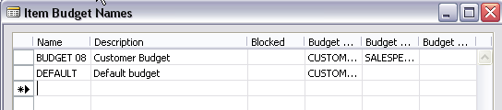
- Go by cursor to the next empty line and create a new budget name (e.g. Budget 10). By use of F6 you may choice predefined dimension codes (e.g. AREA or Salesperson)
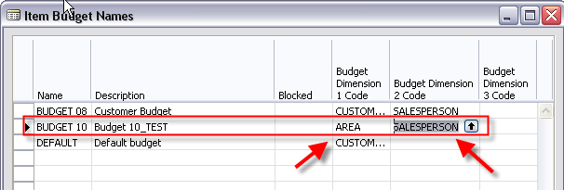
- When you enter created Item Budget Name Budget10 and enter by use of F6 new lines (e.g. Customer) and Show value as Sales Amount (by F6). Then you enter expected Sales amount to chosen date fields and you will get :
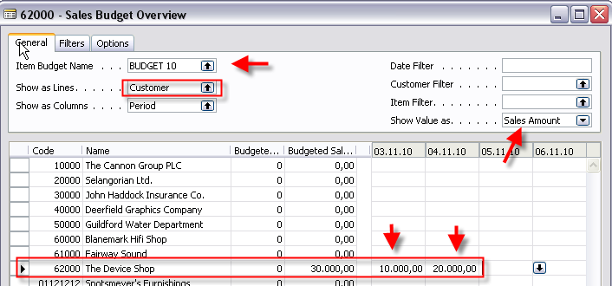
- Setup of the budget represents a business plan as far as sales amount is concerned. Then you should create one or two sales order for the customer 6200 and related dates (in our example 3.11.20101 and 4.11.2010.) Try to sell something (Items) with lower amount that this entered in the budget (e.g. around 5000 at 3.11. and 7000 at 4.11.). You can check the total amount on order by F9 (Statistics). You will get these Customer ledger entries (from Customer card 6200 and Ctrl-F5) .
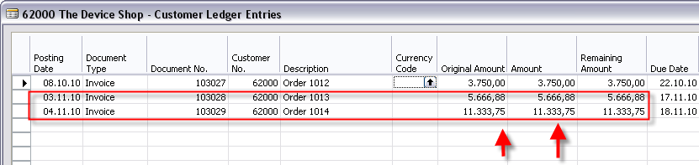
- Before you will start analysis you should go to Setup->Analysis Line Templates and you will get :
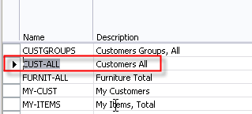

- You will for our small exercise make a choice CUST_ALL. From the above window you will go by use of button Lines to the window where you can see, that our customer 6200 from where we have setup budget belongs to the group Outlet
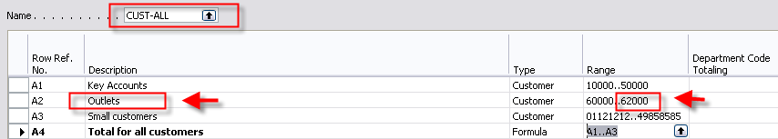

- Go to Analysis->Analysis Report and enter data to the fields in the analysis header as it is visible in the next window :
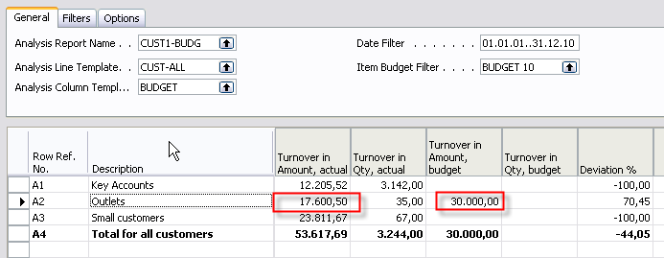
- From the matrix fields in the Analysis (Data area - see explanation in the picture at the beginning of this material) by F6 you can see from the field Turnover Amount in budget entered Budget Ledger Entries and from Turnover in Amount Actual you will get Customer Ledger Entries related to the posted orders:
and

