MPH_AOMA (Enterprise Resource Planning Systems) – questions 2010
Created by : J.Skorkovský, KPH ESF MU BRNO, Czech Republic ; 1730@mail.muni.cz;skorka@cmail.cz
Date : 1.12.2010
Version : I.

All questions could be studied with the help of related study materials handed over to students during lessons.

Resources:
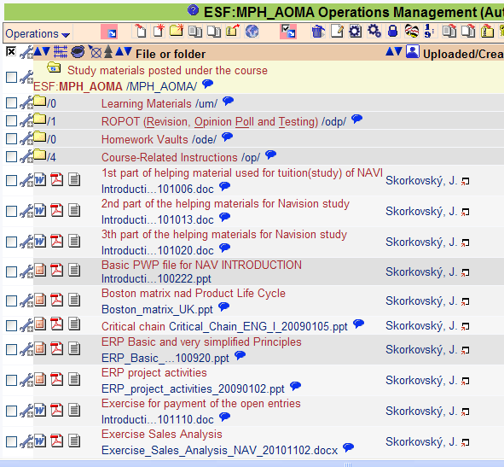
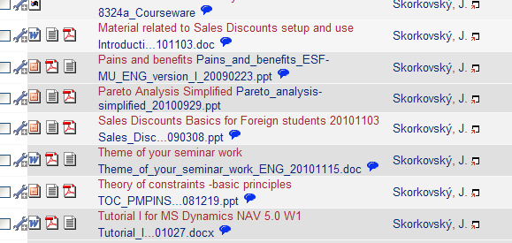

And resources stored at 1.12.2010 such as
- Applying principles
- Ishikawa fishbone diagram
- DBR-Drum Buffer Rope (only key chosen slides will be used!!!)

Detail specification taken from above list of stored study materials which have been handed over to students during autumn term 2010

Theory resources

A. ERP project activities _ 20090102
B. Pains_and_benefits_ESF-MU_ENG_version_I_20090223
C. Critical_Chain_ENG_20090105
D. TOC_PMPINSA_English_version_20081219
E. 8324a Courseware for Dynamics NAV Introduction – zip
F1. Short explanation of applying principles (will be presented 01122010)
F2. Boston Matrix and Product Life Cycle
F3. Applying principles MS Dynamics NAV 20090320
G1. Ishikawa fishbone diagram ENG
G2. Drum Buffer-Rope : Theory (chosen slides only !!!! )
G3. Pareto Analysis Simplified

ERP resources (practice)

- Demo version of MS Dynamics NAV 5.0
- 1st Part of Helping material
- 2nd Part of Helping material
- 3th Part of Helping material
- Exercise for payment of the open entries
- Sales discount basic for foreign students (PWP)
- Material related to Sales Discount setup (Intro to MS Dynamics ERP NAV in concise clauses-part four)
- Tutorial for MS Navision NAV 5.0 W1 (Step-by-step Hand On)
- ERP Basic and very simplified Principles (chosen slides only- not the ones with feedbacks)

Theory:

Structure of the theory question:

Number Description : Resource (slides if required )

1. What is required by competitive ERP markets: A, B, F2 (innovation, road map, PLC,..)
2. Name some reason for change the old ERP system: A and B
3. Name key activities of the implementation project (project entries): A
4. What is a Gantt chart: A and C
5. Evaluation of the project result. How we can know, that the Project was successful? : A
6. Which knowledge is necessary for project management? : A
7. Simplified chart (diagram) of ERP functions : A, P
8. What is the profit valley and how to escape from there? : A
9. Specify the basic concept of the Theory of Constraints : D, G2
10. TOC metrics :D
11. Cost World and Throughput World : D
12. TOC five steps: D

13. Basic trees (Thinking process tools) – CRT,EC and FRT : D
14. Project and its budget: C
15. What is bad multitasking? : C
16. Critical path and Critical Chain: C
17. Use of project buffer (buffer management concept) : C
18. Pains and benefits: B
19. Creation of the vision: B (nine steps slide)
20. Ishikawa fishbone diagram: G1
21. Boston matrix and product life cycle- PLC: F2
22. Pareto analysis: G1(end of the slide show) and G3

Practice (resources H-P):

1. Modularity of the ERP systems.
2. Main windows (forms) used in ERP and syntax for Debits and Credits.
3. Users modification of the ERP windows.
4. Main tables (Item, Customer, Vendor and Account).
5. Purchase of an item and impacts of F11 (posting) -> item and vendor entries, G/L entries.
6. Sale of an item and impacts of F11 (posting) -> item and customer entries, G/L entries.
7. What is the applying principles.
8. Payment of the open entry (customer or vendor) by use of the Financial Journal.
9. Discounts and the use of this.
10. Contact card and its profile and use of it.

