Created by : Ing.Jaromír Skorkovský, CSc. MU – ESF – Department of Business Economics
Date : 9.11.2011
Due date : Have to be presented and argued during final exam. The dates of the exams will be
setup during December week starting 5.12.2011.

The reason of chosen deadline (exams) is a necessity to hand over related theories and needed time to write a seminar work.

Expected extent : Minimum 6 pages
Suggestion : 30 % might be description of the used theories, which will be used as a bridgehead for
practical part of the work. The practical part of this 2nd seminar work should have a
character of contemplation ( reflection essay). The reasons of this suggestion is as
follows:

- granted fact, that you did not work with ERP systems so far, so your practical knowledge is obviously negligible
- anyhow, the use of ERP systems in your future professional lives will be undoubtedly your daily routine.

Theory : the material specified bellow touching basics of ERP was already handed over to
Your study materials

Name of the seminar work (suggestion):

The ERP systems (Enterprise resource Planning Systems) as an valuable tool for Operations Management : seminar work

Resources:

1. Study material (see below)
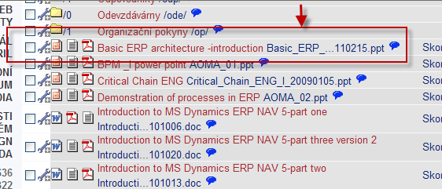

- http://en.wikipedia.org/wiki/Enterprise_resource_planning
- http://www.microsoft.com/dynamics/growyourbusiness/ (helpful inspiration video only)
- http://www.microsoft.com/en-us/dynamics/erp-nav-overview.aspx (see brochures, see next steps – link to resource number 3 above) )
- http://www.microsoft.com/en-us/dynamics/erp-explore-nav-capabilities.aspx (for better inspiration (help) you can download MS Dynamics NAV Product Capabilities Guide)
- Any internet of other resource (books, magazines, journals,…) you will assume as a handy material

Some suggested questions, which may be answered in the seminar work:

- Operation domains where the use of ERP is a must and why it is so (e.g. manufacturing,…)?
- Name some (your opinion) benefits of ERP use (similar as a reason for use specified in clause number 1 above)
- Name some problems (pains), which can be solved by use of ERP and how ERP system and its functions may kill or diminish influences of named pains?
- Name some ERP products you know or you have found by use of internet

