Batch – lot numbers – basic principles
Datum : 26.4.2010
Autor : Skorkovský
Version NAV : MS Dynamics W1 5.0 English
Working date –> 28.2.2010!!!

- Setup of lot tracking on the item card (e.g.. 8920-W). It must be a card without any already item entry !!!! Viz další snímek = see another slide .Dávka vše = All lots =Free Entry

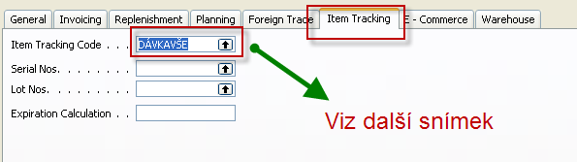

- Sledování určité dávky = tracking of s specified lot

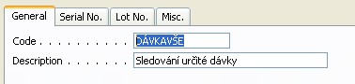

And what and where it has to be specified

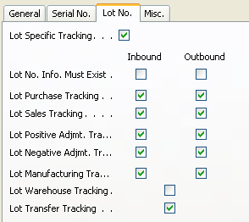

3. Create a new purchase header and lines for specific item (where the lot tracking will be used)

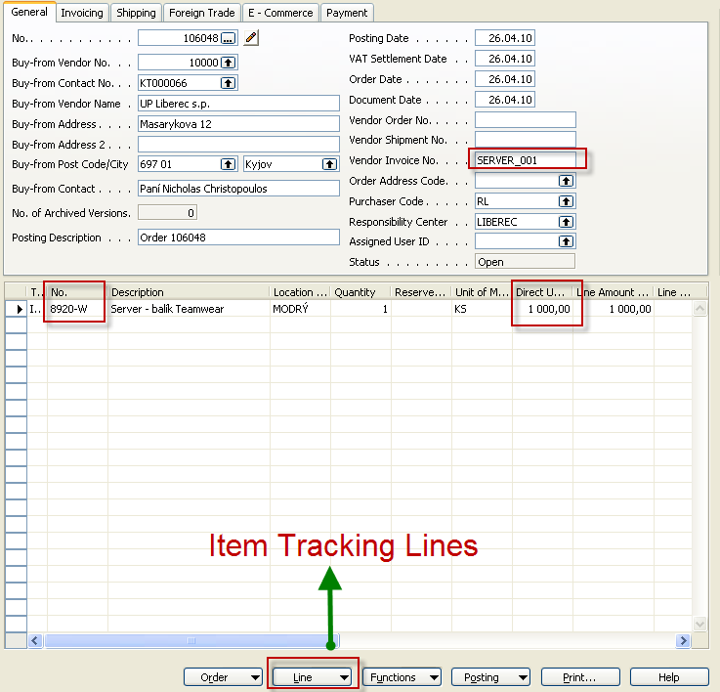

- From the line button and Item tracking line choice you will open a window below and you specify Lot Number code (see green arrow) and enter the required quantity

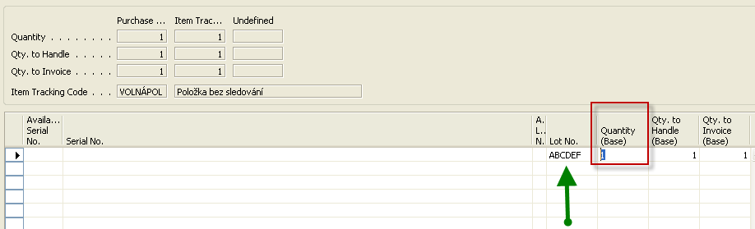

And by use of line you can enter property

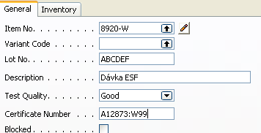

- Post it by F11 and after see item ledger entries by use of key combination Ctrl-F5 (maybe you have to setup some account as specified below)

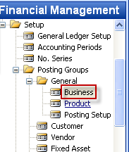

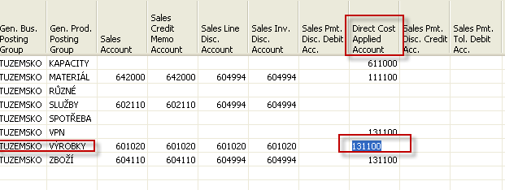

- Item ledger entry (after showing of column Lot No)

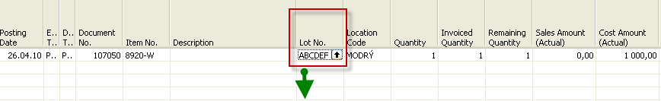

And by use of F6 you will get :

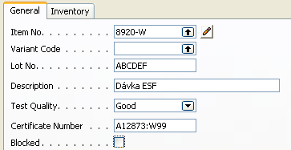

So every item entry is specified uniquely by lot number (batch number) which is for the quality reason and back tracking necessary.

