Basic budgets and analysis – examples and principles
Created by : Skrokovský
Date : 17.4.2009
Reason : EIS (ERP system lessons)

1. Basic principles - see PWP presentation

2. See menu Financial menu and see account 8320 and its G/L entries (Ctrl-F5)

. 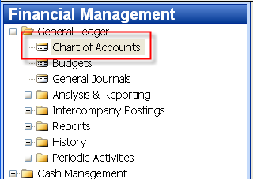

3. 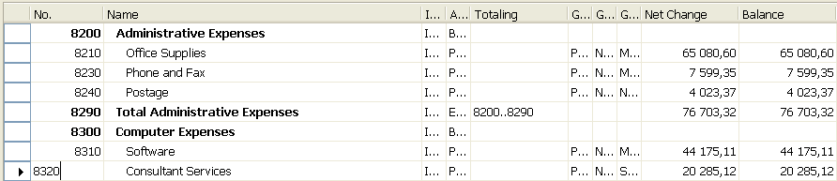

4. G/L Entries

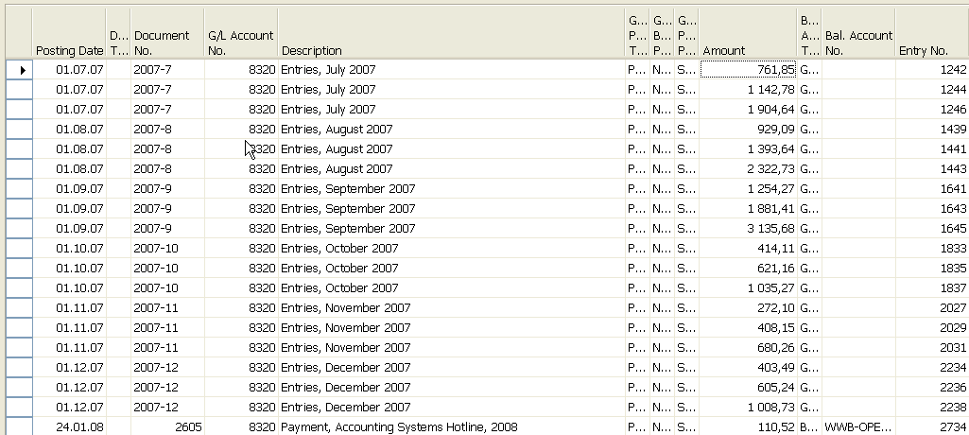

5. Budget menu

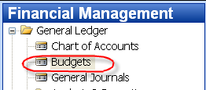

6. Budget form

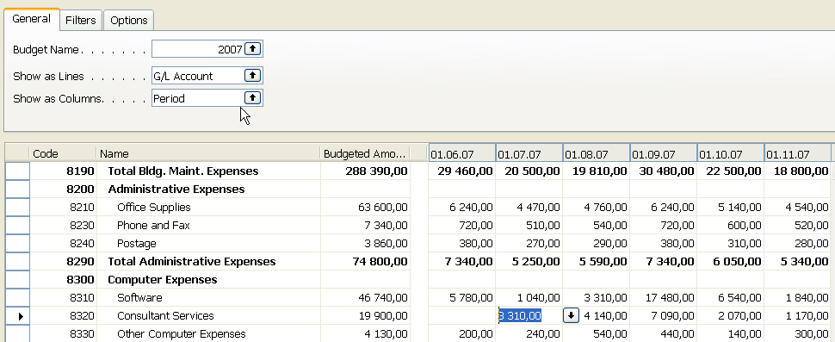

7. Using key F6 you will get forms below, where 660+990+1600 = 3310 for three different dimension (Department codes ADM, PROD and SALES). This is expected expenses (costs) planned for July 2007
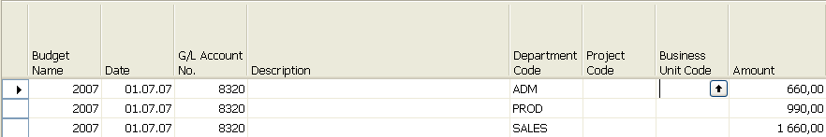

8. What was really posted on July 2007 - use filter below

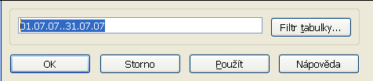

9. G/L Entries of the chosen account:

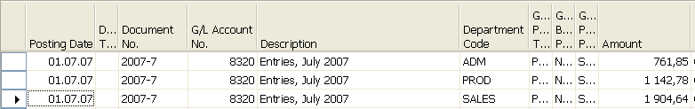

10. Analysis – menu

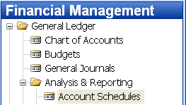

11. From Analysis filed in the header by F6 You will get (see clause 12)

. 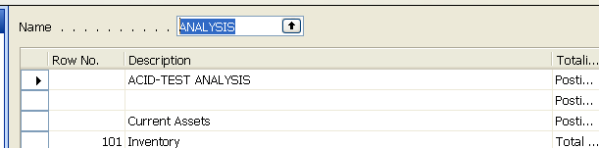

12. You have to enter the data in red frame

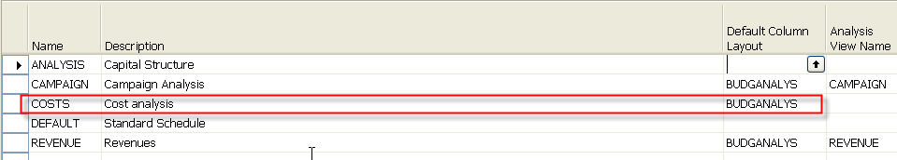

13. You have to enter the data in red frame and thereafter enter by F6 and button
Analysis a new Analysis view card (use also F3-to create a new Analysis view card) :

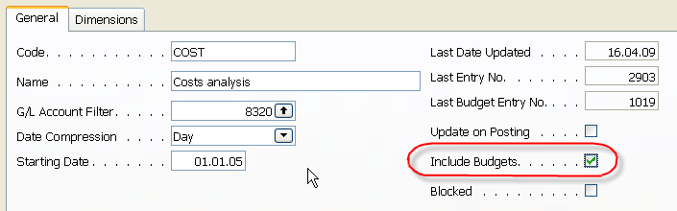

And use update to put under scrutiny all entries (button update):



14. After creation of new Analysis view Card named COSTS 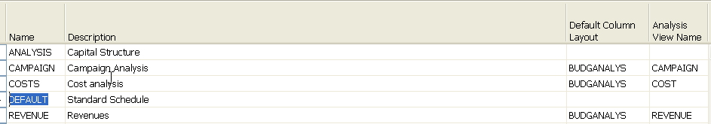

15. Enter new Accounting schedule to the header and add account by use of button Insert Account

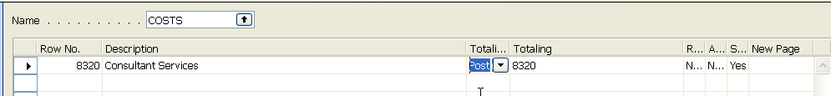

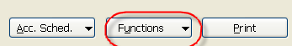

16. Start Accounting schedule using button Acc.Sched.

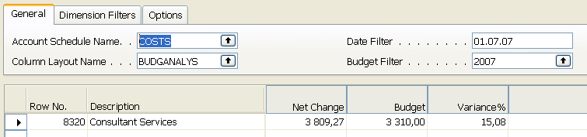

17. If you add to Analysis view card on the Tab dimension a dimension for Department l and you have to do again all the updates by using button Update you will get :

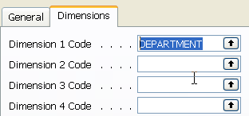

and

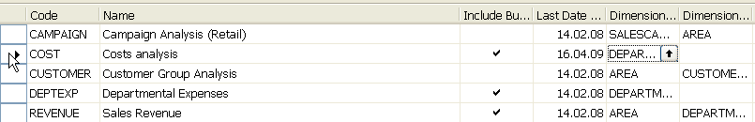

and finally if you apply filter Sales :

