Introduction to MS Dynamics ERP NAV 5.0 SP1 in concise clauses = part three
Created by : Jaromír Skorkovský
Date : 20.10.2010
Reason : Concise instrument helping in tuition and study

Business case II (Simple sales and its impacts)

- Sales and Marketing menu

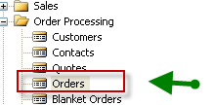

- Use of F3 to cerate new Header and linked empty lines

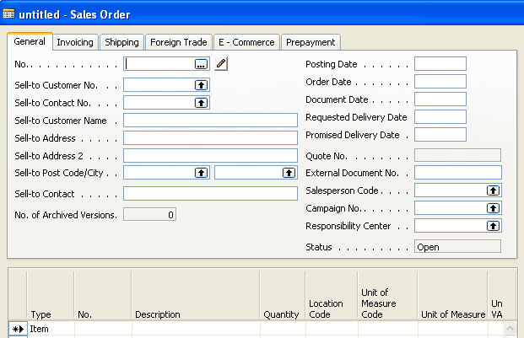

- Use of Enter key You cerate automatically a new document number and from the field Sell-to Customer No. using F6 key you will chose one customer (e.g. 10000)
Confirm by Enter key transfer of the Customer data stored in Customer table, which can be visible in Customer Card . Make scrutiny of the upper right part of the window –information about Sales history and so on.

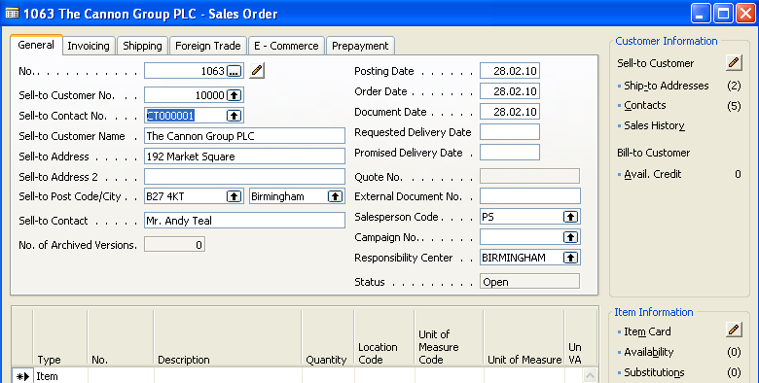

- Go by mouse cursor to the lines and see the type of the line (Item) and then from the field Item by use of F6 (look-up key) you will chose an item. Preferably the same one which was previously in your system purchased.

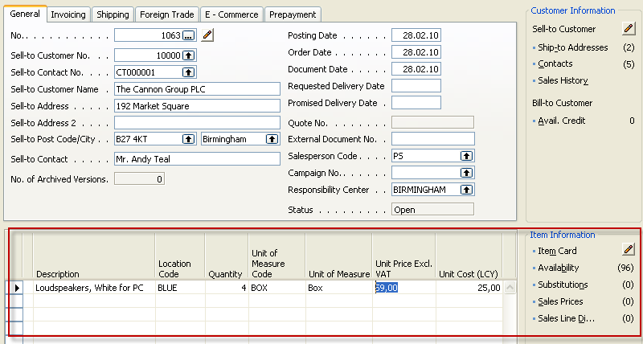

- Make scrutiny of the lower right part of the window –information about Item Card, Availability, Substitution and so on. By use of F9 key (Statistics)You will get

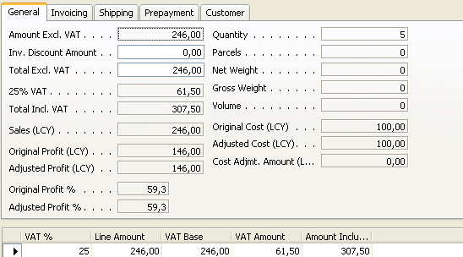

See other tabs of this window and so on…

- Return to the main Sales order by ESC key and You will get :

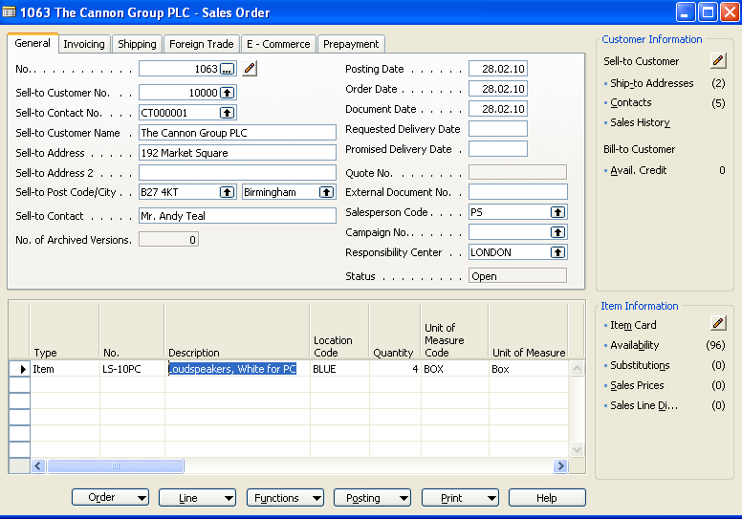

- Make button Print, order Confirmation and Preview and you will get :

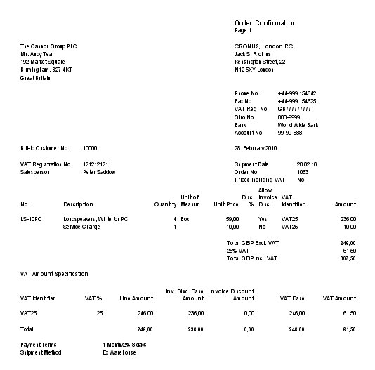

- By use of F11 post it to the DB (make it for Ship and Invoice)

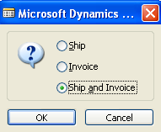

- Go to the Customer Card and make Ctrl-F5 and you will see Customer Ledger Entries.
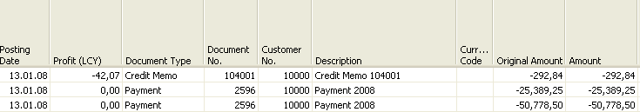

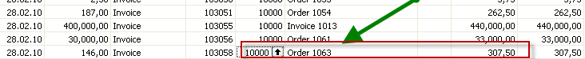

- Go to Financial Management – History-Registers and use by Ctrl-End go to the last line and then button Register and make choice General ledger and you will get

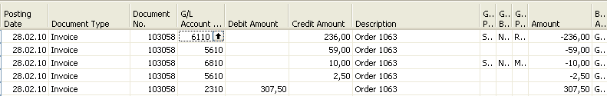
From here by use of F6 go directly to the chart of account please …….

- Go to Item Card (the one used in last Sales Order and make Ctrl-F65 and you will get (see what happened in Quantity, Invoiced Quantity and Remaining Quantity.

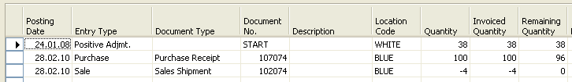

Tutor will explain applying principles

