MPH_AOMA (Enterprise Resource Planning Systems) – questions autumn 2011
Created by : Ing. J.Skorkovský,CSc. KPH ESF MU BRNO, Czech Republic ; 1730@mail.muni.cz;skorka@cmail.cz; jaromir.skorkovsky@navertica.co, tel : +420731 113517
Date : 5.12.2011
Version : I.

All questions could be studied with the help of related study materials handed over to students during lessons held in Brno ( Autumn 2011)

Will be shortly reviewed (explained) during last lessons (7.12.2011). Important parts of below specified questions may be found in your Seminar works.

Resources:

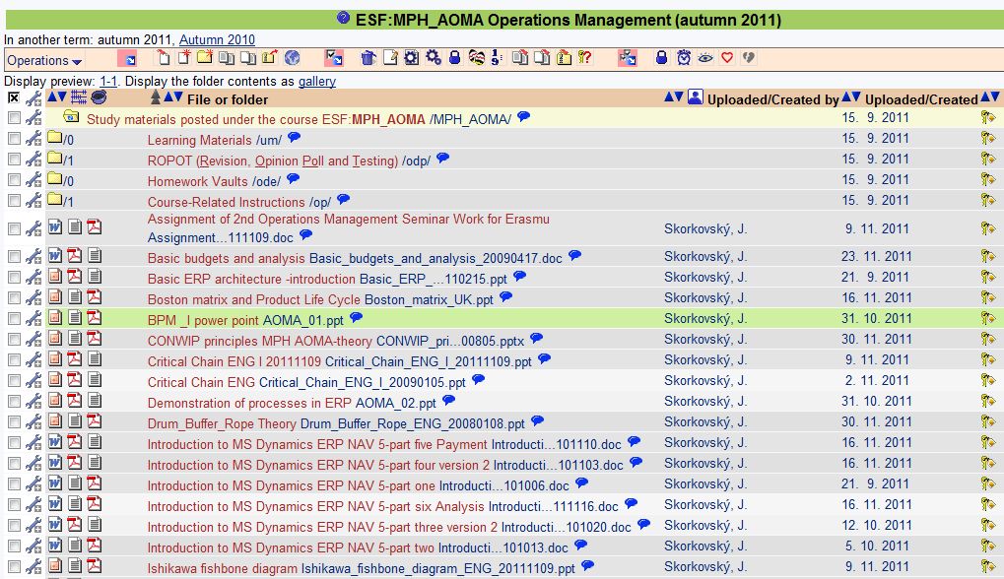
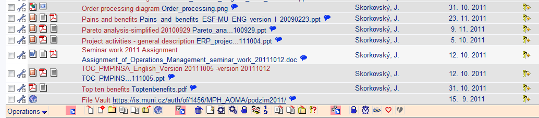

Below listed material (are including in the copy of the student material above as well ) have to be used for MS Dynamics NAV 5.0 studies. Mind you, that access to ERM system MS Dynamics NAV 5.0 ENG version is possible in both public computer rooms.

Introduction to MS Dynamics ERP NAV 5-part one
Introduction to MS Dynamics ERP NAV 5-part two
Introduction to MS Dynamics ERP NAV 5-part three selling : simple business case
Introduction to MS Dynamics ERP NAV 5-part four
Introduction to MS Dynamics ERP NAV 5-part five

Applying principles MS Dynamics NAV (which is not visible in the above listing and was uploaded to the study material 5.12.2011).

Sales discount basics (will be presented concisely 7.12.2011) and it is not visible in the above listing and was uploaded to the study material 5.12.2011).

Basic ERP diagram (purchase-sales) – PWP (which is not visible in the above listing and was uploaded to the study material 5.12.2011).

Listing of Theory Resources – will be used below to show you mapping knowledge -resources

A. ERP project activities _ 20090102
B. Pains_and_benefits_ESF-MU_ENG_version_I_20090223
C. Critical_Chain_ENG_20090105
D. TOC_PMPINSA_English_version_20081219
E. Short explanation of applying principles
F2. Boston Matrix and Product Life Cycle (PLC)
F3. Applying principles MS Dynamics NAV 20090320
G1. Ishikawa fishbone diagram ENG
G2. Pareto Analysis Simplified
- Basic Budget and Analysis

ERP Resources (practice)

- Demo version of MS Dynamics NAV 5.0 W1
- 1st Part of Helping material
- 2nd Part of Helping material
- 3th Part of Helping material –selling (simple business case)
- Sales discount basic for foreign students (PWP)
- Material related to Sales Discount Setup (Intro to MS Dynamics ERP NAV in concise clauses-part four)
- Tutorial I for MS Navision NAV 5.0 W1 (Step-by-step Hand On)
- ERP Basic and very simplified Principles (chosen slides only- not the ones with feedbacks)
- Basic ERP Architecture
- 4th part of Helping material
- 5th part of helping material (Exercise for payment of the open entries)

Theory Questions (resources A-H):

Structure of the theory question:

Number Description : Resource (slides if required )

1. What is required by competitive ERP markets: A, B, F2 (innovation, road map, PLC,..)
2. Name some reason for change the old ERP system: A and B
3. Name key activities of the implementation project (project entries): A
4. What is a Gantt chart: A and C (your seminar works)
5. Evaluation of the project result. How we can know, that the Project was successful? : A, C and your seminar works
6. Which knowledge is necessary for project management? : A ,C
7. Simplified chart (diagram) of ERP functions : A, P
8. Specify the basic concept of the Theory of Constraints : D, G2
9. TOC metrics : D
10. Cost World and Throughput World : D
12. TOC five steps: D
13. Basic trees (Thinking process tools) – Current Reality Tree, Evaporating Cloud Tree and Future Reality Tree: D
14. Project and its budget: C
15. What is bad multitasking? : C
16. Critical path and Critical Chain: C
17. Use of project buffer (buffer management concept) : C
18. Pains and benefits: B
19. Creation of the vision: B (nine steps slide in the PWP presentation B
20. Ishikawa fishbone diagram: G1
21. Boston matrix and Product Life Cycle ( PLC) : F2
22. Pareto analysis: G1 (end of the slide show) and G3

Practice Questions (resources I-S) – not valid for the Erasmus students studying during Autumn term 2011 in Bratislava:

1. Modularity of the ERP systems.
2. Main windows (forms) used in ERP and syntax for Debits and Credits (posted General Ledger Entries
3. Users modification of the ERP windows (Hide and Show column, moving column)
4. Main tables (Item, Customer, Vendor and Account).
5. Purchase of an item and impacts of F11 (posting) -> item and vendor entries, G/L entries.
6. Sale of an item and impacts of F11 (posting) -> item and customer entries, G/L entries.
7. What is an applying principles.
8. Payment of the open entry (customer or vendor) by use of the Financial Journal.
9. Discounts and the use of this.
10. Contact Card and its profile and use of it.

