Introduction MS Dynamics NAV - Purchase process with process diagrams
Written and modified by : Skorkovský
Main resource : MS Dynamics NAV course 80043
Date : 2.10.2013
The main objectives are:

- Outline a complete purchase process and how it connects to other
application areas.

- Set up a new vendor by filling in a vendor card (or take any of already existing ones e.g. 10000)
- Create, post, and review purchase orders (Header, Line(s) with Item(s) and other parameters)
- Process the receipt and invoicing of inventory items.
- Create, post, and review purchase invoices.
- Process the purchase of non-inventory goods or services with
purchase invoices (by use of account with direct posting field checked)
- Plan and make payments to creditors (later in this course)
- Use the Suggest Vendor Payments function (later in this course)
- Adjust general ledger entries with the general journal.
- Use general journal registers to follow the audit trail of all
transaction types.

Microsoft Dynamics® NAV 2009 supports all typical tasks and information needs
related to managing purchases and payables, an essential business area in all
companies. Basic purchasing concepts are introduced by illustrating the complete purchase
process flow and its integration to other application areas. The successful operation of managing purchases and payables involves examining the complete purchase process flow and its integration to other application areas. After following the demonstrations and doing the labs in this chapter, the student is well equipped to discuss the program's core purchasing functionality and to
perform the basic tasks covered.

The program's purchasing features are tightly integrated with all related business
application areas of the program. The figure illustrates how purchase orders
interrelate to other typical supply chain application areas to compile item
transactions in the general ledger (G/L).

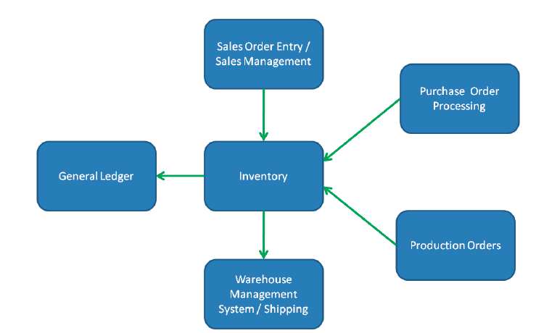

Notice that the production and sale of items have similar effects on inventory and
the G/L as does purchasing. The G/L works as the data collection point for the entire system, while a minimal amount of data flows back in the opposite direction. Much data also flows
horizontally between master data records and documents of different application
areas, for example, when an item is added to a purchase line.

Process Flow

illustrates the process performed in typical purchases and payables tasks and the
impact they have on other application areas.

