Introduction to ERP MS Dynamics NAV concise clauses = part seven:Pareto Analysis
Created by : Jaromír Skorkovský
Date : 7.11.2013
Reason : Concise instrument helping in tuition and study
Accompanying mat. : no

Analysis

- Basically in ERP system you create document such as Sales orders, Purchase orders, Production orders, Credit Notes and so on. You register to the database all transaction connected to these documents by pressing F11. Then you create Item Ledger Entries, Customer Ledger entries, Dimension Entries, Vendor Entries, Value Entries, General ledger Entries an many, many more. In order to get out of these records the reasonable reports you need a simple tool in order to create an easy reports. The following example will show you how to get out of it data which can be used to mark by code A,B and C our business partner. This segmentation is necessary in order to support different group of our business partners. Pareto analysis is also called ABC analysis ( do not mixture with Activity Based Costing please). This explanation follows another material (Pareto Analysis simplified which was uploaded to study material).So it is not intended to explain what does mean Lorenz Curve of ratio 80|20.

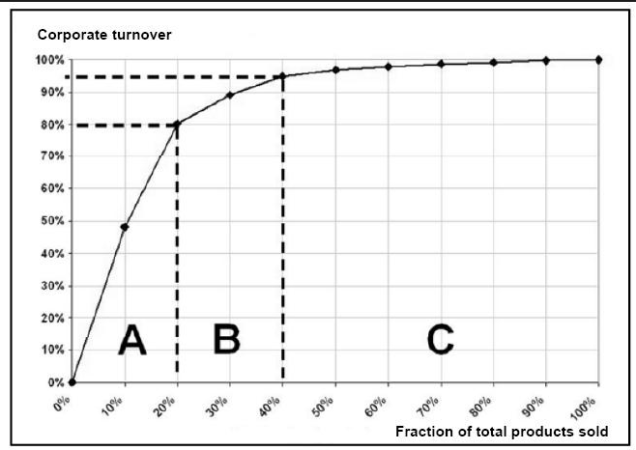

2. Go to Sales and Marketing ->Marketing and setup ->Profiles
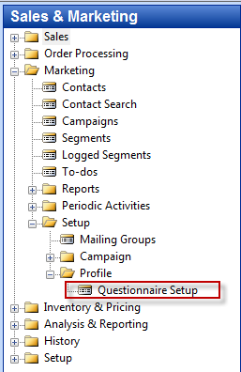

- From there you can open below already created questionnaires , which were explained during practical lessons. On questionnaire example which depends on the chosen Profile questionnaire code in upper part of the window is stated below :

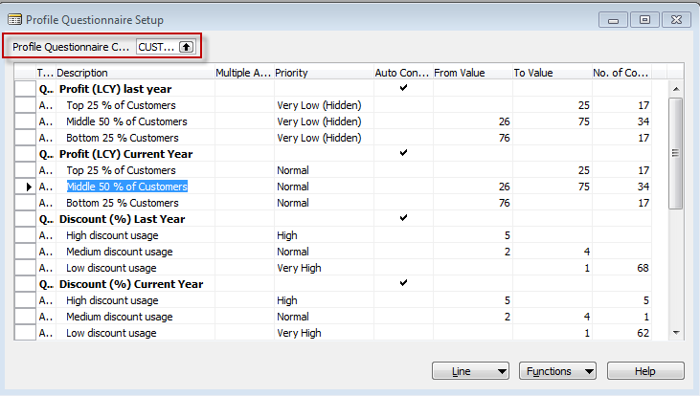

- Go by F6 or mouse to upper filed (marked by res color and open it. Go down and create new code and a name of the new questionnaire (e.g. Pareto and Pareto analysis as it is shown below. You have to setup by F6 and Entre key also a type of the business relation code of the partner –Company and CUST (which means code for Customer). After setting a line (either at the end of this list or by use of F3 (new) push button OK bellow :

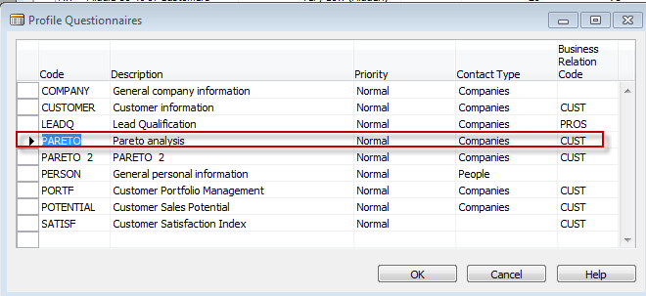

- In the window below you have firstly modify a property of the question by pushing button line but before you have to choose the type of the first line as Question . After you push Line enter details of the question as it is shown below :

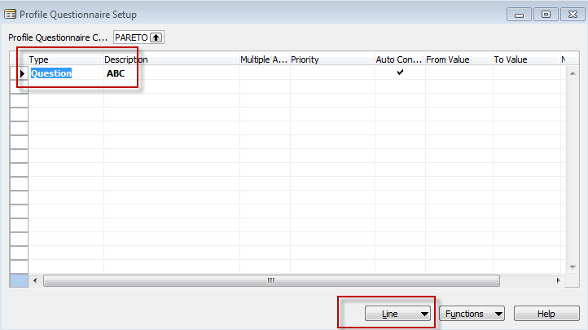

And details setting (by use of F6 -> the values of the fileds can be optional) :

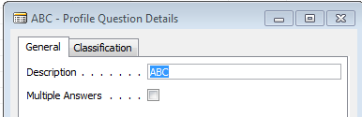 and

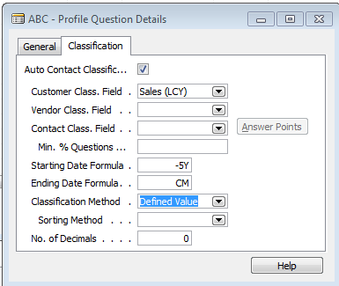

The detail of the question means, that you have to scrutiny all issued invoices from the time five years ago til the and of the current month.
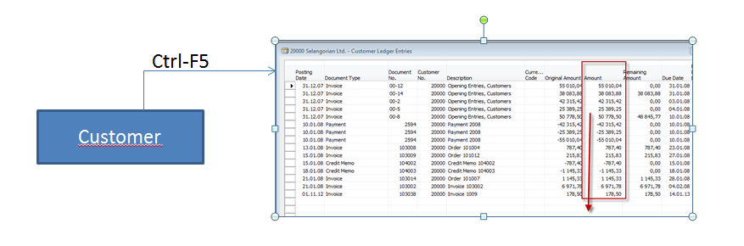

- Than you enter three lines for A, B and C type of the customer and limits of the sales sums which represent more and less type of the ABC specification . After entering limits for Sales you push Function and Update classification) .When you go back to the columns No of Customers and you put a cursor there you will get a number of customer which belongs to the specification (from amount –to amount ) :

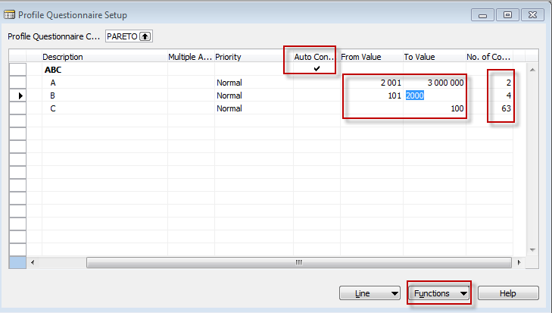

- By use of F6 form the field No of Customer you will get to the list of contacts and if you open one of them by going to contact number , F6 and from there going to the contact card by Shit-F5 you will get :

