MPH_AOMA (Enterprise Resource Planning Systems) – questions autumn 2013
Created by : Ing. J.Skorkovský,CSc. KPH ESF MU BRNO, Czech Republic ; 1730@mail.muni.cz; miki@econ.muni.cz; jaromir.skorkovsky@navertica.co, tel : +420 731 113 517
Date : 04.12.2013
Version : I.

All questions could be studied with the help of related study materials handed over to students during lessons held in Brno ( Autumn 2013) – till 11.12.2013 all in all 13 session

Will be shortly reviewed (explained) during last lessons (probably on 4.12.2013). Important parts of below specified questions may be found in your assigned Seminar work.

Resources:

 and see below copied list fro Study material.

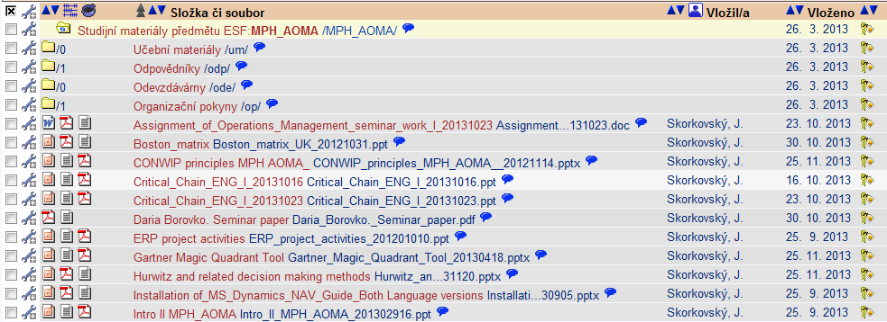
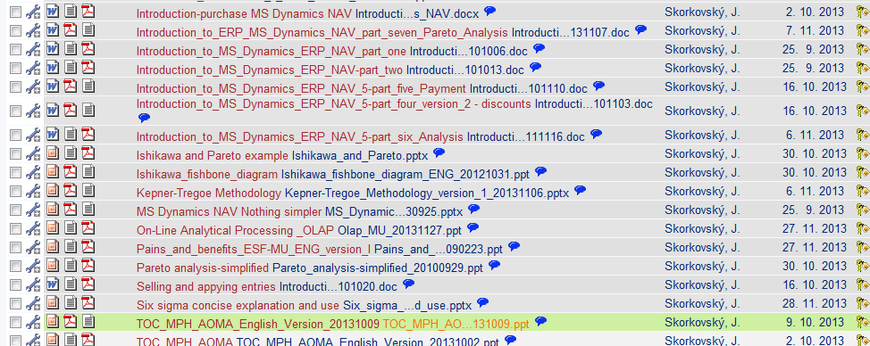

Below listed material (are including in the copy of the student material above as well) have to be used for MS Dynamics NAV 5.0 studies. Mind you, that access to ERP system MS Dynamics NAV 5.0 ENG version is possible in all public computer rooms.

Introduction to MS Dynamics ERP NAV 5-part one
Introduction to MS Dynamics ERP NAV 5-part two
Introduction to MS Dynamics ERP NAV 5-part three selling : simple business case
Introduction to MS Dynamics ERP NAV 5-part four
Introduction to MS Dynamics ERP NAV 5-part five
Introduction to MS Dynamics ERP NAV 5-part six (Analysis)
Introduction to MS Dynamics ERP NAV 5-part seven (Pareto analysis) uploaded 7.11.2013

Basic ERP diagram (purchase-sales) – PWP (which was uploaded to the study material 4.12.2013).
Introduction PWP ERP Basic and very simplified principle - basic architecture. Slides 2-6 containing NAV screens->will be in similar way explained by PWP presentation NAV Nothing Simpler – the latest version with date at the and 20130903 (uploaded 4.12.2013) from slide 32-49- Purchase order.

Seminar work student´s presentations was successfully presented.

Entities which were presented during lessons and which comprises basic elements for the questions.

ERP (NAV): relations between tables, What is the table, Short Hands (F3, F5, F6, Ctrl-F5, Shift-F5 and impacts of use of these key combination), working area (where you can see data)

Cards, Form types, Searching Engine, Purchase Order (further PO) a Sales Order (further SO) creation,
Lists of items, customers and vendors and a meaning of it, F3, F5, F6, F7, Ctrl-F5 and Shift-F5, headers and lines as the basic structure of NAV documents, Availability of Items, History of the Customer, Overdue warning, register in financial management

ERP (NAV): Selling and purchasing processes and its impacts to General Ledger (G/L Entries) and Item Ledger and Vendor and Customer Ledger. How to access and what is the main role and use of these data records.

ERP (NAV): CRM->Pareto analysis, Profiles of the company and person.

Purchasing and Selling->Applying principles. What is CRM.

ERP (NAV): Payment by use of Journals, Vendor and Customer applying, Transfer of an amount from one account to another, cancelling (reverse) transactions.

ERP (NAV): analysis and its setup and use of it. Resource data for analysis, line and columns templates and basic principles of setup. Matrix structure of the analysis output. Export calculated data to Excel

Listing of Theory Resources – will be used below to show you mapping knowledge -resources (see copy of the Study material list above)

A. ERP project activities
B. Pains and benefits ESF-MU_ENG_version_I
C. Critical Chain ENG –your knowledge was trained due to working out of seminar works
D. TOC_PMPINSA_English_version 20121017
E. Boston Matrix and Product Life Cycle (PLC)
F2. Ishikawa fishbone diagram ENG
G. Pareto Analysis Simplified
- CONWIP principles
- Drum Buffer Rope Theory
- Hurwitz criterion and related decision making methods
- Kepner-Tregoe Methodology
- On-line analytical processing
- Gartner Magic quadrant
- Very Basic principles of Six sigma method

ERP Resources (practice)

- Demo version of MS Dynamics NAV 5.0 W1
- 1st Part of Helping material
- 2nd Part of Helping material
- 3th Part of Helping material –selling (simple business case)
- Basic ERP diagram Purchase- Sales uploaded 04.12.2013
- Basic ERP Architecture
- 4th part of Helping material
- 5th part of helping material (Exercise for payment of the open entries)
- 6th part of helping material (Analysis)
- MS Dynamics NAV Nothing Simpler where latest version was uploaded 04.12.2013.
- 7th part of helping material (Pareto analysis and NAV CRM profiles)

Theory Questions (resources A-K):

Structure of the theory question:

Number Description : Resource (slides if required )

1. What is required by competitive ERP markets: A, B, E (innovation, road map, PLC,..)
2. Name some reason for change the old ERP system: A and B
3. Name key activities of the implementation project (project entries): A
4. What is a Gantt chart: A and C (your seminar works can be used as well)
5. Evaluation of the project result. How we can know, that the Project was successful? : A, C and your seminar works
6. Which knowledge is necessary for project management? : A ,C
7. Simplified chart (diagram) of ERP functions (using feedback, entries, decisions,..) : A, P
8. Specify the basic concept of the Theory of Constraints : D, (C)
9. TOC metrics : D
10. Cost World and Throughput World : D
12. TOC five steps: D
13. Basic trees (Thinking process tools) – Current Reality Tree, Evaporating Cloud Tree and Future Reality Tree: D
14. Project and its budget: C
15. What is bad multitasking? : C
16. Critical path and Critical Chain: C
17. Use of project buffer (buffer management concept) : C
18. Pains and benefits (examples): B
19. Ishikawa fishbone diagram: F2
21. Boston matrix and Product Life Cycle ( PLC) : E
22. Pareto analysis: G
23. Use of Kepner-Tregoe methodology (how to make e decision-e.g. cars): K
24. Basic principles of Hurwitz Criterion : J
25. Basic principles of CONWIP production philosophy : H
26. Basics of OLAP (business intelligence tools)- L
27. Basics of Six Sigma method - N

Practice Questions (resources O-Y)

1. Modularity of the ERP systems (name and explain basic modules)
2. Main windows (forms) used in ERP and syntax for Debits and Credits (posted General Ledger Entries)
3. Users modification of the ERP windows (Hide and Show column, moving columns)
4. Main tables (Item, Customer, Vendor and Account) and relations between tables (Look-Up)
5. Purchase of a chosen Item and impacts of F11 (posting) -> Item and Vendor entries, G/L
entries
6. Sale of a chosen Item and impacts of F11 (posting) -> Item and Customer entries, G/L entries
7. Explain applying principles (General ledger and Item ledger) - what is an open entry ?
8. Payment of the open entry (Customer or Vendor) by use of the Financial Journal
9. Contact Card and its profile and use of it (Marketing - CRM section)
10. Explain and show Inventory Location and bins, Show and explain Transfer Order
11. Show chosen example (lines and columns) of Sales Analysis and explain the use of it (benefits of using these reports)

