**5b. Google Buses and san francisco congestion**

In 1998, Lary Page and Sergey Brin, two students in Stanford University, created Google, currently the most-used search engine (67% of web users) in the world.

Many young people want to work at Google because it has a good image as a place to work. Google is known to take considerable interest in the welfare of its employees.

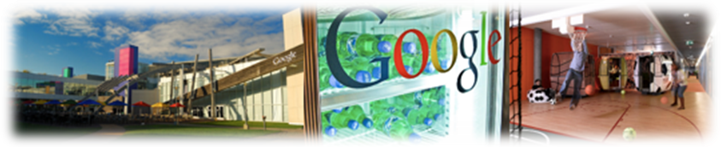

In addition, Google wants to keeps its employees, so the company wants to look like an employee « home, » e.g., you can bring your pets with you to work. There are also steam-pressing, a hairdresser, a dentist, a doctor, permitting employees to minimize lost work time.

However, Google knows some troubles because it and other Silicon Valleny high tech companies are causing a form of « class warfare » in San Francisco.

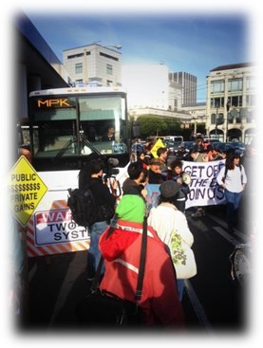

In 2007 launched a network of 32 buses to bring Google employees living in San Francisco to its headquarters in Mountain View, 30 miles south in the center of Silicon Valley. The buses are very comfortable with wifi, and use San Francisco Municipal Transit Agency (SFMTA) city bus stops to pick up Google employees.

Many citizens of San Francisco see negative consequences in this transportation network. Over a recent 2-day period, local critics blocked Google buses to show their displeasure.

From the point of view of the protesters, the employees of Google represent the “gentrification” of the city. By becoming established in San Francisco, Google is attracting another kind of inhabitants that increase the level of income and vitality of the city but also increase the cost to own or rent housing. Critics also say the company should have paid to use the SFMTA network, so as to not appear as an enterprise that only takes advantages of the city.

To avoid new conflicts, starting in July 2014, Google shuttles will pay to use San Francisco´s SFMTA public bus stops $1 for every stop they make to the SFMTA. Furthermore, to avoid any traffic snarls caused by conflicts between SFMTA and Google buses, the new Google shuttles will have a GPS to be able to facilitate easier traffic flow.

**Question:**

1. **How would you define Google’s social responsibility in terms of its impact of:**
2. **its buses on traffic in San Francisco?**
3. **the gentrification of the city?**

*This case was prepared by Florence Lassalette, a student at Masaryk University, under the direction and with the assistance of Professor Earl Molander."*