MPH_AOMA (Operations Management) – questions Autumn _ Winter 2014
Created by : Ing. J.Skorkovský,CSc. KPH ESF MU BRNO, Czech Republic ; 1730@mail.muni.cz;skorka@cmail.cz; jaromir.skorkovsky@navertica.co, miki@econ.muni.cz , tel : +420 731 113 517
Date : 19.11.2014
Version : I.

All questions could be studied with the help of related study materials handed over to students during lessons held in Brno (Autumn-Winter 2014)

Will be shortly reviewed (explained) during last one of the last lesson (26.11.2014 or 3.12.2014) taking into consideration, that date 10.12.2014, 16.12.2014 and 17.12.2014 is so far assigned date for the final exams. Important parts of below specified questions (TOC and CCMP) may be found in your Seminar works, which was as assigned to you, handed over, presented and defended and remarked (revised) by your tutor.

Resources (actual to 19.11.2014). It is expected, that some files will be added later (26.11. and 3.12). These files will be related to MS Dynamics NA Analysis and Accounting schedules as far as ERP system is concerned and some theoretical passages mentioned below (marked by characters L and M). If these files will not be uploaded and subsequently presented the questions related to these files will be not examined (Theoretical questions 15 and 22)!!!!!!
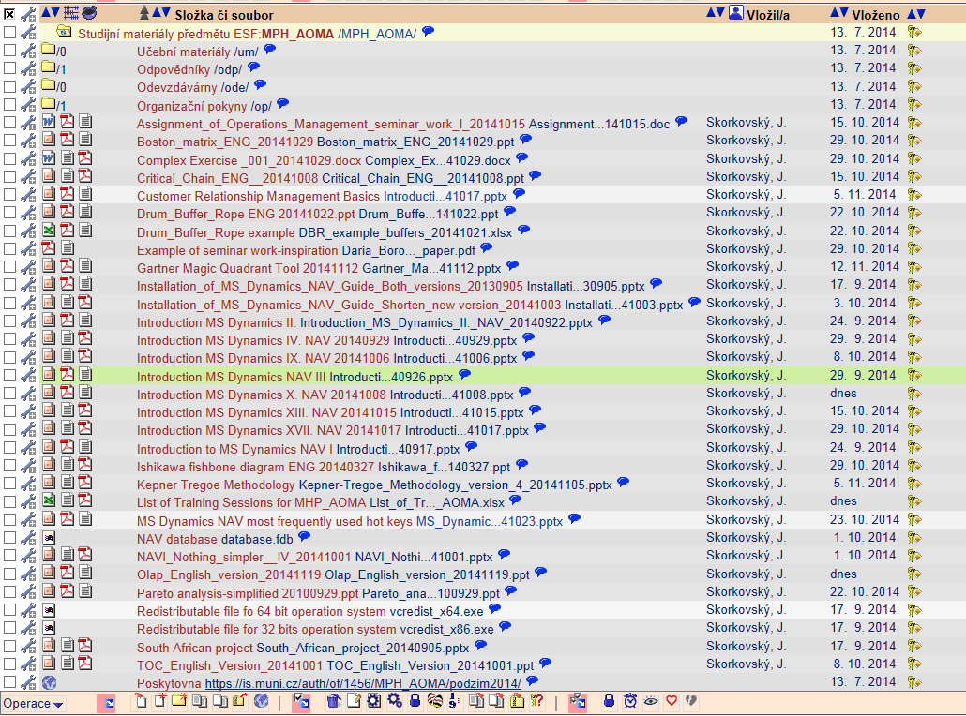

Below listed material, which can be accessed from your study material above as well, have to be used for MS Dynamics NAV 2009 studies.
Mind you, that access to MS Dynamics NAV 2009 English version (British local currency) is possible also in public computer rooms! Copy of the below table is also part of your study materials. From this table mentioned below it is visible and clear which passages (TSx) were trained and shown during MS Dynamics NAV system hands on seminars. Training session marked by yellow colour will be handed over next on 19.11., 26.11. and 3.12.2014. Some of the TS were not used, because they are outside of the course scope. For MPH-AOMA course only 178 slides will be used + still not created TS21 and TS25.

Listing of Practice Resources (MS Dynamics NAV 2009).
(mapping questions-resources – see list of questions below)

 | List of Training PWP presentation for AOMA | 357 |  | MHP AOMA | MHP AOMA
Code | Description | Slides | Presented (date) | Lecture given | Lecture planned
TS0 | South African project -real one | 19 | 17.9. | OK
TS1 | Introduction to MS Dynamics | 13 | 17.9. | OK
TS2 | Basic data, Sales Order and Customer creation-template | 28 | 24.9. | OK
TS3 | Purchase | 22 | 1.10. | OK
TS4 | Item card creation, PU 2 items and SO 1 item | 12 | 1.10 and 8.10. | OK
TS5 | Cross Reference, Substitution and extended texts | 9
TS6 | Blanket Orders | 16
TS7 | Drop Shipment | 11
TS8 | Stock Keeping Units | 11
TS9 | Transfer Orders | 7 | 22.10. | OK
TS10 | Sales discounts | 10 | 19.11. |  | OK
TS11 | Warehouse Management | 19
TS12 | Non Stock Items | 10
TS13 | General Journal (apply, un-apply, reverse,..) | 25 | 15.10. and 22.10 | OK
TS14 | Item Charges | 19
TS15 | Lot numbers and Item tracking | 11
TS16 | Customer Relationship Management | 24 | 5.11. and 12.11. | OK
TS17 | Credit Notes | 17 | 29.10. | OK
TS18 | Reminders and Finance Charge Memos | 22
TS19 | Return Management | 20
TS20 | Combined Shipment | 10
TS21 | Accounting schedules |  | 3.12. |  | OK
TS22 | Budgets | 11
TS23 | Expected costs
TS24 | MS Dynamics Most Frequently used hot -keys | 11 | Used every lesson | OK
TS25 | Analysis |  | 26.11. |  | OK
TS26 | Production | 19
TS27 | Requisition Worksheet | 16

Practice Questions MS Dynamics NAV 20O9 (Classic)

1. Modularity of the ERP systems. What areas can be controlled by ERP MS Dynamics NAV. (TS1 resource)
2. Main windows (forms) used in ERP and syntax for Debits and Credits (posted General Ledger Entries) – card window, line window, matrix window (e.g. Item by location from Item cards) header and line window (form and sub-form, which is basic structure for every NAV document (Sales Order, Purchase Order, Credit Note, Contact Card (CRM), Transfer Order,..) (TS1 and TS2 resources). Do not take into consideration creation of the new customer card by use of template (TS2) which was not presented!
3. Main tables (Item, Customer and Vendor- basic data field such as balance, Basic unit of measure, Payment condition, Costing methods and so on. You can use Help which can be accessed by key F1for better and more concise presentation !! (TS1 and TS2 resources).
5. Purchase of an item and impacts of F11 (posting) -> item and vendor entries, G/L entries (TS3 and TS4 resources)
6. Sale of an item and impacts of F11 (posting) -> item and customer entries, G/L entries (TS2 resource)
7. Payment of the open entry (Customer or Vendor) by use of the Financial Journal and impacts. (This can be shown in Financial Management area (menu) ->General Ledger->History->Registers)! (TS13 resource)
8. Discounts and the use of this incentives! What kind of discount do we have ? (TS10 resource)
9. Contact Card and its profile and use of it. Connection to Customer (Vendor) card. (TS16 resource)
10. What is an Opportunity and Sales cycle? (Show from Contact card or Salesperson card) and how to create a new interaction from the contact card (use of wizard) (TS16 resource)? How to see after it is created (see main hotkeys short-hands (TS24 resource)?
12. What is Credit Memo and how this can be created (TS17 resource) ?
13. Transfer Order (transfer chosen item from Blue to Red location). After Transfer Order will be posted show by use Ctrl-F5 created item entries (TS9 resource)!
14. Analysis examples and Accounting schedule. Start chosen Accounting schedule. Only basic principles (name of the analysis, line template and column template) (TS21 and TS25 resources)

Listing of Theory Resources – will be used below to show you mapping knowledge -resources

A. ERP project activities PWP presentation (17.9.2014 and 24.9.2014)
B. Theory of Constraints (1.10.2014 and 8.10.2014)
C. Critical Chain (CCPM) (15.10.2014)
D. Boston Matrix and Product Life Cycle (PLC) (29.10.2014)
E. Ishikawa fishbone diagram (22.10.2014)
F. Pareto Analysis Simplified (22.10.2014)
G. Reserve clause (not used so far) !!!
- OLAP (uploaded 19.11.2014 and will be presented 19.11.2014)
- Magic quadrant from Gartner ( 12.11.2014)
- Kepner-Tregoe methodology (5.11.2014)
- Drum-Buffer Rope (22.10.2014)
- CONWIP -will be uploaded before lesson on 26.11. (26.11.2014)
- Pains and benefits - will be uploaded before lesson on 3.12. (3.12.2014)

Theory Questions (resources A-M):

Structure of the theory question:

Number Description : Resource (slides if required )

- Name key activities of the implementation project (project entries): A
- Name key skills, which should be part of project manager knowledge portfolio : A
- What is a Gantt chart. What is represented by line segment of this diagram? : A , B and C Name advantages of this graphical approach. : A , B and C.
4. Evaluation of the project result. How we can know, that the Project was successful? Consider time, due date, capacities, budgets limits, required knowledge portfolio, changes, and so on: A, B and C
5. Simplified chart (diagram) of ERP functions (feedback diagram). Explain ! You can use MS Dynamics NAV demo version as well : A and TS24,TS21 and TS24
6. Specify the basic concept of the Theory of Constraints: B
7. TOC metrics : B
8. Cost World and Throughput World. Explain differences ! : B
9. TOC five steps: B
10. Drum-Buffer- Rope. Explain this methods. : K
11. Basic trees (Thinking process tools) – Current Reality Tree, Evaporating Cloud Tree and Future Reality Tree: B
12. What is bad multitasking? : C
13. Critical path and Critical Chain differences: C
14. Use of project buffer (buffer management concept and graph with three zones): C
15. Basic Pains and Benefits in chosen areas (Financial management, Sales and Purchase, ..) : M
16. Ishikawa fishbone diagram: E
17. Boston matrix and Product Life Cycle(PLC) : D
18. Pareto analysis and its applications (use of PWP presentation Ishikawa allowed): E
19. OLAP (Business Intelligence) : H
20. Basic principles of Kepner –Tregoe method supporting decision making: J
21. Magic Gartner Quadrant: I
22. CONWIP : L

