MPH_AOMA (Operations Management) – questions Autumn _ Winter 2016
Created by : Ing. J.Skorkovský,CSc. KPH ESF MU BRNO, Czech Republic ; 1730@mail.muni.cz;skorka@cmail.cz; jaromir.skorkovsky@navertica.co, miki@econ.muni.cz , tel : +420 731 113 517
Date : 23.11.2016
Version : IV.

All questions could be studied with the help of related study materials handed over to students during lessons held in Brno (Autumn-Winter 2016)

Will be shortly reviewed (explained) during two remaining lessons (23.11.2016 or 30.11.2016) taking into consideration, that partly date 30.11.16 and the whole lesson on 7.12.16 is assigned to seminar work presentation. 14.16 are so far assigned for the final exams (preliminarily). Important parts of below specified questions (TOC and CCMP) may be found in your Seminar works, which was as assigned to you and I hope handed over, presented and defended and remarked (revised) by your tutor.

Resources (actual to 16.11.2016). All files in below presented study material list were used during theoretical and practical lessons of or will be still used till the end of course MPH-AOMA course. The other files related to session which will be held on 23.11.2016 will be not added to this material and can be accessed directly from Study materials.
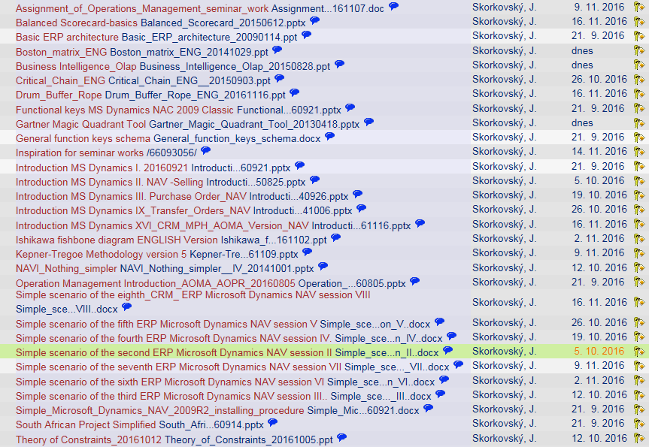

Below listed material corresponds to all MS Dynamics Functions and its impact to operation management during practical lessons. This list have to be used for MS Dynamics NAV 2009 R2 studies.
Mind you, that access to MS Dynamics NAV 2009 English version (British local currency and English database) is possible also in all public computer rooms! From this table mentioned below it is visible and clear which passages (TSx) were trained and shown during MS Dynamics NAV 2009 system hands on seminars. Training sessions marked by yellow colour will be handed over during next remaining sessions. Some of the TSx were not used, because they are outside of the course scope.

For MPH-AOMA course only 158 slides will be used + 63 slides in PWP presentation MS Dynamics NAV Nothing simpler, which is also part of your study material as well !!! So all in all 221 slides !!

Listing of Practice Resources (MS Dynamics NAV 2009).
(mapping questions-resources – see list of questions below)
 | List of Training selected PWP presentation for AOMA | 368 |  |  | MHP AOMA | 159
Code | Description | All slides | Presented (date) | Ready | Lecture given | AOMA slides
TSINT1 | Basic ERP architecture |  |  |  | OK | 8
TSINT2 | Operation Management Introduction |  |  |  | OK
TS0 | South African project -real one | 19 |  | OK
TS1 | Introduction to MS Dynamics | 13 |  | OK | OK | 13
TS2 | NAV Nothing Simpler | 28 |  | OK | mentioned | 62
TS3 | Purchase PWP III | 22 |  | OK | OK | 21
TS4 | Item card creation, PU 2 items and SO 1 item | 12 |  | OK |  | 12
TS5 | Cross Reference, Substitution and extended texts | 9 |  | OK
TS6 | Blanket Orders | 16 |  | OK
TS7 | Drop Shipment | 11 |  | OK
TS8 | Stock Keeping Units | 11 |  | OK
TS9 | Transfer Orders PWP IX | 7 |  | OK | OK | 11
TS10 | Sales discounts PWP X | 10 |  | OK | OK | 9
TS11 | Warehouse Management | 19 |  | OK
TS12 | Non Stock Items | 10 |  | OK
TS13 | General Journal (apply, un-apply, reverse,) | 25 |  | OK
TS14 | Item Charges | 19 |  | OK
TS15 | Lot numbers and Item tracking | 11 |  | OK
TS16 | Customer Relationship Management PWP XVI | 24 |  | OK | OK | 13
TS17 | Credit Notes | 17 |  | OK
TS18 | Reminders and Finance Charge Memos | 22 |  | OK
TS19 | Return Management | 20 |  | OK
TS20 | Combined Shipment | 10 |  | OK
TS21 | Accounting schedules PWP XXI | 11 |  |  | OK | 8
TS22 | Budgets | 11 |  | OK
TS23 | Expected costs
TS24 | MS Dynamics Most Frequently used hot -keys | 11 |  | OK | OK | 2
TS25 | Analysis | 11
TS26 | Production | 19 |  | OK
TS27 | Requisition Worksheet | 16 |  | OK

As it was already mentioned, most of these functionalities are covered by PWP show MS Dynamics NAV-Nothing simpler (all in all 63 slides) ! Shorthand of this show used in Practise question below is NS! In addition to P/WP presentation you have a set of simple scenarios (SS_I-SS_IX) describing in detail basic operations step by step. These materials serve as ERP MS Dynamics NAV 2009 R2 “cookbook”. Relation to every basic process (Purchase, Sales, Transfer,…) is clearly stated in the header of these document which were (almost all of them) printed by teacher and handed over to students. Approximately 18 pages.

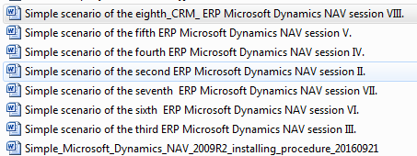

In the list above we have only eight SS. Th ninth SS (Discounts and Accounting schedule) will be part of the study material on 23.11.2016

Practice Questions MS Dynamics NAV 2009 R2(Classic version od database)

1. Modularity of the ERP systems. What areas can be controlled by ERP MS Dynamics NAV. (TS1 resource and Nothing Simpler=NS). How to move from one table to another one (see T24 –basic hot keys used.)
2. Main windows (forms) used in ERP and syntax for Debits and Credits (posted General Ledger Entries) – card window, line window, matrix window (e.g. Item by location from Item cards) header and line window (form and sub-form, which is basic structure for every NAV document (Sales Order, Purchase Order, Credit Note, Contact Card (CRM), Transfer Order,..) (TS1 and TS2 resources and NS ). Do not take into consideration creation of the new customer card by use of template (TS2), which was not presented! All these windows used in ERP NAV is mentioned in step-by-step explanation given by related Simple scenarios
3. Main tables (Item, Customer and Vendor- basic data field such as Balance, Basic unit of measure, Payment condition, Costing methods and so on. You can use Help which can be accessed by key F1 for better and more concise presentation!! (TS1 and TS2 resources and NS).
5. Purchase of an item and impacts of F11 (posting) -> item and vendor entries, G/L entries (TS3 and NS and Simple scenario 2-4). Create new Purchase Order and show all impacts (Item ledger entries, General Ledger entries and Vendor Ledger Entry!
6. Sale of an item and impacts of F11 (posting) -> item and customer entries, G/L entries (TS2 resource and NS and Simple scenario 5). Create new Sales Order and show all impacts (Item ledger entries, General Ledger entries and Customer Ledger Entry!
7. NOT FOR MPH_AOMA 2016 !!Payment of the open entry (Customer or Vendor) by use of the Financial Journal and impacts. (This can be shown in Financial Management area (menu) ->General Ledger->History->Registers)! (TS13 resource). Show how to get payment from chosen Customer with non-zero Balance on Customer Card. Explain what is the meaning of Open entry! NOT FOR MPH_AOMA 2016
8. All presented discounts (price, % and invoice) and the use of this incentives! What kind of discounts do we have in MS Dynamics NAV? (TS10 resource and SS IX). Show setup of discount specified by examiner and impact of applied discount in sales lines !
9. Contact Card and its profile and use of it. Connection to Customer (Vendor) card. (TS16 resource and Simple scenario VIII). What is use of contact card profile? How the contact card is connected to Customer?
10. What is an Opportunity and Sales cycle? (Show from Contact card or Salesperson card) and how to create a new interaction from the contact card (use of wizard) (TS16 resource)? How to see after it is created in MS Dynamics NAV database? Use already created Opportunities, where you can easily access Sales Cycles from the opportunity lines (see main hotkeys short-hands) (TS24 resource)?
11. Transfer Order (Present to examiner transfer of chosen item from Blue to Red Location). After Transfer Order will be posted show by use Ctrl-F5 created item entries (TS9 resource)! How many item entries will be created during transfer?
12. Accounting schedule. Start chosen Accounting schedule. Only basic principles (name of the analysis, line template and column template) (TS21 and TS25 resources and SS IX). Explain benefits and use of it.
13. Explain and show use of listed keys and its combinations : F3,F5,F6,F7,F9,F11, Ctrl-F5 and Shift-F5.

Listing of Theory Resources – will be used below to show you mapping knowledge -resources

A. Operation Management Introduction –see PWP presentation presented (TSINT2)19.9. and 26.9.
B. Theory of Constraints (5.10. and 12.10.)
C. Critical Chain (CCPM) (19.10. and 26.10.)
D. Boston Matrix and Product Life Cycle (PLC) (23.11.) –will be uploaded and presented 23.11.
E. Ishikawa fishbone diagram and its combination with Pareto Analysis (2.11.)
F. Pareto Analysis Simplified (2.11.)
G. Reserve clause (not used so far) !!!
- OLAP and Business Intelligence (will be uploaded on 23.11. and will be presented on 23.11. )
- Magic Quadrant Matrix from Gartner company -will be uploaded and presented on 23.11.
- Kepner -Tregoe Methodology (9.11.)
- Total Quality Management (11.11.2015) - NOT FOR MPH_AOMA 2016 !!!!!
- Drum-Buffer-Rope ( was uploaded on 16.11.and presented on 16.11.)
- Reserve clause (not used so far) !!!
- Balanced Scorecard ( was uploaded on 16.11.and presented on 16.11.)

Theory Questions (resources A-M):

Structure of the theory question:

Comment : Indicative questions which are written below in italics are only ancillary issues !!!!
It is assumed that your answers will be much more complex!!!

Number Description : Resource (slides if required )

- Name key OM activities and use of OM : A
- Name key skills, which should be part of OM knowledge portfolio : A
- What is a Deming cycle? What supposed to be your main task in order to improve company processes? : A, B and C N.
4. Evaluation of the project result. How we can know, that the Project was successful? Consider time, due date, capacities of resources, budgets limits, required knowledge portfolio, changes, and so on: A, B and C
5. Simplified chart (diagram) of ERP functions (feedback diagram). Explain! You can use MS Dynamics NAV demo version as well: A and TS24, TS21 and TS24 and mainly TSINT1 (slide 6)
6. Specify the basic concept of the Theory of Constraints: B
Very complex question! It covers among others questions 7,8,9 and also 10.
7. TOC metrics: B
Name three main metrics and their trends, explain benefits of using this metrics. How to calculate NET Profit and ROI by using these metrics?
8. Cost World and Throughput World: B
Define and explain differences
9. TOC five steps: B
10. Drum-Buffer- Rope. Explain simple methods: L
11. Basic trees (Thinking process tools) – Current Reality Tree, Evaporating Cloud Tree and Future Reality Tree: B
Explain main use and how these trees are constructed. This question is more and less also related to you seminar work!
12. What is bad multitasking? : C
13. Critical path and Critical Chain differences: C
Specify differences between CP and CC!
14. Use of project buffer (buffer management concept and graph with three zones): C
Specify use of buffers, how the size of buffer is set.
15. Total Quality Management Basics: K (not a part of MPHS_AOMA_2016 questions)!!!!
16. Ishikawa fishbone diagram: E
17. Boston matrix and Product Life Cycle (PLC). State some examples of PLC: D
18. Pareto analysis and its applications (use of PWP presentation Ishikawa allowed): E
19. OLAP (Business Intelligence): H
Basic principles and use of using BI. What is n-dimension cube?
20. Basic principles of Kepner –Tregoe method supporting decision making: J
Must and Want criteria and its use, principles of WHO, WHAT,WHEN WHERE EXTENT and Why to distinguish between It Is and It Is Not.
21. Magic Gartner Quadrant: I
22. Balanced Scorecard (BSC)basic principles and use. What is KPI ? Name all four sections of BCS : N

