Simple scenario of the third ERP Microsoft Dynamics NAV session IX.
Created by : Jaromír Skorkovský
Date : 23.10.2016
Reason : Orientation in the MS Dynamics. Material which helps to understand discount principles one basic type of financial reporting (accounting schedules)
For : MPH_AOMA students
Used database : MS Dynamics NAV 2009 W1 (British one)
Used abbreviations : Q=question, G/L=General Ledger, Simple Scenario = SS,
PWP=Power-Point
Accompanying material : PWP X (Discounts) and PWPXXI (Accounting Schedules)

- Example : You have one item e.g. 1964-W and on TAB Invoicing you have Unit price e.g. 292 .Go there and see !
- You have one client who is buying a lot of different items.so you would like to give him discount. First type is Price discount, meaning change of standard unit price. For instance from 292 to 280 !
- You have two possibilities to do so : One is changing manually this price in the Sales line by rewrite it) :
To
- Second possibility to do it automatically for one chosen client or even for some group of client of for all client and for specific period only. Jump from already created Sales line from field Item number to list of Items .Cursor should be on 1964-W. Then use button Sales and make choice Prices. By mouse put to the Sales Code field Customer 10000 and to Unit Price new value of Unit price 280. Then go to the next line and do to same, but add to field Minimum value 10 and enter price 270. And leave this form (window) by ESC key (2x). You are again in Sales line
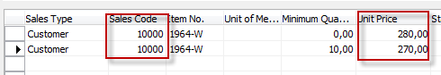
- In Sales line create another Sales line with same Item and enter Quantity 20. Automatically you will get another modified price 270. It is called bulk or quantity discount used mainly in retail business.
- Then you would grant to the same client some % in Sales line. You can enter it again manually, but let do it automatically again. Jump from already created Sales line from field Item number to list of Items. Cursor should on 1964-W. Then use button Sales and make choice Line Discount.
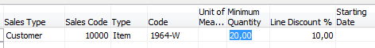
- Go back to sales lines by 2 x ESC. Enter third line with the same Item and enter quantity 20
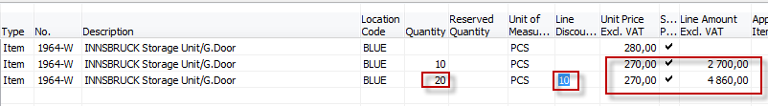
- It is clear as daylight how the system calculated final price (20*270*0,9=4860).
- Third possibility is to reward client if final amount on future invoice will be higher than predefined limits. It is called Invoice discount. Also used in retail business.
- Go to menu Sales & Marketing->Order processing ->Customers->make choice of customer 10000 and go to button Sales and make choice of Invoice Discount, Enter what can you see below :

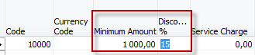

- ESC and go to order processing->F3 create new order with client 10000 in the header of this document. In the Sales line enter item 1964-W and quantity 25. Make F9 (Statistics). What can you see ? Do you have already price discount and Line discount granted ? What about Invoice discount ?

And if F9 is pushed -> 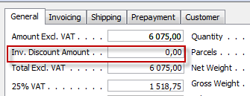

- So we have to apply it manually based on our setup on customer card. Go to button Function from Sales order and make choice Calculate Invoice Discount (the first one from the top ). To the question Do you want to calculate say YES and ENTER. Make F9 (Statistics) and you see, that Invoice Discount was granted !!! Then make a Print and Show Order confirmation .You see all discount calculated and granted. Post this Sales order by F11 !!! We will used posted date later !!!!!
- Basic financial reporting is done by running user defined reports called Account Schedules. This is, beside tens of predefined and existing reports, basic tool to access data of vital importance All these reports use as resource data General Ledger Entries created automatically by posting various documents (e.g. Sales and Purchase orders) by key F11.
- Go to menu Financial management ->General Ledger ->Analysis & Reporting. There you can see Account Schedules.
- In the form go to field Name in the header and find Analysis. There somebody who created demo database inserted by button Function set of some accounts from Chart of accounts and changed also row numbers in order to use these values as variables for later calculations.
- Go to button Acc.Sched. and make the only choice Overview. Based on initial setup of matrix lines and columns you will get :
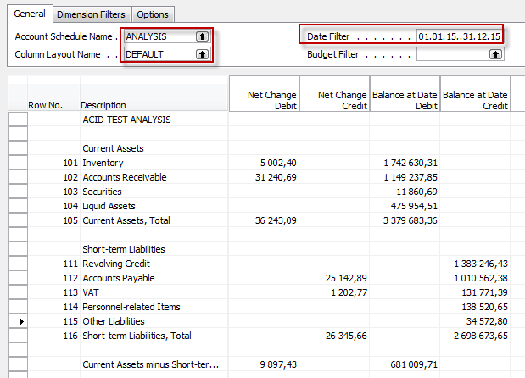

- If you change Default Column layout Name to BUDGANAL (Budget Analysis) you close and open it again by Overview you will get different report.

- Let´s create your own analysis !! Go to the Name field and in the list enter new analysis name (e.g. TEST) as it is shown below.

- Make OK and Insert by button Function an account 6910 Discount Granted . Insert manually also the first line in analysis (TEST Discount Granted). Push button Acc.Ached. and Overview.

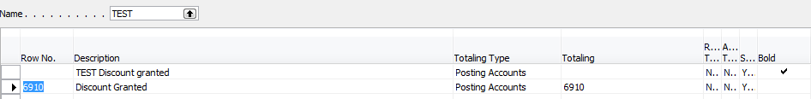

And you will get (after overview)

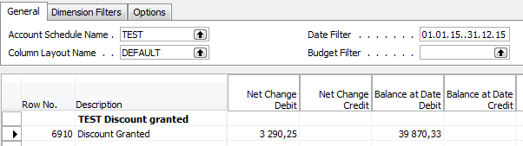

- Go to the field Net Change Debit and drill down (here I have an amount 3290,25)

- You will get :

- Go to field Net change and make drill down again and you will get General Ledger Entries :

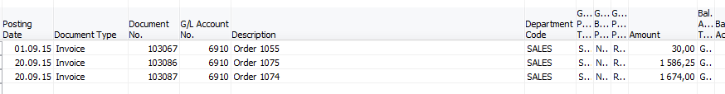
- Go to menu Financial management ->History->Register and go to the last line with Source Code=Sales. From there by use of button Registers and choice General Ledger you will get :
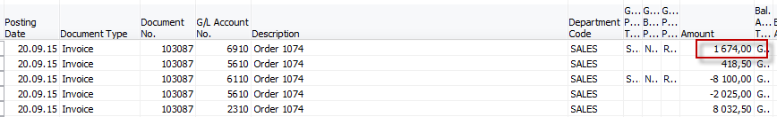

And from there you can see an amount 1674 from our last posted invoice where we applied Price, Line and Invoice discounts !!!!!!!!! The same amount was displayed in your simple Account Schedule.

