- Introduction scenario – MS Dynamics NAV 2016
Based on : MS courses and Miki Skorkovský modifications
Date : 11.1.2017 ..18.9.2017
Pictures are parts of PWP show number Intro_I_NAV 2016_20170111
Materials : Scenarios, PWP, videos,…
Resources : MS courses, internet, MS Dynamics NAV 2016 demo helps,…
FOR : BPH_PIS1 and PIS2, RIOP and partly for AOMA,EPS1 and AOPR courses

here you will find videos (if connected to NVR VPN) – or will be handed over to your hard disks

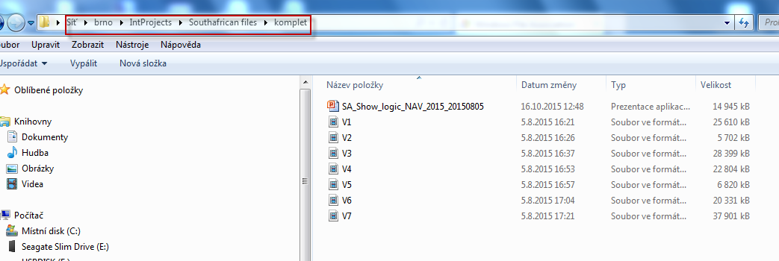

What are the goals for this Section ?
- Explain the concept of ERP and Microsoft Dynamics NAV 2016
ERP =Enterprise Resource Planning System
Resources : financial resources, machines, people, items,…….
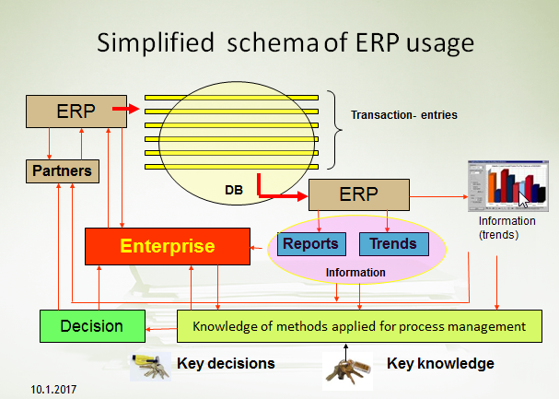
Decision making based on data created and structured by transaction system (ERP) .
Different data, different requirements in different times, different set of reports ,…
Comment (BSC- trainer se below)
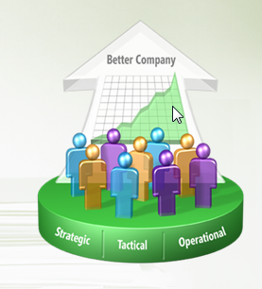

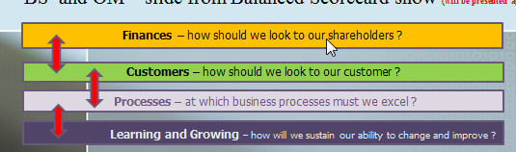
3 tiers (will be more in detail presented later in technology section) not part of AOMA,AOPR or EPS1 courses
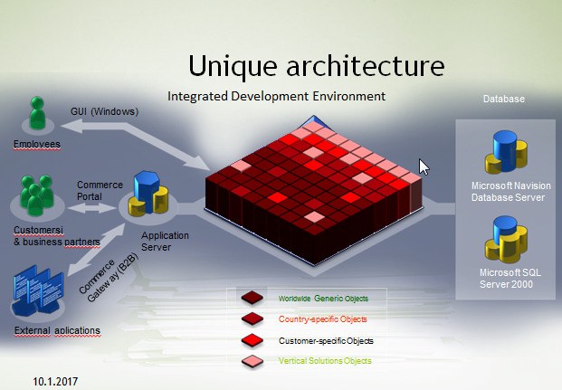
Objects : tables, forms, reports, menu and data ports.
Table : how to store data
Form: how to see data
Reports : how to give you right information based on stored data
Menu : how to navigate user throughout ERP system

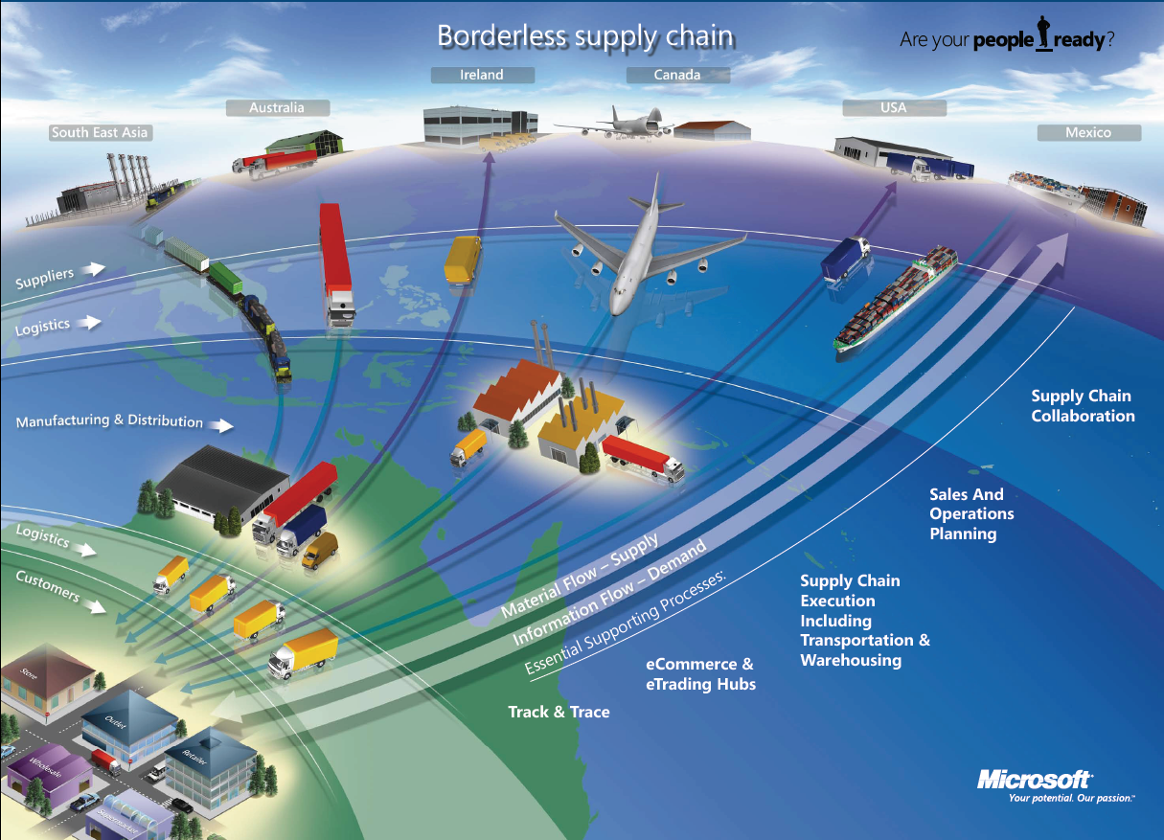
- What makes MS Dynamics NAV an ERP system ?
So Microsoft Dynamics NAV is an ERP system. But why is it an ERP system? What are the main features of an ERP system and how do we recognize these in Microsoft Dynamics NAV? Let's have a look at the overview slide. So one of the challenges that some companies might have to address is the one of island systems. And that's what you see typically when a company is using bookkeeping software in which only the bookkeeping can be done. That same company might also have a warehouse, might have a production department, is selling goods and services and so on, but in the bookkeeping software, items, physical locations, the actual stock count is not maintained. And what you will see, and that's why we call it island systems, they're using different software products. And in some cases this might also be Excel in which they keep their item master, for example. So they're using different software products to maintain all these data. But they can -- as you can see here in warehouse data, we need items; in production data we also need items; and in sales and customers we also need items. So this means that in a typical island system you have to maintain, you have to enter data several times. And that's, of course, first of all, a lot of work, but also a lot of errors could be made. So and that's why the island system is not, of course, the ideal system. In an ERP system we will work in a different way. In an ERP system we have a common database that contains all the information. So item information is maintained in the common database and can be used by the manufacturing department, by the sales department, and so on. So everyone working with the system, for example, the bookkeeper in financial management, the sales representative in sales and marketing, the warehouse worker in the warehouse management, the HR manager in human resources and so on, so they all work with the system in their specific application department but with a common database. And that's very, very important. That's one of the main features of an ERP system. Because the item master should be maintained only one time in that common database and everyone can use items in the way that they prefer and based on the information that they need. So that's a very important feature of ERP. Some other features that are important is, of course, real time. Because of the common database, we have all the information available at real time. So we don't have to wait, we don't have to carry out processes, imports, exports. No !!!!. Everything is there in real time.
Also typically for an ERP system is that it can grow with a company. So you can start in a very simple way without, for example, using warehouse management, but if your company grows and you're starting to use a new warehouse, you might be interested in implementing, for example, a warehouse management system. And an ERP system will allow this. So it's tied to the company's business processes and it will grow with the company. So if we require warehouse management at a specific point, then we can start using that in our ERP system. And then of course also typically for an ERP system are the job roles and the authorization. So we can set up a security system, we can assign different job roles, you have bookkeepers, as we just saw in the previous slide, we have salespeople, we have warehouse workers and so on. So all these job roles are based on these job roles we will start using the system in a specific way, and of course we also need a security system in order to define what users can or cannot do in our ERP system. So these are the main features, and that's also why we can consider Microsoft Dynamics NAV as an ERP system. So we have a central database on SQL Server, we can work in real time, we can define users and apply security and so on.
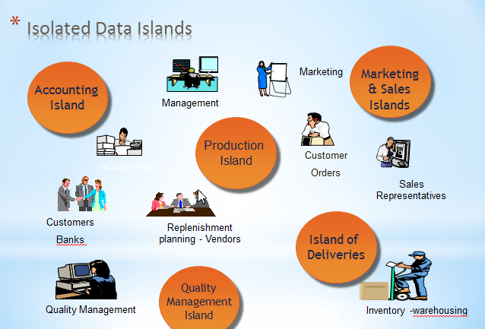

Another example of island system (resource : Microsoft)
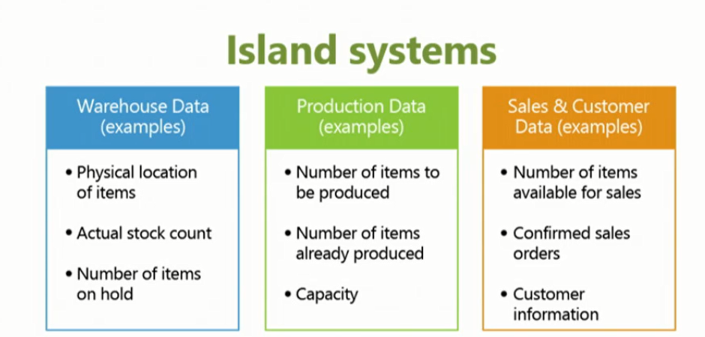
Simple example about problems related to different applications delivered by different SW suppliers
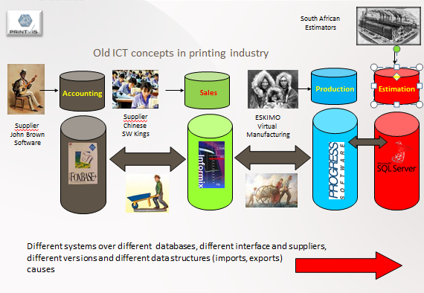
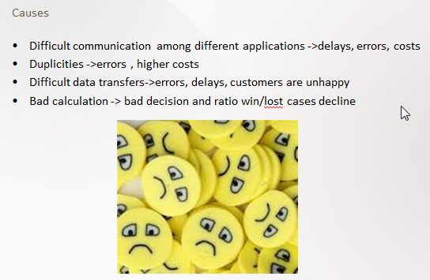
Ideal ERP solution : One Application- one database
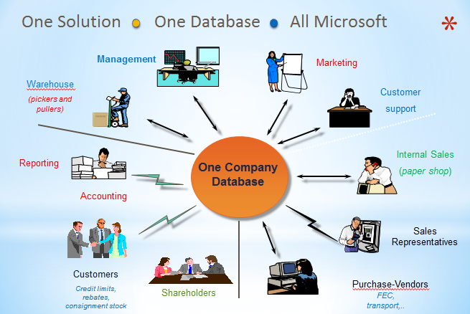
¨
Similar picture about data island (see below)
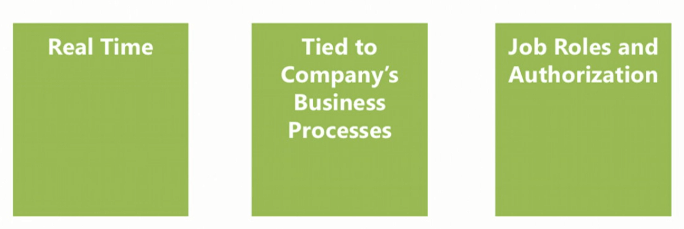
b) Browse application areas

Module Overview (text part)

So now that we know why Microsoft Dynamics NAV is an ERP system, I thought it would be interesting to have a look at everything that we can do with NAV because we just saw that one of the main features of an ERP system is the common database around which we have all these different application areas. Now, what are the application areas that we can use in NAV? So in this module we will browse all these application areas. And we will start with financial management, then a little bit combined with financial management we also will have a look at reporting and analysis. Then there's a marketing module and trade. There is, of course, inventory management because the item can be something very important in a NAV application. And we can also extend inventory management with warehouse management. There is manufacturing, so for companies that manufacture and that produce their own items. We have jobs and resources for service-oriented companies. There is a service management and human resources. So these are all the different application areas at which we will have a very short look in the upcoming lessons of this module.
c) User interface – profiles, ribbon, …main working area
d) User personalization ..lines (Hide and Show,…height of the column,..)
e) Basic functionalities (searching and filtering,…)
f) Master data : Customer, Item, Vendor, Sales Order and Purchase Order and G/L accounts

This picture will be part of course section regarding Dimension and BI
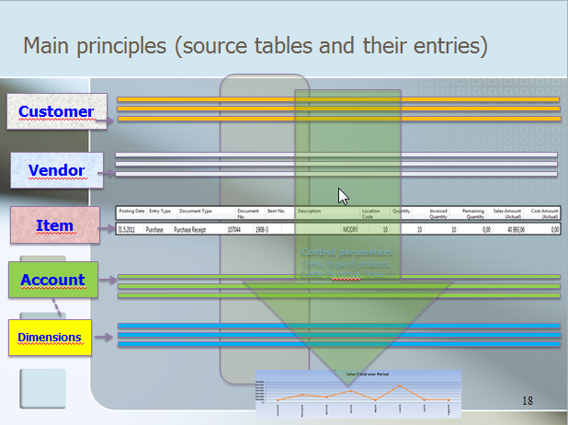
This 10 bullets represent basic sections during introduction of this course
- Discuss the concept of the ribbon and its different components
- Demonstrate how to use the Navigation pane
- Explain how to customize the Microsoft Dynamics NAV user interface
- Use function keys and basic keyboard shortcuts
- Enter and edit information
- Use zooms, search, filters, and other navigation functions
- Integrate with Microsoft Office products such as OneNote, Word, and Excel. (One Note will be not used in these courses)
- Introduction to customer cards, vendor cards and item cards and G/L account as well
- Describe the different client types
- Explain the multi-language functionality
- How to enter data (numbers, dates, periods)

Marketing (CRM) – only basics (Cards, Profiles, Opportunities)- will be presented later

Besides a very extended sales application area, we can also set up and use marketing in Microsoft Dynamics NAV. Let's have a look at the main features. So if I go to departments and if I click here on sales and marketing, so you can see, like I just said, we can set up a very extensive order processing based on sales quotes, orders, invoices, return orders, and so on. But we can also start using marketing functionalities. So we can set up, for example, contacts. So this is the main master data in our marketing, and so our relationship application area in Microsoft Dynamics NAV. So if I double click, for example, on a contact, you can see that we can have company contacts but also person contacts. And a person can be linked to a company. For example, here to this company we have Alan Brewer, which is a person working for the Gibson Law Firm, as you can see. Once that we have created companies, that we have created contacts and so on, we can start creating interactions. So each interaction that we have with a contact, and this can be a phone call, this can be sending an email, this can be writing a letter, whatever. Of course also sending a sales quote. So each interaction can then be saved and linked to a specific contact. And in that way I always have a very extended overview of all the interactions that we have that we have had with a specific contact. So let me go to the sales module. What else can we do? So we can also set up opportunities. So if you have a sales opportunity, so it can be linked to a, for example, salesperson. So if there is a sales opportunity, you can start setting up opportunities to which you can assign tasks. So, for example, salespersons will have to carry out specific tasks in order to perform or to try to close the opportunity. So these opportunities can then be included in a sales quote. And then if we win the opportunity, you can start selling to the customers. So a full opportunity management is also included in the system. If I go to marketing, you can also see that we can set up and create segments. So we can create segments in order to address a specific segment based on events that we are doing, based on activities in order to increase sales. So all the typical marketing activities that you want to set up and carry out in real life, you can start using in Microsoft Dynamics NAV. Now, furthermore, in this new version, Microsoft Dynamics NAV 2016, you can set also -- you can also set up an out-of-the-box Microsoft Dynamics CRM integration. So if you have set up contacts in NAV, you can link them, for example, with accounts in Microsoft Dynamics CRM. So you can also see that there is a link possible with sales orders, with quotes. So if you might be using Dynamics CRM and Dynamics NAV, there's no reason anymore to keep them separated. Out of the box we now have functionalities in which we can fully integrate Dynamics CRM with Microsoft Dynamics NAV. So that makes using marketing in Microsoft Dynamics NAV even more interesting as before.

The list of contact cards (Companies and Employees)
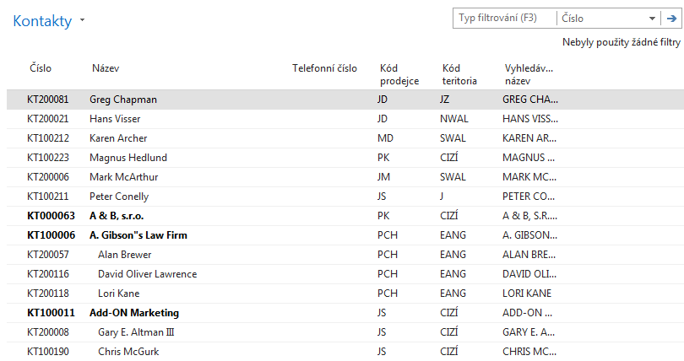

One contact card of chosen employee (Czech data- during course a student will see English data) 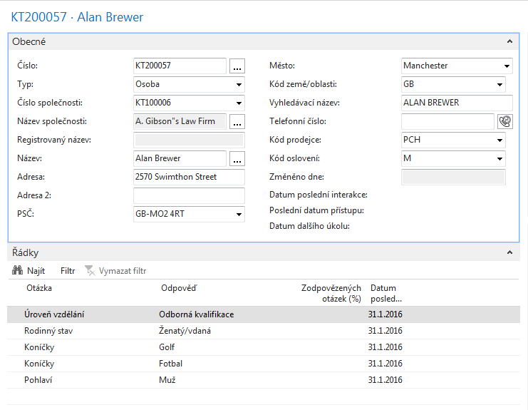
Opportunity (Czech data- during course a student will see English data)
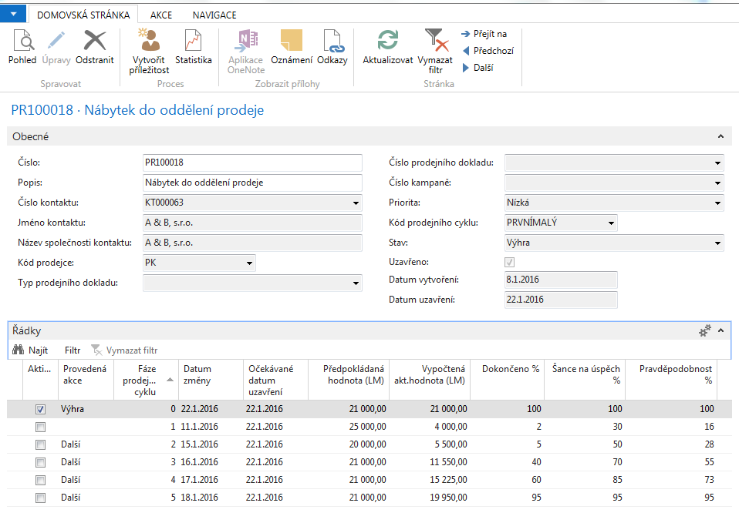
Segments (Czech data- during course a student will see English data)
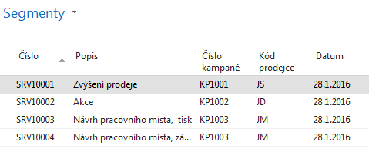

Trade (text part) - will be created during course (related to existing PWP presentations) – use of Czech Database

Many companies using Microsoft Dynamics NAV are companies using items, so their company is purchasing and selling items. They might produce items with manufacturing functionalities. So this means that the trade application area is for many companies a very important application area. Let's look at some of the important and interesting features to use
List of Items (Czech data- during course a student will see English data)
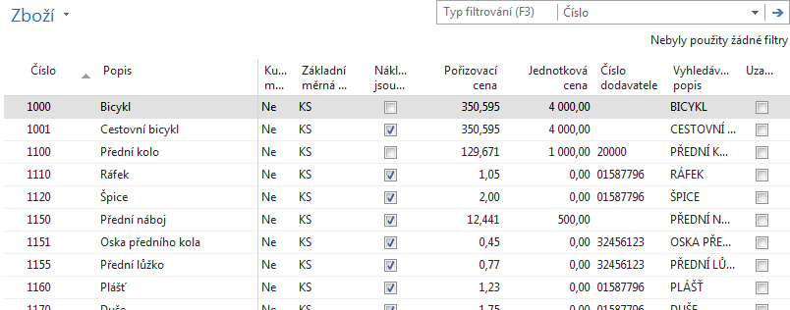
So the trade application area is, of course, based on items. And one of the things that companies want to do is specify specific item prices and discounts. So, for example, if I open here an item, you can see here on the invoicing FastTab that the item has a cost of 350,594 and a unit price of 4000.
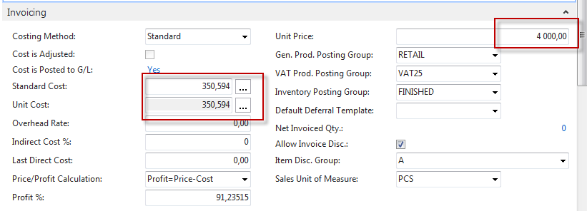

Now, Microsoft Dynamics NAV allows us to very efficiently add additional prices and discounts. So, for example, if I want to add additional sales prices for my customers (in our case all customers), I can very simply go to the navigate tab in the ribbon, click on prices, and start entering additional prices.

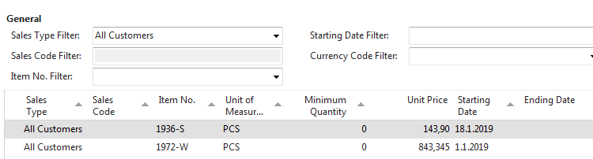

I can target with my prices an individual customer, a group of customers, all customers, or I can combine it with a campaign that we have set up in the relationship management application area in NAV.

Item Card (Czech data- during course a student will see English data)
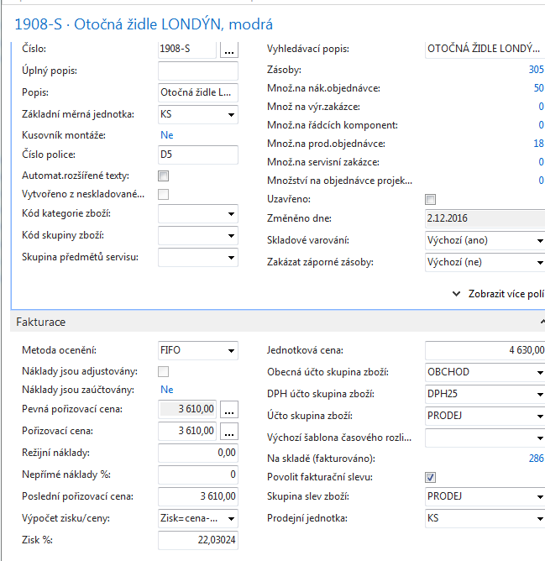

Prices and discounts (Czech data- during course a student will see English data)
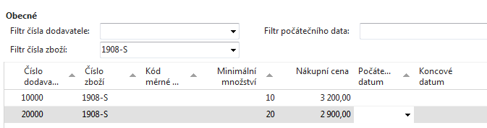
Next I can combine my price with an item, and I can make it available or make it dependent on the minimum quantity, a starting date, an ending date, and so on. So in that way I can very flexible set up a new price of let's say 3200, but the minimum quantity should be 10. See picture above
Now, similar to what we just saw with prices, we can also set up line discounts. So I can also group my customers here in specific discount groups, and then I can specify, for example, that large accounts on a specific item or even on a specific group of items, so, for example, on finished goods, receive a discount of 10 percent. Maybe also here depending on a specific quantity or on a specific ending date as similar to what we just saw with prices. So this is another thing that we can do, also here very flexible, so set up line discounts in Microsoft Dynamics NAV. See picture below.
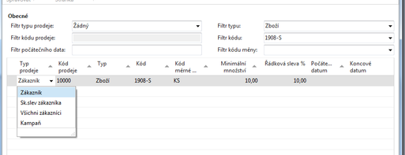
Now, besides discounts, another very important component in the trade application area is the workflow component. So let me go to workflows. So this is also something that Microsoft has added in NAV 2016. Now, in previous versions we had document approvals, and based on document approvals workflow has been added. So it's an extended way of integrating workflow in your company. In this case, I've made an example of the purchase order approval workflow. And as you can see, we can set up a number of requirements in the purchase order approval workflow that we have to -- that we have to meet in order to be able to create and process a purchase order. So in this case, you can see that a restriction is added, which is, for example, a specific user, then the document is set to pending approval. So if you send the approval request, for example, an approver request is created for the approver, and the approver request has been sent and a notification is created. So in this way you can see all the different steps that we have to perform in order to get a purchase order approved.
So this is something that we can set up ourselves as a user, and that's very interesting. It's not limited to purchases and sales. So if I click, for example, on create new workflow from template, you can see that in the standard application we have a number of templates already included such as the overdue approval request for workflow but also very interesting a general journal approval. So now we can also use approvals in the finance system. So not only in the purchase and the sales but also in the finance system.
Below you see workflow templates (not for the courses AOMA,EPS1 and AOPR)
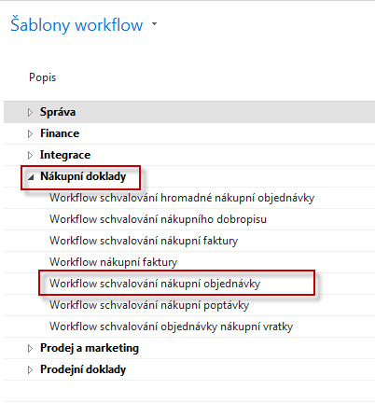
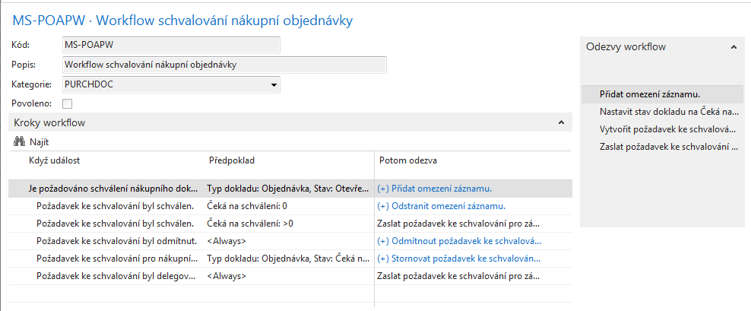
And you can also see that there is an integration with the incoming document function where we can set -- where we can also set up a workflow in NAV. So also that is very interesting to use in the trade application area. Another thing that we can do is set up assembly management. Now, in one of the following lessons in this module, we will have a look at manufacturing. But manufacturing could be too complicated for a specific company that still wants to put items together but not with a manufacturing process. Now, for these companies, we can use assembly management. So with assembly management I can set up assembly items.
Assemblies (not for the courses AOMA,EPS1 and AOPR)

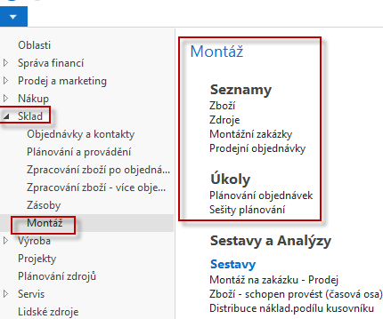

So, for example, here you can see the assembly bill of material. And if I click on one of the assembly items, you can see the bill of material.
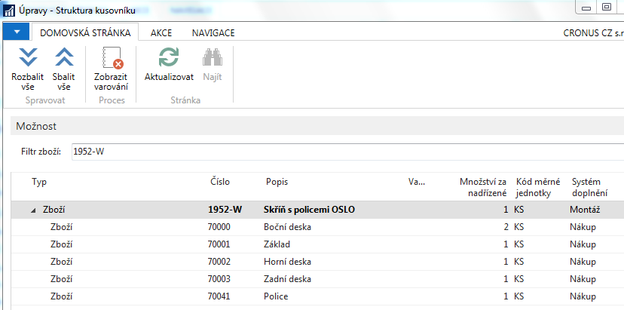

So in this case a simple item with two side panels, a base, a top, a rear panel, and a shelf. And this assembly item can now be used in assembly orders. So if I go back one step, so if I click on assembly, you can see here that we can create assembly orders.

So if I create a new assembly order, if I assign a number, and if I then retrieve my item, so for example 1952, the one that we just had a look at, you can see now that based on the quantity the system will, first of all, in this case give me a stock out warning because I don't have enough components in order to assemble the storage units. But if I click on yes, we can still proceed. And you can see now that all my components that we just had a look at are now inserted here in the lines section of my assembly order.
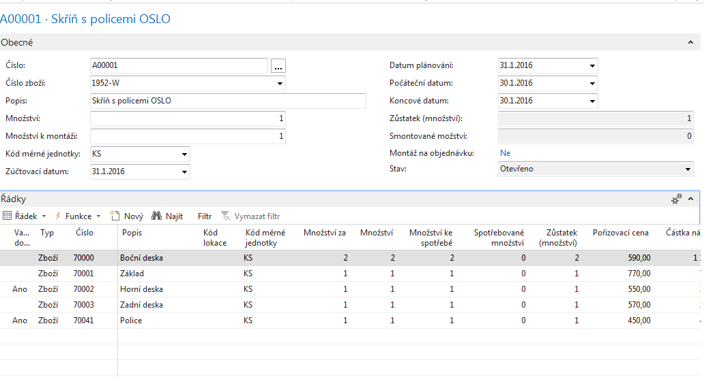
If I would have all these components on stock, then I could post. And posting the assembly order means that we have put together all the different components and created the assembly item. So this is a very simple way of assembling items, but -- and that's the big advantage -- fully integrated with the rest of Microsoft Dynamics NAV. So you just had a look at the stock out warning that we saw. We can also make reservations. We can also use item tracking searches, lot number, serial numbers and so on. So that is the big advantage of assembly management. It's a simple way to assemble, to put components together, but fully integrated with Microsoft Dynamics NAV. The last thing I want to show you in the trade application area is order promising. So also a very interesting function that you can use in order to have the system calculate the delivery date, so the date that we can deliver items at our customer's site. So something very important because most customers are interested and they will also ask, of course, the delivery dates. So let me create a new sales order to demonstrate.
Next section regarding ATP and CTP is not a part of the courses AOMA,EPS1 and AOPR !!!!

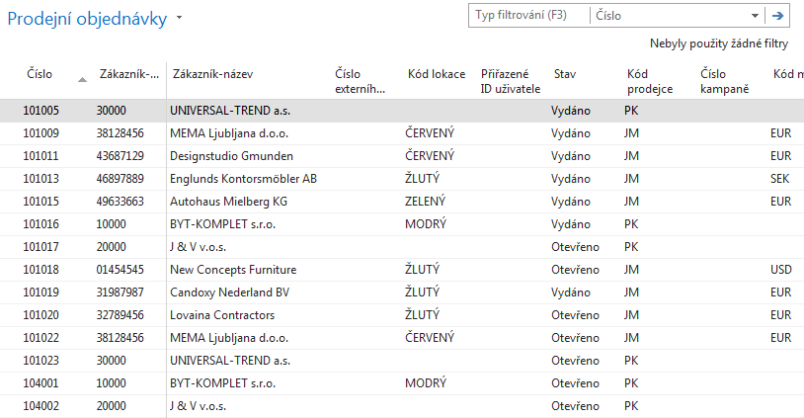
And I will sell to customer 10000. So the customer orders a specific item. So they're ordering an item, 80001. And so you can see a computer, and they ordered 10 computers. Here I can see now that we don't have the computer on stock, and there's also no earliest availability date which means that it's not included in a purchase order, a purchase, production planning or whatsoever.
Sales Line of created Sales order
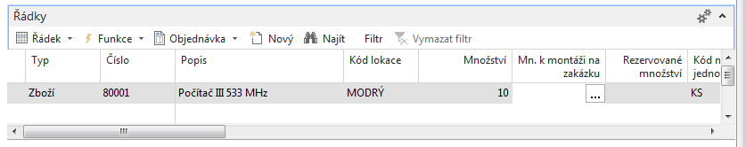
So we don't have the item on stock. Now, in order to be able to sell the 10 computers to the customer, I can go now to the order promising functionality in the ribbon. In this case, I can run the available order capable to promise. Now, the available to promise wouldn't make sense because we just saw that the item is not available. We don't have it on stock, and it's also not planned in the near future. So what I can do now is run capable to promise.
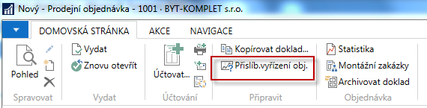

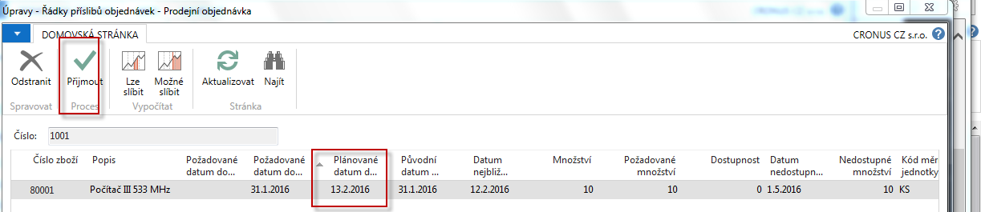
Now, the system will do now an order promising. It will look at the lead time of the item, so how much time will it take the vendor to deliver the item at our location and how much time do we need in order to ship it to the customer. And in that way, it will calculate the planned delivery date. So now if I click on accept, you will see that the system will, first of all, make a reservation.
Sales Line of creted Sales order after running Capabple to promise
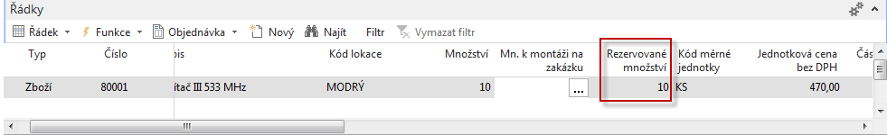

So in this case it's reserved with the requisition line that it has created in the requisition worksheet. So it will plan the item now in order to purchase it in this case from the vendor.
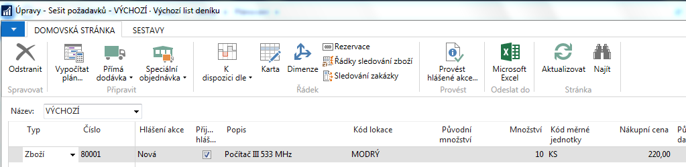

and related Purchase order based on REQ Worksheet Planning tool
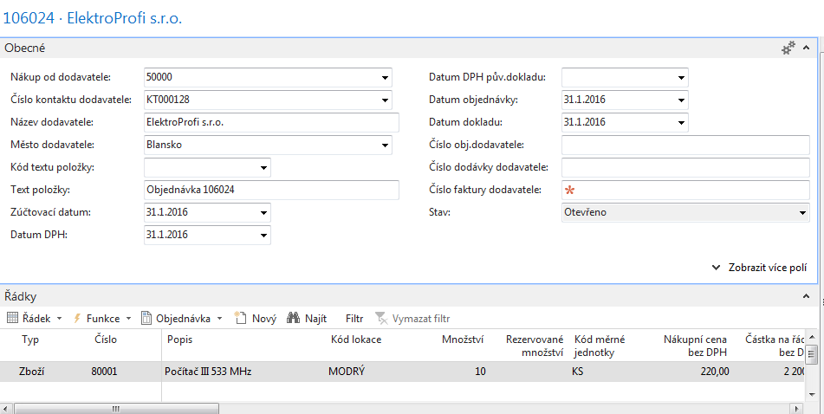
Sales Line again
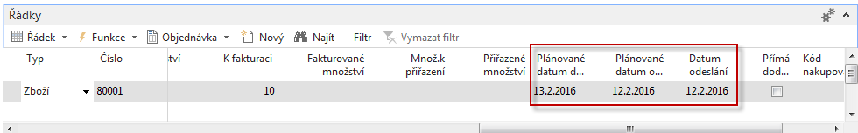

And you will also see, if I scroll to the right, that it has entered a number of dates. So in this case you will see that we will be ready on the 12 th of February to start shipping the item from our location. There is, as you can see, so let me show you, here on the shipping FastTab we have -- if I click here, we have an outbound warehouse handling time of one day, which means that on the 13 th of February we are ready to start shipping the item to the customer. So also here with only a simple couple of clicks, you can see that the system will fully calculate, based on the availability figures, when we can have the item at our facilities, when we can start shipping to the customer, and, very important, when the customer can expect the order that they have placed. So this is also a very interesting function that we can use in the trade application area. Also here we only covered a couple of features of the trade application area, and also here there's a specific training that you can follow to learn more, which is the training Trade in Microsoft Dynamics NAV.
Next section regarding Inventory management is not a part of the courses AOMA,EPS1 and AOPR !!!!

Inventory Management (text part) - will be created during course(related to existing PWP presentations)

Next section regarding Financial Management will be partially simplified for the courses AOMA,EPS1 and AOPR !!!!

Financial Management (text part) –already created (related to existing PWP presentations) – be aware of one simple condition :this part here is created by used of English version of MS Dynamics NAV database

Let's start with looking at financial management. So a very important application area that most companies that use NAV will also set up and use. Now, I will not show everything because that would take me several days, but let's have a look at the main features of financial management in NAV. So here if I go to departments, you will get an overview of all the different application areas. You will see that the first one is financial management. Now, like I just said, there is quite a lot of functionality in financial management. You can see the different departments such as general ledger, cash management, and so on.
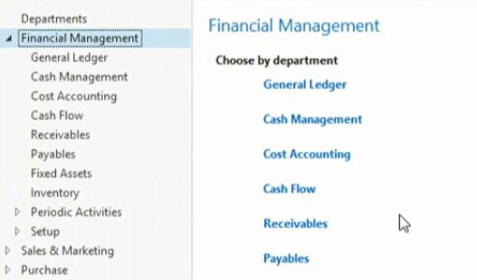
And so one of the main parts in financial management is of course general ledger in which we have the chart of accounts. So the chart of accounts which is a list of all the different G/L accounts that a company has set up and can use in sales and purchases and so on. So that's one of the main features, so a very basic one, but a very important one.
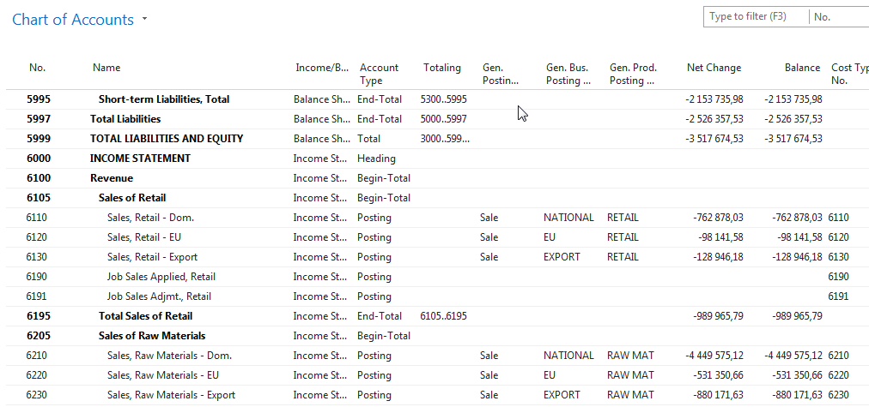
Now, also important in Microsoft Dynamics NAV is that G/L accounts can be used directly. So if I go to in the G/L account, you can see that there is a field, direct posting, in which I can define that we can post directly on a G/L account such as, for example, the expense account office supplies. But we also have G/L accounts in which we cannot post directly.
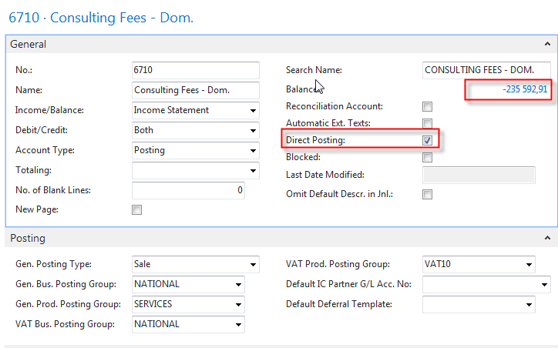
So, for example, if I scroll up to the balance sheet accounts, and if I go, for example, to the account customers domestic, you can see that our demo company, Cronus, doesn't allow to directly post on this account.
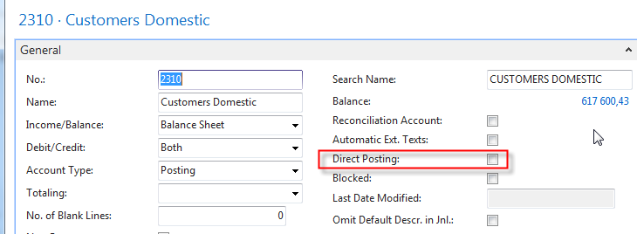
Now, why is this? Well, this is because a very important concept in NAV, and that's the concept of posting groups. So if I click here, posting groups, I can go, for example, to the customer posting group, and there you can see that we can set up posting groups to which we can link G/L accounts.
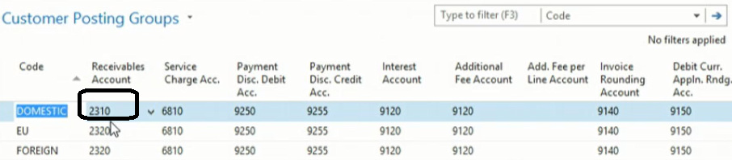
And following picture will clearly specify how it works (see PWP I.)
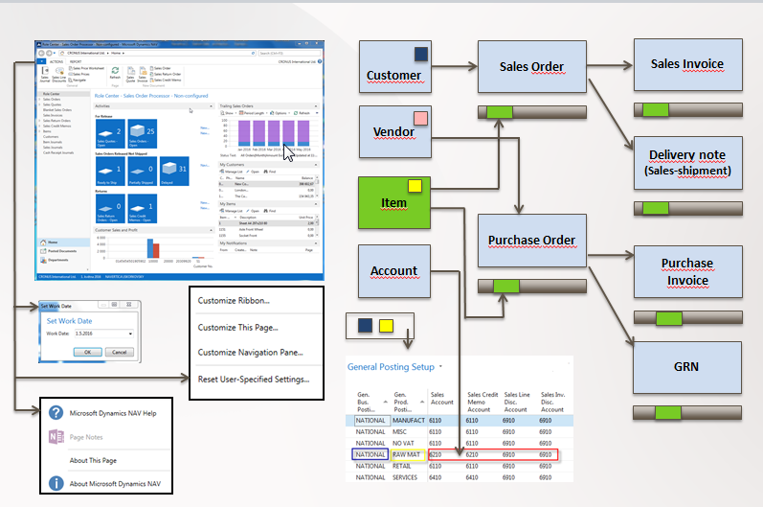
So that's one of the main concepts in financial management. So by setting up posting groups, we can start assigning them, for example, to customers. And in that way we can start posting on customers. For example, we can start selling to customers. And the system will be able to fully automatically retrieve G/L accounts on which to post. So a very important concept that is used throughout the whole application, the concept of posting groups. Now, besides general ledger, besides G/L accounts, we can of course also start using cash management.
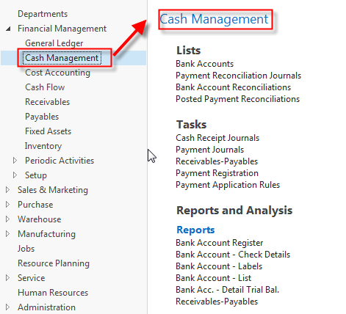
So companies have bank accounts that they use to pay vendors to receive payments from customers and so on. In NAV, this is done based on bank account cards. So for each bank account that we want to process in NAV, we can set up a bank account card with information, general information, but also information that I will show you here that we can use to process payments electronically, to process bank statements electronically.
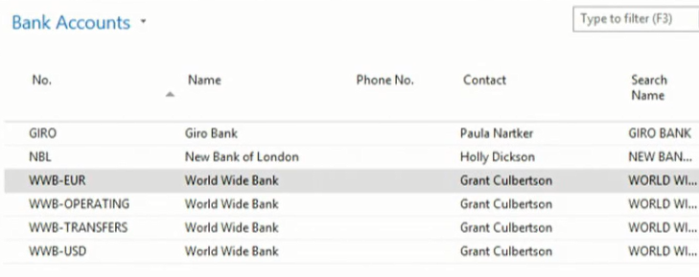
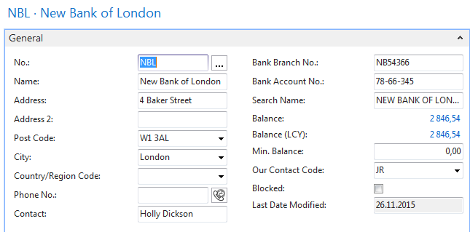
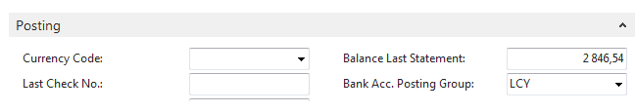
Next section regarding SEPA is not a part of the courses AOMA,EPS1 and AOPR !!!!
You can also see here that Microsoft Dynamics NAV is fully SEPA compliant. (not for SA)
Single Euro Payments Area (SEPA) is a payment-integration initiative of the European Union for simplification of bank transfers denominated in euro. As of July 2015, SEPA consists of the 28 member states of the European Union, the four member states of the European Free Trade Association (Iceland, Liechtenstein, Norway and Switzerland), Monaco and San Marino.[
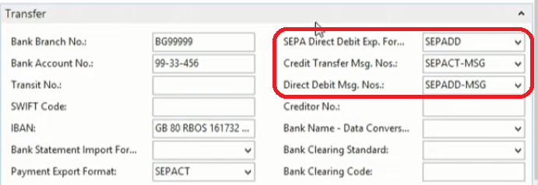

So we can create electronic payment files, we can import bank statements and so on. So this is done by using functions such as the payment reconciliation journals, such as the bank account reconciliation and so on. So if I open a payment reconciliation journal, you can see, for example, that I can start importing bank transactions. So these are some basic functionalities that you can use to implement an electronic banking system out of the box. So very interesting. Now, in financial management we can also set up fixed assets management. So each company has a number of fixed assets.
Next section regarding Fixed Assest is not part of the courses AOMA,EPS1 and AOPR and Czech courses MPH_RIP and BPH_PIS1 and BPH_PIS2 !!!!

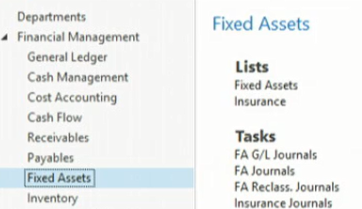
Think of buildings, machinery, cars, computer equipment, and so on. So by creating fixed assets cards for all these fixed assets, as such, for example, a computer, you can start assigning depreciation methods, number of depreciation years and so on.
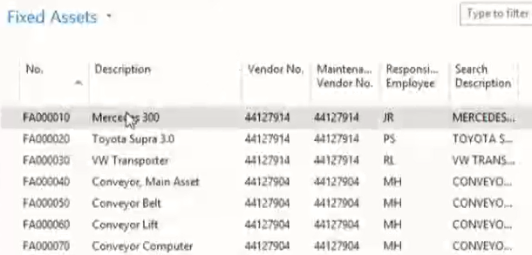

And the system will then be able to fully automatically calculate and post depreciations.
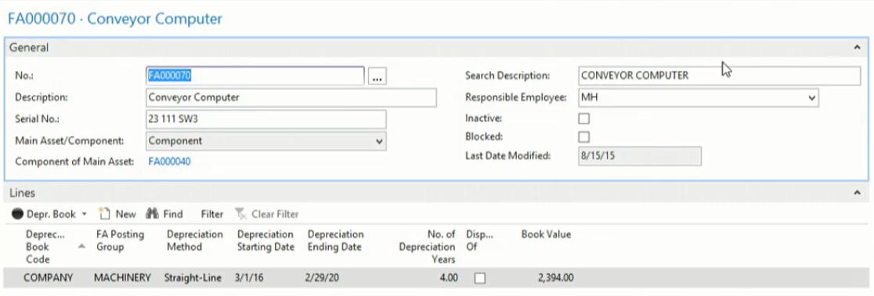
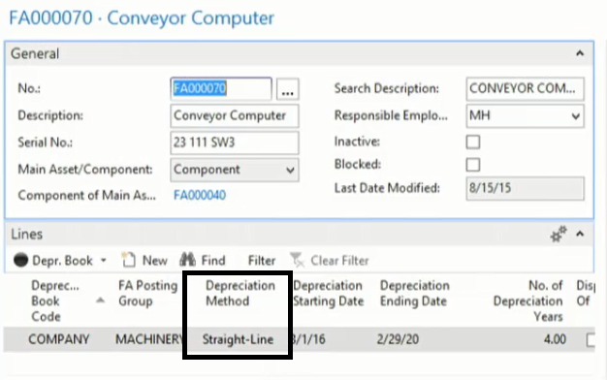
So all different fixed asset transactions can then be processed in the fixed asset module with, for example, the purpose of running a number of interesting depreciation or fixed asset reports. So let me show you one. So I will show you, for example, a typical depreciation table. So if I click on preview, you can see here a depreciation table of our demo company, Cronus International.
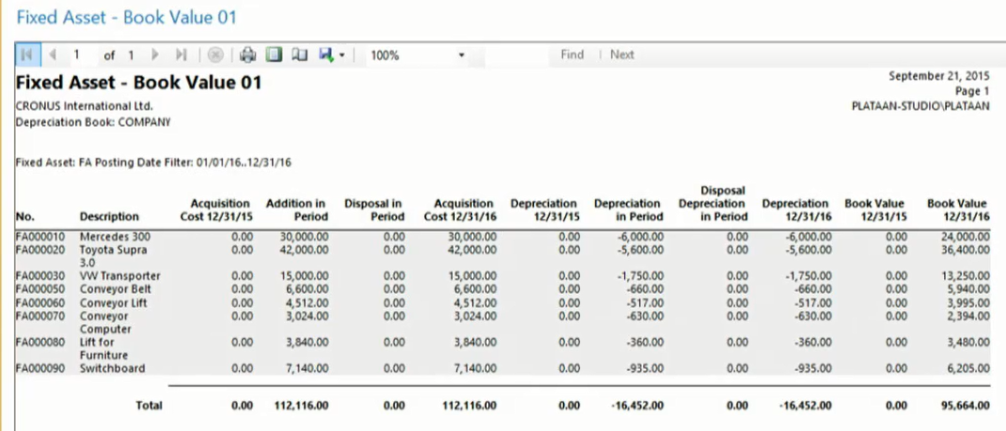
So with the acquisitions, with the depreciations, and with the book value based on the date filter. So that's basically typically something that we can use in fixed asset management.
Then the last component that I would like to show you in financial management is the one of currencies. So we can also very efficiently, very easily work with foreign currencies in NAV.
Next section regarding Currencies is not part of the courses AOMA,EPS1 and AOPR and for the Czech courses MPH_RIP and BPH_PIS1 and BPH_PIS2 this section will be simplified !

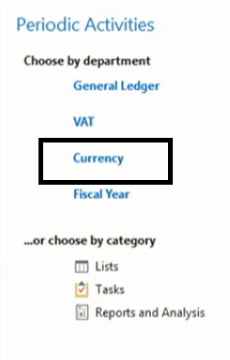
So if I go to currencies, you can see that that demo company has a number of currencies so that I can see here. So they use quite a lot of foreign currencies. And based on the specific currency, I can set up, for example, currency exchange rates.
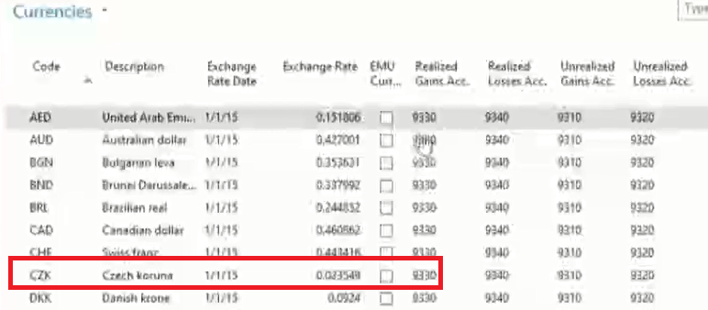
So if I click here for a currency on the exchange rates button in the ribbon, so I can specify, for example, the currency on the 1st of January 2016 and the exchange rate is, for example, 57.
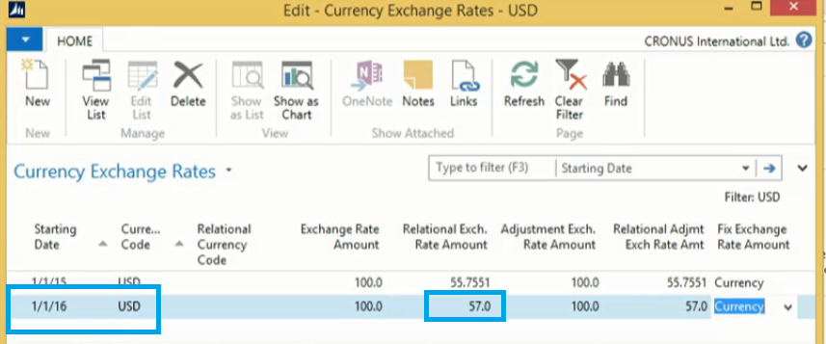
So based on the new exchange rates, I can run then an update of the exchange rates.
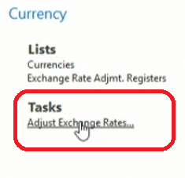
So, for example, I can specify that I would like to update the exchange rates on the 31st of December 2016. So and I will enter EX001.
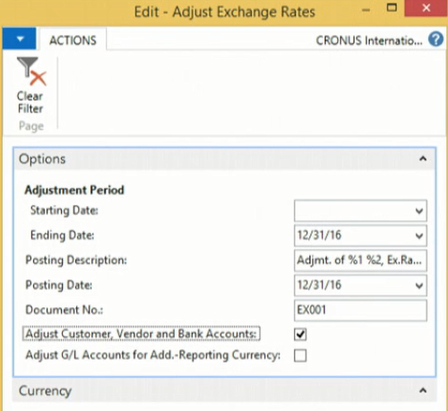

And if I now click on OK, you will see that the system has calculated the exchange rates.
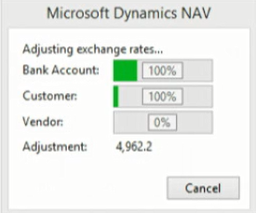

And if I go, for example, to the archive in order to have a look at the posting, you will see now that the system fully automatically has posted all the different exchange rates based on the new currency that we have entered in the system.

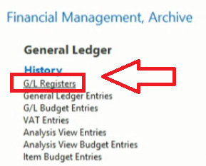
How to display G/L entries->this is part of hands on part of the course
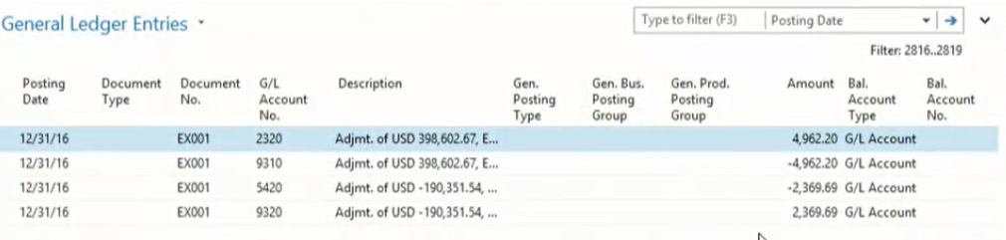
So this is also a very important component of financial management, especially for these companies working with foreign currencies. So these are some of the components of financial management in Microsoft Dynamics NAV, but, of course, not all of them. You can also set up intercompany, you can set up consolidation and so on. So in order to have a more detailed overview of everything that you can do with financial management, I could advise you to have a look at the courses Financial Essentials and Finance Advanced in Microsoft Dynamics NAV.

Financial Reporting and Analysis

So with the financial management functions that we just had a look at, we're putting quite a lot of financial data in the system. But typically decision takers, business owners and so on, they also want to take information out of the system, and that's something that they want to do based on financial reporting and analysis. Let's have a look at the main features in NAV. So if we're looking at financial reporting and analysis, then we can go to departments, and the financial reporting and analysis starts with some basic reports that we have available in the chart of accounts. So if I go to a typical expense account to show you a first example, so, for example, here office supplies, I can go to the G/L account balance, and there you can have a look at the postings. So everything that we have posted on this G/L account, for example, based on months.
Some of these analysis and reporting will be not part of the courses AOMA,EPS1 and AOPR and for the Czech courses MPH_RIP and BPH_PIS1 and BPH_PIS2 this section will be simplified !

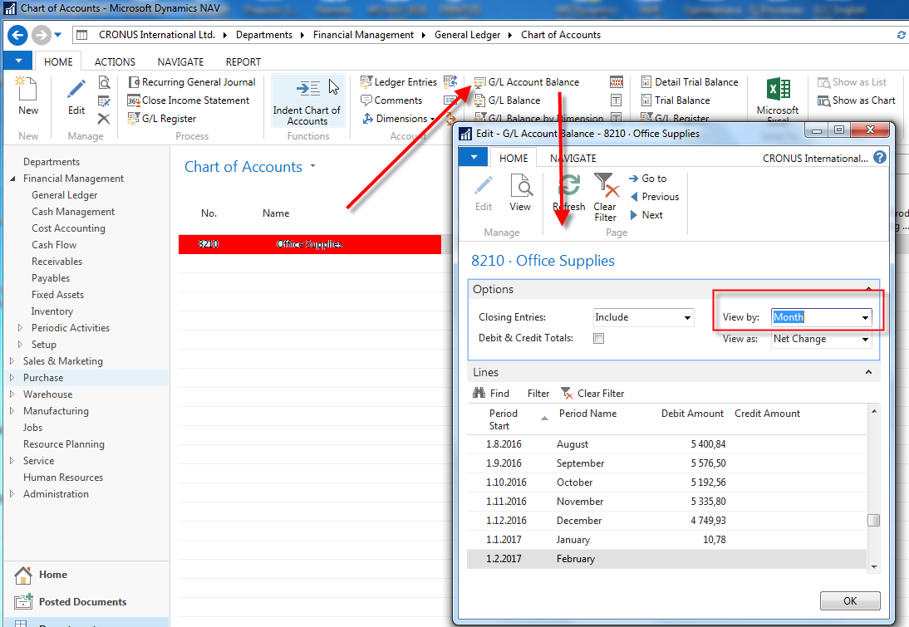

So in this way I can compare my office supply expenses of 2016 month by month or week by week or even year by year if you want. So this is a very simple example of a typical report that you can run from the chart of accounts. Another very nice example is a G/L balance by dimension. So in the G/L balance by dimension, I can include my analytical dimensions to retrieve a report. So, for example, suppose that I would like to have a look at my expenses per department. In this way I can choose my department dimension here in the show as columns fields. Next I can specify, for example, that I want to have a look at the 2016 expenses, so I will click here on year. My G/L account filter is 81 star because the G/L accounts start with 81. And I want to have a look at 2016. So now if I click on show matrix, you can see here my expenses, so my building expenses in this case compared month -- sorry, department by department. So in 2016 the administration department had this amount on cleaning expenses, the production department, the sales department, and so on. So this is a second report that we can run from the chart of accounts.
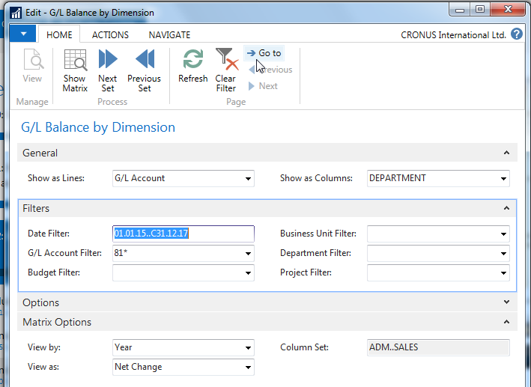
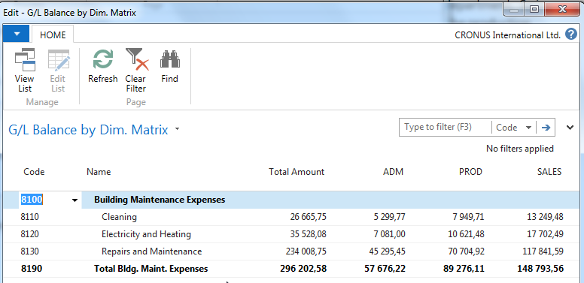
And the advantage of these kind of reports is that they are very easy to use. So I don't need to do an extended setup, so the only thing I need to do is apply a couple of simple filters, and I can run my report. Now, if we want to go a step further, we can also use account schedules. So if I go to reports and analysis, I can click here on account schedules. And with account schedules the system will allow me to set up some reports based on G/L accounts, but where I will have the flexibility to define what I would like to report. So if I run one of the typical account schedules that our demo company Cronus is using -- so let me click here on overview -- you can see here that I get a report in which I can see current assets, their net change, their net change debit, their net change credit. But let me switch, for example, to quarter. So here I can see now the net change of the current quarter, debit and credit, the balance at date, and so on.
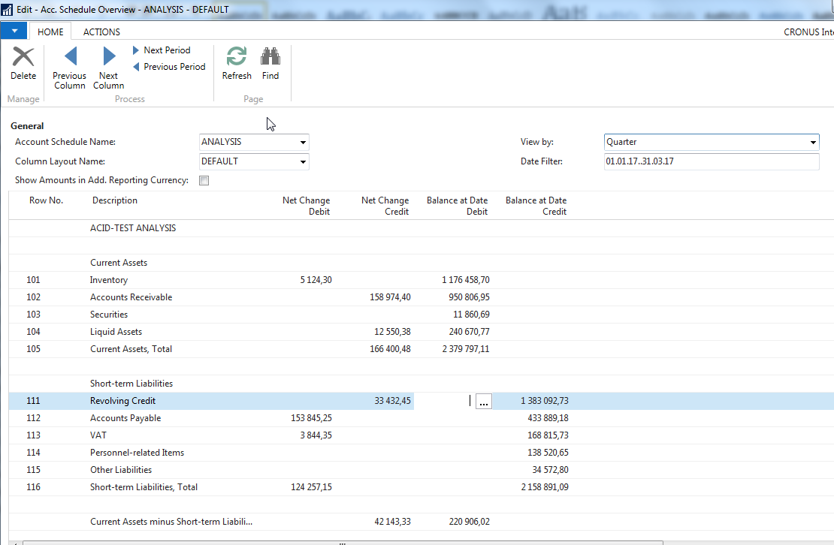
Again, so this is a report showing the current assets and the short-term liabilities. But more important, this report is created by the user. So if I go back one step and if I go to the edit account schedule function, you can see that as a user I can fully define what I would like to see in this report. And my report is based on G/L accounts but can also be based on cost accounting and even cash flow. And so in that way I can very easily define what I would like to see. And by setting up column layouts, I can also define the columns I would like to see.
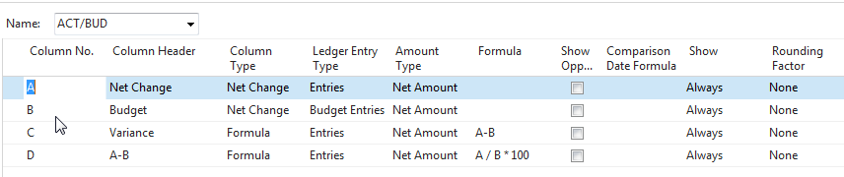
I would like to see, for example, a net change, compare it with a budget, I would also like to see the variants between the two and so on. You see? So that's a function, the account schedule, a very flexible function that we can use as a financial user to set up our own reports and run them in the system.
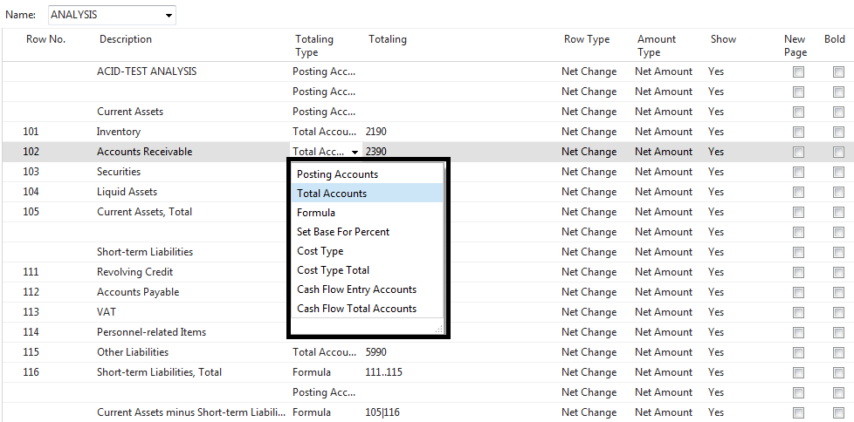
Now, in one of the reports that I just showed you, you saw me using departments. Now, department is a dimension, and that's of course also something very important in Microsoft Dynamics NAV. So we can use dimensions in order to be able to report on these dimensions. So, for example, as a company I am interested in the sales that we did by area.
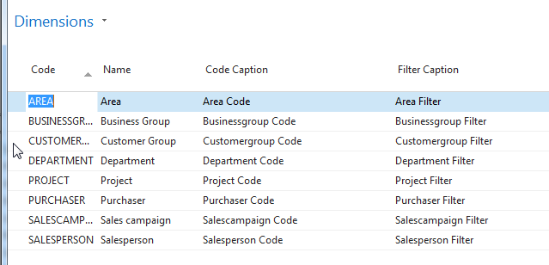
So did we sell quite a lot in our local area, or did we sell quite a lot in other countries? How much did we sell by customer group and so on. So you can set up as many dimensions as you want as a company in order to start using them in financial reporting. So also here let me show you an example. So what I can do is go to the analysis by dimensions, and here, for example, we have an analysis in which I would like to analyse my sales by customer group, by area. So let me do this. If I go to edit analysis view, you can see that here I have the flexibility to define the dimensions to see as lines. So, for example, I would like to see my areas as lines and my customer groups as columns. So now I can see my sales by area, by customer group. By going to matrix options, I can define that I want to see this by year. And in filters I can, for example, switch from 2017 to 2016, which is a typical year in which my demonstration company has quite a lot of data.
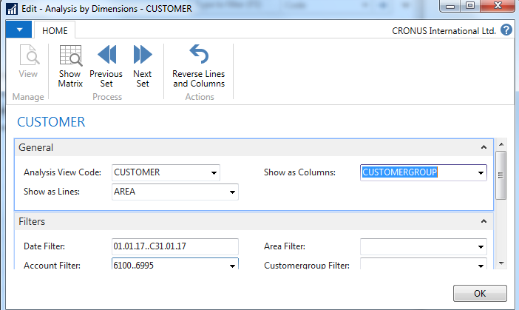
So now if I click on show matrix, you can see now my sales by area, by customer group. So now I can very clearly see that we have sold to large customers, 1 million 2 in Europe North; that we have sold to medium customers in the same area, 1 million 4; that we have sold to medium customers, 112,000, in America North.
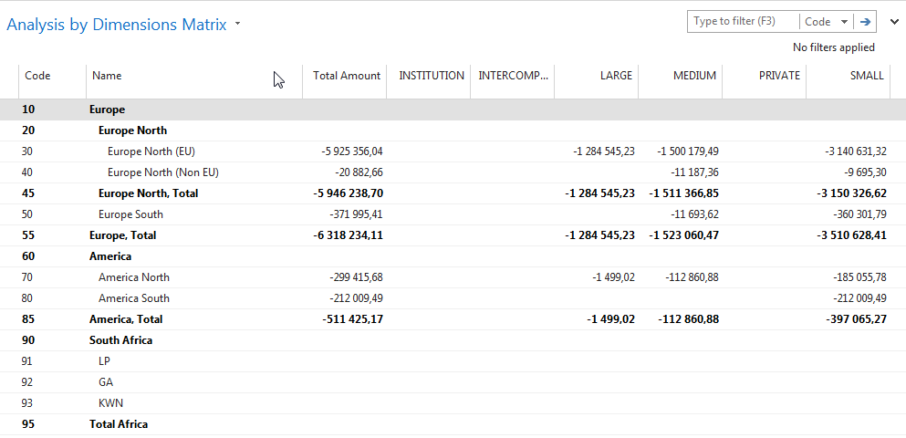
You see? So that's a typical dimension analysis that I'm doing here. So I would like to see my sales based on a number of dimensions. Also very interesting in this report is that we can export it to Excel. So you will see that a lot of these financial reports are fully integrated with Microsoft Office. So in this case I have a very nice export to Excel in which the system will create a pivot table. So based here on my data sheets, so in which I have all the data of my analysis view, you will see now that the system will create a pivot table that I can start working with now in Microsoft Dynamics NAV.
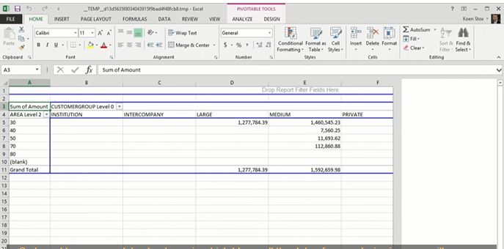
And in Czech Language
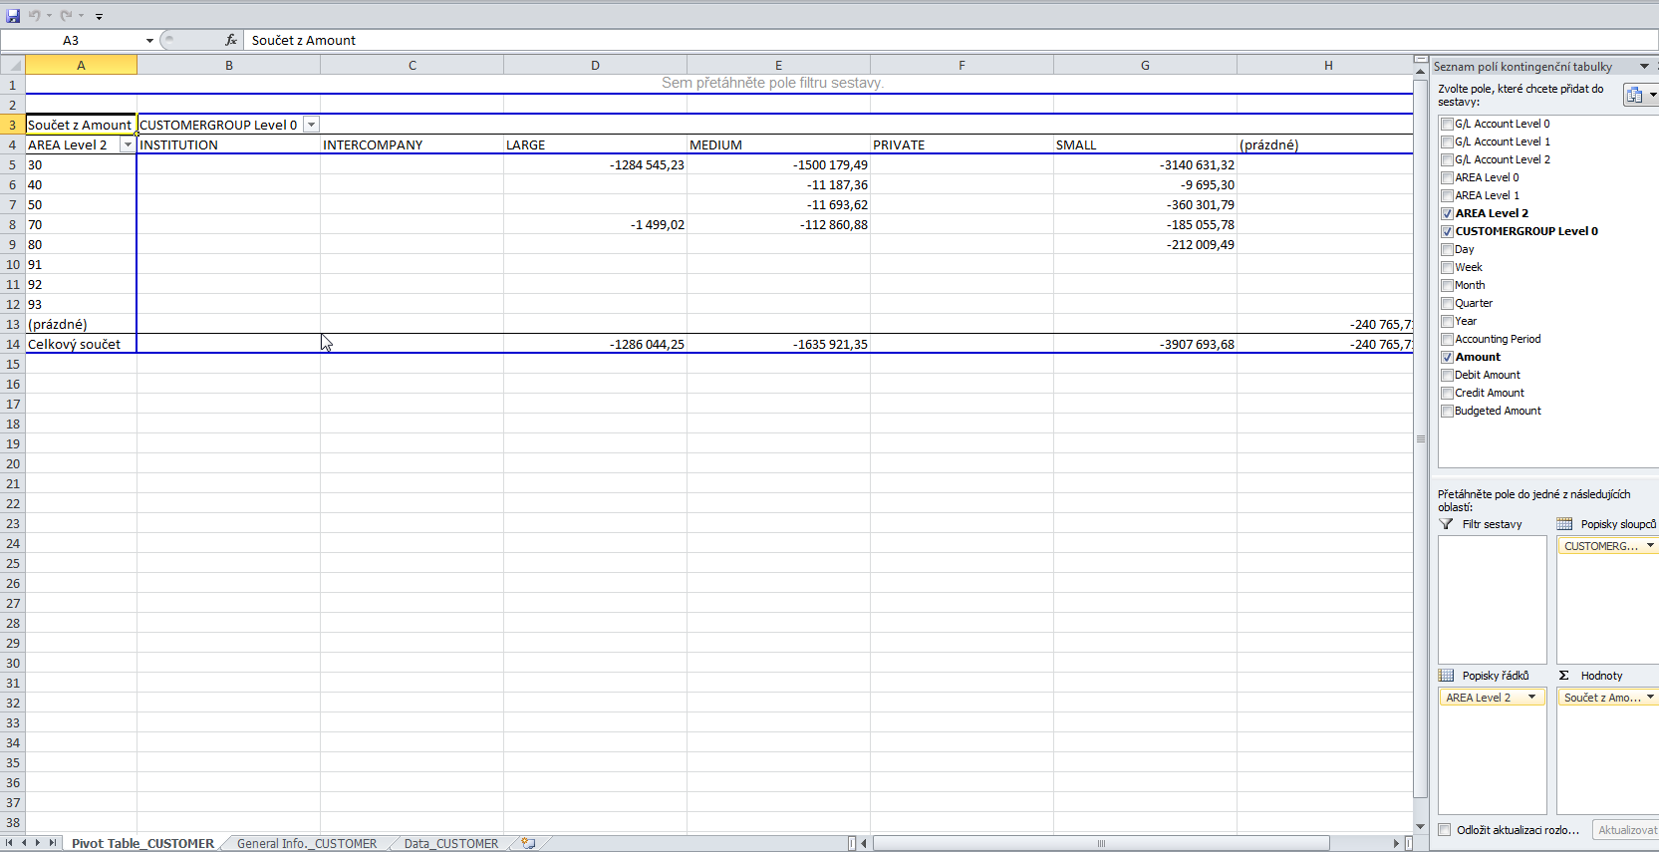
So these are a number of financial reports that we have out of the box. So we can run reports from the chart of accounts, we can use account schedules, or we can set up analysis views based on a number of dimensions that we can then also export to Microsoft Excel. Now, finally, there are also a number of ways that we can show financial information graphically. And one of the ways or one of the things that we can do is, for example, add a finance performance in a Role Centre. So here we can see that I'm using the accounting manager Role Centre, and based on an account schedule, in this case the revenue account schedule, you can see that Cronus has displayed graphically the financial data. So instead of running the account schedule in the way I just did in the previous section, you can also display it graphically. So in this case I can see, for example, now my sales retail domestic for the second quarter 2016. You can see, for example, what we have budgeted and so on. You can see the difference between the two, and there is only a very small difference. 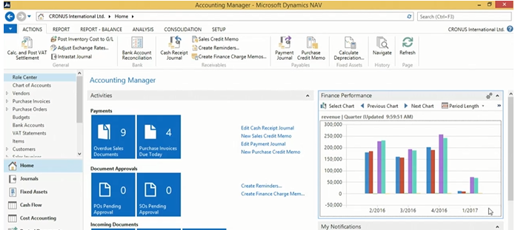
So, again, this is one of the many ways that we can use in NAV to display our financial data in a graphic way. So very interesting to extend the typical reports that we just had a look at graphically in the system.

Trade (text part)
Will be created and modified and during winter term 2017 (only for Czech courses)

Inventory Management (text part)
Will be created and modified and during winter term 2017 (only for Czech courses)

