Warehouse management setup
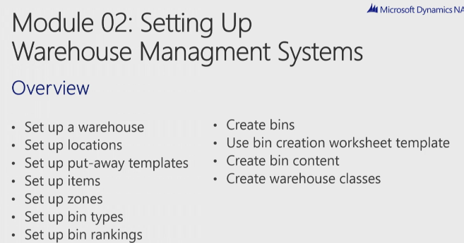

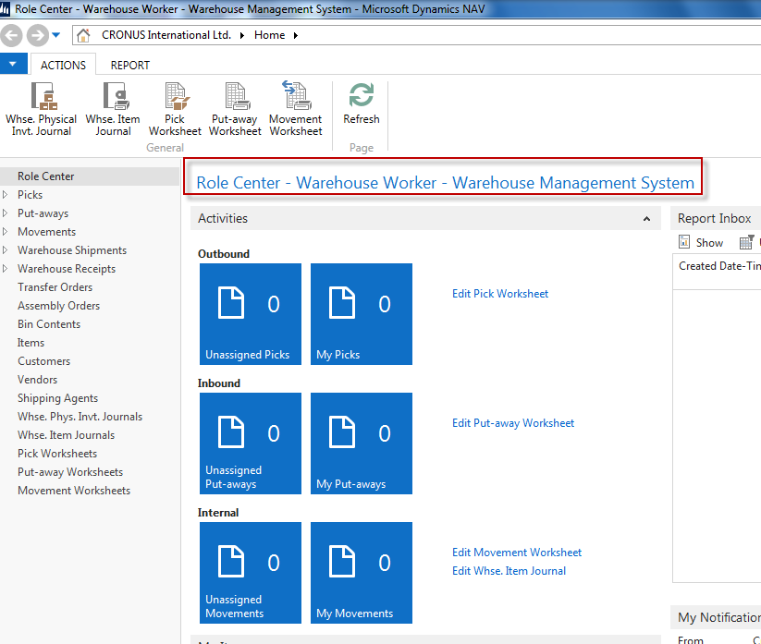

You have to assign yourself as a warehouse employee (go to administration)
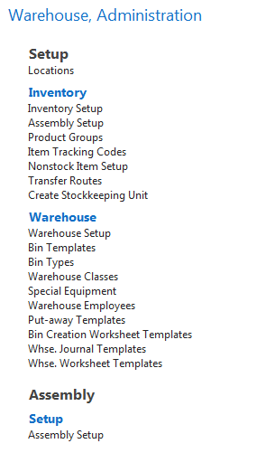
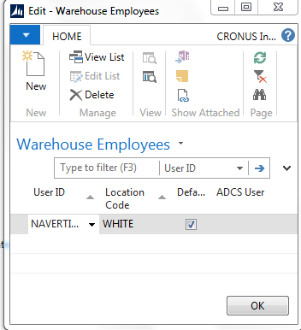

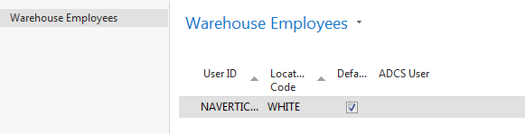
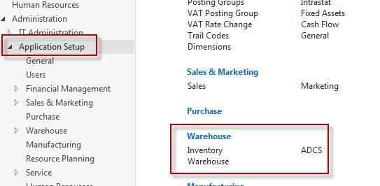

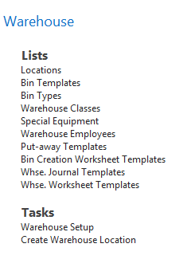

In this form the setup influences all locations, so it is recommended to setup these requirement for concrete location (e.g.White one) !!!
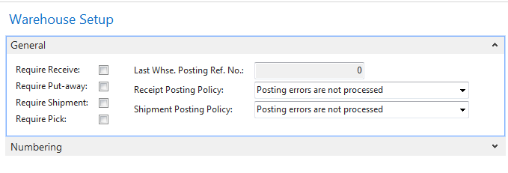
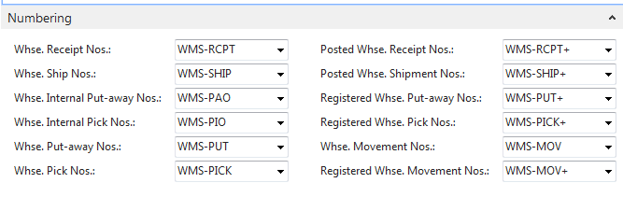
These numbering is OK

LOCATION SETUP
In this lesson let's now have a look at locations. And as I already explained, the location can be considered as a warehouse, as a physical location. And we just saw in the warehouse setup that you can enable a warehouse receive... a warehouse shipment, the put away and the pick in the warehouse setup, but that you only will do this when you're using blank locations. So if you're setting up different locations as warehouses, then you will enable these fields on the location cards

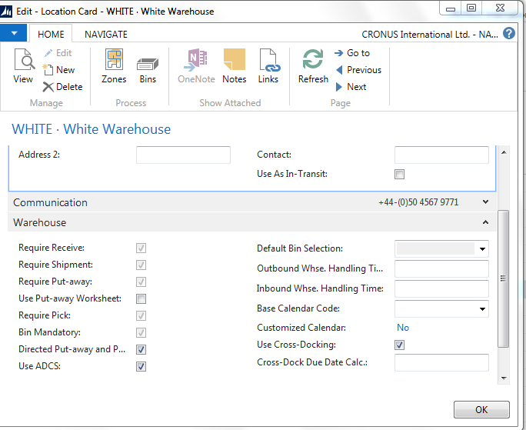

So require receive, shipment, put away, and pick. Now, once again, these fields are used to enable what I called in the first module decentralization. So if you say that, for example, the shipment of an item should not be done any more from a sales order, you can enable this field. And require shipment literally means require a warehouse shipment. So a specific warehouse document will be used instead of performing the shipment from the sales order. And the same for receive, but then purchase order. Now, on top of receive and shipment, you can also then enable the put away and the pick. So if you receive an item in the warehouse, you will have to put it away on, for example, it's a designated place. And before you can ship items to the customer, you first will have to pick them. Now, you can see that these fields, together with bin mandatory, are not highlighted, so they're un-editable. I cannot change them. And that's because the fact that we are using the directed put away and pick. So the directed put-away and pick, which we also call advanced warehousing in NAV, means automatically that we use all these different warehouse documents and that using bins will become mandatory.
We have ADCS, which stands for Automated Data Capture System. So this is a system where we can use RF scanning on items.

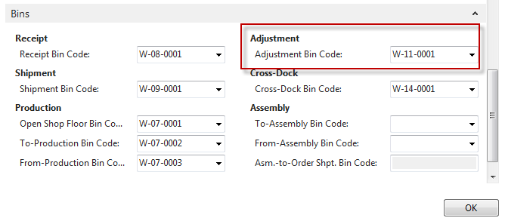

So directed put-away and pick means... so sorry. Let me just go back one more time. So means that we will use bins. And I can already say now that a bin is the smallest space that we will like to define in NAV. So a shelf, for example, in a warehouse. Okay. Now, because we are using bins, we can also set up a number of standard bins. So in here you can see a number of bins that can be assigned, for example, to post receptions on the shipment. We will also talk about integration with production and assembly. And so here you can see that we can specify production and assembly bins. There is an adjustment bin, a cross-dock bin, and so on. And so also typical about directed put-away and pick, that you can assign these bins so that NAV can use them in all these different warehouse documents as I will see... as I will show you in one of the following modules. And then finally we have bin policies. So these are a number of, well, very specific features that can be used for specific situations. Like, for example, special equipment. So it could be possible that you have very heavy items or items that... or bins, sorry, that are quite high. So where, might be possible that you need a warehouse lift to put away or pick some of these items. And then it could be interesting that a warehouse worker is informed about the fact that he or she will need special equipment. Okay? So on these documents it will be mentioned, then, if special equipment is needed. So a small feature. Then very interesting, the bin capacity policy. Now, one of the features, one of the important functions that we have in the advanced warehousing that you don't have in basic warehousing is that you can assign capacity to bins. So, for example, how much... what is the weight, what is the cubage that you can store on a bin. So with this field you will define how NAV will use these capacities. So you can say, for example, never check capacity. So that's quite obvious, I think. Then you can also say allow more than maximum capacity. So if a put away would result in exceeding the maximum capacity defined for a bin, then you will get a warning. If you choose this option, you will get a warning. But you can still register the put away. And then if you choose the last option, prohibit more than maximum capacity, you will see that it's not possible to exceed the maximum capacity of a bin. So it could be very interesting in directing put always in a warehouse. Then breakbulk, also something that we will cover more in detail in one of the next modules, which is basically breaking up, for example, the units of measure of a specific item. For example, I will need one piece of a pallet. Is it allowed to take a piece of a pallet. That's what we call breakbulk. Then the put-away template code, we will come back to this in detail. So very, very important in the directed put-away and pick. Then there's an option where you can say always create put away line and always create pick line. So also this I will use in this course in a specific... a very specific situation. And then finally pick according to FEFO. And FEFO stands for first expired, first out. And also here I'll come back to this function a little bit later in this same module when we talk about setting up item tracking in a warehouse. So this is how you can set up a location. Quite a lot of fields because in the directed put-away and pick it's very important that these features are set up in the proper way to get the proper direction in the warehouse. Now, the location is the first level, you could say, in defining a warehouse in Microsoft Dynamics NAV. In the following lesson, we will have a look at the other levels that we can set up.

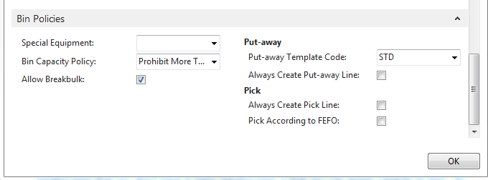

So in the previous lesson we talked about locations, and this is the first level that we can use in setting up a warehouse in NAV. In this lesson we will have a look at the other levels, and the best way to see how we can set up a warehouse is by looking at an example in the PowerPoints. Okay, so like I just said, location, the first level. So we saw what the location is. And so suppose this is my warehouse, so this is my location. The next thing that we will do in warehouse management systems is defining zones. And so a warehouse has got a number of zones. Now, what is a zone? Well, for example, you can have a shipping zone, you can have a receiving zone. You can also have a bulk zone where you will store items in large quantities, for example. You can have a picking zone, a production zone, and so on. So this is a large division, you could say, of a location. Very important, the directed put-away, and picks, so the advanced warehousing NAV is the only warehousing form that has zones. So the other variants don't have zones. This is only available in directed put-away, and pick. And then very important, the bins. So this is where we will really store items. So, for example, if we need to do a put away, we will always put away an item on the bin. If we need to pick an item, we will always pick it from a bin. So in a zone, we can then define a number of bins. So this is the smallest storage unit that we can set up in the warehouse management systems in NAV. Okay. Then, and that's something that we will also see in this module. We can set up a number of things such as a bin type. We can assign rankings to a zone. We can specify warehouse classes. And what you will see is that when you assign these to a zone, they will be used as default values for all the bins that you will create for that zone. So that's something that you can see here, okay? And some of the example... or some of the, yeah, examples, a bin type can be a put-pick bin. Bin rankings could be, for example, ranking 50/80. You can have a cold or a frozen class. And you can also see a number of zones, like the picking zone, the receiving zone, and this shipping zone. And so this should give you a very good idea of how you can define the layout of your warehouse in Microsoft Dynamics NAV. Okay. So this is an overview of the warehouse. So we already saw locations. So in the next lesson we will have a look at zones.
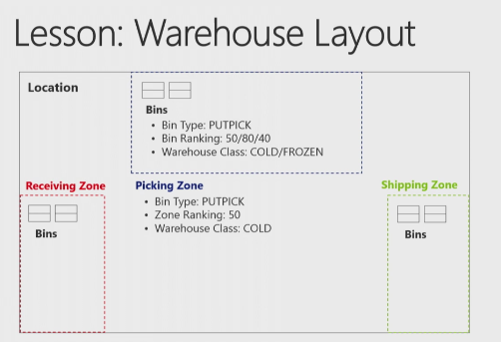
Let's now have a look at zones. So we already saw locations. We saw the general layout of warehouse and one of the levels that we can set up in the directed put-away or zones. Now, zones on bins as we saw comprise the basic structure of the warehouse. As zones are used to subdivide the warehouse into logical parts, and then we will divide them into bins. Now, when defining a zone, we can specify a number of parameters. So as we will see in the application a couple of moments. And every bin that we will create in a zone will inherit these parameters as a default, which also means that you can overrule them as you can apply specific parameters to a bin in a specific zone. So once again only default values that can be changed at any time. Let's go to the application so that I can show you how we can set up zones in NAV. Okay. So here we still have our list of locations and if I now go to the ribbon I can click on zones. And so there you can see the zones that are created for our demo company Cronus. Now, the number of zones that you create is completely up to you or up to the real life situation. You can use only two zones or you can create 20 zones. So there's really no limit in defining the number of zones, okay? But here you can see a number of or a couple of very good examples. So there's the bulk zone where we'll store items in large volumes. There's a picking zone. There's a receiving zone, a shipping zone and so on. Now, basically what we will do is we will assign a code and a description to a zone. And then there's the bin type. Now, I can already say now that the bin type defines the type of transaction that is allowed for zone or a bin. But that's a lesson that we will cover in a couple of moments. There's the warehouse class. Also here we'll come back to this a little bit later. Here remember the setup option that we saw in one of the previous lessons. We can assign special equipment to a zone. Like, for example, a lift, a hand truck and so on. And then you can also assign a zone ranking. Now, typically like zone ranking and bin type or use them as a default to create bins for a zone as we will see in the following lesson, and that's once again that's one of the most important purposes of setting up zones, assigning these default values so that it will become easier to create bins in a zone. And then you can also see if cross-docking is allowed in a specific zone. So by assigning this zone field you can assign a specific zone as a cross-docking zone. So we had locations. Now we saw zones. In the following lesson we will have a look at bins.
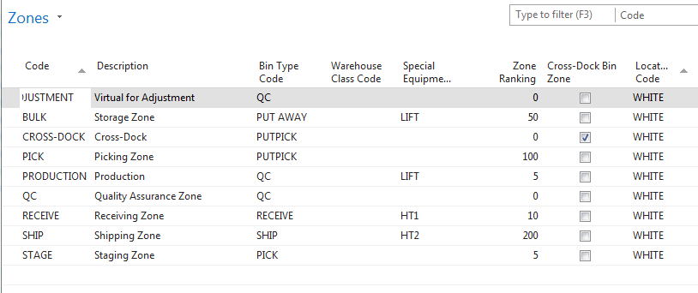

Warehouse Layout - Bin Setup
In this lesson we will have a look at the third level that we can use in setting up the layout of a warehouse, maybe one of the most important ones, and that's the bin. Now, what is a bin? It's the smallest unit in which to place and register items. So the bin is the backbone of a warehouse structure. And to make the architecture more complete and build up business logic, the company can define bin types, and there are a combination of warehouse actions indicating the purpose of the bins. And bin types we will cover in the following lesson. So, here, let's go and have a look at the bin itself in the application. Okay. So, once again, you can still see the other two levels, the location, then the zones. And now, for example, for the storage zone, so the bulk zone, I will click on bins. So here you can see the bins defined for the bulk zone. Okay. A couple of things are very important. Let's start with the code. Because the bin is the smallest storage unit that we define in NAV, this should also point to what we would like to use as the smallest physical storage unit. You could say, okay, my smallest storage unit is a shelf, for example, but is that actually the smallest storage unit that you would like to define. Maybe it's a rack of a shelf, for example, or maybe a part of a rack of a shelf. You see? So that's something that you will have to think about in real life, how you want to set up bins. And so... and, once again, the code should point to the smallest storage unit. For example, we see W, which probably stands for white. Then we say 5, which could be the hallway in a warehouse, for example, so hall number 5. And then you see 01, 02, 03, which could point, for example, to a shelf or to a specific place or to a rack or whatever. And so that's something that you need to take into account when defining the bin code. Okay. Then you see a couple of other fields like description and dedicated, so we'll cover these a little bit more in detail in one of the following lessons. But this is also the way that you should use bins in basic warehousing. Okay. And as I already explained, the difference between basic warehousing and advanced is the direction that you can get from the system. Now, in order to set up this direction, we need to specify a lot more on bins for advanced warehousing, and that's why I will go now to choose columns. And you can see that there are a number of additional columns that I can add. And I will just add all of them. So there you go. And so as you see... and let's move up this field a little bit. That's better. Okay. This one I don't need. Okay. So there you go. So this is, these are the fields that I will add. And so now if you open a bin, you can see a completely different picture. You see? So now you see all the fields that we might need when we want to set up a bin in warehouse management systems. And there's a lot more, and they'll all need the code and the description that we just saw. And we can also see now add the bin ranking, the bin type, the block movement, and so on. So most of these fields we will cover in one of the following lessons. But, once again, this is very important when defining bins that we specify all these different fields in order to get the proper direction that we need from the system. Okay. So this is our third level, bins. So we saw the basic definition of a bin, but in the next lessons we will stick with looking at these bins because we will have a look at the bin types, bin rankings, and so on
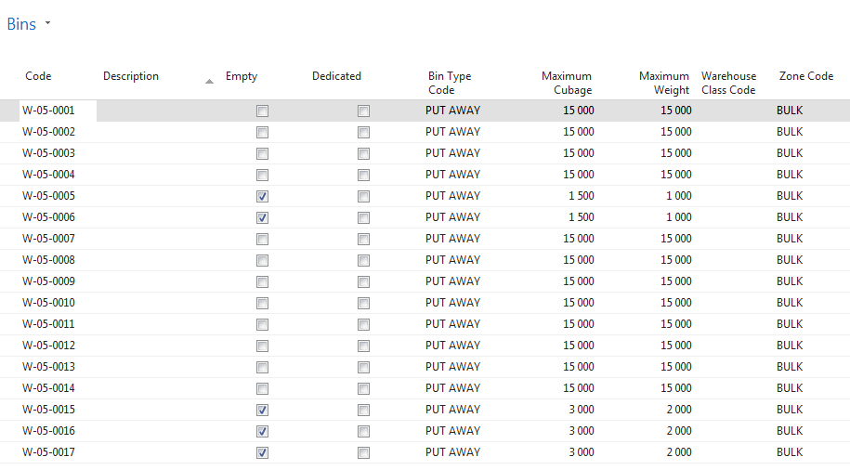

Bin Types Setup
So in the previous lesson we had a look at the bin and the smallest storage space that we can define in a warehouse and we saw that on the bin we can setup a lot of features. And one of the maybe most important features is the bin type. Now a bin type is a kind of high level business process qualifier that will allow the program to build up some code logic to perform fast. It works together with the zone first of all. The zone will act as a geographical qualifier. Then it will also work together with the bin content that will act as the content qualifier, so by linking the bin and the item together. It will also work together with warehouse class codes. So when the warehouse class code is then the content qualifier so that we can distinguish the warehouse in specific workflows, such as frozen and antistatic and so on. Then it will also work together with the bin ranking, which is a qualifier for selecting a bin in the put away or the picking process of an item. Let's go to the application so that I can show you how you can setup the bin type. Okay, so I'm still in my overview of my bulk bins. Well, another way of defining the bin type is specifying which actions are allowed on a specific bin. Take now for example the bulk bin. We can imagine that the bulk bin or a bulk zone is a zone in the back of the warehouse where we store everything in large quantities, as I already mentioned. Now from the efficiency point of view, it's probably not very efficient that a warehouse employee is sent by the system to bulk bin to pick for example one piece. So that would not be very efficient, because typically picking is done in front of the warehouse, very near by the exit for example, or the shipping zone. In order to prevent users to send them to, for example the bulk bin to, for picking an item. We will simply not allow picking from a bulk bin. That's what you do with the bin type you see. If I now go to the list of different bin types and if I now click on advanced you can see what the bin type actually means. Now here you can see the different actions that we can use in warehouse management. So the physical transactions receive, ship, put away, and pick. And here you see for example our put away bin that we are looking at right now. So the bulk bin there only put away is allowed. You see so a picking is not allowed and by assigning this bin type to these bulk bins we will have the result that the application so that the system will never send the warehouse worker to a bulk bin for performing a pick. Just as for example on the picking bin we will never be sent to a picking bin to do for example the put away. You see, so you can define the action which is allowed or not allowed on a specific bin pick, put away. Then there's put pick, which is a flexible bin. So you can both do the put away and the picking. Then we have a type quality control. That's something which is used internally. I will explain this when we cover for example the internal warehouse processes. And then quite obvious we have the receive bin where only a receive is allowed. And we have the ship bin where only the shipment is allowed. So once again this is a first but very important feature that we need to setup on a bin, in order to specify what you can do or what is not possible from the physical action point of view on a bin, so very important bin type. In the next lesson we just saw at the introduction of this lesson. That the bin type will work together with the bin ranking. That's something that we will have a look at in the next lesson.
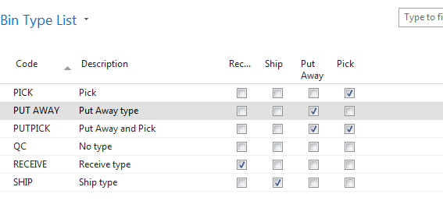

Bin Ranking Setup
In this lesson let's have a look at bin ranking. And bin ranking is a method of prioritizing replenishment movements picks and put-aways. Indicating which bin needs to be replenished or needs to have items picked or put away first. And this is done so with a bin ranking. And a bin with a high ranking number has a higher priority than the one with a low number. So very simple what that's concerned. So when bins are created, they will get the default ranking of the zone as we already said. But you can still change the ranking for an individual bin. Let me show you in the application how we can or how the bin ranking looks like. Okay. So in the application, first of all, let me go back one step. So I will... there we go. So I will go back to the zone. So in here you can see we started from the storage, the build zone and so I will stick with this zone. And the zone has got a zone ranking of 50. So this means that if you create a new bin, if I would go to the last line, and if I will set up a new bin, you see that, for example, the bin ranking here is automatically 50. You see that's what we mean with inheriting or getting the bin ranking from the zone as a default. However, what you also see here, sorry, is that the bin ranking can be changed for individual bins. Some of the bins in the build zone have got a bin ranking of 60. Now, this is very important. The bin ranking is for me one of the most important fields in setting up warehouse management, because once again as we saw in the introduction, the bin ranking is used for prioritizing bins. I always explain this with a very easy example. Suppose that you're a warehouse worker and you need to pick an item. And you have a shelf of let's say, for example, ten feet or ten meter high and exactly the same item is placed at the bottom level and at the top level. Now, for the top level you would need a lift, for example, which item do you prefer to pick. I think the answer is probably the item on the bottom level. Well, that's something that you can achieve with bin rankings. If you assign a higher bin ranking to the bottom level than the one to the top level, you will see that the system will, in my example, will guide you, will lead you to the item on the bottom level. You see, so that's why a bin ranking is very important. So even within the same zone, it could be important or even within the same rack or shelf it could be very important to specify different levels. But also between different zones it's important, because NAV will also use bin rankings for the replenishment as we will see in the module on internal warehouse processes. So replenishment is always done from a lower to a higher level, for example. Also from that point of view the bin ranking is very important. And also for this reason it's not always very obvious to set up immediately correct bin ranking. So this is something that in real life might require some testing before we can specify the correct bin ranking, but once we have the correct bin ranking, you will see that the efficiency of our warehouse processes NAV will increase quite a lot. So that's the bin ranking. And together with the bin type very important setup feature on the bin. In the next lesson we will have a look at how we can create bins.

Creating Bins
In this lesson let's have a look at how we can create bins. So we saw now the different levels that we can set up to specify the layout of a warehouse, so the location, the zone, and the bin. But it's also very important of course to have a look at how we can create bins. Especially because, well in real life you probably will have to create a lot of bins, and especially for large warehouses they typically have a lot of bins. That's why a bin can be created manually but also automatically. And let's go to the application so that I can show you how this is done. Let's start with manually. So there I will also take the occasion to explain some of the other fields. So suppose I would like to create manually a new bin in the bulk zone, so the storage zone. I can just go to a new line. I can enter the following bins. So I will just enter manually bin 18. Then you have a description. You can enter a description but as you can also see here you don't have to. So that's an optional field. You will also see that NAV will automatically assign if a bin is empty or not. So all these bins which have no check mark are bins that contain content, so we will talk about bin content a little bit later, but here you can see the empty bins, but also the bins that contain some items. Then there's a field dedicated. Now dedicated is used for example in manufacturing in order to specify that the bin contains dedicated content, for example a work center in manufacturing. But I will talk a little bit more about this in the module on Internal Warehouse Processes. Then we already talked about the bin ranking and the bin type. There's the block movement which I will also explain in the module on Internal Warehouse Processes. There's cross docking, which we will also have a look at by making a scenario. And then there's the maximum cubage and weight. So this is used for capacities as we already saw. So here I can enter the maximum cubage and the maximum weight that can be stored on a bin. So this should of course be also defined sort of on an item, but I'll come back to this a little bit later. Then there's the special equipment which I already explained. And we can assign a warehouse clause, which is also something I will come back to a little bit later in one of the following lessons. So that's how you can create a bin manually. But like I already said in the introduction of this lesson, typically for large warehouses you will have to create a lot of bins. There it could be very useful to use the function in NAV to create bins automatically. So first by setting up a template you can create a worksheet with specific features for a lot of bins, and then create the bins. Now you can go to the demonstration in this lesson, where you can have a look at how to use the bin creation worksheet. So how to create multiple bins, and then you can go to the practice where you can setup manually a number of bins

Manually
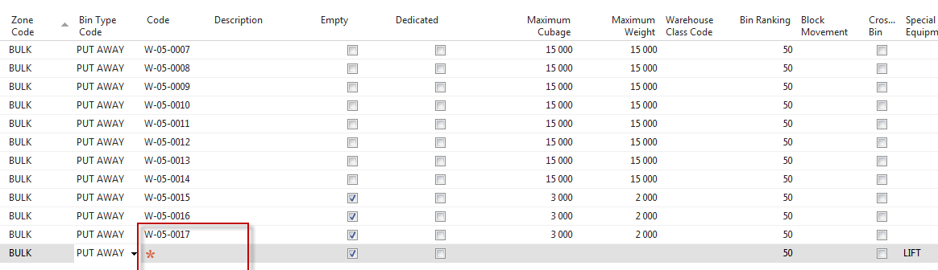

Demo: Create Multiple Bins

Set up the user as a warehouse employee.
- In the Search box, type "Warehouse Employees".
- Click the related link.
- Click New.
- In the User ID field, click the drop-down arrow.
- Select the ADMINISTRATOR user.
- Click OK.
- In the Location Code field, enter "WHITE".
- Select the Default field.
- Click OK.

Create a bin template.
- In the Search box, type "Bin Templates".
- Click the related link.
- Click New.
- Right-click on one of the column headers.
- Click Choose Columns....
- Select Bin Ranking.
- Click Add >>.
- Select Bin Type Code.
- Click Add >>.
- Select Zone Code.
- Click Add >>.
- Select Maximum Cubage.
- Click Add >>.
- Select Maximum Weight.
- Click Add >>.
- Click OK.
- In the Code field, type "NSB".
- In the Description field, type "New Storage Bins".
- In the Location Code field, enter "WHITE".
- In the Zone Code field, enter "STAGE".
- In the Maximum Cubage field, type "300".
- In the Maximum Weight field, type "300".
- Click OK.

Create multiple bins.
- In the Search box, type "Bin Creation Worksheet".
- Click the related link.
- Click the ACTIONS tab of the ribbon.
- Click Calculate Bins....
- In the Bin Template Code field, click the drop-down arrow.
- Select NSB.
- Click OK.
- In the Rack From No. field, type "W".
- In the Rack To No. field, type "W".
- In the Section From No. field, type "15".
- In the Section To No. field, type "15".
- In the Level From No. field, type "001".
- In the Level To No. field, type "250".
- In the Field Separation field, type "–".
- Select the Check on Existing Bin field.
- Click OK.
- In the ACTIONS tab of the ribbon, click Create Bins.
- Click Yes.
- Click OK.
- The demonstration is now completed.

Practice: Creating Zones and Bins

High Level Steps
- Scenario.

Create a new Zone for the WHITE location.
- Click the Search box.
- Type "Locations".
- Click the related link.
- Select location WHITE.
- In the HOME tab of the ribbon, click Zones.
- In the ribbon, click New.
- Click the Code field.
- Type "Internal".
- Click the Description field.
- Type "Internal Use".
- Click the Bin Type Code field.
- Click the drop-down arrow.
- Select SHIP.
- Click the Zone Ranking field.
- Type "0".
- Click OK.

Create 5 bins in the internal zone.
- In the Location list page, select location WHITE.
- Click Zones.
- Select INTERNAL.
- In the ribbon, click Bins.
- Click the Code field.
- Type "W-16-001".
- Click the next line.
- Click the Code field.
- Type "W-16-002".
- Click the next line.
- Click the Code field.
- Type "W-16-003".
- Click the next line.
- Click the Code field.
- Type "W-16-004".
- Click the next line.
- Click the Code field.
- Type "W-16-005".
- Click OK.
- Click OK.
- The Practice has been completed.

Put-away Template Setup
In this lesson let's have a look at the put away templates. Now, warehouse management systems, as I already explained, it's all about directing of put away and picks. So we should be directed. Now, in the Dynamics NAV, we will use the put away templates to optimize the put away process. Now, with this feature we will place goods to certain places the first time and then have the program retrieve the goods from their proper place whenever required. Now, as a company, you can create a number of put away templates to suit different business needs and then select one of them to use the general put always, and you can overrule on, for example, an item card. Let me show you in the application how this looks like. Okay. So I'm in the warehouse setup, so I will go to warehouse. There you go. And here you can go now to the put away templates. So this is very, very important, obviously for the put always so that's why it's called the put away template. Now, once again, if we just think about the efficient use of a warehouse system and suppose that you receive an item in the warehouse, so a vendor delivers an item, then it's very important that you will find the best possible place in the warehouse to put away the item. And then this can be defined by using a number of rules. For example, one of the rules could be if the same item is already stored somewhere in the warehouse and if there's still capacity on that specific place in the warehouse, then that might be the best place to put all the of the same items together. You see? So that could be a rule that you would like to apply when putting away items in the warehouse. And that's typically what you will do with the put away template. So let's show an example. And so if I show you the put away template standard, so the one that Cronus has created, you can see here an example of the put away template. And let me... let me... there's a little bit... there. There you go. So basically what you see here, so these lines represent a number of requirements. The requirement of a bin that NAV will look for when putting away an item. And so we will always start... or NAV will always start by checking the requirements of the first line, so by looking at these requirements and comparing or looking for a bin that has these requirements. So, and once again, this is just an example, but an example that shows quite well how a put away template could be set up. So the first requirement is that it will look for a bin, a fixed bin, which means that a... a bin where an item is assigned as a fixed item. So they're linked together. A fixed bin where the item with same unit of measure is already stored. In... sorry, in the same unit of measure (Miki corrected text already) . Less than the minimum quantity, which we can define in the bin content, as we will see a little bit later. And if the system will find such a bin, so a bin meeting these requirements, it will select this bin in the put away document, so and it will guide the warehouse employee to that specific bin. So that would be the best possible bin in this template. Okay. But quite a lot of requirements. So the chance that the system doesn't find a bin meeting all these requirements is of course quite high. So and if that would be the case, then the system will go to the second line. So the second line almost the same requirements but the last one is removed. And so we're finding a bin with less than the minimum quantity is not required anymore. It should still be a fixed bin with the same item and the same measure. Once again, if that bin is not found by the system, then it will go to the next line where it shouldn't be a fixed bin anymore but it can be a floating bin, floating bin with the same item and the same unit of measure, and so on and so on. You see? So we will start with the most requirements and then by going to the next line, everything will be less strict defined, as you can see. And, for example, the last line here is just any floating bin. You see? And that's the way or that's the process that the system will check when looking for the bin to put away an item. So first line, second line, until it finds a bin with the requirements of that line. . So that's very important. Now, another thing which is important, just as you can see here, you can define multiple put away templates. So, for example, if I go back to the standard, you can see that the standards is a template setup based on the concept of a fixed bin. Now, it could be possible that some items that you're storing in a warehouse don't have a fixed location in the warehouse. Okay? So then there's no need to have the system find fixed bins because they will never exist. And in these cases you could specify, for example, a second template where you say, okay, we will not have the system find fixed bins because for some items they don't exist, so just start looking for floating bins, as you can see here. So that's something which also might be very important. So based on the type of item, you might want to create specific put away templates. And what you will see then is that the general, the standard or the default put away template is defined on the location. So if I go to location and if I go to edit, we could see, remember, on the bin policies there you can specify the put away template code, which means that this is the default. Okay? So for all of the items that don't have a specific put away template assigned, it will use this one. However, if you would like to overrule, you can go to an item or a stock keeping unit, either of the two, and there on the item you can then specify on the warehouse step... and let me just take any item. I will take the bicycle, for example, just an example. On the warehouse that you can specify, then, another put away template code. So, for example, if I would like... if I don't want to use the standard which is specified on the location card, I can specify, for example, a variable on the item card. You see? So a very flexible way of setting up and assigning the put away templates. So this is the put away template. And, as you can imagine, very, very important in order to increase the efficiency of our warehouse processes, especially then the put away process, in a warehouse. Now, you also saw that you can assign the put away template on an item card. So that was the first time that we use... used an item in this training. But there are some more things that you can assign or set up on an item which are important to be used in the warehouse management systems. And that's something that we will cover in the next lesson.
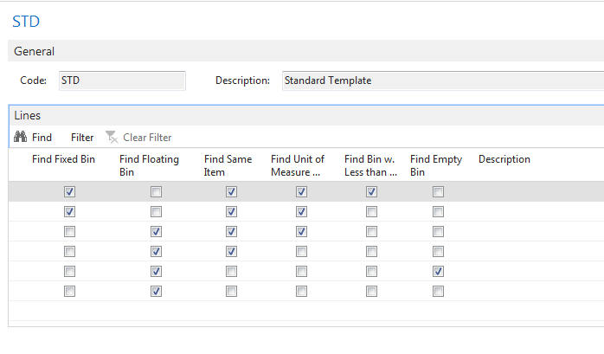

Item Setup
In this lesson, let's have a look at the item set up, and to make the most of the Warehouse Management Systems functionality and to fully use the available space in the warehouse, we can set up information on an item such as the weights, the height, and so on. So this will help the program to make the calculations which are necessary to suggest the most efficient and effective way to conduct warehouse activities. Now, besides these capacities, there are also a number of other things that we can set up related to warehouse management on an item card, and that's something I will show you now. Okay. So here I have an item, a loudspeaker, which is one of the items used in the white warehouse for CRONUS, so this is an item that we will also use in the following modules when we start processing warehouse activities. And each item, as you know, has a base unit of measure and can have a number of additional units of measures, such as the sales or the purchase and so on. Now, what you can do is, based on the unit of measure, you can assign the height, the width and so on. So if you go in the ribbon and you click on "Unit of Measure," you can see... and these fields I have just added by going to the choose columns function. You can add the cubage, the height, the weight, the length, and the width, and so fields that you can use then to enter this specific information for an item. So my loudspeaker, per piece, has got a cubage of 1.1, a height of 1.1, a length of 1, and so on. You see? So also the width very important, of course. This is then compared by the system with the cubage and the width that you decide... that you assign to a bin, okay? And in that way the system can check the capacity. And so as a bin... does a bin have enough capacity to put away a number of items, you see? So that's very important what the capacity measurement is concerned. And it speaks for itself that if we would also have this item in pallet, for example, that you can enter specific cubage, height, length, and so on a bin for pallets, okay? So that's the first thing that is important on item setup. Then the second thing, I already showed you the warehouse FastTab of an item for pointing at a put away template code. There are a number of other things that you can specify here, such as the special equipment code. So for example, if an item would be very heavy, then you can assign special equipment such as a hand-truck, for example. You can assign to put away a unit of measure. You can set up a physical inventory counting period, which we will have a look at in the internal warehouse processes and so on. And so here a number of warehouse features or information on warehouse management for an item. Also notice that you can assign the same fields on a stock keeping unit. As if you would use stock keeping units on top of items, you can see that if I've created, for example, a stock keeping unit for location white, that might also be necessary to go to the stock keeping unit card and to do warehouse FastTab and assign these fields on the stock keeping unit instead of the item. So this is the item setup that we need to do when we use items in Warehouse Management System environments. In the following lesson we will have a look at warehouse classes.
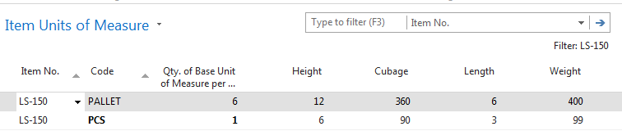
So :

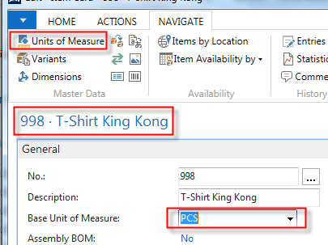

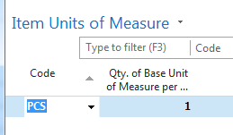

and chose column :

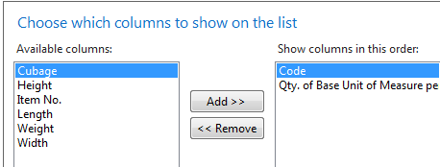

and

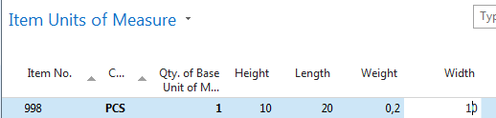 ¨

Go to tab Replenishment and purchase unit and add new unit of measure (pallet)

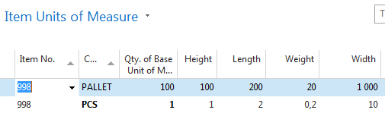

Nastavení pro různé typy skladů (i pro skladové jednotky)

Warehouse Class Setup
So in this lesson let's now have a look at warehouse classes. A warehouse class is something that we use to assign a specific condition to a bin, so you can set it up the zone to use it as a default for all the bins in that zone. And this is a condition that should be met in order to store an item on that bin. So let's go and have a look in the application where we can see that Cronus already has set up a number of warehouse classes. Okay, so first let me go to the setup. And if I go to the setup, you can see the warehouse classes that Cronus has created like Cold, Dry, Frozen, Heated, Nonstatic and so on. So creating a warehouse class is very easy. You just enter a code and a description. You can see a number of very good examples. For example if you have items that should be stored in freezers, you can create Frozen as a warehouse class. If they should be stored in a cold environment, a fridge for example, you can create Cold and so on. So once the warehouse classes are set up it's very important to assign them both to the bin and to the item. So let's start with the bin. So, I will go to a location... There we go... so, of course, Location White and then, you can go to bins. We already saw that it's possible to create, to assign a warehouse class to a bin... sorry, to a zone. Excuse me. So if we would have a zone, for example, a complete zone with freezers, you can create the zone and assign a warehouse class to that zone. And then if you go to bins... And that's the most important of course because it's on the bin that NAV will check the warehouse class... you can setup also the warehouse class on the bin, like I just said. If a specific bin would point to a freezer, you can then specify, for example... Let me take the empty one, for example the warehouse class Frozen. You see? So very easy. Very easy but very important that the application is able to compare the warehouse class assigned to a bin with the warehouse class for an item. Now let's also go and have a look at the item and where we can specify the warehouse class for an item. And I will go to warehouse. There we go. Planning and Executions. I will go to Items. And if I open an item, you have to go to the product group. So that's something that you might want to remember is that the warehouse class is not assigned directly on the item card but is assigned to a product group. So you can create, for example, new product groups per warehouse class. So I could say, for example, Anti-Static. I will call my product group the same as the warehouse class, which you don't have to but that's of course always easy to work with. Anti-Static Items. And what you can do now is go to the Choose Columns function and add the warehouse class. So there you go. I will open it again. Advanced. So there we go. So, the warehouse class is opened and now if I assign Nonstatic So let me Edit List. So, if I assign Nonstatic, so you have assigned, now, the warehouse class to the product group. And by assigning the product group to an item, NAV is now able to compare the warehouse class assigned to the item to the one assigned to a bin and find a bin where this item can be stored. So that's how you can set up a warehouse class, assign it to the bin and assign it to an item. In the following lesson, which is also the last lesson of this module, we will have a look at how to set up item tracking in Warehouse Management.
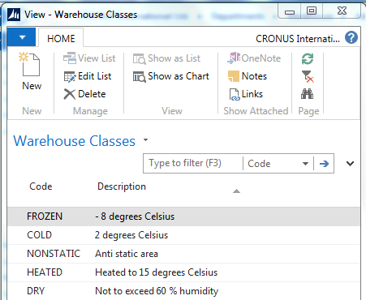

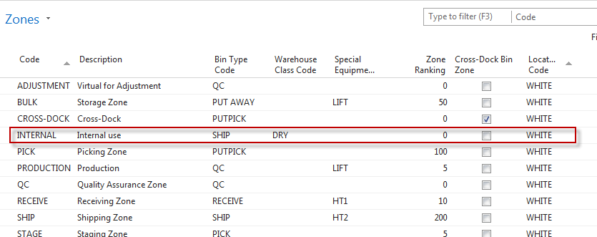

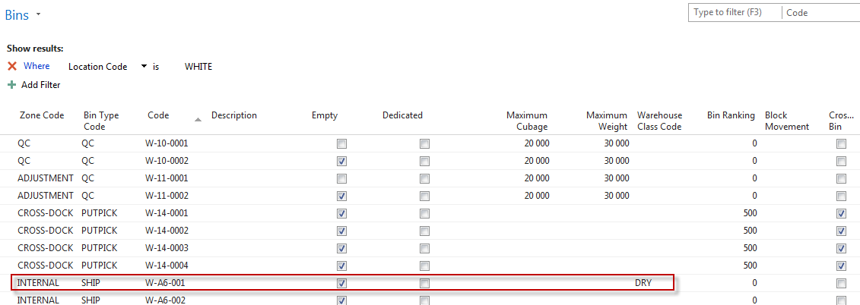
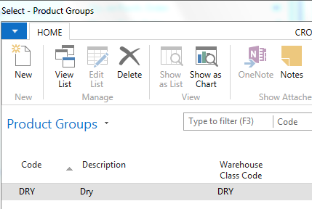

Preparing WMS for Item Tracking
Like I said in the introduction of this course, we will also spend some time on looking at item tracking and warehouse management. So if you are storing items with serial numbers with lot numbers in a warehouse, it's, of course, very important to set up item tracking information on an item so that you can also process serial and lot numbers in a warehouse. Now, in order to do this, we first need to do some setup and that's what we'll have a look at right now in the application. Okay. There are two things that we need to pay attention to. And the first one is, of course, the item tracking code. So for those of you who know how to work with item tracking, you know that item tracking is processed by assigning item tracking codes to an item. So if I take an existing item, so let's take, for example, a monitor. So this one. So I will open the item code. We can go to item tracking and here you can already see by looking at the item tracking codes that this item requires serial number tracking. So let me open the item tracking code card. So here I have the list. And if I click edit in the ribbon, there you go. So this is the item tracking card. Now item tracking card has got different file steps. So depending on what we need to perform with a specific item tracking card for an item, we can set up the serial number, the lot number and the miscellaneous file step. Once again, this is typically serial numbers. I will open serial number. And here you can see that the specific tracking is selected, which means that serial number tracking is required for all inbound and outbound transactions, however which is a field that's not selected automatically is warehouse tracking. So in order to be able to use serial numbers and lot numbers, so in this case serial numbers, in a warehouse, we should also select this field. You see. So in by doing this, we can, for example, when you're processing a pick, you can also specify in the pick document the serial numbers of the items that you have picked. So that's the first thing that needs to be set up. Then a second thing, but that's purely conditional, is that you might have to enable FEFO picking on the location card. So, we already mentioned this briefly in one of the previous lessons. If I go back to the warehouse setup... there we go... to the locations, and if I open location white again we saw on the policies file step pick according to FEFO. So this basically means if you have lot... if you're using items with a lot number, with expiration dates, so, for example, food or medicine, it's very important that the picking is done according to FEFO, first expired first out. If you check this field in this warehouse, NAV will then overrule for items using expiration dates all the standard settings such as the bin ranking, for example, and will look at expiration date to define the items that should be picked. So the expiration date will become the most important feature when picking items in this case. But once again this is only used when you're using expiration dates in item tracking. Okay. So this is how you can set up item tracking in warehouse management. So for tracking serial numbers, lot numbers and warehouse, you need to specify and warehouse tracking on an item tracking card. You can now go to the practice of this lesson and there you can try yourself to set up an item tracking code for warehouse tracking. And after the practice, I would like to invite you for the module review.
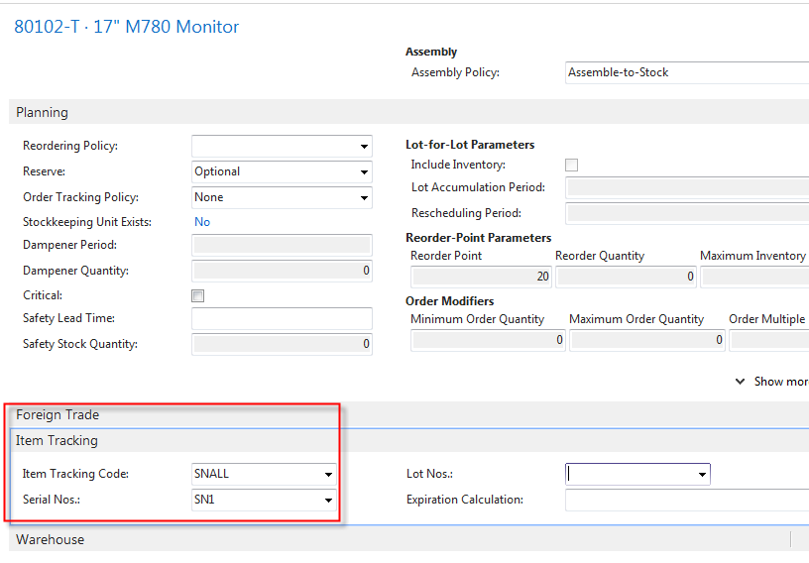

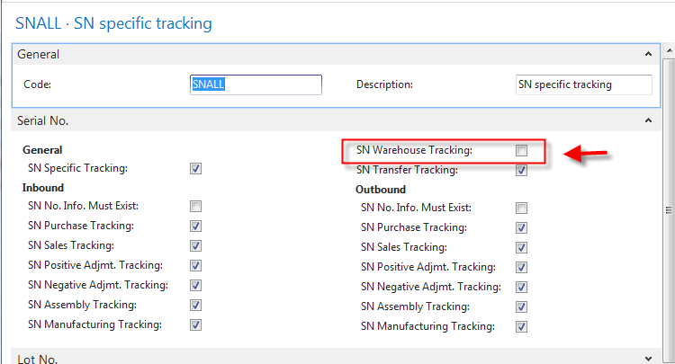
SN Warehouse Tracking filed have to be checked !!! See previous screen please !!
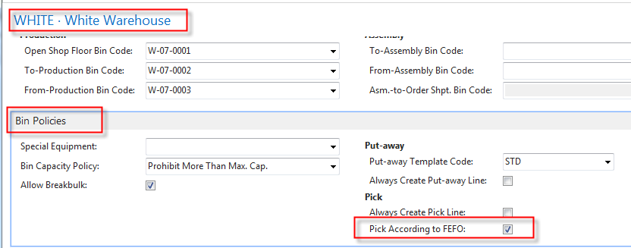
Pick According to FEFO (First expired first out) – if you have e.g. some alimentary products or medicines .

Practice: Set Up Item and Tracking Code for Warehouse Tracking

High Level Steps
- Scenario.

In CRONUS International Ltd., set up a new Item Tracking Code for warehouse tracking.
- Click the Search box.
- Type "Item Tracking Codes".
- Click the related link.
- In the HOME tab of the ribbon, click New.
- Click the Code field.
- Type "SNWH".
- Click the Description field.
- Type "SN Warehouse Tracking".
- Expand the Serial No. FastTab.
- Select the SN Specific Tracking field.
- Select the SN Warehouse Tracking field.
- Click OK.

Assign the new item tracking code to the items.
- Click the Search box.
- Type "Items".
- Click the related link.
- Locate and select item 80102-T.
- Click Edit in the ribbon.
- Expand the Item Tracking FastTab.
- Click the Item Tracking Code field.
- Enter "SNWH".
- Click OK.
- Locate and select item 80103-T.
- Click Edit in the ribbon.
- Expand the Item Tracking FastTab.
- Click the Item Tracking Code field.
- Enter "SNWH".
- Click OK.
- The Practice has been completed

Module Review
Welcome to the module review. So in this module we had a look at how to set up Warehouse Management Systems in Microsoft Dynamics NAV 2013 R2. So in NAV we can use a highly effective tool for handling items and Warehouse Management System. To meet business needs, the Warehouse Management System needs to be set up, of course, and there are several steps involved in setting up Warehouse Management Systems, and we saw providing warehouse management setup. We also defined warehouse policies for locations. We provided additional information on the item unit of measure such as the weight and the cubage. We created put away and bin creation worksheet templates. We have set up bins. We also had a look at the zones, so the location, the zone and the bin, which is the warehouse layout. We also saw how to specify or how to assign conditions by using warehouse classes, and the different combination of setup options corresponds to the different business needs. So thank you for following this module in which we had a look at the setup of Warehouse Management Systems, and in the following one we will start with the first physical flow, which is receiving and putting away items, so it would be great if you could also follow this module.

Module Overview
Hi and welcome to this module in which we will have a look at the receiving and the put-away process in Warehouse Management Systems in Microsoft Dynamics NAV 2013 R2. Now warehouse receipts that we will start using in this module will ensure the availability of items in the particular quantity, type and quality in the warehouse. So in this module we will have a look at how Warehouse Management Systems functionality in NAV 2013 R2 will help companies to manage the receipt of inbound orders and then handle the process of putting the items away in the most efficient way. The different type of inbound orders that you can have are purchase orders, inbound transfer orders and sales return orders. We will also pay attention to receiving and putting away items with items tracking in this module. Let's go to the first lesson where we will have a look at the receipt and the put-away process.

Receive and Put-away - Part I
In this lesson I will explain the Receive and Put-Away process in the Warehouse Management Systems. Now in the previous module we saw that in the warehouse management systems we will register all physical movements of an item. For this reason receiving and for example a purchase order in a warehouse management system environment will be different from receiving an order, when you're using an environment without warehouse management systems. That's something I will explain by going to the warehouse layout. Okay, so here this is a slide, this is the warehouse layout that we also had a look at in the module on setting up warehouse management systems. And here we can perfectly explain how the receiving of an inbound order is done, as you will see in the second part of this lesson where I will show you the application. So the receiving and the put away is always based on an inbound order. So we just saw that an inbound order can be a purchase order, it can be inbound transfer or a sales return order. So if we take the purchase order as an example, so if we have ordered items our vendor will deliver the items, which basically means that we will receive them. And in warehouse management systems we will receive them in the receiving zone. Remember we saw zones in the module on setting up. So we receive the items in the receiving zone on a specific bin. So the bin can, sorry the receiving zone can contain one or more bins on which we can receive items. But that's only the first step. This step will have the result that the item will be on the inventory in the Microsoft Dynamics NAV. So you can see the item or the quantities of the item on the item court for example. But the item isn't available for picking yet. That's because the item should be put away in the warehouse. You see and if you just take a look at the physical transaction. So what will a warehouse worker do in real life? They will take the items and they will put it away somewhere in the warehouse on a specific place. That is the put away process, okay. So for example the warehouse worker will take the items from receiving zone and will put them away for example in a picking zone, a billic zone, and so on. Okay, so that's basically the second step that needs to happen. That's of course also the difference with an environment in which you're not using warehouse management systems. So there you don't have to do a put away. You can only do the reception of it here. We will also put away the items on their specific place in the warehouse. So in the second part of this lesson I will now show you how we can do this in the Microsoft Dynamics NAV by making an example
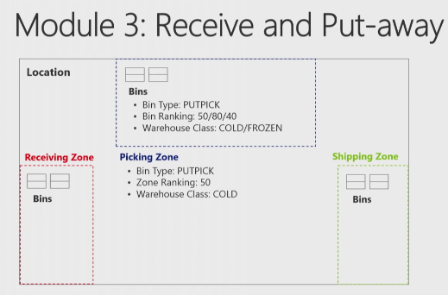

Receive and Put-away - Part II
So in the second part of this lesson, let me show you how we can receive and put away the items in the warehouse, and I will make a purchase order to show you this. Okay. So here in the application let's start with creating a purchase order. So I will go to departments. Then in warehouse I can go to order and contacts, and there I can go to purchase orders. A couple of things are important when creating a purchase order. So we will start in a normal way. So we will click on new. And next we can assign a number. And I will... for this example I will use customer 60,000. Customer 60,000, which is assigned to location white as you can see here on the promoted field of the first step you see, so that's very important. So if you want to make an example yourself, you need to be sure that you're working with location white and our demo company Cronus. Okay. So this is my order header. Next I will go to lines. And suppose this customer is ordering a couple of loudspeakers, which is item LS-100. There you go. And suppose that in this case he orders eight loudspeakers. Okay. So this is an item. First thing that you can see here, if we are using locations that are not set up for receive and ship in the warehouse, you would see that the quantity would be copied to the quantity to receive and quantity to invoice fields. Okay? But in this case, because we are using white and because in white the reception should be done in warehouse, you see that we don't have a quantity to receive here. So we cannot do the reception from the purchase order which is showing or pointing to the decentralization, as I explained in the introduction. So then the purchaser will create the purchase order, and then the warehouse worker will go to the warehouse receipts where they can receive the order. Okay. So eight pieces. Now, this is... this is a bill of material. And I will use functions explode BOM to explode the bill of materials so that I have a number of items that we can now go and receive. Okay. So this is what we are ordering. Next thing that we need to do is release the order. Now, this is very important. So we need to release the purchase order because only released purchase orders or only released orders can be processed in warehouse management. And so as long as the order is still open, the warehouse worker can not even see the order in their warehouse management environment. And so that's why in this case releasing is very, very important. Okay. The next step in my process would be creating the warehouse receipt. Now, the warehouse receipt can be created in two different ways. You have the push and the pull way. Now, push would mean that I would click here on the warehouse receipt... or, sorry, on Create warehouse receipt function in the ribbon which means that, based on the purchase order, NAV will push the warehouse receipt to the warehouse environment. So that would be a very good way to say, okay, I'm the purchaser and I will already prepare the warehouse document for my colleagues in the warehouse, so then you could push the receipt to the warehouse. However, in this case I will not do this. I will also show you the pull way, so how can we pull the receipt from the purchase order and the warehouse environment. Okay. In order to do this, I will go to my role centre. And so now I'm the warehouse worker, and I see that items are received in the warehouse, so that one of my vendors is delivering some items. Okay. So like I just said, now we will pull the receipt from the purchase order. So I will go to warehouse receipt page, and there I will click on new. I will assign a number and I will assign location code white. And what you see is that the zone and the bin code are assigned automatically. And remember what we saw in the location setup. So this is one of these default bins that is set up in location white, and so the reception bin. Okay. So now there are two different ways to get the receipts in this warehouse receipt page. The first thing that you can do is you can get source documents. So if you click on this function, you can see an overview of all the different documents that are available to receive in the warehouse. And, for example, the first line is the one that I just created, so that would be the receipt or the order that I would need. And then you can also see the other lines. What you can also see is that if you start working with, for example, expected receipt dates, you can create warehouse receipts based on the day that you expect items to arrive in the warehouse. You see? So that, from the planning point of view, could be a very good thing to do. Now, the second way that we can use this, a little bit more of an advanced way, and that is use filters to get source documents. So here you can create a number of filters so that you can have the system to search for source documents based, for example, on the vendor number, based on an item number, and so on. So, for example, if I enter now a vendor, okay, a vendor, and if I now click on modify, you can see the different functions or features that you have to create filters. So I can say, for example, I know which item is arriving in the warehouse but I don't know from which vendor this is coming or I don't know the purchase order. You can have the system search, for example, an item number. You can have the system search on variant, on unit of measure. So you can see all the different fields that are available to use as filters in this search function. Okay. I will go to purchase now because I would like to search based on the vendor. So I will enter the vendor number 60,000, so the vendor that we have used. And now if I click on, okay... sorry... and if I click on run, there you go, you will see that the system will start searching now for all the lines, all the items that we have received or that we have ordered from this vendor. Okay. In real life this might be too much because you can see that this is not... this is not only the order that I've created but there is another one. So that's something of course that you will have to check. So are all these items arriving in the warehouse. But as you can also see here, this is a perfect way to make a reception of multiple purchase orders so I'm not limited to a one-on-one reception. So in this case I can receive two purchase orders in one warehouse receipt, and that's something that would never be possible if you post the receive... the receipt from the purchase order. Okay. Suppose now that this is what we are receiving in the warehouse. I've checked everything. I've counted the quantities and everything seems to be okay. Then I can go to post receipt. Okay? So and as we just saw in the warehouse layout, I explained that posting the receipt will put the items in inventory. So if I now click on yes, everything will be posted and all these items will now be in the inventory. But they're not yet available, and that's because of the fact, what you can see here, we still need to put away the items in the warehouse. And posting the receipt will also result in creating a put away activity. So if I now click on okay, my receipt is posted. My items are in stock. But we should... we still should put them away. Okay. So this is of course also one of my tasks as a warehouse worker, so now I can go to the next page, and here you can see put away number tree, white. So if I double click on it, you can see this is the put away document created when posting the receipt. Okay. So and the put away document is literally an instruction of what we have to do in the warehouse. So you can see each item appearing minimum two times. So this one two times, this one even three times, and so on. And by looking at the action type, you see that the system will instruct us to take, for example, this item from the receiving zone and the receiving bin and to place it in the bulk zone and on this specific bin. You see it will give us an instruction to take, place, take, place, place. And based on the put away template that we saw in setting up, NAV will look for the best possible bin to put away the items on. So and the result is what you see here. Okay. In real life what you will have is that a warehouse worker will print the put away list. Let me just very quickly show you an example. So this is a report... well, I'll have to see if... let me just check. There it is. So this is a report where I can see exactly the same but then print it on paper. In more advanced warehousing you can also set up, of course, hand terminals with barcode scanning. But at the end what we have to do as a warehouse worker is put away the items on the bins selected by the system. Okay. Before I register this page, what you can see is that if you go to the place lines you can of course change the bin. Like I just said, NAV has defined these bins based on the put away template. But as a user, if you decide that you would like to put away the items on another bin, you can of course very easily change the bin from one to the other. That's of course no problem. But it's always of course very efficient when you get a suggestion of the best possible bin based on the put away template. Okay. Suppose that I've done the physical put away so the items are now on their specific location in the warehouse. I can then at the end register the put away. So in the ribbon I will click on register put away. There you go. So everything is put away now and the items are unavailable for further processing, for selling, so that you can pick and ship, but also for production for assembly and so on. So this is an example showing you one way to receive and put away the items in the warehouse. So as I explained, there are different variants on this process. For example, the way that you create warehouse receipts can be different. Also in the put away you can do a couple of more things that we will see in other lessons in this module. But now you can go to the practice, and in the practice you can try to do the same as I did by receiving and putting away the items in the warehouse.
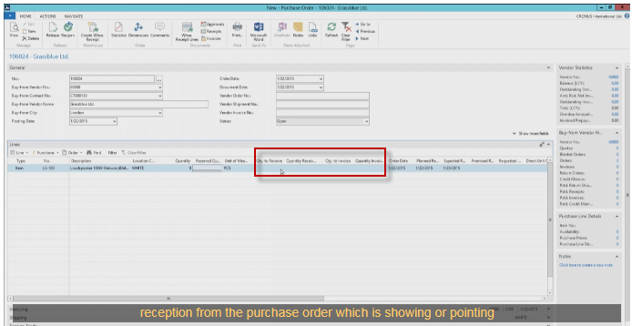
If White location is used, so Quantity to receive is empty !!!
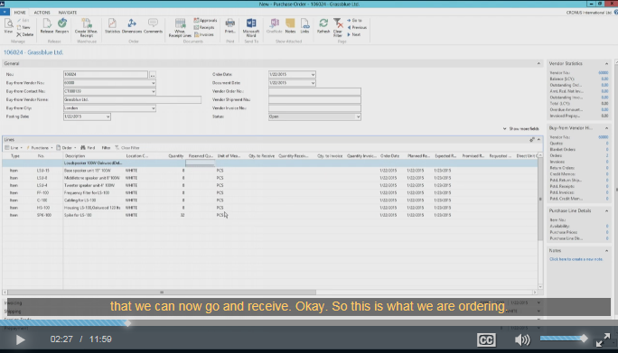
We have used from Function (lines) Explode BOM) !! See above. Then you have to release (by use of Ikon on ribbon).
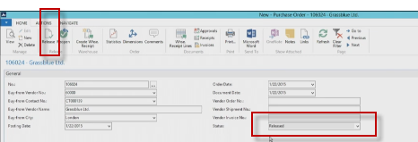
Two ways , Push and Pull. Push by Action and create Warehouse Receipt Lines! But in this example we will stick to Pull way. See below form:
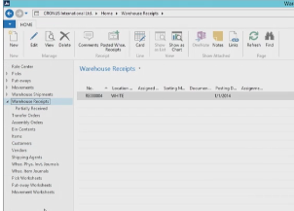
He create new by pushing button New on the ribbon
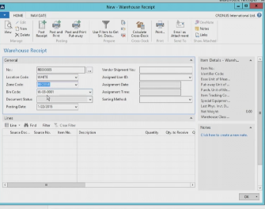
The Get Source Document (on possibility) in order to create lines. It is no used in this example. The second shown way is to use Filters to get Source e documents . There is very tricky search function !!!!
