Simple scenario Accounting Schedules MS NAV 2016
Created by : Jaromír Skorkovský
Date : 14.11.2018

Reason : Orientation in the MS Dynamics NAV 2016. Material helping to understand basic discount principles and one basic type of financial reporting (accounting schedules)
For : MPH_AOMA, MPH_AOPR, PIS1, PIS2, EPS1 and MPH_RIOP
BPH_PIS1 and MPH_RIOP for summer terms 2018
Used database : MS Dynamics NAV 2016/17 W1 (British one) – RTS
MS Dynamics NAV 2016/17 Czech – RTS
Used abbreviations : Q=question, G/L=General Ledger, Simple Scenario = SS,
PWP=Power-Point
Accompanying material: PWP-Accounting Schedules

- Useful tool to create new financial reports used for financial analysis without programming. This tool complements standard mighty reporting system (hundreds of reports)

- Basic financial reporting is done by running user defined reports called Account Schedules. This is, beside hundreds of predefined and existing reports, basic tool to access data of vital importance. All these reports use as a resource data General Ledger Entries created automatically by posting various documents (e.g. Sales and Purchase orders) by key F9. You can also calculate different parameters such as IRR, ROI and many more.

- IRR= Internal Rate of Return -> is the discount rate that makes the net present value (NPV) of a project zero. In other words, it is the expected rate of return that will be earned on a project or investment. When calculating IRR, expected cash flows for a project or investment are given, and the NPV equals zero.

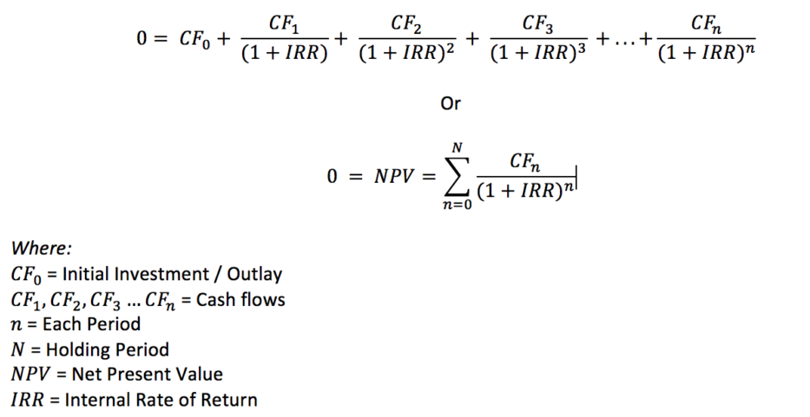

- Return on Investment (ROI) is a performance measure used to evaluate the efficiency of an investment or compare the efficiency of a number of different investments. ROI tries to directly measure the amount of return on an particular investment, relative to the investment’s cost. To calculate ROI, the benefit (or return) of an investment is divided by the cost of the investment. The result is expressed as a percentage or a ratio.
ROI = (Gain from Investment - Cost of Investment) / Cost of Investment

- Go to menu Financial management ->General Ledger ->Reporting & Analysis ->Analysis & Reporting. There you can see a list of the Account Schedules.

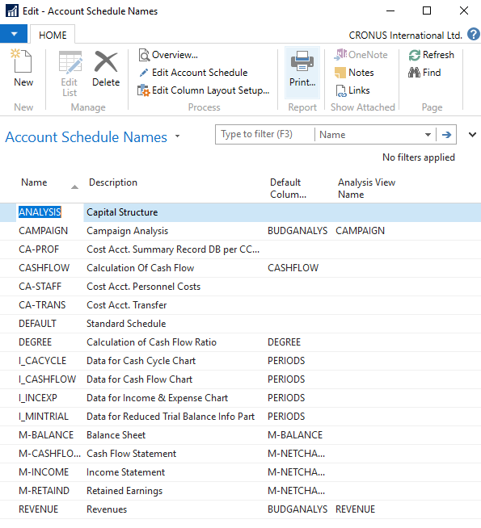

- In the form go to field Name in the header and find Analysis (one of many). There you see a template of the report created by somebody else who already created this Accounting schedule in our demo database. In order to see data go to the icon Edit Account Schedule and push this icon. There you see all G/L accounts used in this report. The structure will be explained by tutor. Then you push icon overview in order to see data. The next only possible option there data taken from G/L entries based on initial setup of matrix lines and columns:

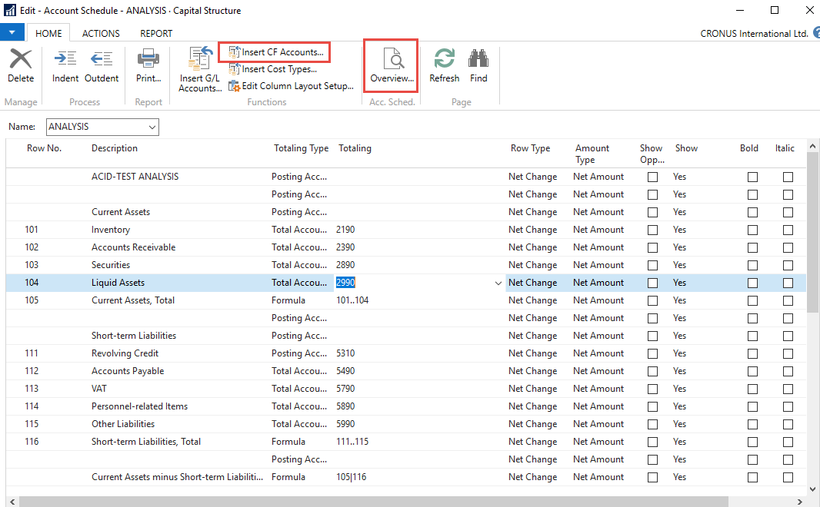

Push icon Overview and to see real data you can also change periods by related fields (by date, dimension filters such as Department, project of G/L budget filter)
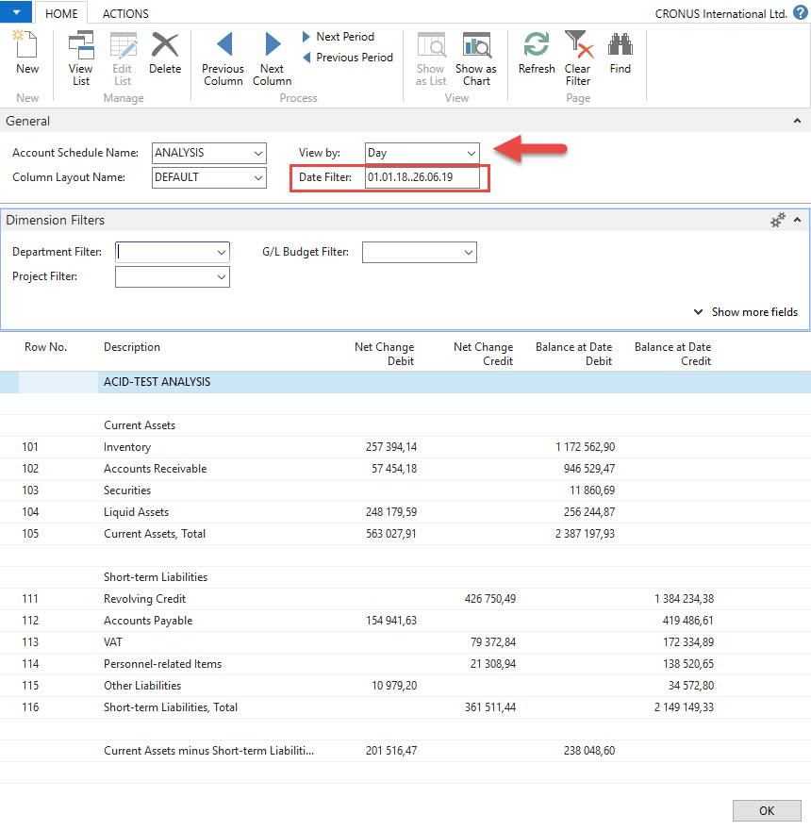

- If you change Default Column layout Name to BUDGANAL (Budget Analysis) you have to close and open it again by icon Overview you will get different report. You have to have some data in Budget matrix (will be presented later in this course)

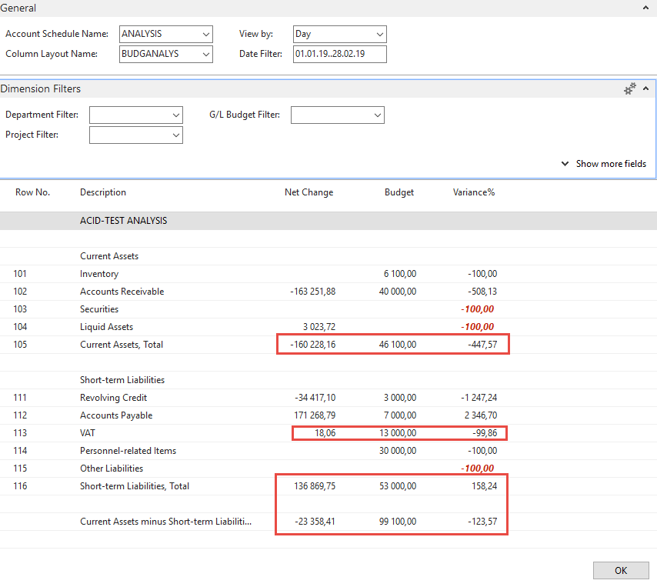

- Let´s create your own analysis!! Go to the Name field and in the list enter new analysis name (e.g. TEST) as it is shown below. Description will be for instance TEST VAT (Value Added Tax)

Normaly VAT Report stands for document that summarises a company’s VAT-eligible transactions over a specified accounting period, helping the company complete their VAT Return. Our report will much more simple.
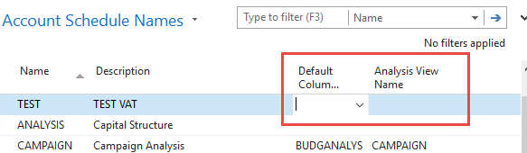

And enter Default column layout = DEFAULT!!! By use of mouse or the key F4 to see and chose this possibility.

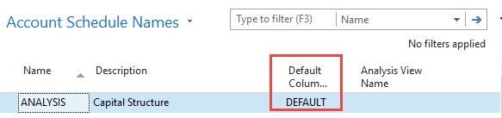

- With the help of the key F4 from the field Default column layout (see above) and by used of Advanced option you will get this form after creation of new line by Ctrl-N or icon=NEW :

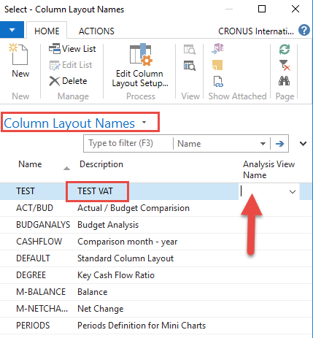

Next you have to Create Analysis View Name. Use F4 and Advanced button and the New. Enter VAT accounts From-To (5600-5790), which are G/L account used for VAT posting, dimensions (Area and Department) and use icon Update. This will create subset of data, which will be used in our just created Accounting schedule. The last entry numbers are visible in the form below. First picture is before Update and the second one after.

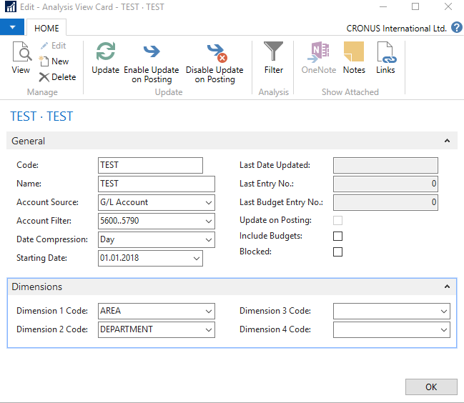

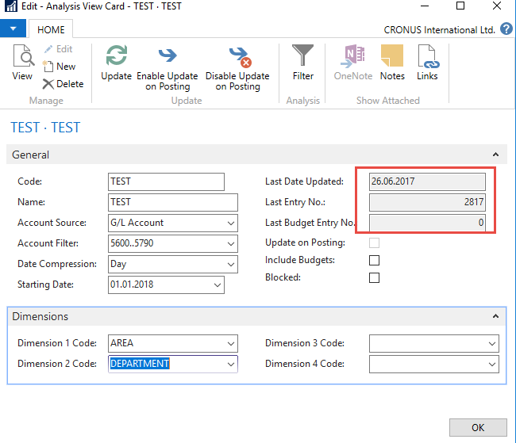

Finally you will get this and use layout of column=Default. Anyhow, this was already presented.

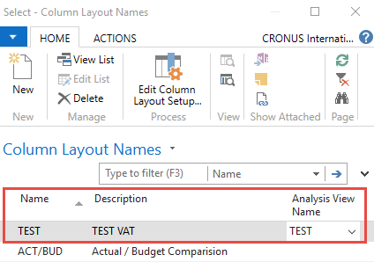

Go to Account Schedule Names, chose TEST and Edit Account Schedule icon. Then use icon create and enter two VAT account for purchase and two for sales and formulas as shown in the next form (use G/L account icon) and modify manually first column to chosen variable names IN 10, IN 25….). These are in fact variables which may be used in calculation.

To enter new lines with description use right click and New line!!!

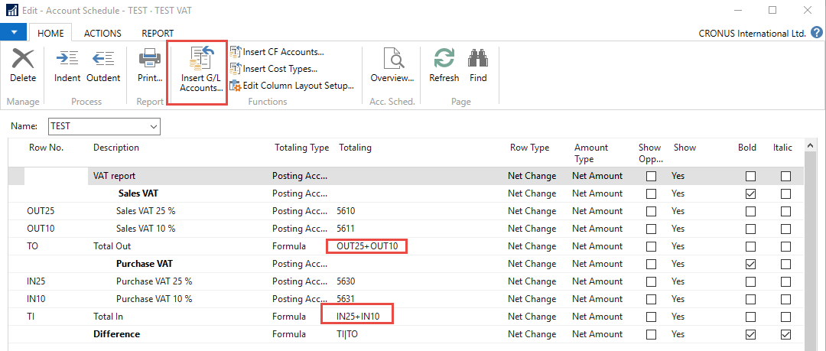

And you will get (after us of icon Overview)

