Complex example I ERP Microsoft Dynamics NAV 2018w1
Created by : Jaromír Skorkovský
Date : 23.10.2019
For : MPH_AOMA and AOPR and BPH_EPS1
Database : MS Dynamics NAV 2018w1
Keys : Ctrl-N=New, F4=Look-up, Ctrl-F7-entries, F7-statistics, F9-post
Shorthands : G/L General Ledger, TO-Transfer Order
Tutor-TU
- Find Item 80208->Searching windows->Item->List of items ->Filter (right upper corner)->80208
- See Item Ledger Entries->Ctrl-F7- >should be none. It means, that no Purchase neither Production was processed, which action may increase inventory
- Go to Departments (lower-left corner of the working area)->Purchasing ->Order Processing->Purchase Orders and icon New
- Enter Vendor Number into the first field (use mouse or typing or F4) -> 20000 and confirm by key
- Go to Purchase Lines->Enter Type=Item and Item Number 80208 and Location->BLUE (the YELLOW location must be overwritten) ->Quantity 10 and Direct Unit Cost=2 (the original cost have to be overwritten)
- In the Purchase Order Header, you have to enter Vendor Invoice Number (ESF_20191023)
- Post document by F9 (Invoice and Receive option)
- Go to Departments (lower-left corner of the working area)->Financial Management->General Ledger ->Tasks->General Journals
- Use Batch name =Default (if some lines created previously were already there- erase them by icon Delete-upper left corner)
- Enter Document Type>Payment (use mouse of F4) ->Account Type=Vendor-> Account Number =20000->Balance Account Type=Bank->Bank Account->Balance Account Number=NBL
- Upper Bar Menu-> Actions and icon Set Applies-to ID
- Chose our External number ESF_20191023, which is in fact Vendor Invoice Number and click on Set Applies-to ID ->internal number starting with G000x will be created
- Confirm by OK
- See what happened in General Journal and post it by F9
- Go to the searching window and find Vendor 20000->Ctrl-F7 and see created Vendor Ledger Entries
- Go to Items ->80208 and Ctrl-F7 and see Item Ledger Entries
- Go to Departments->Purchasing->Order Processing->Transfer Orders and click NEW
- Transfer-from code =BLUE to Transfer-to code=RED
- Enter data into Transfer line ->Item number=80208, Quantity =5
- Post two times Transfer Order by F9 and the go-to Items->find Item 80208 and Ctrl-F7 to see Item Ledger Entries
- Go to Departments->Sales&Marketing ->Order Processing->Sales Orders->Icon NEW->Enter Customer Numer (second field from above) =10000 into Sales Order Header ->go to Sales Lines and enter Type=Item->Item Number=80208->Location=BLUE->Quantity=2 and Unit price=4 (original unit price must be overwritten)- >Print SO confirmation and post it by F9
- See Icon by Location window
- Go to the General Journal and accept Payment from Customer 10000 (the actions taken are more and less the same which we carried out with payment to our Vendor (see bullets 8-14 of this example)
- See Customer Ledger Entries and Item Ledger Entries – final results

- Customer Ledger Entries
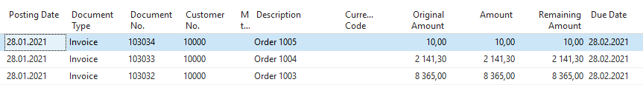
- Vendor Ledger Entries

- Item Ledger Entries
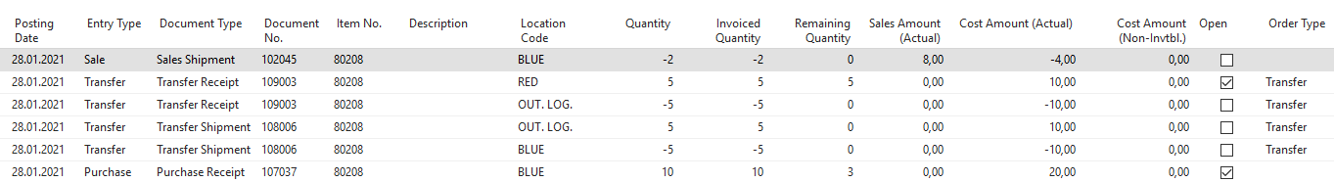
- Item by Locations
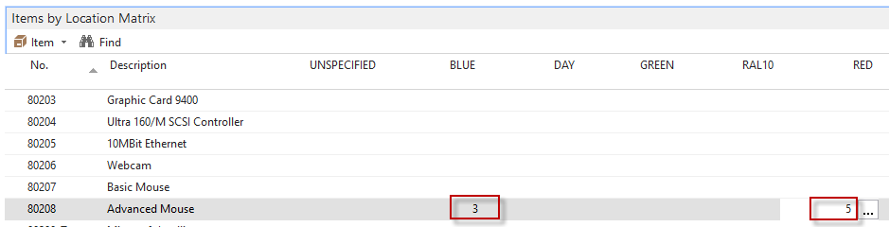
- General Ledger Entries->Financial Management->General Ledger->Archive->History->G/L Registers->upper-left corner icon G/L Entries
