A simple scenario of the ERP Microsoft Dynamics NAV2018w1 for SALES

Created by : Jaromír Skorkovský
Date : 25.9..2019
Reason : Basic terminology and principles - Sales order

For : RIOP and PIS1 students and NAV users (NAV uživatelé)
MOH_AOMA and AOPR and BPH_EPS_1
Database : MS Dynamics NAV 2016 CZE (W1 database-English, Czech database )
Comment : Languages (ENG
Keys : F4= Look up, Ctrl-N= New , F9- Post , Ctrl-END = End of List
Ctrl-F7= Entries , ESC, ENTER, F7-Statistics
Shorthands : G/L=General Ledger, SO=Sales Order,

The essential task is to create a sales order and track the impact before and after posting and registering this document.

1. In the Search box, enter string Sales, and all sales options appear. Just like in the Area-> Sales-> Order Processing section. Select Sales Orders and a list of all non-billed documents of this type will appear.

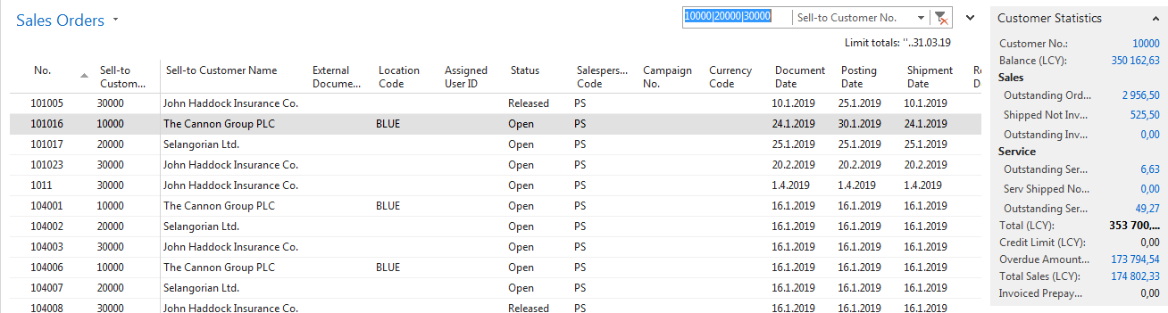
2. Follow the information panels on the left side of the screen. There are balances (calculated fields), pending orders, maximum loan amount, and so on. There are also available fields of the Code of Payment Terms field, whose value determines when the due date will be the invoice that is created by posting the SO.

3. Select the New Icon on the toolbar or use Ctrl-N. Due to this action a new empty sales was created

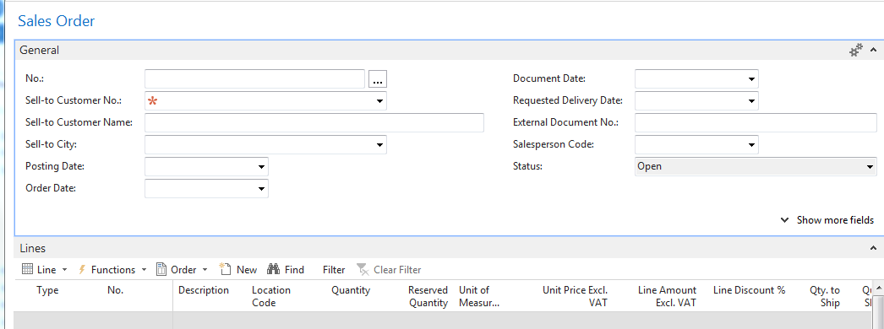

4. Use the ENTER key to create a blank document and use the mouse or F4 key to select your customer in the Customer-Number field. For instance, customer number 10000 and confirm it with the ENTER key as always in the following jobs. Possibly you can see a credit limit warning appears because the customer has set this field to zero value and owed us enough money even after maturity. We will, of course, approve of this and we will continue.
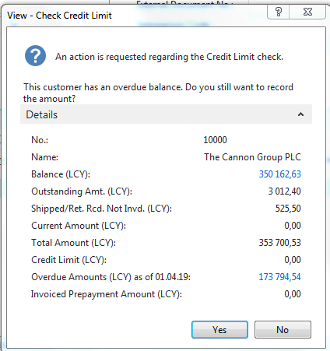

The relevant data required for SO management from the customer card (from its table) is transferred to the SO document header. You will see it later in this document when you enter data into one sales order line

In the SO line, select the type (mouse or F4) that we use. In our case, Goods, which represents both Material and Goods.

5. Select the Goods (item) number equally. In our example, choose 1964-W from the list of items. Whenever a manual entry is expected, an orange star appears. Confirm by key Enter.
9. Add a quantity, such as five pieces, where the storage unit will appear in the line automatically (from the merchandise card where it is defined).

10. Select the Blue option in the Location field. Location is a warehouse (Stock) area.

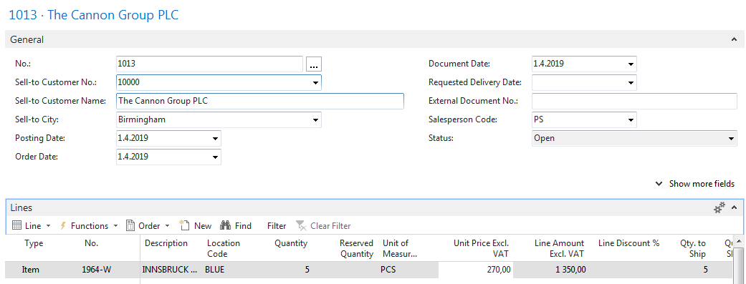

12. Using the Print Confirmation icon (see the icon in the top bar), you can print SO. You can get same result by using the Printer icon on the tab titled ACTION.

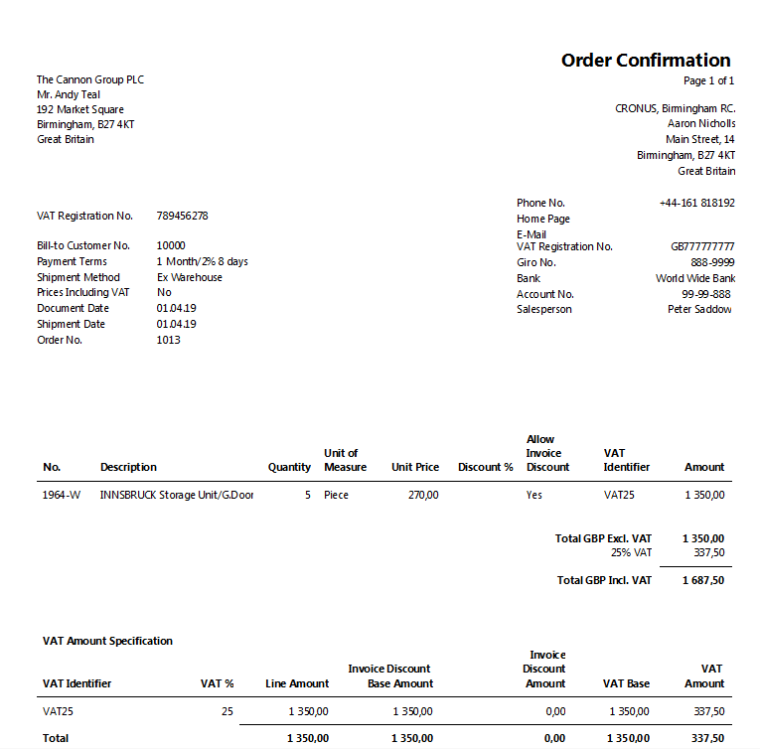

13. The document will be sent to the customer either by post as a printed document or electronically.
14. As soon as our goods are sold ready for shipment, it is possible to (after approval) and looks at the statistics (F7): margins, automatically calculated VAT rate, etc. SO to post with the appropriate icon or F9 key. At this stage of the example, select the "Ship and Invoice" option. The posted document moves to another area of the system.

Statistics (F7 key):
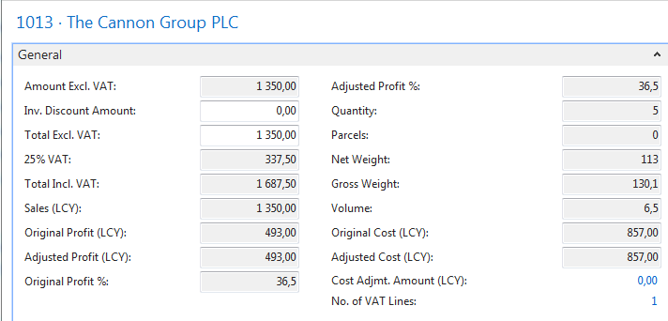
Posting document (F9 key)

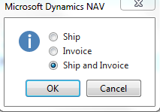

15. The result will be a sales invoice and delivery note. Reimbursement of the invoiced invoice from the customer will be our task in the next lessons of the course (payment section called Use of General Journal.
16. Expected impacts (impacts) will be both in inventory depreciation and customer balance (receivables) and undoubtedly in the main book (General Ledger =G/L).
17. How to Find a Sales Invoice: Areas-> Sales and Marketing-> Archive-> Posted Sales Invoices. You can use a filter on Customer (in our case 10000-> click right mouse button and filter to this value).
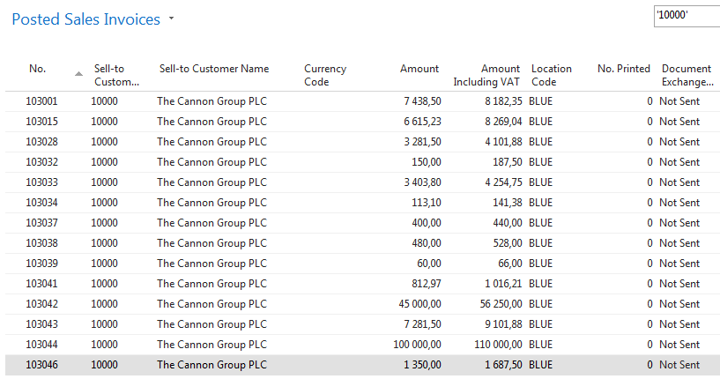
It looks like the last one on the list is our posted invoice. To see it use icon Edit od View
18. Go to Customers by using Search window, select customer=10000 and made Ctrl-F7 or use of icon Customer ledger entries and then use icon Navigate

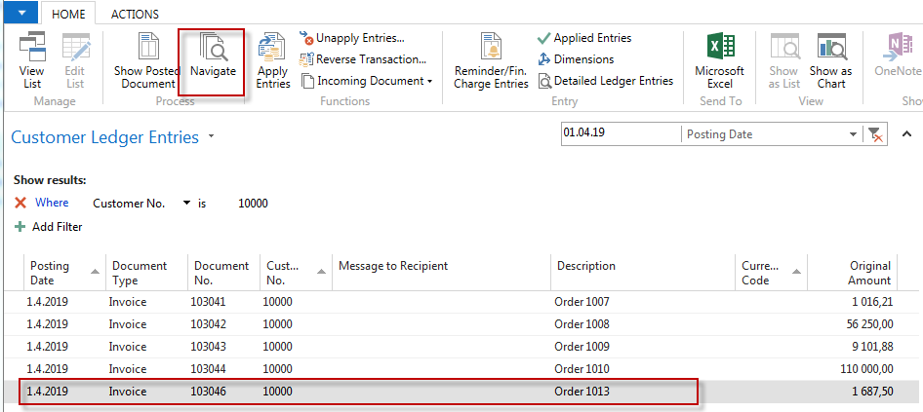

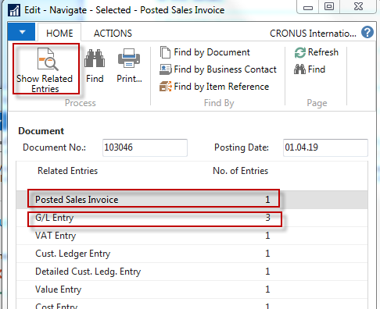
Firstly go to the Posted Sales Invoice and Show Related Entries and you will see our posted document (not shown in this example)
Go to the Search window, type Items go-to items, and use filter Number=1964-W:
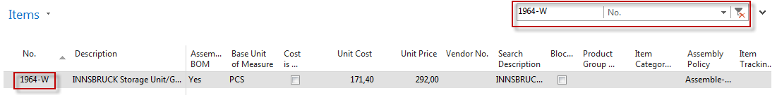

From there use Ctrl-F7 or icon Entries->Ledger entries, and you will see last entry representing the last Selling event

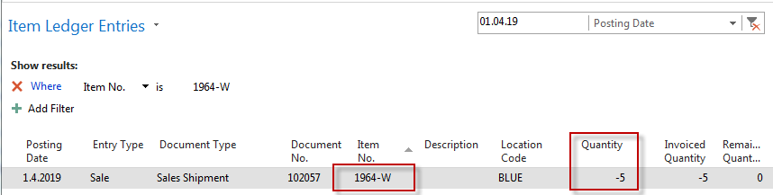

Moreover, by use of ESC go back and place the cursor G/L Entry and Show Related Entries and you will get

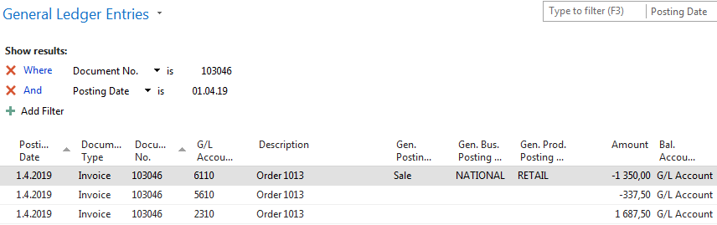

1 687,50
1350,00
Customer Domestic
2310
Sales VAT 25%
5610
Sales Retail Domestic
6110
1687,50=1350,00 + 337,50
337,50

