Simple scenario (Budgets) ERP Microsoft Dynamics NAV 2016
Created by : Jaromír Skorkovský
Date : 21.11.2018
For : MPH_AOMA and AOPR and BPH_EPS1
Database : MS Dynamics NAV 2016 W1
Keys : Ctrl-N=New, F4=Look-up, Ctrl-F7-entries, F7-statistics, F9-post
Shorthands : G/L General Ledger, TO-Transfer Order
Tutor-TU
- We have to create real data in order to compare it to data in the budget
- So we have to compare actual and expected (budget) data posted on the account number 8320 cost of Consulting services (or a similar one in its neighborhood such as 8310 or 8330).
- Working date should be set up in such a way, that new posted G/L entries will be in our budgeted period unique. We have below last G/L entry 24.1.2019 so set new WD to 1.4.2019.
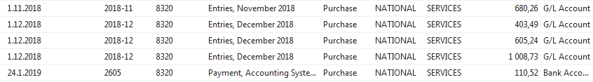
- Create one Purchase order with two lines- Every line should be marked by different dimension value. In our case Department= ADM and SALES. In our example, we show only the purchase line. The supplier could be for instance 10000. To enter dimension value to every line go to icon Line->Dimension and enter Department =ADM for the first line and Department =SALES for the second one. Below we show the only Setup for the first purchase order line
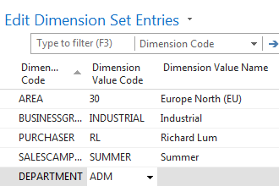

- Purchase order lines look like :
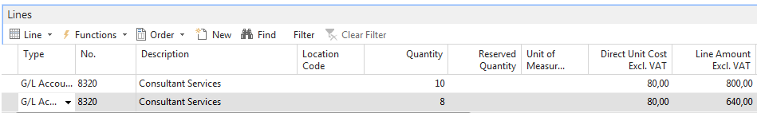

- Post this Purchase order by use of F9
See G/L entries ->Financial Management->General Ledger->Archive->History->G/L registers and go to the last record and use icon General ledger entries in the upper left corner of the screen.
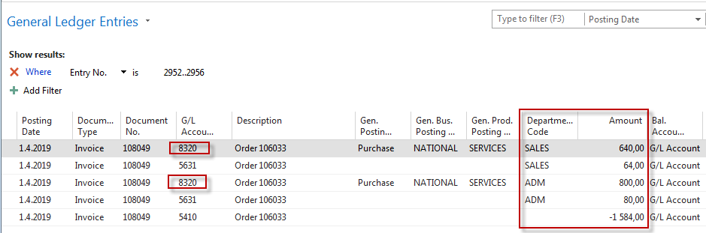
- Go to General Ledger->Lists->G/L Budgets ->icon Edit Budget and go by use of a cursor to the account number 8320. For chosen date 1.4.2018 we will get :
Use the three-dot button to go to these lines and enter figures and department values as follows
So the amount in the budget will be 900 and posted by us was 640 for department dimension value =ADM. For the other dimension value= SALES the actual posted amount is 640, and our budget is 700. In order to see the total budget amount for both dimension value 1600, you must close and open budget window in order to refresh the data

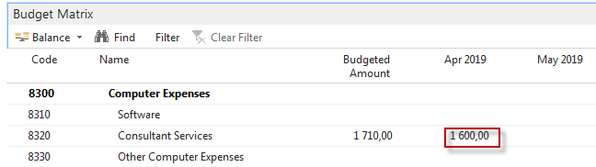

One possibility to see % deviation you have to use icon G/L Balance/Budget (in newest versions of databases it could be a different name, and TU will explain.
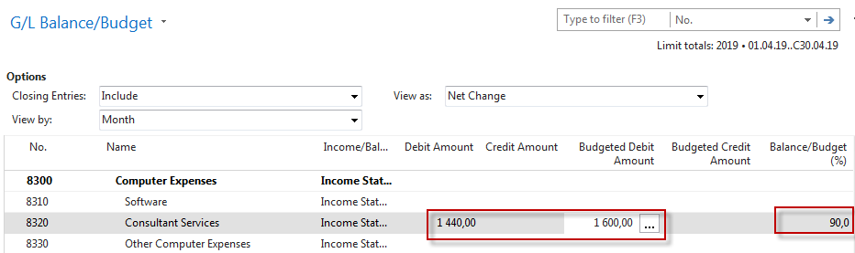

- We can also see the result by use of accounting schedule (we went through last week) Find Accounting Schedule and create a new one (icon New). Enter manually Budget SW and Description and Default Column by use of a mouse or F4->Budganalysis
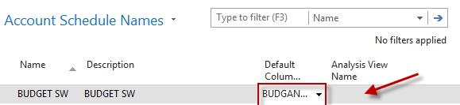

- Open Analysis View Name and use Advanced->enter New and ad data to the following window. After push icon UPDATE. This action will automatically upgrade fields such as last Date Updates and Last Entry number.
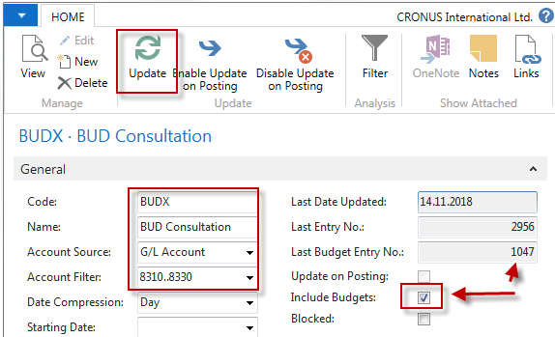

- You will get this line in the accounting schedule window
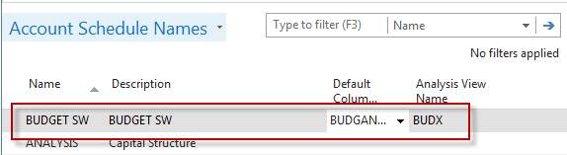
- Now use icon EDIT Accounting Schedule and enter by use of icon Add G/L Accounts account 8320. So simple design of the report structure has been created.
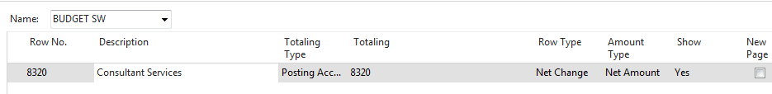
By use of icon Overview, you will finally get this result
