Simple scenario (Item Transfer ) ERP Microsoft Dynamics NAV 2016
Created by : Jaromír Skorkovský
Date : 17.10.2018
For : MPH_AOMA and AOPR and BPH_EPS1
Database : MS Dynamics NAV 2016 W1
Keys : Ctrl-N=New, F4=Look-up, Ctrl-F7-entries, F7-statistics, F9-post
Shorthands : G/L General Ledger, TO-Transfer Order
Tutor-TU

Menu Warehouse-> Administration-> Setup> Locations
Select Locations = White and top in the window to select Manage
Open card Location=White and see all the tabs of this card. The primary field
and meaning will be explained by TU . See icon Bins. Open it, and you will see
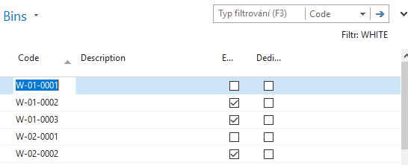

See bin contents by use of icon Contents
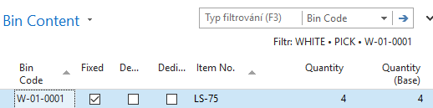
The bin is the smallest possible storage location. Limits, Empty and Assigned -> TU, Zones will show you again
Go back by ESC key (several times)

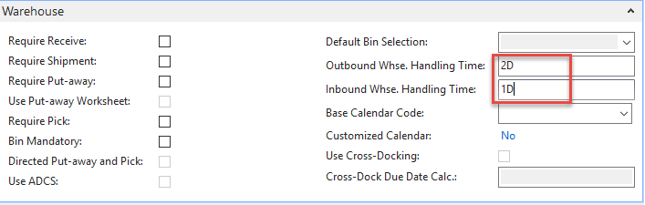
Select Locations=Blue and Edit-> see Warehouse tab and Inbound and Outbound times

Do the same action for chosen inventory Location=Red
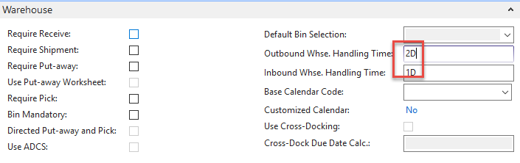
Inbound handling time =1D and Outbound handling time =2D

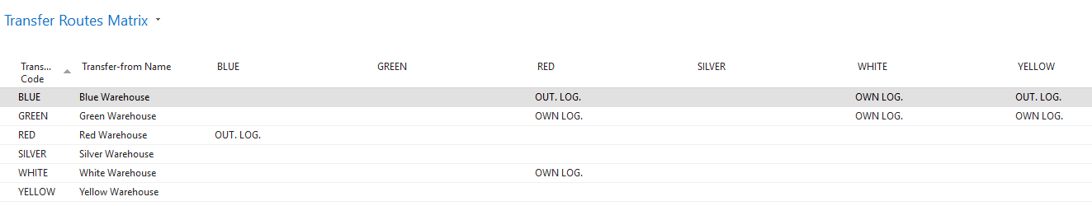
Menu Warehouse-> Administration-> Inventory-> Transfer Routes -> TU will explain

Go to searching windows and find Shipping agents
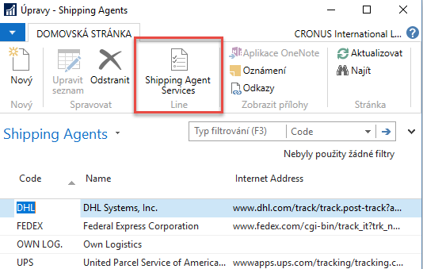
Use icon Shipping Agent Services
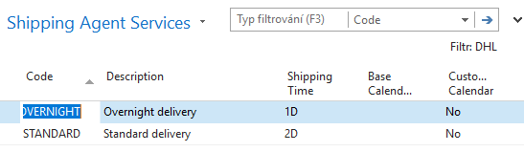
Go to the searching window and enter string Transfer Orders or use Menu Warehouse-> Orders & Contacts-> Lists->Transfer Orders
For an explanation of principles, see PWP Presentation about Transfers
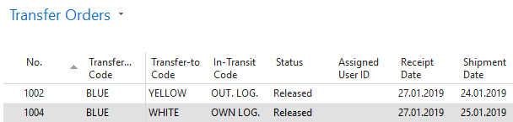
Ctrl-N Create a new Transfer Order - confirm with key Enter from the screen below

Add by F4 values of Location From and To. In our case, it will be Blue and Red
In transit, lorry will be automatically entered from Transfer Routes matrix
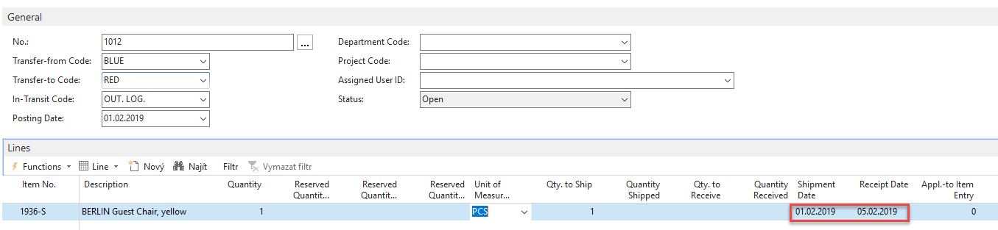
Enter Item-1936-S and 1 pcs.

On the tab Transfer From you will see
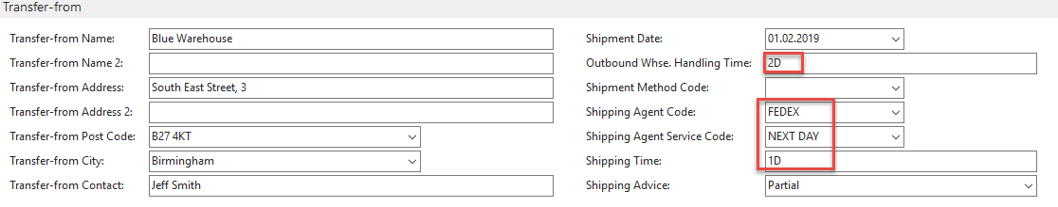
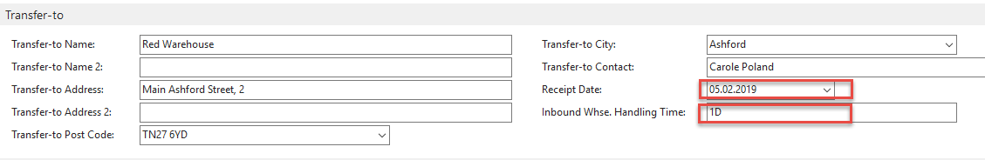
On the tab Transfer To you will see

Shipping date=1.2.2019 and Receipt date= 5.2.2019 ->4 days. 2 days outbound warehouse handling time + 1 day shipping time + 1 day inbound warehouse handling time
Post TO by F9
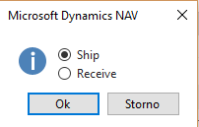
And TO line changed :

Before posting TO for the second time see please matrix item by location from item card or from item list by using Icon
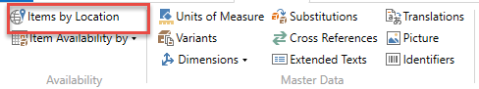
and
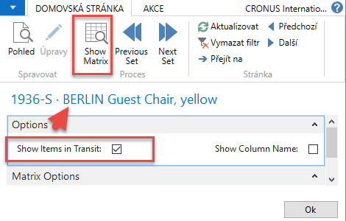
You will get this type of screen
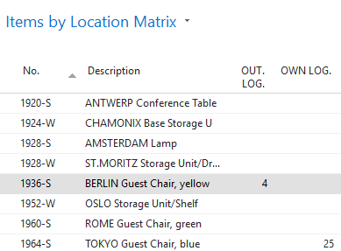

Click on a number to see transfer moves
Post TO 2nd time by F9
You will get
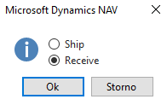
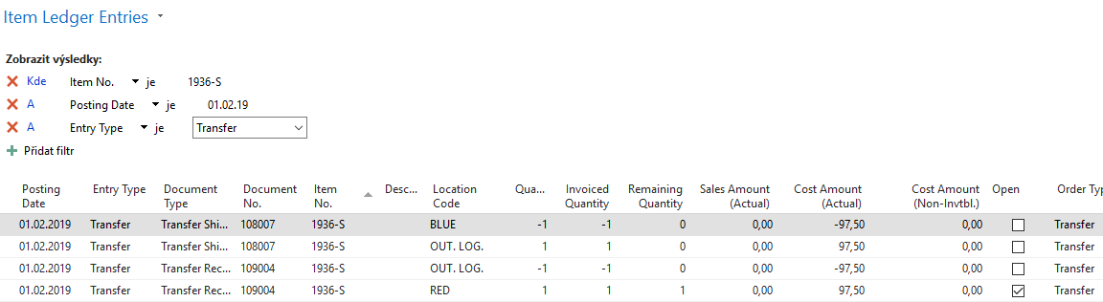
And see Item entry of chosen item 1936-S

