Simple scenario Accounting Schedules MS NAV 2016/17
Created by : Jaromír Skorkovský
Date : 26.6.2017

Reason : Orientation in the MS Dynamics NAV 2016|17. Material helping to understand basic discount principles and one basic type of financial reporting (accounting schedules)
For : MPH_AOMA, MPH_AOPR, PIS1, PIS2, EPS1 and MPH_RIOP
BPH_PIS1 and MPH_RIOP for summer terms 2018
Used database : MS Dynamics NAV 2016/17 W1 (British one) – RTS
MS Dynamics NAV 2016/17 Czech – RTS
Used abbreviations : Q=question, G/L=General Ledger, Simple Scenario = SS,
PWP=Power-Point
Accompanying material: PWP-Accounting Schedules

- Useful tool to create new financial reports used for financial analysis without programming. This tool complements standard mighty reporting system (hundreds of reports)

- Basic financial reporting is done by running user defined reports called Account Schedules. This is, beside hundreds of predefined and existing reports, basic tool to access data of vital importance. All these reports use as a resource data General Ledger Entries created automatically by posting various documents (e.g. Sales and Purchase orders) by key F9. You can also calculate different parameters such as IRR, ROI and many more.

- Go to menu Financial management ->General Ledger ->Reporting & Analysis ->Analysis & Reporting. There you can see Account Schedules.

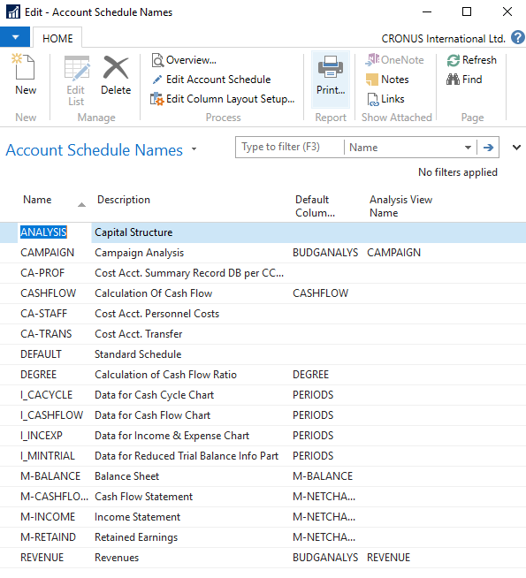

- In the form go to field Name in the header and find Analysis (one of many). There you see a template of the report created by somebody who already created this Accounting schedule in demo database. In order to see data go to the icon Edit Account Schedule and push this icon. There you see all G/L accounts used in this report. The structure will be explained by tutor. Then you push icon overview in order to see data. The next only possible option there data taken from G/L entries based on initial setup of matrix lines and columns:

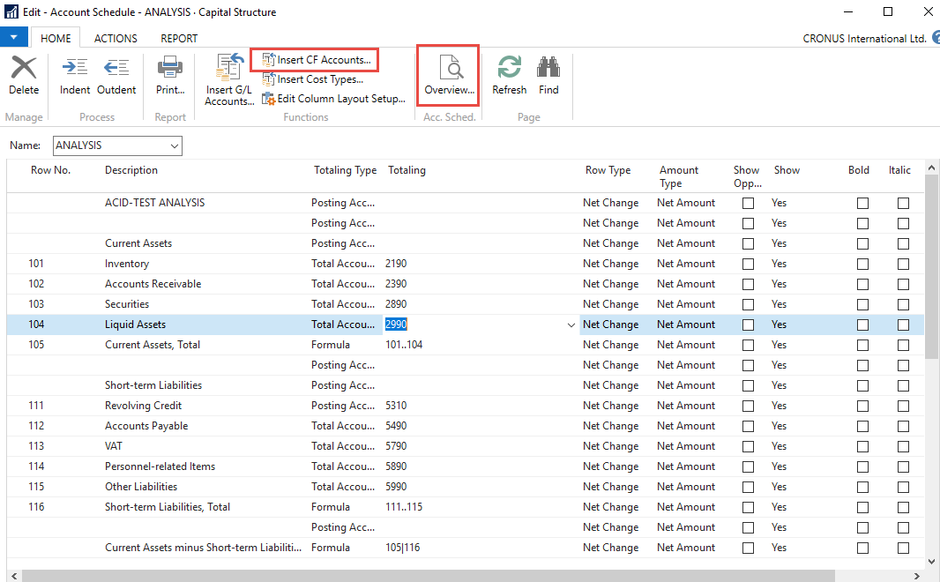

And to see real data you can also change periods by related fields (by date, dimension filters such as Department, project of G/L budget filter)
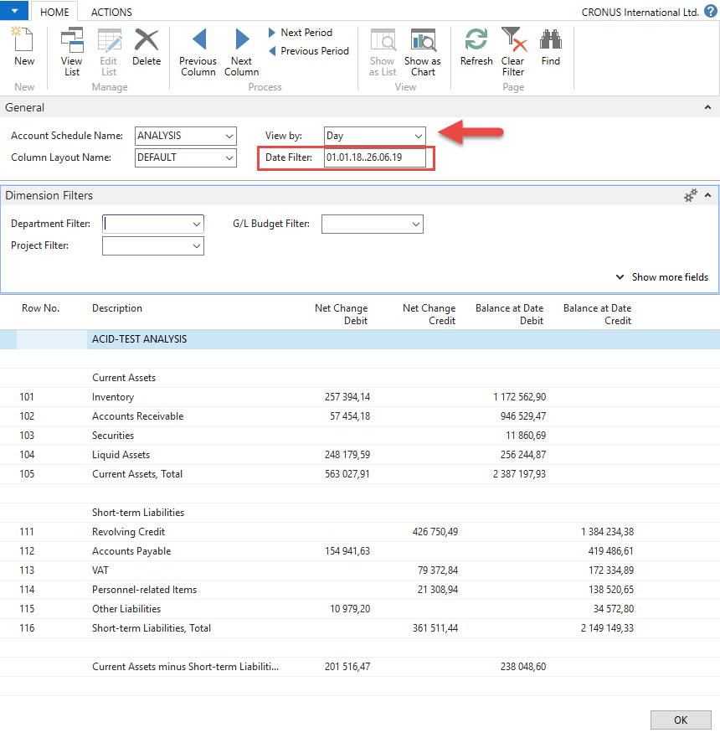

- If you change Default Column layout Name to BUDGANAL (Budget Analysis) you close and open it again by Overview you will get different report. You have to have some data in budget matrix.

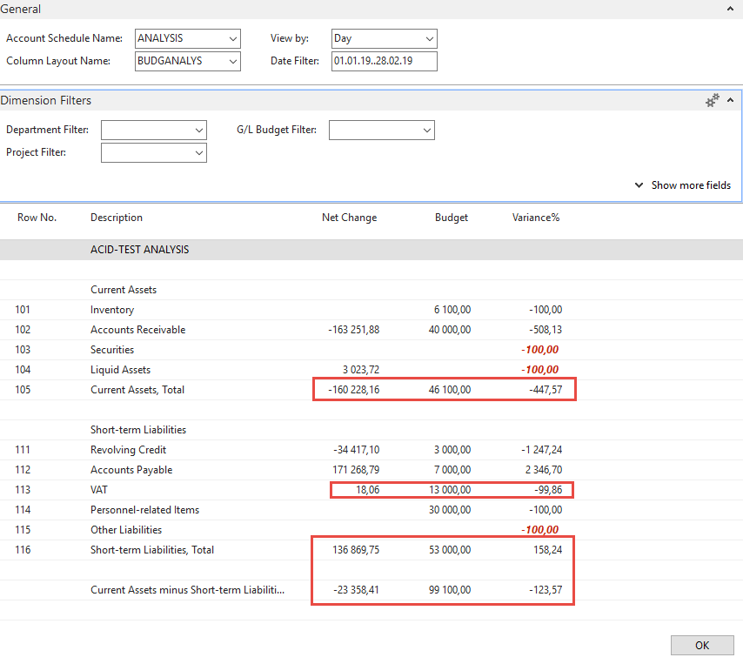

- Let´s create your own analysis!! Go to the Name field and in the list enter new analysis name (e.g. TEST) as it is shown below.

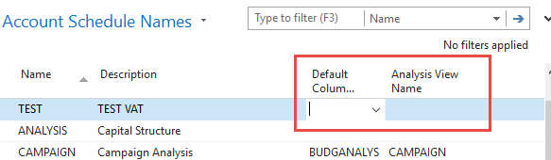
And enter Default column layout = DEFAULT!!! By use of mouse or F4 to see and chose this possibility.

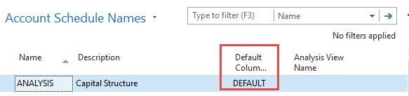

- With the help of F4 from the field Default column layout (see above) and by used of Advanced you will get this form after creation of new line by Ctrl-N or icon=NEW :

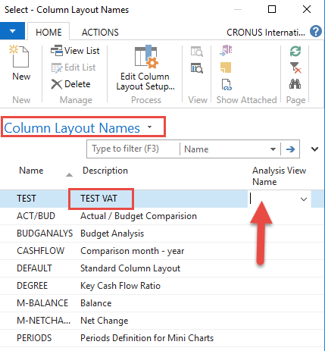

Next you have to Create Analysis View Name. Use F4 and Advanced button and the New. Enter VAT accounts From-To (5600-5790), which are G/L account used for VAT posting, dimensions (Area and Department) and use icon Update. This will create subset of data which will be used in our Accounting schedule. The last entry numbers are visible in the form below. First picture is before Update and the second one after.

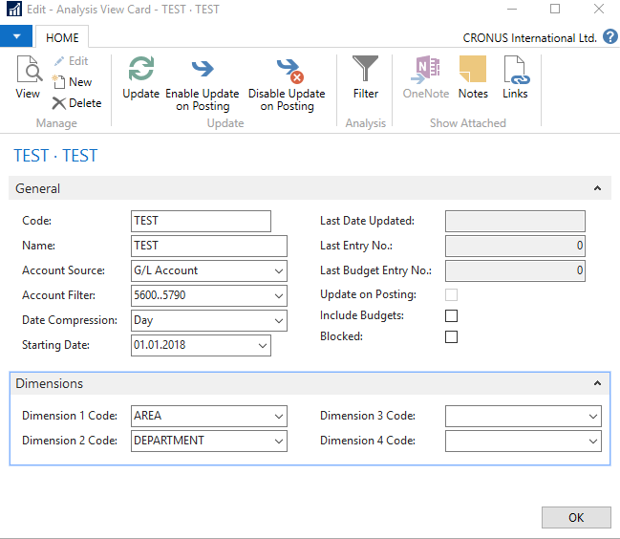

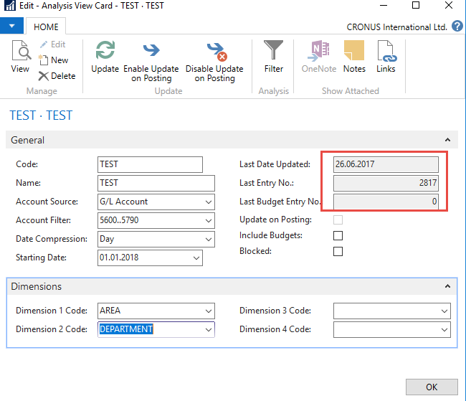

Finally you will get this and use layout of column=Default. Anyhow, this was already presented.

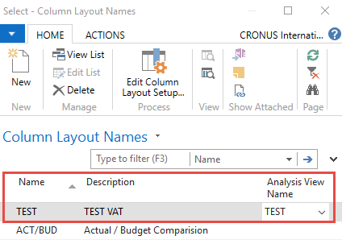

Go to Account Schedule Names, chose TEST and Edit Account Schedule icon . Then use icon create and enter two VAT account for purchase and two for sales and formulas as shown in the next form (use G/L account icon) and modify manually first column to chosen variable names IN 10,IN 25….). These are in fact variables which may be used in calculation.

To enter new lines with description use right click and New line!!!

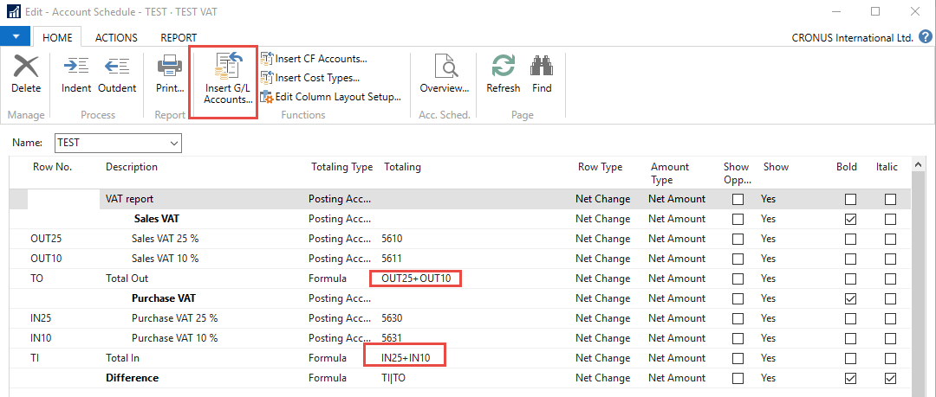

And you will get (after overview)

