Simple scenario Customer Relationship Management MS Dynamics NAV 2016w1
Created by : Jaromír Skorkovský
Date : 5.11.2018

Reason: Orientation in the MS Dynamics NAV 2016|17. Material helping to understand basic CRM principles
For : MPH_AOMA, MPH_AOPR, PIS1, PIS2, EPS1 and MPH_RIOP
BPH_PIS1 and MPH_RIOP for summer term 2019 (if required)
Used database : MS Dynamics NAV 2016/17 W1 (British one) – RTS
MS Dynamics NAV 2016/17 Czech – RTS
Used abbreviations : Q=question, G/L=General Ledger, Simple Scenario = SS,
PWP=Power-Point. PO-Purchase Order
Accompanying material: Introduction MS Dynamics Purchase NAV RTC 20181003

- Simple task: orientation in the MS Dynamics NAV part oriented to CRM. It means relationships between business partner cards (Vendors and Customer) and its Contact Cards.
- We do have two types of Contact Cards (Company Cards – Bold ones and Person Cards)

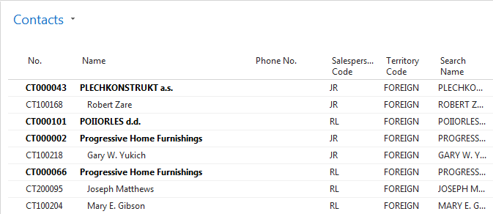

- To see Interactions related to these Contact Cards, use relevant icon or key combination Ctrl-F7.
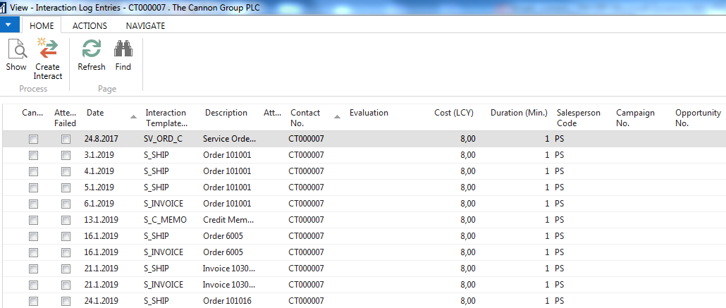

- Interaction (Telephone calls, meetings,…) –see interaction Groups from searching window
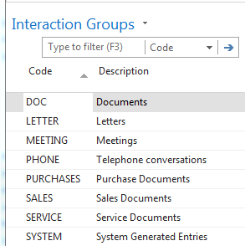

- It the lower part of the contact card you can see profile (TU will explain more in detail)
Profile of the person
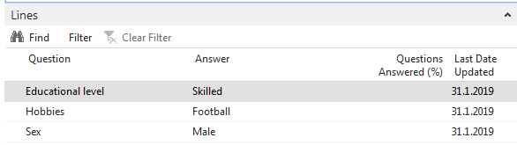

Profile of the company

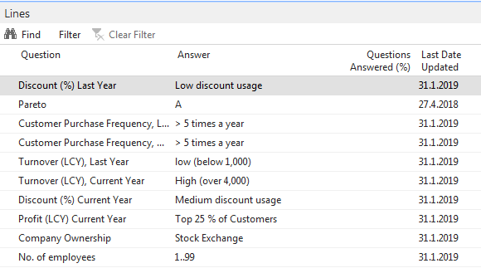

- Create new Contact Card and then create from there new Customer card by use of the template
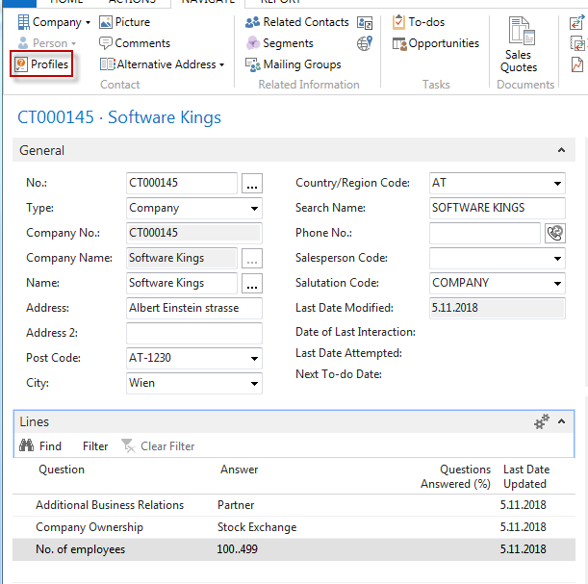

moreover, person contact working for Software Kings
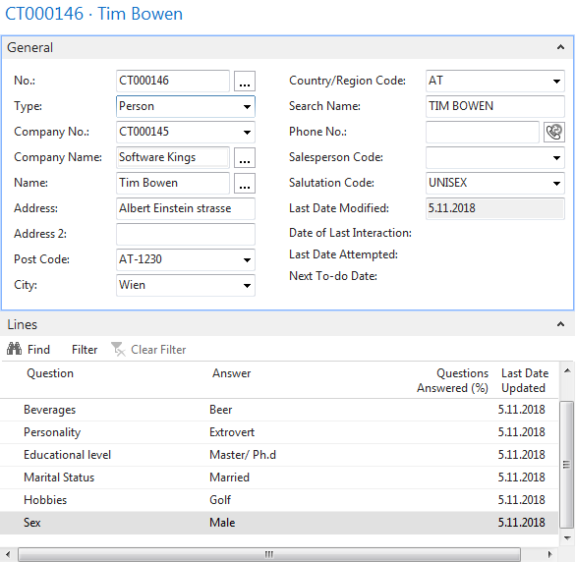

the template will be found here and Create as a Customer:
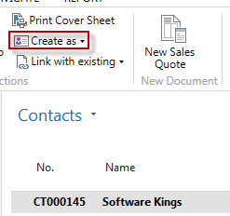

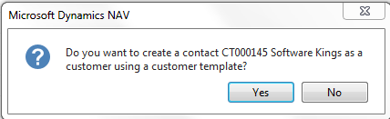

You can also create a template for the Austrian Company. In our case, the British company has a subsidiary in Vienna. Click on chosen template 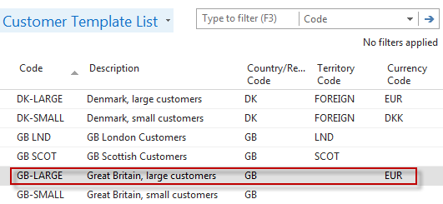
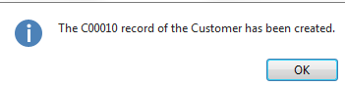
Create new interaction for Tim Bowen (just created contact) by use of wizard (e.g., incoming telephone call). The tutor will explain more in detail the sequence of actions.
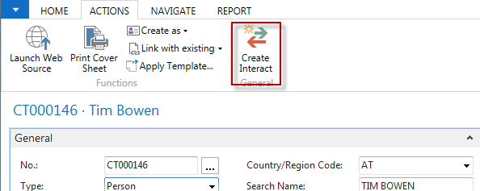
Go and see how to setup questionnaires (profile) ->Sales->Sales and Marketing->Administration->Profile->Setup
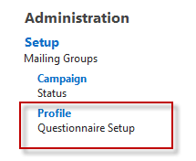

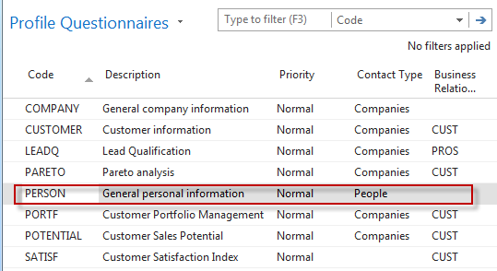
Go there and ass some new properties
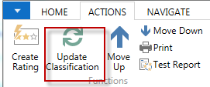
By use of Update Classification, you will find actual quantity of all contacts related to properties named in the questionnaire
Go to Opportunity list by the searching window (see Sales Cycle and other vital fields in the Opportunity lines) Make a choice of one of them (Status = In progress:
Tutor explain the primary meanings of these fields
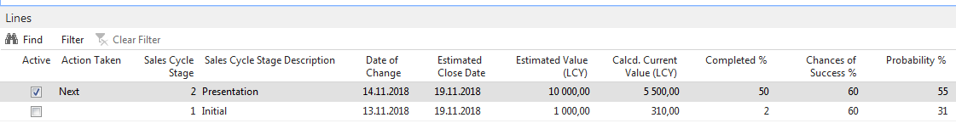

Create a new opportunity by use of the wizard.

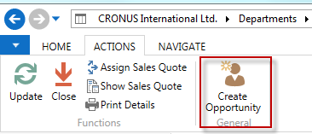
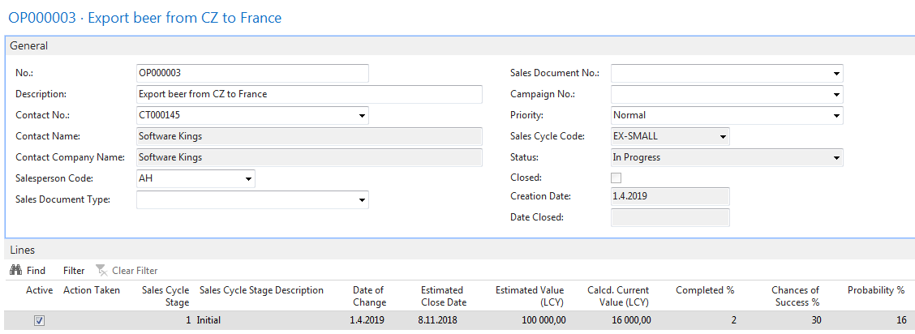

Let ´s setup a new profile called Pareto based on Sales figures :

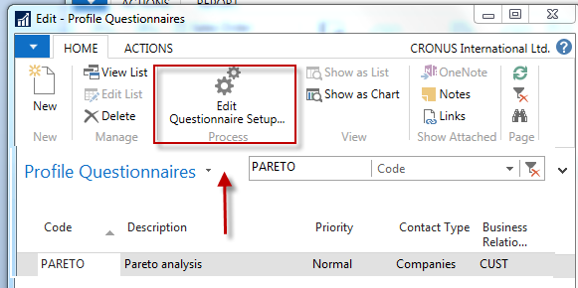

Before you enter data to the second form will be entered you must specify Details of the Question
(Use icon Question Details ?)

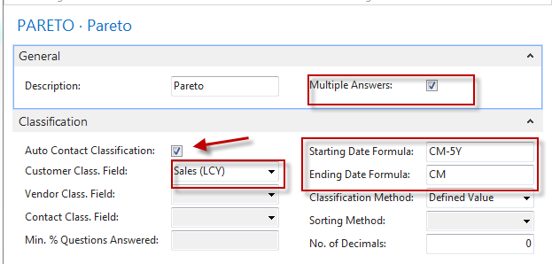
Date Formula CM-5Y means Current month – 5 years.
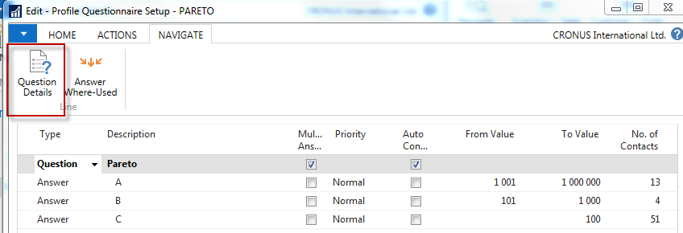

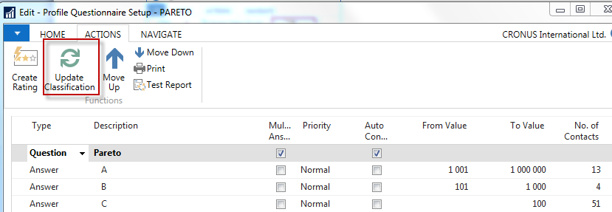

See profile of contact cards of the customers, and you will see, that A , B or C codes classify most of them. Click on the calculated field No. of Contacts. We have chosen code B in our example. So you can see, that we do have four contacts
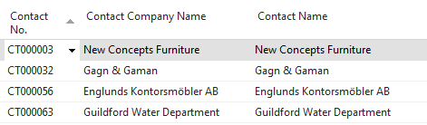
From one chosen contact click od Contact number->Advanced->Edit and you will get

