Simple scenario (Discounts) ERP Microsoft Dynamics NAV 2016
Created by : Jaromír Skorkovský
Date : 31.10.2018
For : MPH_AOMA and AOPR and BPH_EPS1
Database : MS Dynamics NAV 2016 W1
Keys : Ctrl-N=New, F4=Look-up, Ctrl-F7-entries, F7-statistics, F9-post
Shorthands : G/L General Ledger, TO-Transfer Order
Tutor-TU
- Find Customer card and Customer with code 10000.
- On the Tool bar, you will see in Navigation section three icons.
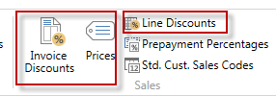
- Open icon Prices and enter in this window Customer (it should be already there) and enter item 1964-W. Standard Unit price from the item card supposed to be 292.
- Enter 3 pcs and enter a new price for this quantity and higher amount 290 and 5 for 280.
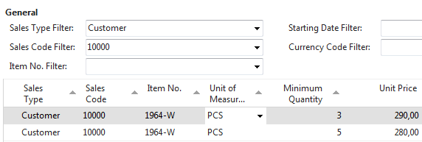

Confirm by OK and go to the icon Line Discount and enter different quantity and % values as shown below.
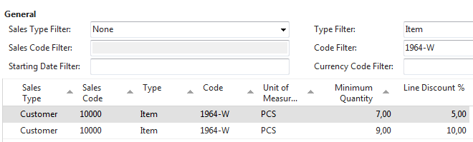

Be aware, that this is only tested on how ERP NAV can calculate discounts.
Pcs | Unit Price | % | Final unit price | Total
1 | 292,00 | 0,00 | 292,00 | 292,00
3 | 290,00 | 0,00 | 290,00 | 870,00
5 | 280,00 | 0,00 | 280,00 | 1 400,00
7 | 280,00 | 7,00 | 260,40 | 1 822,80
9 | 280,00 | 9,00 | 254,80 | - 293,20

Create Sales Order with several lines as we have done is in a normal business situation this situation is pointless.
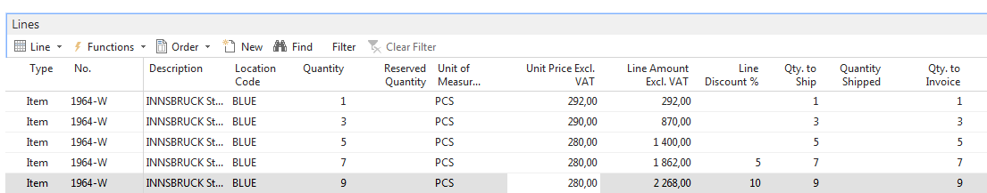
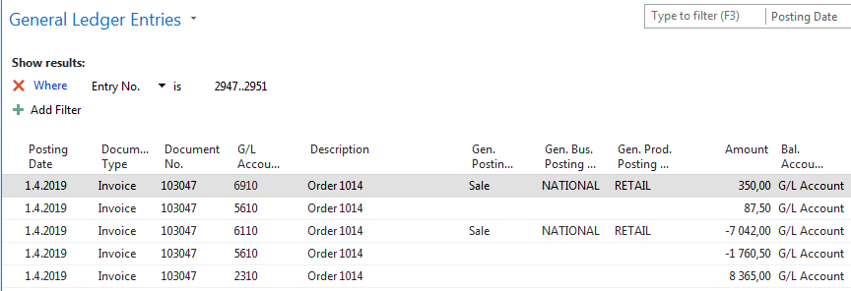

- Go back to the Customer 10000 and in the tool area find and use icon Invoice Discount in order to set this type of discount

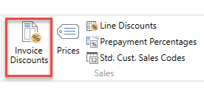

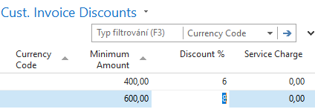
The meaning of setup is clear. If the total amount related to created Sales Order will be higher the set limits, the customer will get setup % off discount for this document.

- Create new Sales Order with Customer 10000 in its header with enough quantity of item
1964-W in order to exceed the set limit. See only Sales Order lines

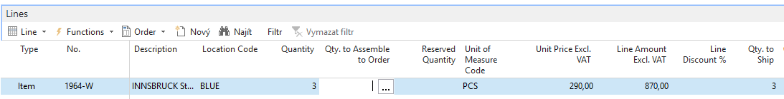
There is only Price discount applied but not Invoice discount which has to be activated by selling person manually. Before calculation of an Invoice, discount see Statistics of this Sales Order by use of key F7. You could see, that the filed Invoice Discount is empty so far.
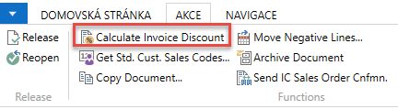

When using icon Calculate Invoice Discount, you will see calculated Invoice Discount by use of Statistics window or you can u can see this field with the show column (right mouse click on the line description area. Czech word Přidat means Add
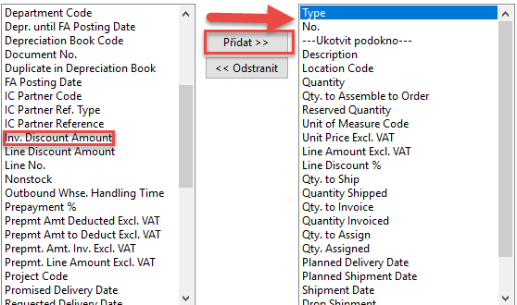

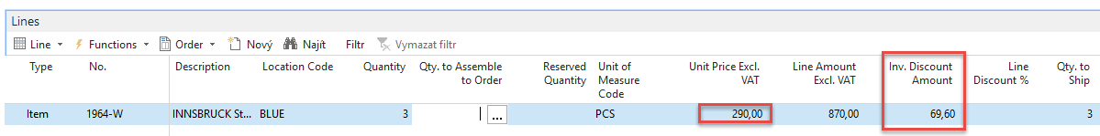
Statistics F7 will show total amount 870 British pounds and 870 x 0,92 =800,4 and 870-800,4=69,60
If you change the number of items to 7 in order to get at least some % discount um the line and you will recalculate Invoice Discount, you will get
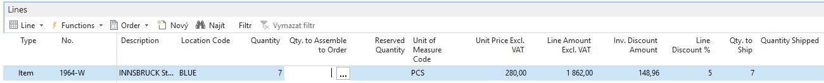
Post Sales Order by use of key F9 and see General register and General Ledger Entries. Financial Management->General Ledger->Archive ->History->G/L Register and last line and upper left corner icon General Ledger
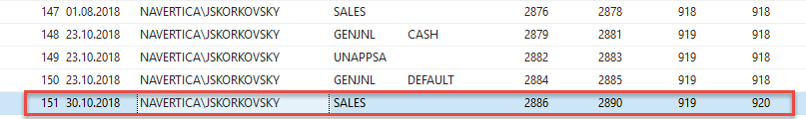
General Ledger will show
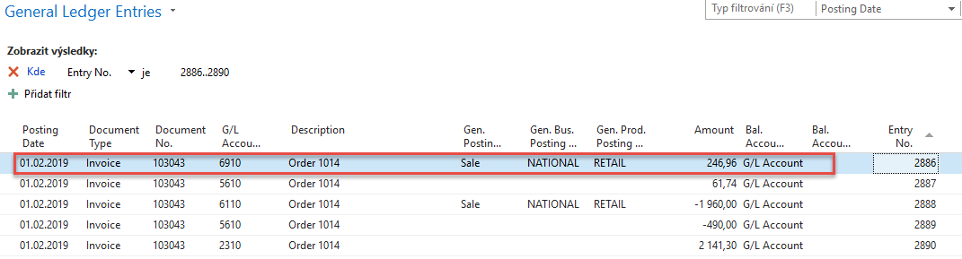New set price was 290.Total 1960 and after 5% line discount we have got 1960*0,95=1862. And after Invoice Discount of 8% is applied, we have got 1862*0,92=1713,04. If we will get posted document from G/L Register via Customer Ledger Entries->Navigate we will get:
