Simple scenario Sales Analysis Creation ERP MS Dynamics NAV 2018w1
Created by : Jaromír Skorkovský
Date : 14.11.2019
For : MPH_AOMA and AOPR and BPH_EPS1
Database : MS Dynamics NAV 2018w1
Keys : Ctrl-N=New, F4=Look-up, Ctrl-F7-entries, F7-statistics, F9-post
Shorthands : G/L General Ledger, TO-Transfer Order
Tutor-TU
- Go to working date 1.1.2020
- We have to create some item ledger entries in year 2020. Our choice will be selling some chairs on 1.1.2020 and 1.2.2020. So for that purpose we will create two sales orders on these two dates. For the sake of simplicity, we present only selling lines of the first sales order. In red frame you see number of invoices because author recently posted another SO, and this is the copy of it You will use the copy for the second SO. By use of sequence Action-> Copy document. After posting the first SO change the working date to 1.2.2020
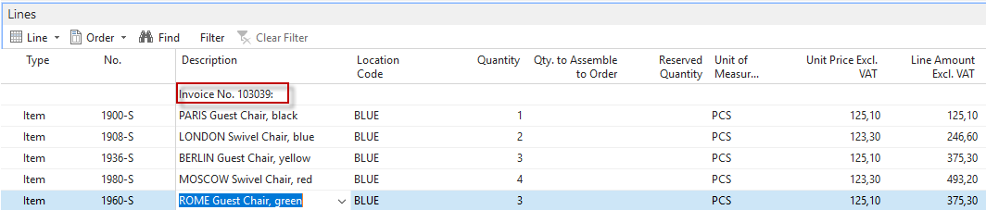
- You should see just created item ledger entries. Below entries are the one from the first posted sales order.
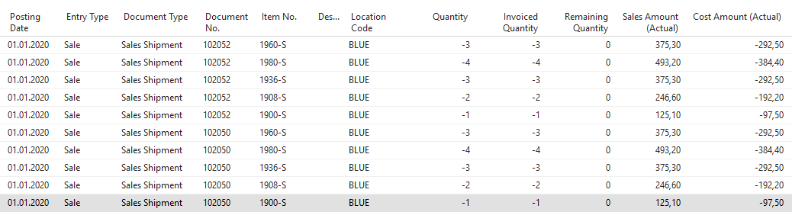
- Go back in time to 1.1.2020 (the working date) and then use Sales &Marketing ->Administration and you will get:
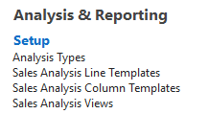

- Let's create a new Sales Analysis Line Template by icon new
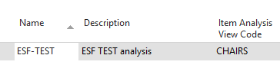
By icon Lines, you will enter data by use of icon Insert items
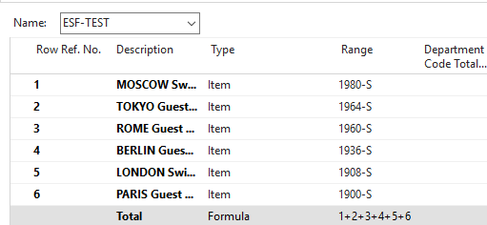
- Item analysis View Code looks like this (the principle I similar to the one already presented in the examples related to Accounting schedules. In item filter, we have manually entered all chairs separately by|character “|” (right alt gr +W). New created Vies must be updated.
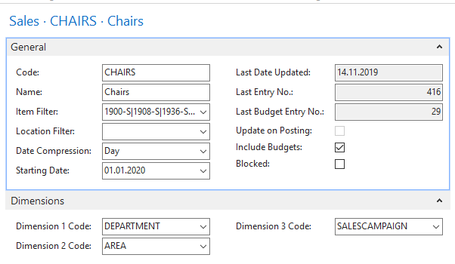
- Sales & Marketing -> Reports and analysis
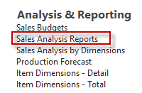
- By use of New icon you create a new line representing our brand new report Chairs
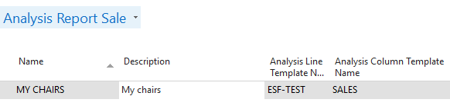
- To open it you must Edit Analysis report and then use icon Show-matrix, and you will get
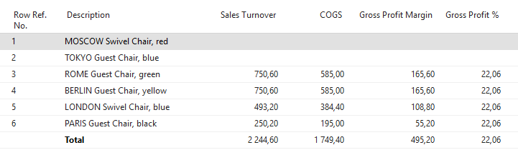
10. You could modify the report by changing the Column template. To show the logic of the column template, we present below the template Profit
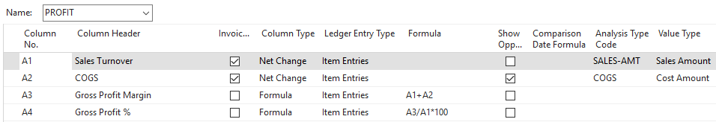
- Go to the Sales budget, and you can see some figures already entered to budget matrix. Then from the set of already created reports, try to see some data. Firstly icon Edit report and then Show-matrix
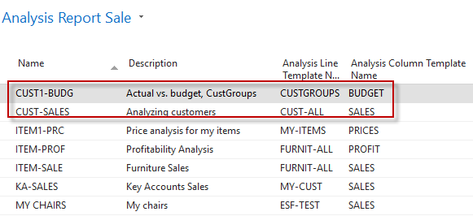

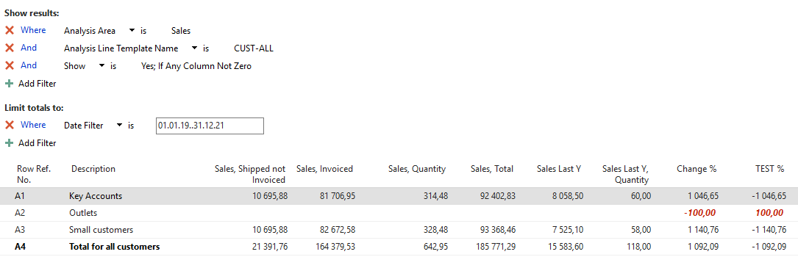
or
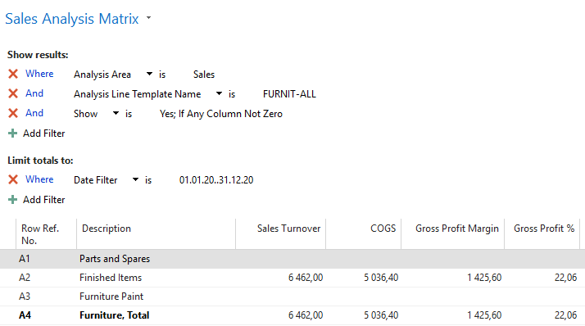

and lastly
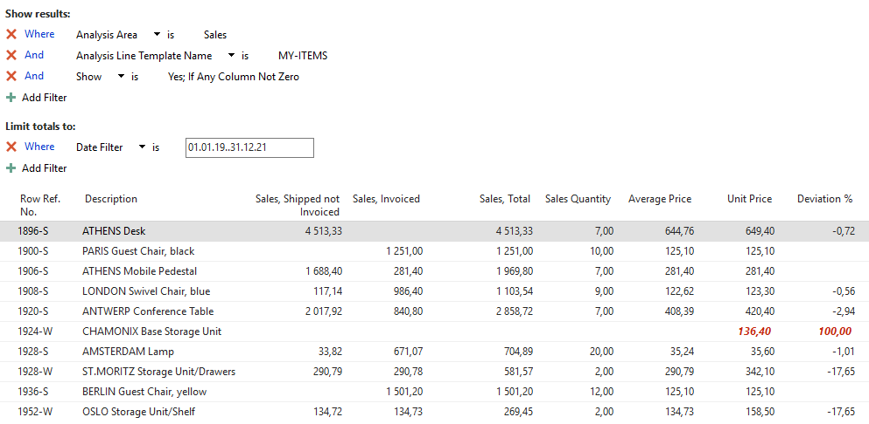
Another set of reports is called Analysis by dimensions and as one result will show one possible setup out of many and the results
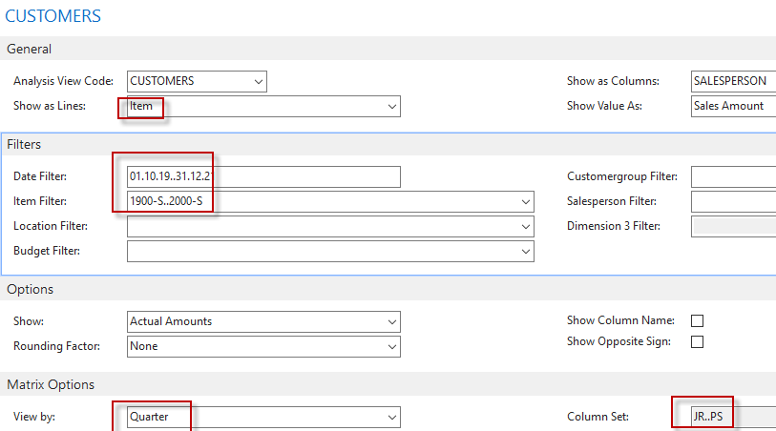

The report starts by use of icon Show-matrix
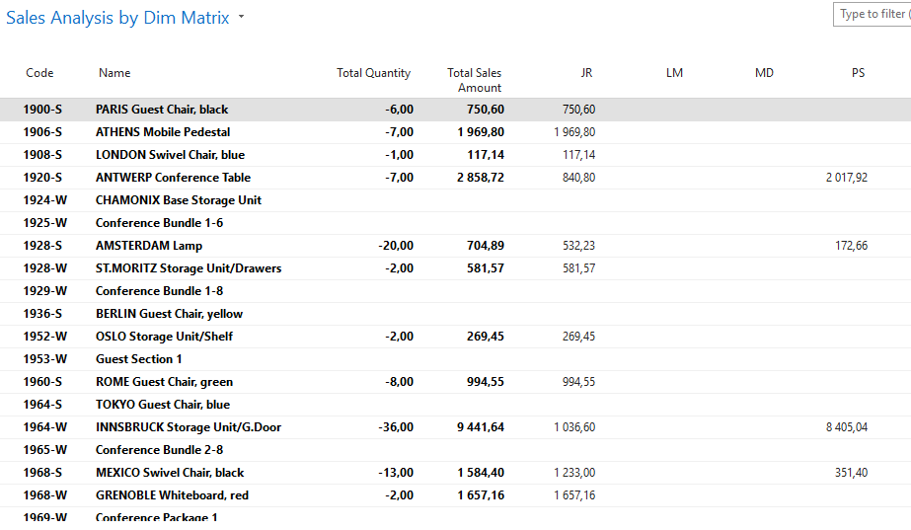
Other possibilities might be
