Complex example III_Purchase-Transfer_Sale_Payment_MS_ Dynamics NAV 2018w1
Created by : Jaromír Skorkovský
Date : 27.11.2019
For : MPH_AOMA and AOPR and BPH_EPS1
Database : MS Dynamics NAV 2018w1
Keys : Ctrl-N=New, F4=Look-up, Ctrl-F7-entries, F7-statistics, F9-post
Shorthands : G/L General Ledger, TO-Transfer Order, Tutor-TU
- By use of searching window go to the list of items – use filter to restrict list to item number 80102.
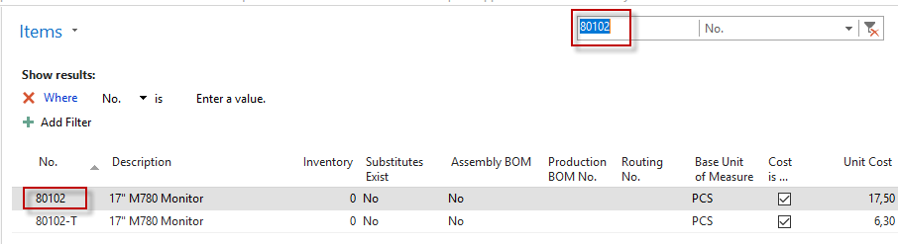
- Use icon Edit to see basic parameters of the chosen item.Use key combination CTR-F7 of appropriate icon to check if any item ledger entry exists. For chosen item there should be none.
- Go to the searching window and find a list of Vendors. Use the filter to see only Vendor number 4000. See if there is any vendor ledger entry. Use Ctrl-F7. For chosen Vendor there should be none
- Create new Purchase order (Departments->Purchase->Order Processing->Purchase orders). Use icon New in the left upper corner. Enter Vendor number 4000. Go to purchase lines and enter Type=Item, enter Item number 80102, rewrite location (from existing Green to Blue), entre quantity =10.
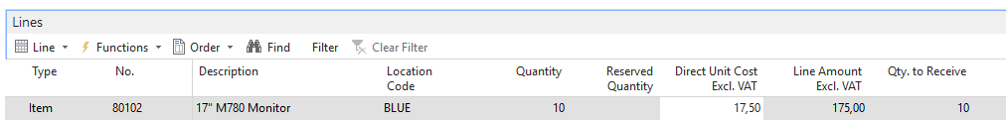
- Go to the Purchase header. Enter Vendor invoice number 20192711_ESF and post PO by F9 Use predetermined option Receive and Invoice.
- Create new Transfer order (Departments->Purchase->Order Processing->Transfer orders). Use icon New and in the header enter data as in the form below:
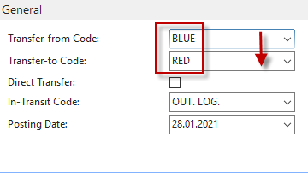
- Enter data into TO lines. Follow the form below.
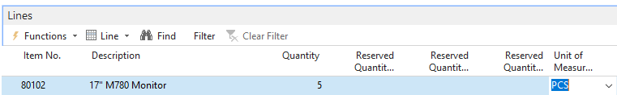
- Post-it (you have to post it two times). From Blue->Vehicle and Vehicle->Red (Ship and Receive)
- Create new Sales order ( Departments->Sales &Marketing ->Order Processing->Sales orders->icon New ->clik to create new unique Sales order number and enter chosen Customer number. In our example 61000.
- Go to the Sales line (rewrite location white to the location Blue and finally post it by F9. Use predetermined option Ship and Invoice.
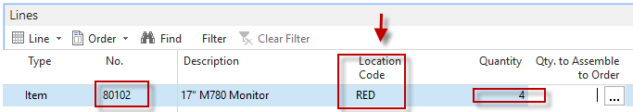
- Go to the item card 80102->searching window->item ->list of items->firlt 80102 and icon Edit.
- Ctrl-F7 and see created item ledger entries:
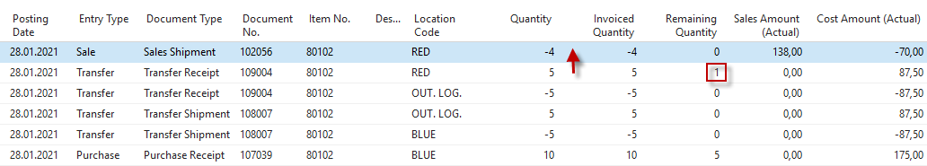
- Go to Departments->Financial Management->General Ledger->Tasks->General Journals. Use Batch name=Default (see upper part of General Journal). You should change Cash - >Default. Enter First line wit Payment and Vendro=4000 on one side of GJ and Bank type=Bank and Bank number = NBL. The use Applied entries icon.
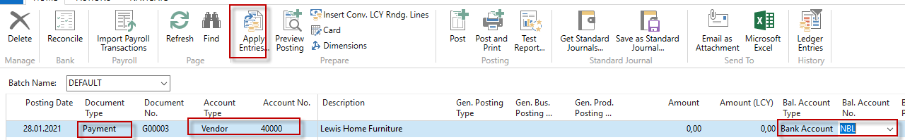
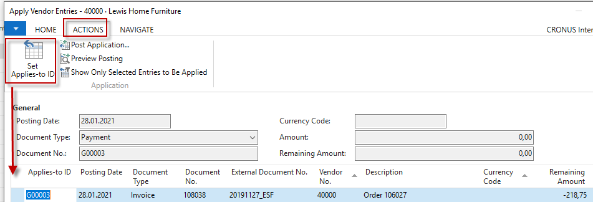
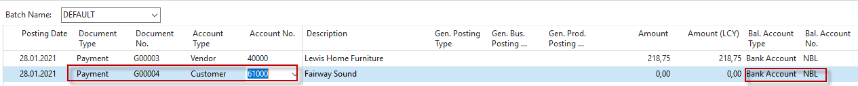
Confirm by OK button and enter the second line into General Journal. The scenario will be the same (only instead of Vendor you will use Customer=61000.

- Use again Applied entries icon, and you will get
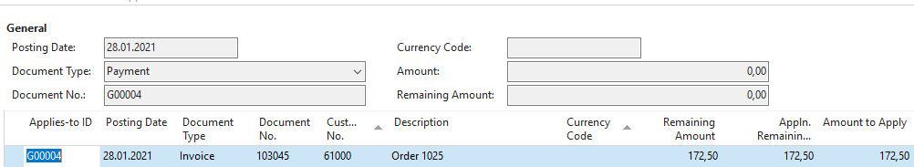
- Confirm by OK you you will have in General journal two lines ready to post by F9
- Post I by F9 and the Demartments->Financial Management->General ledger->Archive->History G/L registers
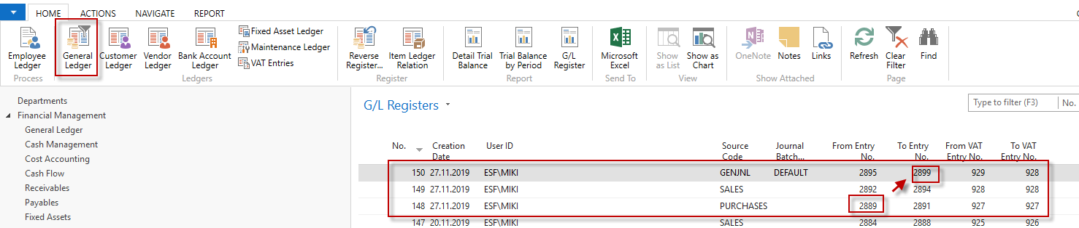
To see all General ledger entries (financial transactions), you have to use (in this example ) pair of Entry numbers (from 2889 to 2899). Any student can have slightly different numbers.
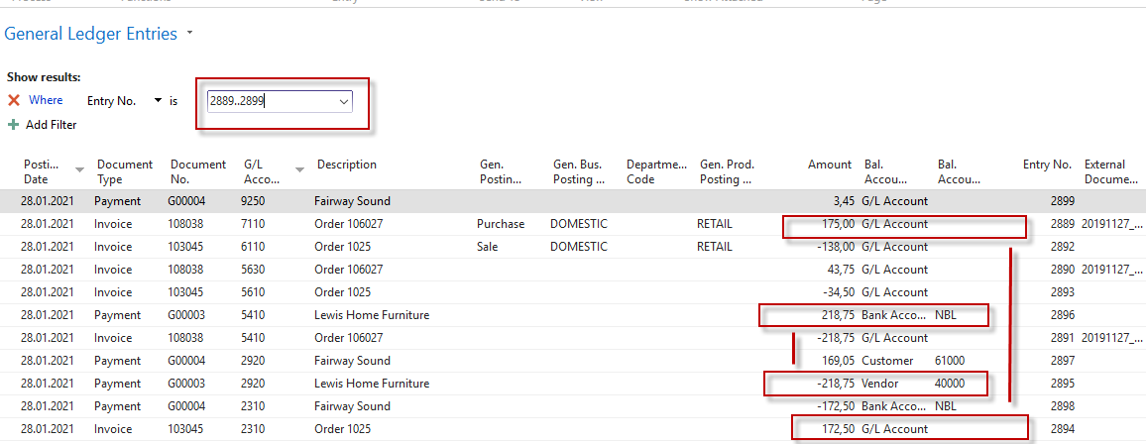
Ye can see two payments and applied entries for sales and purchase invoices.
Material VAT Vendor
218,75
43,75
175
Sales
VAT
Customer
172,50
138
34,50
172,50

